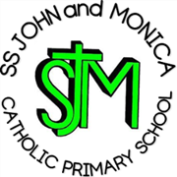
SS John & Monica Catholic Primary School
Head Teacher:
M.Elliott (B.Ed. Hons, NPQH)
Chantry Road
Moseley
Birmingham B13 8DW
Telephone: 0121 464 5868
Fax: 0121 464 5046
Email: enquiry@stjonmon.bham.sch.uk
Website: www.stjonmon.bham.sch.uk
Twitter: @SSJohnMonicas

24.04.20
Dear Parents/Carers,
I am writing to you at the end of another week of school lockdown and hope that all our families are keeping safe and well. Although the situation remains very challenging for everyone, I hope that you are able to keep as positive as possible and are keeping busy under such difficult circumstances. It has been a blessing to have had such wonderful weather to lift our spirits!

Staff have been busy this week starting to call our parents/carers to check how our children are coping. They have also been answering any queries/concerns that parents/carers may have regarding homework set. It has been lovely to speak to some families myself and catch up with how our children and community have been managing over the past few weeks. I am so impressed and proud of the resilience our SS John and Monica families continue to show.

We have been busily sending you lots of information to keep you up-to-date. This includes recent Department for Education Guidance and useful on-line educational websites including https://www.bbc.co.uk/bitesize and https://www.thenational.academy/online-classroom. We have also updated our Home Learning Programmes for another seven weeks, which can be found on our school website via https://www.stjonmon.bham.sch.uk/school-life/home-learning

There has been a small amount of building and maintenance work over the last few weeks. Our Y3 and Y4 classrooms have been painted and are bright and welcoming for our pupils. We have also used the time to have our KS1/KS2 playgrounds re-marked and know that this will welcome improvement for our children when they return.

Thank you for all your photos and video clips for our school Twitter feed. It is lovely to see how everyone is keeping busy– keep them coming in!

We continue to pray for the health and well-being of all in our school community.

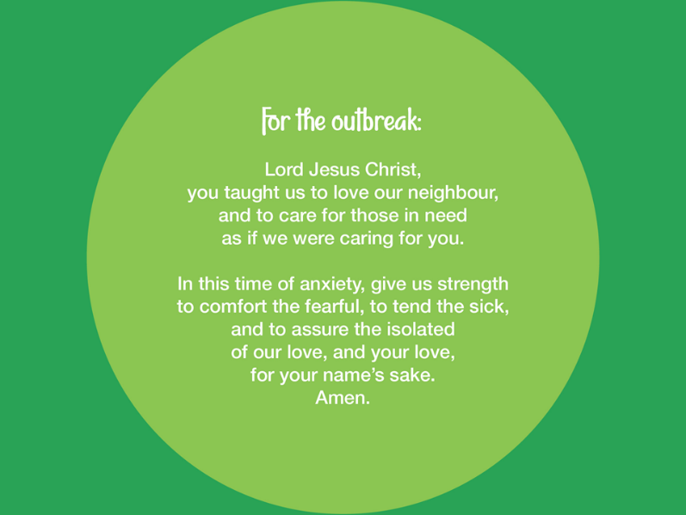
Stay Safe and God Bless,

Mrs. M. Elliott

Head Teacher

If a child is in immediate danger of significant harm a call should be made to CASS on 0121 303 1888.​

If you encounter a dangerous or unsafe situation, please contact the police.​

