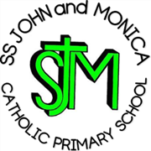
SS John & Monica Catholic Primary School
Head Teacher:
M.Elliott (B.Ed. Hons, NPQH)
Chantry Road
Moseley
Birmingham B13 8DW
Telephone: 0121 464 5868
Fax: 0121 464 5046
Email: enquiry@stjonmon.bham.sch.uk
Website: www.stjonmon.bham.sch.uk
Twitter: @SSJohnMonicas

15.05.20

Dear Parents/Carers,

Many of you are aware of the important government announcements made regarding the proposed re-opening of schools to Rec, Y1 and Y6 pupils from 1st June. We recognise that you may have many questions and concerns about this proposed reopening. The following government documents clarify some questions you may be asking and address some concerns you may have.

- https://www.gov.uk/government/publications/closure-of-educational-settings-information-for-parents-and-carers/reopening-schools-and-other-educational-settings-from-1-june

- https://www.gov.uk/government/publications/coronavirus-covid-19-implementing-protective-measures-in-education-and-childcare-settings/coronavirus-covid-19-implementing-protective-measures-in-education-and-childcare-settings

As you can appreciate, we are currently in the process of completing our own school risk assessments and working tirelessly to plan for these proposals. Please be rest assured that we will be following all government guidelines and will be updating you regularly in preparation for reopening. All Rec, Y1, Y6 parents will be contacted next week regarding protocols for reopening.

Restoration of services at University Hospitals Birmingham NHS Foundation Trust (UHB)
We are sharing information on the restoration of local NHS services with you. Please select this link to download the briefing from University Hospitals Birmingham NHS Foundation Trust and NHS Birmingham and Solihull Clinical Commissioning Group. https://content.govdelivery.com/attachments/topic_files/UKSOLIHULL/UKSOLIHULL_200/2020/05/04/file_attachments/1442430/BriefingNHS20200504__1442430.pdf

Mental Health Awareness Week 18th – 24th May
The focus of Mental Health Awareness week this year is kindness. This is a theme that we are always trying to develop within our own school. We know from research that kindness and mental health are deeply connected and that kindness is an antidote to isolation and creates a sense of belonging. Visit the following link for research and advice about good mental health for all.
https://www.mentalhealth.org.uk/campaigns/mental-health-awareness-week

Remember, if you have any concerns about helping your child learn or if you need any other support from the school, please let us know by contacting the school office on 0121 464-5868, emailing enquiry@stjonmon.bham.sch.uk or contacting your child’s class teacher via the school office.

We ask you to please keep checking your emails, as we will continue to send out important information over the coming weeks.

We continue to pray for the health and well-being of everyone in our school community.

God Bless, To recognise the International Day of Families 15th May 2020

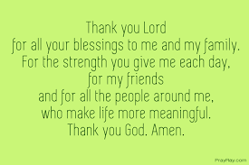

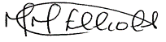

Mrs. M. Elliott

Head Teacher

If a child is in immediate danger of significant harm a call should be made to CASS on 0121 303 1888.​

If you encounter a dangerous or unsafe situation, please contact the police.​

