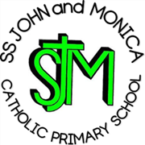
SS John & Monica Catholic Primary School
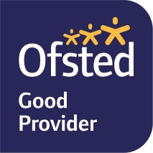
Head Teacher:
M.Elliott (B.Ed. Hons, NPQH)
Chantry Road
Moseley
Birmingham B13 8DW
Telephone: 0121 464 5868
Fax: 0121 464 5046
Email: enquiry@stjonmon.bham.sch.uk
Website: www.stjonmon.bham.sch.uk
Twitter: @SSJohnMonicas

04.12.20

Dear Parents,

As part of the RE curriculum, each class studies a different world religion. This helps pupils to develop an understanding of themselves and others, promoting their spiritual, moral, social and cultural development. This in turn contributes to society by increasing mutual respect between those of different religions.

In Year 1, we learn about Catholicism. Usually, this would include a visit to a Catholic Church but unfortunately that will not be possible this year. Instead we will be studying Catholicism in the following ways:

- A virtual tour of a Catholic Church
- Learning about the teachings from the Bible in our weekly RE lessons
- Taking part in Collective Worship by writing and sharing prayers
- Following our school mission by learning to love, respect, understand and value each other, through the example of Jesus.

We are looking forward to continuing to expand our knowledge and understanding of the Catholic religion and wanted to let you know how this will be done this year in the current circumstances. We will be sharing work that we have done with you through Seesaw.

Yours sincerely,

Miss Millar

