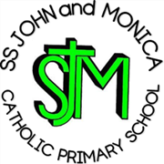
SS John & Monica Catholic Primary School
Head Teacher:
M.Elliott (B.Ed. Hons, NPQH)
Chantry Road
Moseley
Birmingham B13 8DW
Telephone: 0121 464 5868
Fax: 0121 464 5046
Email: enquiry@stjonmon.bham.sch.uk
Website: www.stjonmon.bham.sch.uk
Twitter: @SSJohnMonicas

Y2 Gurdwara virtual Tour

Dear Parents/Guardians,

I am pleased to inform you that Year 2 pupils will be having a virtual tour of a Gurdwara in our Year 2 classroom. We usually visit the Guru Nanak Nishkam Sewak Jatha Gurdwara in Handsworth, Birmingham, as part of our multi-cultural development unit, however we are unable to do this due to the current circumstances. We will be learning all about the Sikh faith, looking at wonderful artefacts and completing some fantastic activities. We will be sharing our day through see saw.

Yours Faithfully,

Miss Geoghegan and Miss Mckeown.

