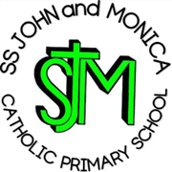
SS John & Monica Catholic Primary School

Head Teacher:
M.Elliott (B.Ed. Hons, NPQH)
Chantry Road
Moseley
Birmingham B13 8DW
Telephone: 0121 464 5868
Email: enquiry@stjonmon.bham.sch.uk
Website: www.stjonmon.bham.sch.uk
Instagram: ssjohnmonicacatholicschool

Friday 8th May 2026

Year 3 Creation Climbing Centre Visit

Dear Parents,

On Monday 6th July, Year 3 will be visiting the Creation Climbing Centre in Moseley for a two hour climbing session with qualified instructors. Our session is from 10.15am-12.15pm.

Please pay online on the parent pay app and remember to tick the consent form.

Please send your child to school wearing comfortable and flexible clothes so that children can move their arms and legs easily. Trousers must be full-length (e.g. leggings or tracksuit bottoms) with no crop-tops or jeans, as this would affect the children’s movement and comfort. Please also ensure your child has a water bottle.

Many Thanks,
Miss Geoghegan

