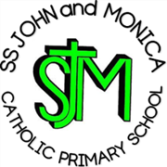
SS John & Monica Catholic Primary School
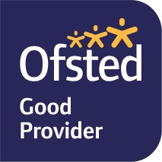
Head Teacher:
M.Elliott (B.Ed. Hons, NPQH)
Chantry Road
Moseley
Birmingham B13 8DW
Telephone: 0121 464 5868
Fax: 0121 464 5046
Email: enquiry@stjonmon.bham.sch.uk
Website: www.stjonmon.bham.sch.uk
Twitter: @SSJohnMonicas

30.11.20

Dear Parents and Carers,

As part of the RE curriculum, each class studies a different world religion. This helps pupils to develop an understanding of themselves and others, promoting their spiritual, moral, social and cultural development. This in turn contributes to society by increasing mutual respect between those of different religions.

In year 4, we learn about Buddhism. Normally, this would include a visit to a Buddhist temple but unfortunately that will not be possible this year. Instead we will be studying Buddhism in the following ways:

- A virtual tour of Buddhist temple
- Learning about a day in the life of a monk
- Looking at Buddhist artefacts
- Craft work related to Buddhism

We are looking forward to continuing to expand our knowledge and understanding of world religions and wanted to let you know how this will be done this year in the current circumstances. We will be sharing work that we have done with you through Seesaw.

Yours sincerely,

Mrs Catling and Mrs Litchfield

