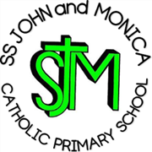
SS John & Monica Catholic Primary School
Head Teacher:
M.Elliott (B.Ed. Hons, NPQH)
Chantry Road
Moseley
Birmingham B13 8DW
Telephone: 0121 464 5868
Fax: 0121 464 5046
Email: enquiry@stjonmon.bham.sch.uk
Website: www.stjonmon.bham.sch.uk
Twitter: @SSJohnMonicas

Friday 11th September 2020
Dear Parents / Carers,

This term Year 1 have their P.E. lesson every Wednesday- starting 16th September.
On Wednesdays Year 1 should come to school wearing their full P.E. kit which they will stay in all day therefore no uniform is required that day.
This includes:
- Black or navy tracksuit bottoms
- Yellow or white P.E. top
- School jumper / cardigan
- Trainers
Your child must have their black P.E. pumps in school to change into for the P.E. lesson. Please ensure these are marked with their name. Pumps can left in school, in a bag, on your child’s peg.

Kind regards,

Miss Millar

