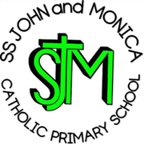
SS John & Monica Catholic Primary School

Head Teacher:
M.Elliott (B.Ed. Hons, NPQH)
Chantry Road
Moseley
Birmingham B13 8DW
Telephone: 0121 464 5868
Fax: 0121 464 5046
Email: enquiry@stjonmon.bham.sch.uk
Website: www.stjonmon.bham.sch.uk

September 2026
Parents Meeting - Reading at Home – Monday 14th September at 2:45pm at School
Dear Year 1 Parents and Carers,
We would like to invite you to a short ‘Reading at Home’ Meeting on Monday 14th September at 2:45pm.
The meeting will be led by the Year 1 Staff and Mrs Elliott and will last for approximately 25 minutes, finishing in time for the end of the school day.
During the meeting, we will share some information about the importance of reading regularly at home and give you some simple, practical tips for supporting your child with their reading.
Regular reading at home plays an important part in helping children develop their fluency, confidence and enjoyment of reading, and we would like to share some easy ways you can support this at home.
We hope that as many of you as possible will be able to join us.
Kind regards,
The Year 1 Team

