Year 6 Transition Learning Projects
WC 01.06.2020: Reflect On Your Feelings
This week’s learning project focuses on your child’s feelings about their transition to secondary school.
It will give them the opportunity to reflect on their time at primary school whilst also considering their hopes and anxieties for the future.
One activity is highlighted in a green font. This is an activity that secondary schools often ask for in order for them to fully support the children.
Transition Activities:
Monday- Starting secondary school is a time for your child to say farewell to current teachers and classmates and hello to many new faces. It is important for your child to cherish their favourite memories. Ask your child to create a drawing of their special memory and frame it in a photo frame. They may choose to draw a favourite lesson, a funny moment with friends, a school trip, their favourite teacher or a job role they were proud of. They may choose to decorate the photo frame provided or to craft their own using card. Click here for photo frame ideas
Tuesday- During their time at secondary school, your child will encounter a variety of different experiences. Ask your child to interview someone about how they coped with some of the changes they faced at secondary school. This could be a family member in their household or a neighbour/relative that has been to secondary school (please ensure that you either use technology or follow social distancing guidelines). Ask your child to consider what questions they could ask e.g. how did you make new friends? What did you do if you got lost? What did you do if you forgot your PE kit/forgot to do your homework?
Wednesday- As your child moves to secondary school, it is important that they consider their hopes and concerns. Using an outline of a face, draw the aspects of secondary life that they are looking forward to e.g. clubs, lessons; what they are nervous about e.g. homework, friends and areas that they have thoughts and questions about e.g. Who will be my teacher? Where will I eat lunch?
Thursday- Secondary schools may ask for a piece of writing to be sent to them on your child’s transition day and this is a perfect opportunity for your child to tell their new school some information about them. Ask your child to write a letter to their secondary school telling them what they are looking forward to, what they are nervous about, what they enjoy doing and something they dislike. Watch this video to learn how to set out your letter.
Friday- Your child may wish to reminisce about their memories of primary school in the future. Capture these memories in a fun way by asking your child to create a ‘Memory Jar’. Using coloured paper ask your child to write down their favourite memories. They can use different colours to show different categories of memory e.g blue for friendship, yellow for teachers, red for favourite lessons, green for school trips. Use a jam jar or a plastic bottle to collect their memories; they could even personalise their jar with decoration.
Staying Safe Online
In preparation for moving to secondary school, why not have a go at entering The Childnet Film Competition which invites young people aged 7-18 to create a 2 minute online safety film to inspire their peers to create a safe, supportive and fun online world around the theme ‘We want an internet where we’re free to…’. Within your video you could specifically aim the video at Y6 children who are making the step up to secondary school. You could do this by: highlighting the need to stay in touch with friends safely who move to other secondary schools and by Discussing how Y6 children could safely stay in contact with one other and offer support. The entries that make into the final shortlist will be judged by a prestigious panel made up of representatives from BAFTA, the BBC, the British Board of Film Classification, the BFI, Disney and the Motion Picture Association. The young people who create winning films and storyboards will receive great filmmaking and creative prizes for their school or youth group. Whether used at school or as a home learning project, the competition is a great way of exploring important internet safety messages with young people of all ages. Visit here for more information.
#TheLearningProjects

Year 6 Transition Learning Projects

WC 01.06.2020: Reflect On Your Feelings - Example Work
Below are some examples of how your child could set out their work.
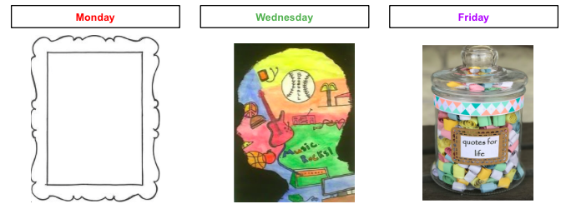

Additional Learning Resources Parents May Wish To Engage With:
- This website has some videos of worries your child may have and explains how other children have overcome them
- If your child is worried about the move to secondary school, the Young Minds website supports with worry and anxiety.
- This video offers advice on how to best prepare your child practically and emotionally for the start of secondary school.
- This video shows ways that your child can stay in touch with their friends from primary school.

