Year 6 Transition Learning Projects
WC 08.06.2020: Organising Yourself
This week’s learning project focuses on your child becoming organised for secondary school.
It will give them the opportunity to reflect on what they will need to take with them, how they will get to school, what meal choices they can make and even how to tie a tie.
Transition Activities:
Monday- Starting secondary school is a time where organisation and independence can flourish; a good routine is essential for this. Ask your child to plan their morning routine (from waking up to arriving at school) and then plan their evening routine too (from leaving school to going to bed). Remind them to think carefully about how long each activity will take and what times of the day they will be able to complete hobbies such as reading or after school clubs.
Tuesday- What should I take to school? Lots of new and different equipment is needed for secondary school. Create a shopping list with your child which includes all of the equipment they will need; consider specific lessons such as P.E and Food Technology. Use their new school’s website for support. Ask your child to draw the everyday items needed. Do they need different equipment on different days? What should they not take with them?
Wednesday- Travelling to and from secondary school requires careful planning and organisation. Talk to your child about how they will get to and from their new school. Will they walk or ride their bicycle? Take the bus? Or travel in the car? Following this, ask your child to plan their journey to school and their journey home from school (see template). What time will they need to leave the house to arrive at school on time? Which route will they take? Will they meet any friends en route? Do they need to take anything with them e.g. a bus pass or a bicycle helmet? These websites may help: Google Maps, Network West Midlands, Think!.
Thursday- Your child’s new uniform may include wearing a tie. Encourage them to practise how to their tie by watching this tutorial. Once they’ve mastered it, can they write a set of instructions for someone else teaching them how to tie theirs?
Friday- As your child begins secondary school, they are likely to have greater freedom over what they choose to eat. Recap with your child what a balanced diet looks like and what a healthy food choice is using this clip and the NHS eat well website. Ask your child to think about what the school canteen may offer for lunch. Using these ideas, ask them to create a balanced lunch plate which they would want to eat. You may want to ask them to create a 5-day menu to encourage them to eat a varied diet.
Staying Safe Online
In preparation for moving to secondary school, why not have a go at entering The Childnet Film Competition which invites young people aged 7-18 to create a 2 minute online safety film to inspire their peers to create a safe, supportive and fun online world around the theme ‘We want an internet where we’re free to…’. Within your video you could specifically aim the video at Y6 children who are making the step up to secondary school. You could do this by: highlighting the need to stay in touch with friends safely who move to other secondary schools and by Discussing how Y6 children could safely stay in contact with one other and offer support. The entries that make into the final shortlist will be judged by a prestigious panel made up of representatives from BAFTA, the BBC, the British Board of Film Classification, the BFI, Disney and the Motion Picture Association. The young people who create winning films and storyboards will receive great filmmaking and creative prizes for their school or youth group. Whether used at school or as a home learning project, the competition is a great way of exploring important internet safety messages with young people of all ages. Visit here for more information.
#TheLearningProjects

Year 6 Transition Learning Projects
WC 08.06.2020: Organising Yourself - Example Work
Below are some examples of how your child could set out their work.
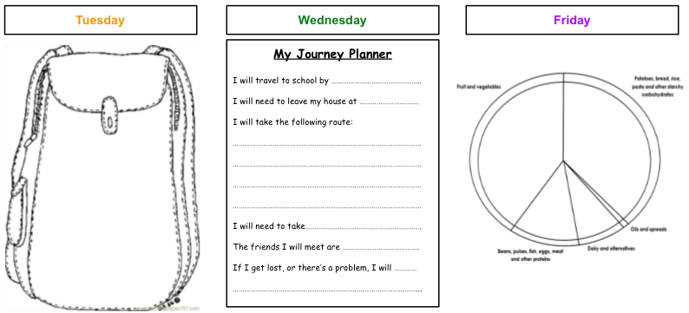

Additional Learning Resources Parents May Wish To Engage With:
- Here is a parental survival guide and cheat sheet for transitioning to secondary school from the BBC.
- If your child is worried about the move to secondary school, the Young Minds website supports with worry and anxiety.
- Here is a video about how to help your child to organise themselves and top tips for if they are struggling with their learning.
- This website has tips and tricks to becoming organised and ready for secondary school.
#TheLearningProjects

