Year 6 Transition Learning Projects
WC 22.06.2020: Growing Your Independence
This week’s learning project focuses on building your child’s independence for their transition to secondary school.
It will give them the opportunity to plan for the different lessons they will have at secondary school and to organise a time for their studies at home.
Transition Activities: | Thursday Scenarios
Monday- Next year, your child will have to be more responsible for things. Work with your child to create an agreement of when they will spend time completing their homework. It might be worth discussing with your child how often they can go on their phone/computer/game console and when they need to have a break from them. After discussing this with them, create a screen time agreement together that includes when and how often they can use their devices. | Scenario 1: You have got a detention at school. How are you going to explain this to your parents?  Scenario 2: Explain to your parents about the after school clubs that take place at your school. Which ones do you want to take part in?  Scenario 3: You return back to school but you have to social distance from your classmates. How is this going to work? How are you going to abide by these rules?  Scenario 4: Your parents want to know how you are going to get to school safely. Explain your route to them and also your back up plan. How long will it take you? When will you arrive at school and return from school? How will you let your family know you are safe? Use the route you created in week 2 to help you.
Tuesday- As your child moves onto secondary school, they will learn many new things and develop new interests. It would be good to encourage your child to work on developing a new skill. This could be something they have always wanted to have a go at, such as cooking or gardening, or could be a new skill that you could explore together, such as learning first aid or DIY around the home. After working on the new skill, your child could write a blog post or an information poster about the new skill/hobby they have discovered.
Wednesday- To support your child as they grow more independent, it might be useful for them to have a key message/messages that they want to stick by. Your child could create their own affirmation, quote or slogan that they will stick by when they are struggling with something and will offer emotional support and encouragement as they develop their independence.
Thursday- Your child will be faced with scenarios that they will have to solve independently. Some of these will involve communicating effectively to you as parents. Look at the different scenarios and get your child to decide the best way to solve them. You might want to discuss different ways they could approach these and decide together which would be the best solution.
Friday- There are many things you need to become an independent thinker. Get your child to create an independence plant, flower or tree. On it they should label all the things they need to help them to grow independence. What skills and attributes do they need? Your child could create this as a poster that they could hang up in their room. This page has an example of how you could present this.

Additional Learning Resources Parents May Wish To Engage With:
- This website gives some ideas on how your child could approach writing their own affirmations.
- On this website, there are some useful ways you can support your child to develop their own independence.
- Here are a range of examples of screen time agreements that you could adapt for your child/home.
- This short video gives advice about how your child can stay safe online and suggests how parents can support this. You could watch this with your child and maybe get them to include some of the things in their screen time agreement. There is also this screen time top tips for parents poster, which might be useful.
#TheLearningProjects

Year 6 Transition Learning Projects
WC 22.06.2020: Growing Your Independence - Example Work
Below are some examples of how your child could set out their work.
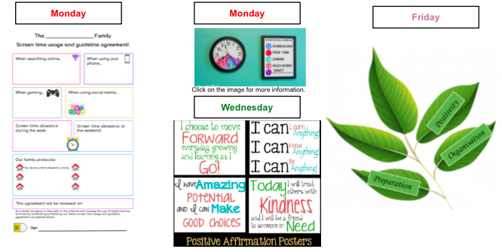
#TheLearningProjects

