Community

Early Years Foundation Stage:
- Children will learn that God is three in one: Father, Son and Holy Spirit
- Know that they are loved and called to love others
- Learn about the different communities they are part of and
the responsibilities they have to them

Key Stage One:
- Children understand that God is love: Father, Son and Holy Spirit
- Learn that being made in His image means being called to be loved and to love others
- Learn about the various communities they belong to: home, school, parish, the wider community, the nation and the global community
- Know that God calls us to live in community with one another

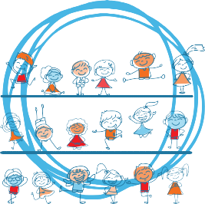
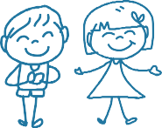
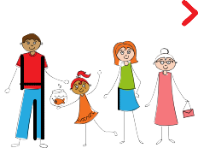
Lower Key Stage Two:
Religious UNDERSTANDING

In the first Unit, Religious Understanding, the sessions help children to develop a concept of the Trinity at a level appropriate for their learning stage. They learn about the creative circle of love between Father, Son and Spirit.
Children will learn that just like the Trinity of God, we are made to love God and love others, and we are made to be loved by God and others. This extends not only to us, our families, our friends and our personal relationships, but also to the wider world.
Module Three: Created to Live in Community explores the individual’s relationship with the wider world.
Here we explore how human beings are relational by nature and are called to love others in the wider community through service, through dialogue and through working for the Common Good.
Online Parent Portal www.tentenresources.co.uk/parent-portal
Information for
PARENTS
School login
School password
- Children will develop a deeper understanding that God is love as shown by the Trinity
- Understand that the human family
refl the Holy Trinity in mutual charity and generosity
- Know that the Church family comprises of home, school and parish
- Catholic Social Teaching on what it means to work for the Common Good

Upper Key Stage Two:
- Children will know that God is Trinity – a communion of persons
- Learn that the Church is the body of Christ
- Develop a deeper and richer understanding of Catholic social teaching
- Learn how certain charities reach out to the wider community with love
saints-13
ss-john-monica-13

DETECTIVE
Module Two: Created to Love Others explores the individual’s relationships with others. Building on the understanding that we have been created out of love and for love, this unit explores how we take this calling into our family, friendships and relationships, and teaches strategies for developing healthy relationships.

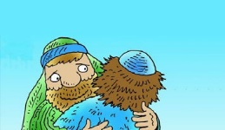
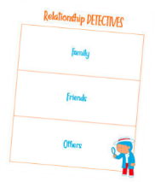
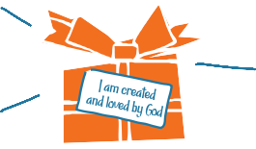
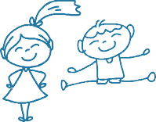
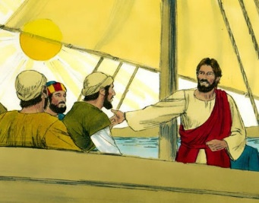
Religious UNDERSTANDING
Story Sessions:
Each learning stage focuses on a different Gospel story, which is repeated in various ways over a week, giving rise to times
of discussion, imaginative refl and creative response, for example, in Key Stage One children will hear and refl on the story of Jesus telling the little children to come to Him and through imaginative refl will put themselves into the story to experience Jesus’ call personally.
In Upper Key Stage Two, the story is that of Jesus calming the storm, and is used to refl on how whatever might come their way through puberty and beyond, Jesus is with them and will help them.
Module One: Created and Loved by God explores the individual.
Rooted in the teaching that we are made in the image and likeness of God, it helps children to develop an understanding of the importance of valuing themselves as the basis for personal relationships.
What would you
put in a Special Box all about you?
My special
BOX
What’s your
favourite animal or favourite food?
What do you
like doing?
Early Years Foundation Stage: Key Stage One:
- Our uniqueness in real terms • We are uniquely made by a loving God
- Celebrating differences, talents and abilities • We have differences and similarities
- Looking after and using our bodies • Key information about staying
- The necessity of when and how to say sorry physically healthy
- Jesus’ forgiveness and growing up • Understanding feelings and emotions, as God’s plan for us including strong feelings such as anger
  - The cycle of life from birth to old age
Lower Key Stage Two:
- Understanding differences
- Respecting our bodies
- Puberty and changing bodies
- Strategies to support emotional wellbeing Including practicing thankfulness
- The development of pupils’ understanding of life before birth
Upper Key Stage Two:
- Appreciation of physical and emotional differences
- A more complex understanding of physical changes in girls’ and boys’ bodies
- Body image
- Strong emotional feelings
- The impact of the internet and social media on emotional well-being
- A more nuanced and scientifi understanding of life in the womb and how babies are made
- Menstruation

Early Years Foundation Stage: Unit 2: Personal Relationships
  - Different family/friend relationships
  - Features of positive/negative behaviour in relationships
  - The importance of saying sorry and forgiveness within relationships
Unit 3: Keeping Safe
  - Practical ways to stay safe inside and out
  - Staying safe around medicines
  - People who help us in emergencies

Lower Key Stage Two:
Unit 2: Personal Relationships
  - Different family structures
  - Activities and strategies for developing healthy relationships with family and friends
  - Techniques for managing thoughts, feelings and actions
Unit 3: Keeping Safe
  - Online safety
  - Teaching on bullying and abuse
  - The effects of drugs, alcohol and tobacco
  - The crucial role of First Aid in emergency situations

Religious UNDERSTANDING
At the start of each learning stage, we begin with a series of story sessions based on a key Gospel story which provides the religious foundation for the teaching that will follow. For example, through an imaginative retelling of the Prodigal Son, children deepen their understanding of the concept of sin and the importance of forgiveness in relationships.

Key Stage One:
Unit 2: Personal Relationships
- ‘Special people’ in their lives who they love and can trust
- Coping with various social situations and dilemmas
- The importance of saying sorry and forgiveness within relationship
Unit 3: Keeping Safe
- The risks of being online
- The difference between good and bad secrets
- Teaching on physical boundaries
- The effects of harmful substances
- Some basic First Aid

Upper Key Stage Two:
Unit 2: Personal Relationships
- Strategies for more complex experiences of relationships and conflict
- How to identify and respond to spoken and unspoken pressure
- The concept of consent
- Further teaching on how our thoughts and feelings impact on how we act
Unit 3: Keeping Safe
- Risks of sharing and chatting online
- A more complex understanding of different forms of abuse
- How drugs, alcohol and tobacco can negatively affect people’s lifestyles
- Essential First Aid such as DR ABC and the recovery position

