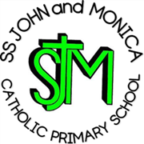
SS John & Monica Catholic Primary School
Head Teacher:
M.Elliott (B.Ed. Hons, NPQH)
Chantry Road
Moseley
Birmingham B13 8DW
Telephone: 0121 464 5868
Fax: 0121 464 5046
Email: enquiry@stjonmon.bham.sch.uk
Website: www.stjonmon.bham.sch.uk
Twitter: @SSJohnMonicas

Friday 19th November 2021
Dear Parents/Carers,

We are pleased to invite you to this year’s Reception and KS1 Christmas Nativity.
This year it will take place on Wednesday 15th December at 2pm in the school hall.
We please ask that upon arrival you wear a mask and adhere to social distancing rules. Due to rising COVID-19 cases we can only invite one parent/carer for each child, however you will be able to record/ take pictures during the performance to show other family members and for personal use only.
We look forward to welcoming you to this year’s Nativity, where you can sit back, relax and enjoy the show.

Kind regards,

Miss Geoghegan, Miss Millar and Mrs Riches.

