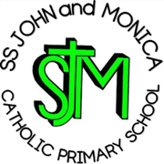

SS John and Monica Catholic Primary School
Prospectus
2023/2024

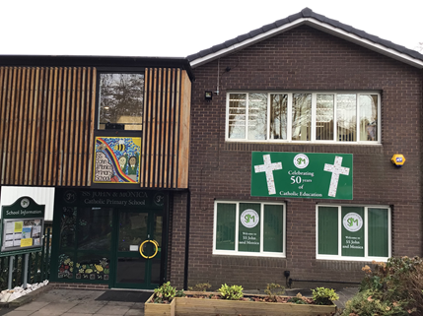
Ofsted June 2018 – Graded Good

Across the school, teaching is effective and enables most pupils to make increasingly good progress’

‘Behaviour of pupils is outstanding’

Section 48 Inspection November 2018 – Graded Outstanding

“The school Leaders & Governors are absolutely determined in the way they promote the Catholic Life of the school. The mission statement is truly at the heart of the school and is relevant to everyone. The entire Community understands and upholds the mission”

MISSION STATEMENT

“At SS John and Monica, we learn through the example of Jesus, to love, respect, understand and value each other.”



WELCOME

Dear Parent/Carer,

This prospectus is intended to give parent/carers with children at our school, or parents selecting a school for their children, a clear view of what SS John and Monica Catholic Primary School is all about. It contains information which we hope will be of value to existing and prospective parents or anyone else who is interested in the school.

As a Catholic school, we have a special responsibility to deliver the National Curriculum, strengthened by the religious ethos of the school and our close links with the parish of St. John and Martin.

The Governors are justly proud of the school and its achievements (see page 29) and place great emphasis on the school's multi-cultural environment. I hope you find the prospectus interesting and if you have any questions please contact the Head Teacher, Senior Leadership Team or any of the Governors.

Mr P Foster

Chair of Governors

WELCOME

Dear Parents/Carers,
I am extremely privileged to be the Head Teacher of SS John and Monica Catholic Primary School, a successful, vibrant and inclusive school which nurtures the ‘whole-child’, encouraging them to grow spiritually, academically, and socially.
Our mission is to strive to learn through the example of Jesus, to love, respect, understand and value each other. Our core purpose is to ensure that all children in our school have the opportunity and support to achieve their full potential. We recognise that it takes a community to raise a child and we are proud of the strong partnership we have with our parents, parish and community.
As Head Teacher, my aim is to work with our whole school community to guide our children throughout their educational journey, helping them to be successful life-long learners and positive role models, who can contribute to society in the future.

Mrs M. Elliott

Head Teacher

GOVERNORS

Chair: Mr P. Foster
(Foundation)

Vice-Chair: Mrs B.Rooney
(Foundation)

Head Teacher Governor: Mrs M. Elliott

Foundation Governors: Mr P. Foster
Mr M. Murphy
Miss A. Phillips
Mrs A. Blackwood
Mr L.Maciel

Parent Governors: Ms J. Hall
Mrs K. Elliston

LA Governor Mr I. Bhomra
Staff Governor Mr A. Ullah

Clerk to the Governors: Mrs D. Feeney

SCHOOL STAFF

Head Teacher: Mrs M. Elliott
(Designated Safeguarding Lead DSL)

Deputy Head Teacher Mr A Ullah
(Deputy Designated Safeguarding Lead DDSL)

Class Teachers Miss C Nolan (Rec Class)
Miss S. Mann (Year 1)
Miss R Millar (Year 2) (DDSL)
MissH.Geoghegan (Year 3)
Mrs K Litchfield/Mrs J Catling (Year 4)
Mr S Walsh (Year 5)
Mr Mrs S Gray/Mr A Ullah (Year 6)
Miss M McEvoy PPA Cover
Mrs Riches

SENCO Mrs H Nicholls (DDSL)

Learning Support Assistants
Mrs T Ali-Shahid
Miss S Dabhelia
Mrs S Griffiths
Miss L Hill
Mrs T Kausar
Mrs J Reed
Miss H Smith
Mrs A Zahid

Office Staff Mrs T. Broadhurst (Senior Office Manager
Part-time)
Mrs R. Khan (Secretary-Part-time)
Mrs M. Croke (Administrative Assistant – Part-time)

Building Site Supervisor Miss L. Goley

Breakfast Club Supervisors Mrs J. Saunders

Lunchtime Supervisors:
Mrs S. Akhtar
Mrs S Akhtar
Mrs N Akhtar
Mrs A. Hussain
Mrs T. Kausar
Mrs K. Saleh
Mrs J. Saunders

SS. John and Monica
Catholic Primary School
OUR CORE VALUES & GENERAL AIMS OF THE SCHOOL

- To develop a Christ-centred community in which the Catholic Faith is nurtured and where a knowledge of and respect for other world religions is fostered.
- To establish an environment and ethos (clearly understood values and attitudes) within which individual children may develop their own potential for the benefit of themselves and the rest of society.
- To enable children to acquire the basic skills of literacy and numeracy.
- To enlarge a child's knowledge, experience and imaginative understanding and thus enhance his/her awareness of moral values and capacity for enjoyment.
- To develop in children, the ability to make reasoned judgements and choices based on the interpretation and evaluation of relevant information, e.g. to develop a critical and discriminating attitude towards the mass media.
- To help children to appreciate human achievements in art, music, science, technology and literature
- To deliver a high standard of education to all pupils guided by the school Mission Statement and in line with and National Curriculum requirements.

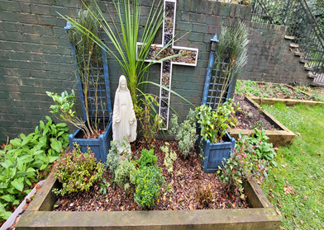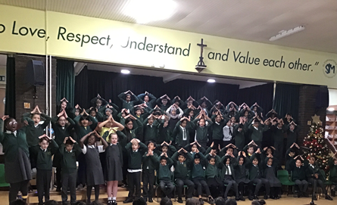

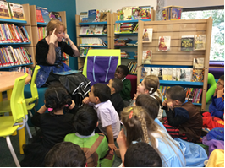

HISTORY OF THE SCHOOL

SS John and Monica Catholic Primary School is a voluntary aided school which opened in September l980, following the amalgamation of the St. John's Infant and Ss. Monica's Junior Schools. The premises occupied at the present time were built in l970. The school serves the Parish of Ss. John and Martin and draws its children from the Balsall Heath/Moseley area.

As a Catholic School, the basic religious ethos is to be found across the whole curriculum and not just within religious education lessons. The aim of the school is to encourage the Christian growth of the child.

SS John and Monica Catholic Primary School recognises the need for children to be prepared for life in a multi-cultural society by fostering respect for diversity, and by seeking to counter racist and discriminatory attitudes.

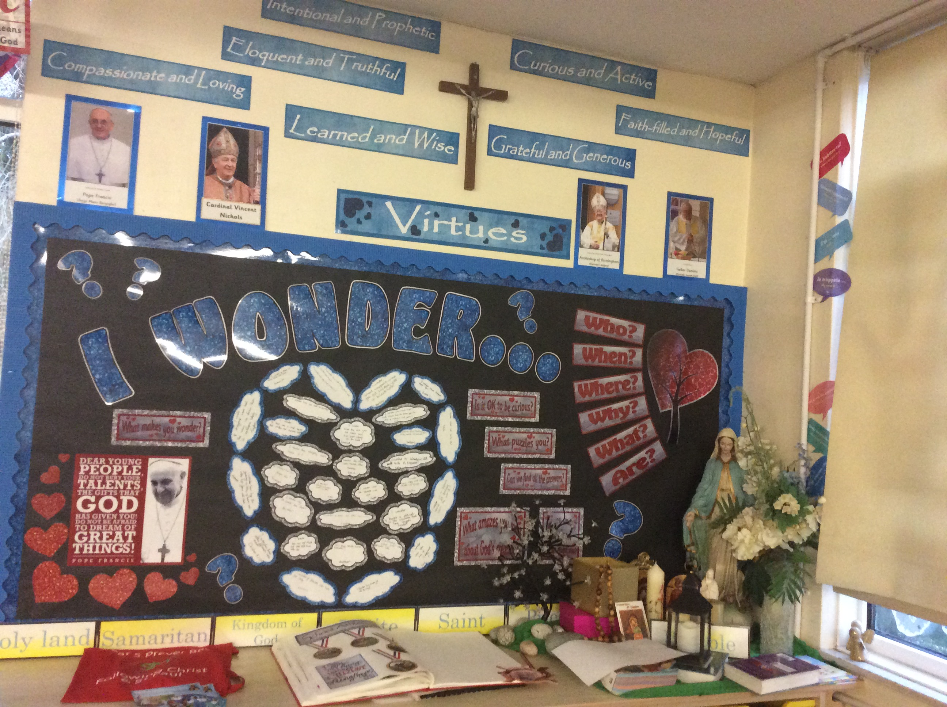

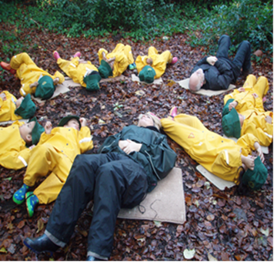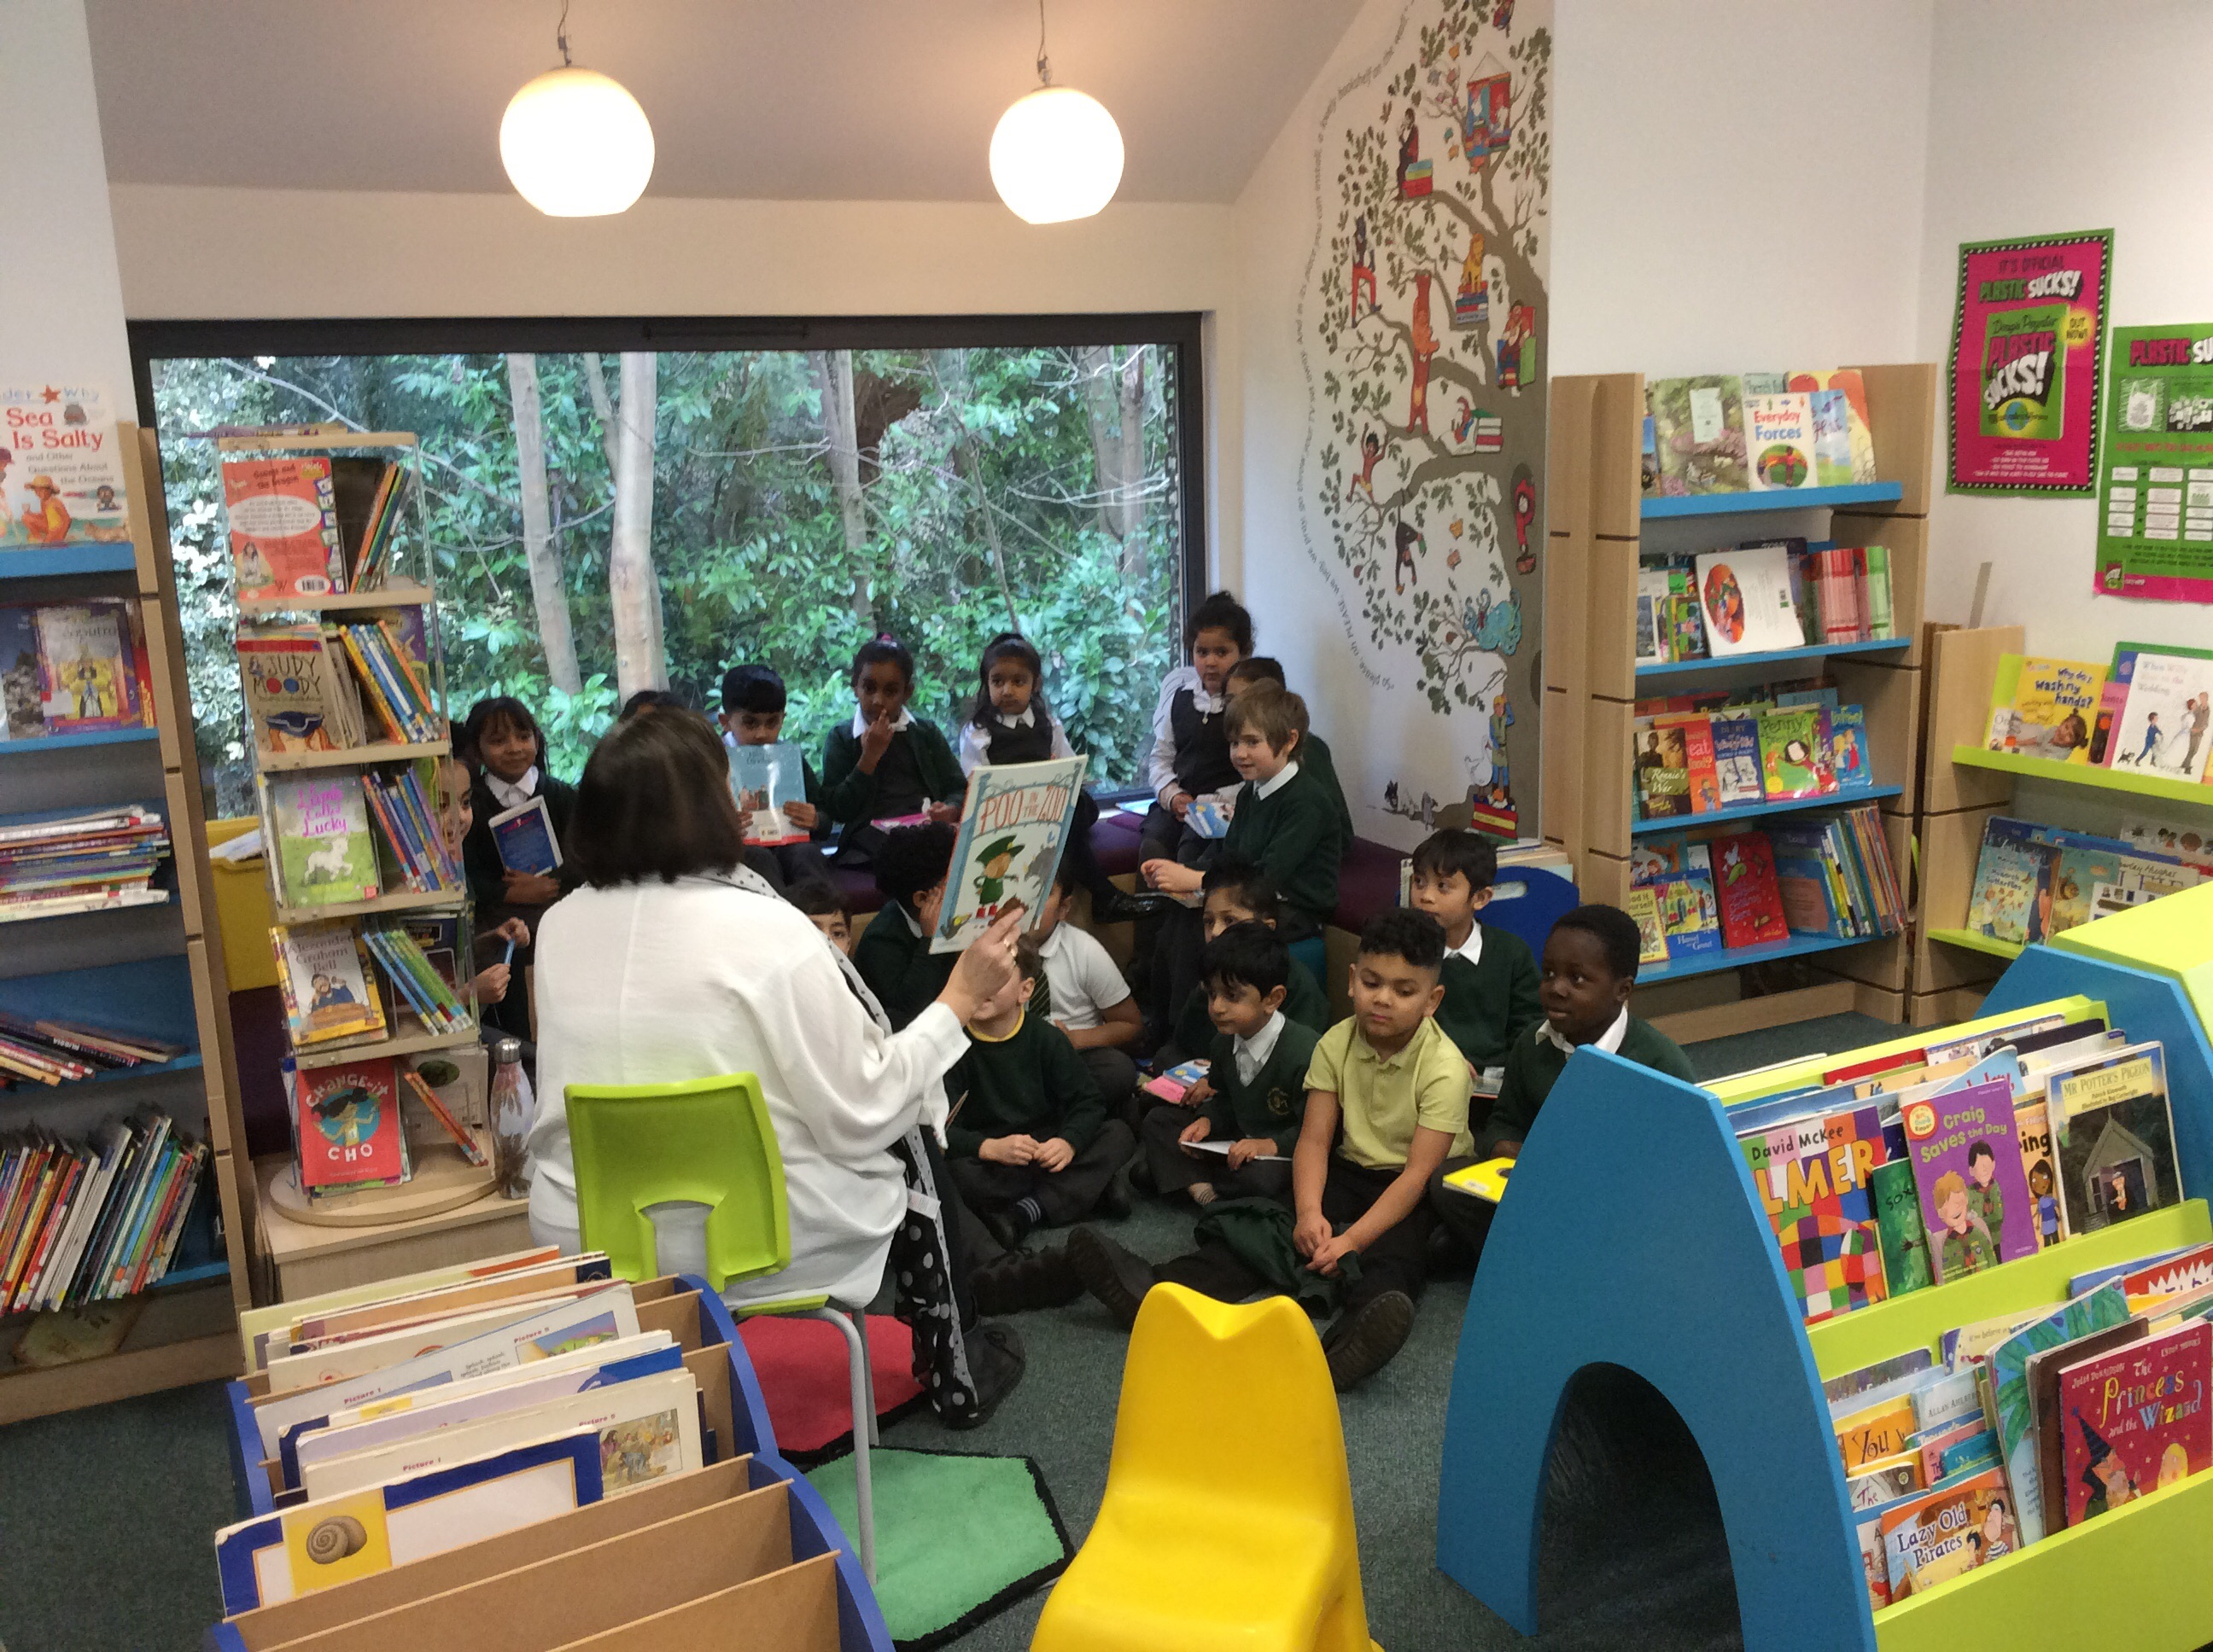

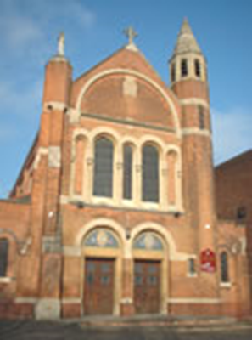

St John & Martin’s Church

Parish Church

SS. John and Martin Church
George St., Balsall Heath,
Birmingham
B12 9RG

Telephone: 0121 440 3025

Parish Priest: Fr. Jagadishmario Kurapati

Email:

ssjohnandmartin.bham@rcaob.org.uk

Website:

www.birminghamdiocese.org.uk/st-john-and-st-martin

St John the Evangelist and St Monica are The Patron Saints of our School

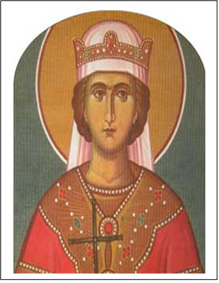

SCHOOL CHAPLAIN

Father Mario is our Parish Priest and works closely with the school in many ways, celebrating mass, hearing confessions. He is concerned with the spiritual welfare of the children. We are very fortunate to have such generous support.

SAFEGUARDNG & CHILD PROTECTION

Our first priority is your child’s welfare and therefore there may be occasions when our concern about your child means that we have to consult other agencies even before we contact you. The Birmingham Safeguarding Children Partnership has laid down the procedures we follow. If you want to know more about this procedure, please speak to the Head Teacher. Following recent September 2016 legislation the school’s policy for Safeguarding and Child Protection has been updated and is available on the school website. If any parent has a concern about a child please speak to the Head Teacher, Mrs Elliott (Designated Safeguarding Lead – DSL) or Mr Ullah, Mrs Riches, Mrs Nicholls or Mrs Doyle Deputy Designated Safeguarding Leads. Alternatively phone Birmingham Safeguarding Children Partnership on 0121 303 1888.



PARENTS AND FAMILIES

The school is noted for its family atmosphere, fostered by experienced and dedicated staff.

We enjoy good relationships amongst ourselves and are equally supportive to our pupils and parents.

When we welcome a child, we welcome a family.

Parents' Consultations are twice a year. The first meeting, which is usually held early in the autumn term, gives parents an opportunity to discuss how their child has settled in with their new teacher and discuss targets for the year. The second meeting, in the spring term allows parents to see their children's work and to discuss progress made during the year. A report on your child's progress will be sent home at the end of the summer term. Parents then have the opportunity to come in and discuss the report if they so wish.

However, if you are ever worried about any aspect of school you should contact us immediately. If you wish to see your child's work or consult the teacher at other times, please contact the School Office to make an appointment. This will ensure that the proper time may be given to deal with the matter. In the case of urgent matters, these will be dealt with as a matter of priority. Staff are available after (not before) school.

Whilst we welcome the support of parents, recent child protection legislation insists that all adults who work with children have a DBS check (Criminal Records Bureau). Occasional support such as on school trips, sports day etc may be exempt from this.

During the course of the academic year we run many social and fundraising events. Our Parents Fundraising Team are responsible for some of the fundraising and are always looking for new volunteers.

Parents are warmly invited to School Mass which is held on Thursdays at 9.00 a.m. (except for the 1st Thursday of every new half term).

Parents of Reception children will be invited each year to join their child for lunch. This is an opportunity for parents to see how their child manages themselves at lunchtime and can be very reassuring.

Parents of Reception will also be invited to attend a Parents Workshop at some point in the year. These prove to be an invaluable insight to parents about how their child is being taught and will help parents help their child at home with their learning:

FOREST SCHOOL at SS JOHN AND MONICA SCHOOL

In addition to our usual classroom activities, we offer children the chance to take part in Forest School learning sessions on a rolling programme, and sessions are conducted in small groups. We employ the services of a fully qualified Forest School Teacher

The school provides weatherproof clothing for the sessions, dungarees, jackets and wellies for the smaller children and rainproof jackets and trousers with wellies for the older children.

We conduct our Forest School sessions throughout the year and in all
weathers – rain or shine!

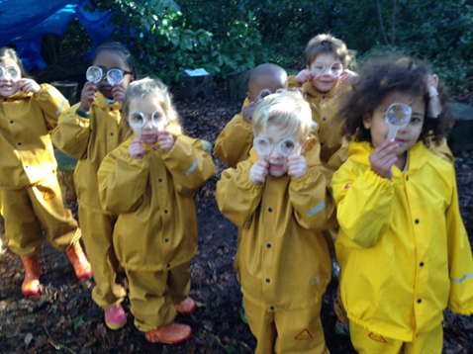
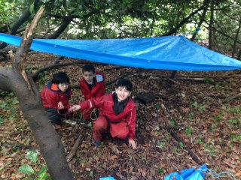

SPECIAL EDUCATIONAL NEEDS & DISABILITIES (SEND)

SS John & Monica’s recognises and values all children as individuals and as such all children are entitled to a quality education that recognises their individuality and responds to their personal, social, emotional and academic needs. We feel that within this recognition of individuality is the potential for children to have a range of academic and behavioral levels and our aim is to respond quickly and appropriately to their needs as far as resourcing will allow.

We recognise that some children will have a “Special Educational Need or Disability” (also referred to as SEND) at some stage of their school life. These needs will come in a range of type (e.g. Moderate Learning Difficulty, Autism), severity and duration and therefore the need for constant observation, assessment, target setting, liaison with parents and external agencies and review of all children is paramount to fulfilling our commitment to a quality education for all. As a result of this cycle of assessment and review we can ensure that all children are offered a curriculum which is broad and balanced, addresses their individual needs and has staff that are responsive to difficulties and ensure quick intervention where necessary.

At SS John & Monica’s we strive to bring school and home into closer and more effective communication in all aspects of their child’s life. We involve parents in all stages of the Special Educational Needs process and aim to provide a supportive network exchange of information and to help parents help their children. Changes in circumstances can impact the needs of the child and we encourage parents to contact school to discuss their children whenever this may be the case, likewise teachers will contact parents as soon as difficulties become apparent. The child is central to education and at all stages of planning and review we aim to make children involved in their goals, ensuring they are consulted whenever practicable and their viewpoint noted. Such records are good indicators of the less measurable success criteria such as improved self-image, confidence, and perception of ability and areas of interest. We aim to give children ownership of their learning and the opportunities to evaluate their achievements.

All schools are in the process of updating their policies and practice to have regard for the Governments SEND Code of Practice 0 – 25 which will become law from September 2014. The school SEND Information Report is available on the school website.

We also respond to the emotional, social and behavioral needs of pupils who may need extra support in these areas.

Mental Health and Wellbeing is always at the forefront of our pedagogy.
Please contact Mrs H Nicholls (SENCO) for any special needs related queries.

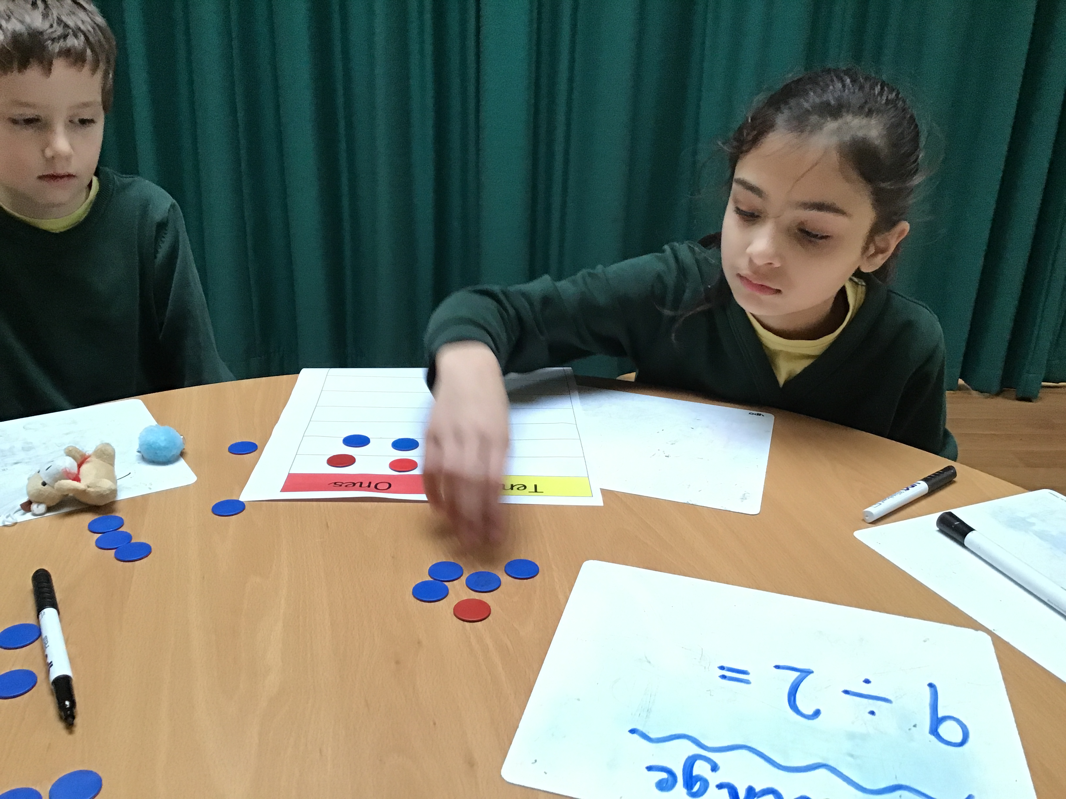

PASTORAL CARE

Our Christian approach to all children makes SS John and Monica School very special in the sense that all children, parents and staff belong to a family.

All staff are very caring from the first day a child comes into school and no pupil should ever feel isolated.

Our multi-cultural education policy ensures that we respect the different traditions and faiths of our non-Christian children.

PHYSICAL EDUCATION

- ALL children take part in all P.E., games, sports and swimming (in KS2 only)

- If a child is ill, a child may be excused by a doctor's note or in exceptional circumstances written request from a parent (authorisation is given by the Head Teacher).

- Please label all items of clothing, e.g. ties, P.E. kit, jumpers etc. with your child's name. Children must have full P.E. kit in school at all times

- Plimsolls/pumps (not trainers) must be worn for PE in the school hall.

Across the school there are opportunities to participate in PE lessons held by a range of sports specialists and coaches.

RELATIONSHIP EDUCATION / HEALTH EDUCATION

Following the Statutory Government and Diocesan guidance pupils in all year bands follow the scheme TenTen – ‘Life to the Full’ as part of their Relationship Education. Health Education is covered using a range of schemes.

HOMEWORK

Homework is set in Reception and KS1 homework consists of reading, spelling and basic numeracy.

Children in KS2 will be asked to complete certain tasks at home during the course of the week. They will also be expected to know all their tables by the end of Year 4. Homework will increase in Years 5 & 6. A homework policy is available on our school website within our whole school Teaching & Learning Policy.

SCHOOL DISCIPLINE & RELATIONSHIP AND BEHAVIOUR POLICY

SS John & Monica School uphold the highest standard of discipline and the co-operation and support of parents is considered to be essential in the maintenance of good order within the school. (A parent may be sent for if the behaviour of a child is thought to be totally inappropriate).

We believe it is essential that SS John and Monica's School be first and foremost a place of justice and peace. This philosophy underpins every aspect of our school life, and is evident in our dealings with each other, the curriculum we present to our children and the ways in which we deliver that curriculum. We are not a Catholic school in name only. Our very ethos proclaims our Christianity, and our attitudes and dealings with everyone connected with school life reflects the teachings of Christ.

Our Relationship and Behaviour policy is aimed at helping every member of our school community to fulfil their potential. It intends to help create and maintain a happy, caring environment where people can work and play in safety. It aims to promote good effort and behaviour, building self-esteem and encouraging self-discipline. It should also provide a support for those children who find self-discipline more difficult to maintain.

A whole school approach to the management of pupil behaviour demands a team effort by all members of the staff, teaching and non-teaching staff alike, where staff are supported and supportive to each other. Adults and children alike must be aware of their individual and collective responsibility to the smooth and safe running of the school.

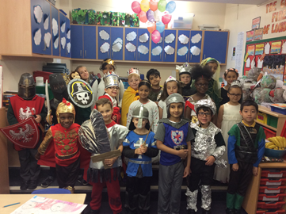
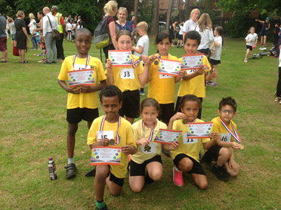

SCHOOL HOURS

It is essential that you get your children to school in good time.(in normal circumstances)

Breakfast Club Available from:
8.00am daily

School Opens from 8.40am

School Starts: 8.50am

Rec Lunch: 11.45 – 12.45pm
KS1 Lunch: 12.00 - 1.00pm
KS2 Lunch: 12.15 – 1.15pm

School Closes 3.20pm

School Day Ends: 3.15pm

There is a 15-minute interval during the morning session for both Reception/KS1 and KS2

Children should NOT arrive at school before 8.40am unless they are using the breakfast club, which opens at 8am. The school building opens at 8.40am and pupils are invited to go straight to their classrooms at this time

At the breakfast club children have a choice of wholemeal toast, cereal, yoghurt and fresh fruit. Activities such as physical development, arts & crafts and games are planned for on a daily basis. The cost for breakfast club is £3.75.

Please ensure that your child is collected punctually at 3.20pm. If you are unexpectedly delayed, or if someone else is collecting your child, please inform the school beforehand. There is a charging fee for those parents who collect their children late from school or After School.

SECURITY

- Electronic gates have been fitted to the entrance of the school. All parents visiting the school during the day will need to press the intercom button to gain access.
- All external doors will be kept shut and locked to the outside at all times.
- All visitors during the school day will have to sign the visitor’s book and wear a badge of identity. All visitors will be escorted by a member of staff. People on site without a badge or accompanying member of staff will be challenged.
- As the Reception Class, Year 1 and Year 2 have a separate external door; parents will collect them from that door.
- Years 3, 4, 5 & 6 will be dismissed from the Junior Playground at 3.15pm where parents will be able to meet them.

SCHOOL UNIFORM

Can be purchased at Clive Marks – Kings Heath High Street

The Governors require all pupils to wear the distinctive SS John and Monica school uniform. This helps to create a feeling of belonging - children can take pride in being a part of SS. John and Monica's family when they wear it. It also has a practical side, in that, uniform clothes are made to last leaving the children's better clothes for home use. Unbranded uniform may be worn.
These are the Governors detailed requirements:

Winter Uniform | Summer Uniform
Grey skirt, pinafore/trousers | Green gingham dress
Green v neck sweater/cardigan | Grey Shorts
White shirt and school tie | Yellow polo shirt
White/black/grey socks/tights (no leggings) | Green v neck sweater/cardigan
Sensible black shoes (no slip-ons) | Sensible black shoes (no slip-ons)
Head Scarf | Black, Green & Grey
School Hoodies (PE)

Please refer to the photographs below:
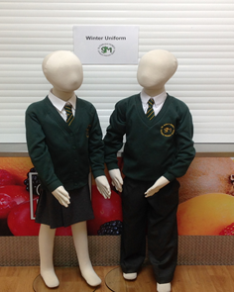
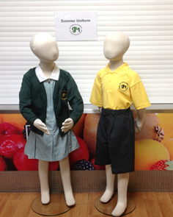

- For safety reasons No jewellery is allowed in school except for one stud earring in each ear.

- Please put your child’s name & year in each item of clothing to enable us to return lost property to you.

PLEASE NOTE: Please DO NOT allow children to bring toys, mobile phones or games to school - these may become lost or broken and the school can take no responsibility for their safety.
SCHOOL MEALS

Dinner money is to be paid online via www.eduspot.co.uk

1 day lunch money = £2.60
2 days lunch money = £5.20
3 days lunch money = £7.80
4 days lunch money = £10.40
5 days lunch money = £13.00

This price is subject to change by order of the Local Authority.

- Applications/enquiries for free meals should be made to the School Office.
- The school operates a ‘Healthy Eating Policy’
- Children may bring a healthy packed lunch. Children bringing a packed lunch can choose to purchase pizza on Friday. Contact the school office for details.
- Please note: liquids MAY NOT be sent in tins or glass containers.
- All containers should be secure to avoid damage to schoolbooks, P.E. equipment.
- Children may only swap from packed lunches to school dinners and vice-versa at the beginning of a half term.

DINNER MONEY

Dinner Money is recorded electronically and the following procedures need to be followed:

Dinner money must be paid weekly in advance using the School Money on line system. An e-mail is generated automatically as a receipt of payment. No cash is accepted in the office.

Please note that the school cannot allow debts to accrue. Repeated failure to pay your child’s dinner money may result in your child having to bring in packed lunch.

YOUR SUPPORT IS APPRECIATED

ABSENCES

Children should attend school every day unless too poorly to come to school. Please ring the school office on 0121 464 5868 by 9.00am. You will receive a text from school asking you to contact us if we do not hear from you on the first day. In accordance with governmental policy holidays during term time will not be authorised by the Head Teacher. Pupils are required to be in school for the prescribed 190 days unless they are too ill to attend. The school’s detailed attendance policy is available on the school website.

Parents who insist on taking their children away during the school term will need to complete a Home School Contract and provide evidence of the return flight date. Failure to do this may result in your child being reported to Missing Children’s Team.

The 2023/2024 school target for attendance is 97% for all pupils in Years Rec - 6. Pupils who attain the school target for attendance will be part of the whole school reward we arrange for the summer term. We hold a focus and punctuality attendance week every month and children who attend for 100% of that week are entered into a prize draw.

ILLNESS OR ACCIDENT AT SCHOOL

In the event of a child needing to go home due to an illness or accident, the parents will be contacted. For this reason - it is essential that we are kept informed of any change of contact number/address including a minimum of 3 emergency contact numbers.

MEDICAL/DENTAL VISITS

The school must be informed in advance when a child will be attending a medical appointment. All non-emergency medical appointments should be made out of school hours to reduce lost learning time for your child. Please report to the School Office before collecting your child. The office will ask to see a copy of the appointment card/letter to confirm why the child is out of school (in accordance with our attendance procedures)

NO CHILD may leave the school premises during the day unless an adult accompanies them and they have secured permission from the Head Teacher

MEDICINES

Wherever possible you must organise administering your child’s medication when they are not in school, but if this is not possible because the doctor has prescribed 4 daily doses for example, we will do our best to accommodate you. If your child needs to take medication you can make arrangements to come in to school to administer the medication yourself or we can supervise your child taking their own medication. Parents must remember that staff are not required to give pupils routine medication but we will do what we can to support parents who would have difficulties managing this due to work or location. We follow the recent Government legislation regarding Managing Medicines in Schools and parents are required to complete a form of authorisation for medication to be administered in school.

In instances where the medication is for a life threatening condition, a member of staff will be responsible for the required administration and record keeping.

Under no circumstances should you send your child in to school with medication in their bags. The school office will ask you to come into school and sign a document stating the names and doses of any medication your child needs to take. If your child can take the necessary medicine themselves, we will supervise them taking it. The medicine should be delivered to the school office if it has to be on site during the school day and we will ensure it is stored correctly. It is the parent’s responsibility to provide only what is required and complete the paperwork correctly or we will be unable to give the medicines.

If your child has asthma and has a prescribed inhaler from your GP you should ensure that they have a spare one that can be kept in school. It should be clearly labelled with your child’s name and expiry date. If your child requires a spacer this must be provided by the family. Each class has an asthma box which will be accessible to your child at all times. It is a parent’s responsibility to check expiry dates. Only reliever inhalers are allowed in school, which are usually blue.

Pupils who require Epipens or Piriton (anti-histamine) must have them prescribed by their doctor. These must be labelled with the child’s name, date of birth and date of prescription.

SCHOOL BOOKS AND MUSICAL INSTRUMENTS

Children are encouraged to take books home. However, loss or misuse or damage to books could result in that privilege being withdrawn as well as a charge being made for the replacement.

Year 3 pupils get the opportunity to learn a musical instrument, which they will be allowed to bring home. The instrument and music books are brought into school each week for the lesson.

COMMUNICATION

A fortnightly newsletter is electronically sent by e-mail each Friday to keep parents informed of the activities taking place in school. This newsletter and more information about the school can be found on the school website (www.stjonmon.bham.sch.uk) or you can join us on our Twitter page (@SSJohnMonicas). Important dates, such as holidays and trips, are included.

EXTRA-CURRICULAR ACTIVITIES 2021/2022

We offer a range of extracurricular activities on a rolling programme across the year.

A charge of £4.50 per session is made for all internal clubs. External clubs are run by a private company who are fully DBS checked.

PARKING

Please remember to be courteous and safe in your parking. Only park where there are no zig-zag lines and do not block the driveways of the neighbouring houses. Lots of our families live within walking distance of the school. Why not park a good walking distance from the school to give your child the chance for exercise in the fresh air and save on congestion around the school. We are continually looking at ways to improve the air quality of our school environment.

HOLIDAY DATES 2023/2024

Autumn Term 2023

Open Close

Tuesday 5th September Thursday 26th October
Monday 6th November Friday 22nd December

Spring Term 2024

Open Close

Tuesday 9th January Friday 9th February
Monday 19th February Friday 22nd March

Summer Term 2024

Open Close

Tuesday 9th April Friday 24th May
Monday 3rd June Friday 19th July

N.B. There are 5 other Teacher Training Days:

Monday 4th September
Friday 27th October
Monday 8th January
Monday 8th April
Monday 22nd July

SECONDARY TRANSFER

Last year children from SS John and Monica Catholic Primary School transferred to the following Secondary Schools:

SECONDARY SCHOOLS

Bishop Challoner R.C. School | 13 | Moseley School & 6th Form | 1
King Edward Camp Hill | 2 | Queensbridge School | 4
Lords Wood Boys | 1 | King Edward Aston | 1
Archbishop Ilsley | 1 | Other | 2
St Pauls Girls School | 1 | Harborne Academy | 1
Lordswood Boys | 1
Solihull School | 1 | Total | 29

CHARGING AND REMISSIONS

A copy of this policy is available from the school office

COMPLAINTS

A copy of the Complaints policy is available from the school office and on the school website.

TELEPHONE NUMBERS

Birmingham Education Department General Enquiries 303 1888

Ss. John and Monica School Tel: 464 5868

E-Mail: enquiry@stjonmon.bham.sch.uk
Website: www.ssjonmon.bham.sch.uk

SS. John and Martin Presbytery 440 3025

