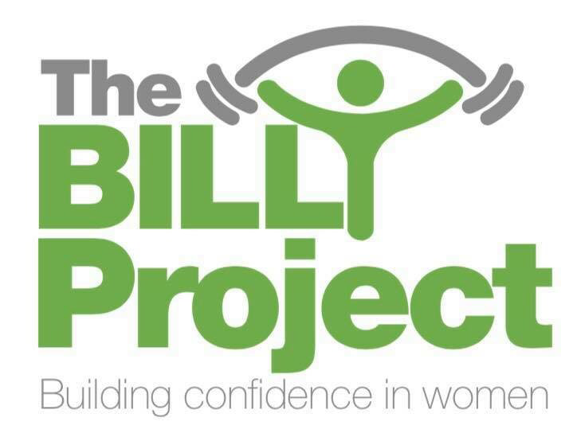

**The Billy Project Referral Form**

Date:

Client Name:

DOB:

Contact Number:

The Billy Project to contact client: **Y/N**

Key Workers name:

Key Workers attending session: **Y/N**

Details (health issues, medication, etc):

Referred by:

Please return completed form to

Sammi Yates sammi@thebillyproject.co.uk

Alternatively, hand in or post to Unit 2 Fitness for Women, Albert Street, Mill Hill Blackburn, BB2 4BL.

Telephone contact details:

Sammi 07960643154