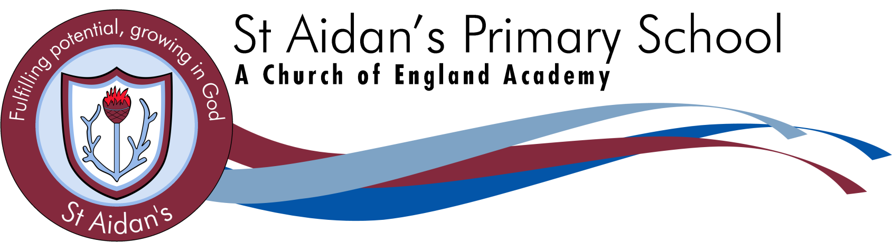
A member of

Headteacher: Mrs Debbie Greenwood Deputy Headteacher: Mrs Kelly Harrison

Dear Parents/Carers,

We have a child who attends St Aidan’s that has a severe nut allergy.

Children who suffer from nut allergies can develop a severe, potentially life-threatening allergic reaction.

If someone has a nut allergy it is not just eating nuts that can cause a severe reaction, just being touched on the skin or smelling the breath of someone who has had nuts or a product containing nuts can trigger anaphylactic shock (which can cause breathing and swallowing difficulties).

All staff in the school are trained to use the Epi-pen (an injection or adrenalin) which is required immediately if this happens.

We cannot have nuts in school in any form.

So please can we ask that you have no nut products in lunch boxes or brought into the school as treats.

We cannot allow the following:
Peanut butter sandwiches
Chocolate spreads e.g. Nutella
Chocolate croissants
Cereal bars
Some granola bars
Cakes that contain nuts
Biscuits / Cookies that contain nuts
Peanut butter cakes
Some Asian food, including satay
Sauces that contain nuts
The list is not exhaustive, so please check the packaging of products closely.

We appreciate this is an additional thing to check and we know that you recognise the importance of it. We do have to insist we are a nut free school. I know if this was your child you would expect that we all help, especially as it is a life-threatening condition.

If you have any questions, please don’t hesitate to speak to a member of staff.

With kindest regards,
Mrs Deborah Greenwood
Headteacher
Norfolk Street, Mill Hill, Blackburn, BB2 4EW
Tel: 01254 53148 Email: staoffice@cidari.co.uk

