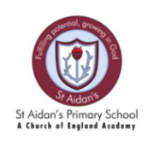
St. Aidan’s Primary School - A Church of England Academy
KS2 - Year 5 Timetable
Autumn term

 | 8.50-9.05 | 9.05- 9:35 | 9:35-  10.35 | 10.35-10.50 | 10.50-11.00 | 11.00-12.00 | 12.00-1.00 | 1.00- 1.20 | 1.20-3.00 |  | 3.00-3.15
Mon | Celebration assembly | Guided Reading | English | Playtime | TTRS | Maths | Dinner | Handwriting | History | RE | Story
Tue | Worship | Guided  Reading | English |  | TTRS | Maths |  | Spellings | Metacognition | PE | Story
Wed | Worship | Guided Reading | English |  | TTRS | Maths |  | Spelling | Science | Art | Story
Thur | Worship | Guided Reading | English |  | TTRS | Maths |  | PSHE | Swimming |  | Story
Fri | PPA  Music, Computing, MFL |  |  |  | PPA  Music, Computing, MFL |  |  | Class worship | English | Maths | Story

