St. Aidan’s Primary School - A Church of England Academy

Marking and Feedback Policy

Rationale.
At St. Aidan’s, we recognise the importance of feedback as an integral part of teaching and learning. It is a vital component in maximising the full learning potential of all our children. We believe that the purpose of marking and feedback is that pupils are given an opportunity to improve, that successes are celebrated and that learning is moved on, otherwise it is a waste of valuable teacher time; time that could be spent on lesson planning and design.
The school’s policy has been devised using key research on effective feedback and the workload implications of the last decade related to written marking, underpinned by the evidence of best practice from the Education Endowment Foundation (EEF) and other expert organisations. The EEF research shows that effective feedback should:
• Redirect or refocus either the teacher’s or the learner’s actions to achieve a goal
• Be specific, accurate and clear
• Encourage and support further effort
• Be given sparingly so that it is meaningful
• Put the onus on students to correct their own mistakes, rather than providing correct answers for them
• Alert the teacher to misconceptions, so that the teacher can address these in subsequent lessons.
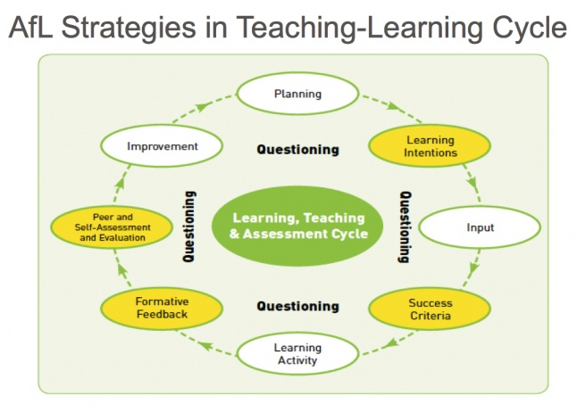
Additionally, the Department for Education’s (DFE) research has highlighted excessive written marking as a key contributing factor in unsustainable teacher workload. As such we have investigated alternatives to written marking which can provide equally effective feedback in line with the EEF’s recommendations, and those of the DfE’s expert group which emphasise that marking should be ‘meaningful, manageable and motivating’.

Key Principles.
Marking and feedback MUST be;
Meaningful – to children
Manageable – for adults and
Motivating - for all.

It should be;
Focused – on the Learning Objective,
Success Criteria and differentiated expectations.
It should;
Consistently address – spelling, grammar, punctuation and presentation in ways which are appropriate to individual child’s age and development.
Marking and feedback in practice- Strategies for marking
It is vital that teachers evaluate the work that children undertake in lessons and use information obtained from this to allow them to adjust their teaching. Feedback occurs at one of three common stages in the learning process:
1. Immediate verbal feedback – at the point of teaching. This would be given by an adult in the presence of the child or group of children. This would happen whilst the children are working. A record of this would take the following form;
- ‘V’ for verbal feedback, using a red pen, plus a brief note in the child’s book to explain if appropriate.
2. Distance marking using the marking and feedback booklet – this takes place away from the children, will be recorded on the whole class marking and feedback sheet (to replace 30+ individual comments) and gives opportunity for further analysis and reflection on children' progress in learning. This may also lead to the need for further dialogue with children as individuals or groups to celebrate successes in learning and inform discussion about application/next steps and/or fully diagnose misconceptions/errors during the dedicated ‘Fix it’ time. See Marking and Feedback book.
When distance marking, the following should be taken into consideration:
- Which work met the LO that can be praised and shared in the next session?
- Which children need further support and why?
- Which children are not following the schools expectations of presentation?
- Which children have not acknowledged the non-negotiables for their year group?
- Are there any common misconceptions that need to be addressed?
- Which children are ready for a next step or challenge?

3. Daily FIX IT TIME Further teaching, (identified on the whole class feedback and marking sheet by the teacher upon review of work from the previous lesson) to enable the children to identify, edit and improve for themselves areas for development. There is no specified way of running ‘Fix it time’ as the age and ability of the children must be considered. It may also take the form of a short, focused intervention group if a number of children have the same type of activity to undertake. Use of purple pens, editing strips and general editing will show that this time has taken place.

Expectations at St. Aidan’s.
Non-negotiables for effective Marking and Feedback.
At St. Aidan’s our expectations are clear and unambiguous.
- Each piece of work will be marked by an adult.
- The support given during a task and whether the learning objective was met will be clearly identified using the support codes.
- All adults mark in red pen and all children will edit and improve their work in purple pens.
- All work will be marked promptly – before the next taught session in that subject and an analysis of the children’s learning by the teacher will be shown in the marking and feedback book.
- Quality feedback that occurs during a lesson will be marked with a ‘V.’
- Any writing opportunities will be quality marked and a whole class feedback sheet will be evident in the whole class marking and feedback booklet. Feedback will be evident from the teacher in relation to the learning objective, success criteria and established non-negotiables.
- FIX IT TIME occurs daily to ensure feedback is acted upon in the marking and feedback booklet.
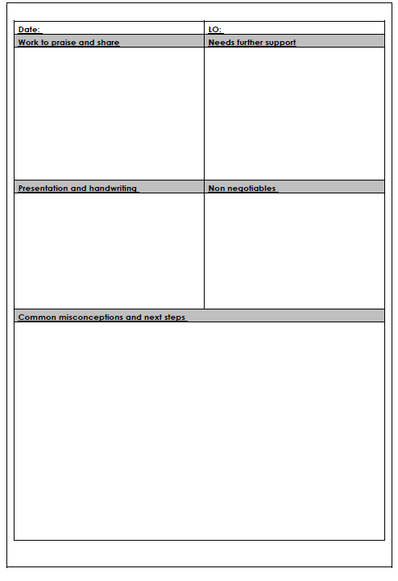
- Each child/group will know what the expectations are for SPAG. These are the non- negotiable elements, which are expected to be seen in ALL pieces of work. These will be commented upon as and when required and SHOULD NOT BE OVERLOOKED.

Mrs. Greenwood
Headteacher
Last reviewed January 2021

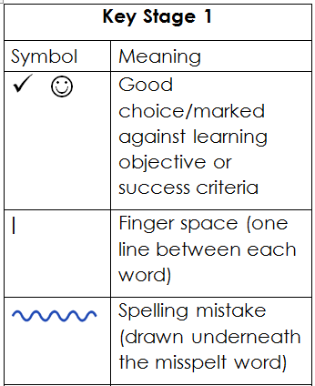
Marking Symbols and Support Codes
Key Stage 2
All the symbols in KS1 plus:
Symbol | Meaning
// | New paragraph
C | Check work for mistakes
 | Start at the margin
 | Better word choice (bag it)
whith | Mistake. Line (drawn with a ruler) used to show a spelling or general error.
 | Word/phrase/idea missing
? | I don’t know what this means

Support codes
T | Teacher support
TA | Teaching Assistant support
I | Independent
CHI | Child Initiated work (EYFS)
V | Verbal support

