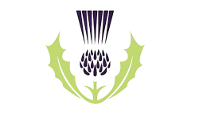
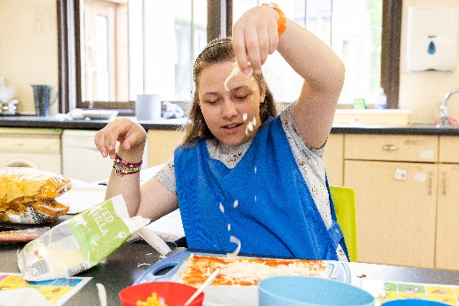
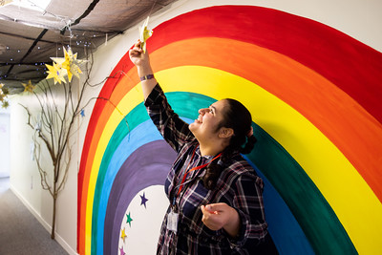
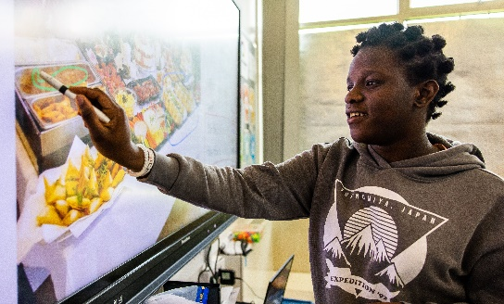
St Andrews Academy Curriculum
Here at St Andrews Academy we offer a rich, varied, ambitious and carefully researched curriculum that prepares our students for adulthood. This document provides an overview of our curriculum offer.
Implementation
Intent
Impact
Intent Drivers- Core Values
We place great importance on a curriculum which develops the whole person. Through our core values, we foster an environment where the emotional, physical, academic, social, moral, spiritual and cultural development of each young person is at the heart of everything we do. We aim to:
- Innovatively deliver a curriculum to meet the needs of every learner.
- Empower students so they have the knowledge and skills to reach their full potential, equipping them with everything they need for their future. This includes future work and community life, healthy living, and becoming as independent as possible.
- Establish and utilise links and learning opportunities within the wider community.
- Inspire, create and have fun!

Preparing our Students for Adulthood and Their Future beyond the School Gates
Glens (Complex Learners)
A creative theme based approach which incorporates interconnected activities, supporting learners to transfer skills for real world and functional experiences.
Highlands (Complex Learners)
Our more complex learners follow a curriculum focussing on developing Executive Functioning Skills and the application of these beyond the school gates.
Person Centred Journey- Our curriculum is broad, balanced, compliant, age-appropriate, and constantly evolving.

Key Stage 3: follow a topic-based approach. Students are taught all National Curriculum subjects. There are 3 lessons a week for English and Maths. Reading is taught every day. Mornings tend to be for core subjects with Foundation subjects being taught in the afternoons.
Key Stage 4: continue to be taught English and Maths skills and knowledge daily, but apply them in wider context, including the Duke of Edinburgh Award. Reading is taught every day. Topics are linked to Preparation for Adulthood outcomes-Employment, Independent Living, Social & Community Inclusion, Health and Wellbeing.
Key Stage 5: continue to learn and apply functional English and Maths skills. Carefully planned visits, work experience, community links and skill workshops enhance learning and develop understanding of how students can contribute to society. This prepares them to take their next step into adulthood, their community and society.

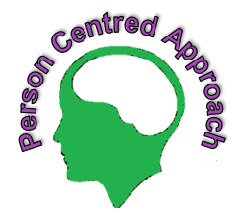
World Health Organisation’s ‘Skills We Need to Live a Healthy Life’ are woven throughout the curriculum. British Values of Democracy, Individual Liberty, Tolerance, Respect, & Law underpin the teaching and ethos at St Andrew’s Academy. There is also a strong focus on Spiritual, Moral, Social & Cultural (SMSC) education throughout the school year.
Learning for Life skills embedded into the curriculum content- Coping with stress and emotion, Critical thinking and problem solving, Creative thinking, Empathy, Self-Awareness, and Decision Making

- Having had a wide range of learning experiences and opportunities suited to their individual needs, students are able to make informed choices about their future-they are as completely prepared for the next stage of their lives.
- Students have the skills and knowledge they need to live the most purposeful, fulfilling lives they possibly can.
- Our young people leave with an acceptance of themselves, underpinned by the application of life skills and support strategies.
- They are equipped to be positive citizens with an understanding of how their culture is an important part of their development
and experiences.

Learning for Life
The St Andrew’s Curriculum focuses on applying six skill concepts, as outlined by the World Health Organisation. These are essential for the health and well-being of children and adolescents. These are:
1 Critical Thinking and Problem Solving
2 Empathy
3 Creative thinking
4 Decision making
5 Self-awareness
6 Coping with Emotions and Stress.
These 6 areas are woven throughout the curriculum, with teaching and wider opportunities supporting their development.
This aspect of our curriculum enables students to adapt and deal effectively with the demands and challenges of life. Lessons are planned and delivered to enable everyone to develop the skills and knowledge needed to problem solve, manage situations and develop a sense of self. Our curriculum focuses on self-development and reflection, supporting students to build their confidence and self-esteem, applying what they have learned in real life situations, thus promoting independence.
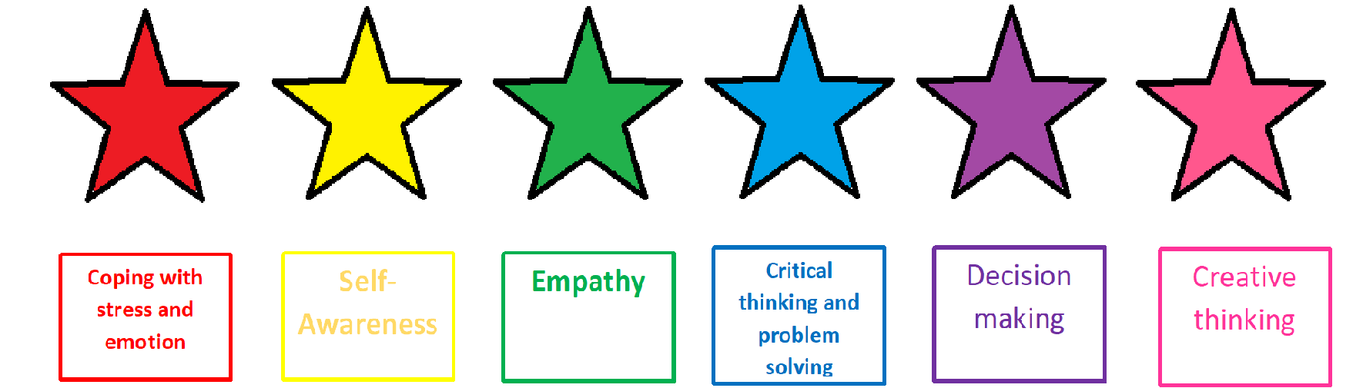
Students are motivated to think logically, analyse concepts and apply their understanding to functional situations. We aim to develop learners into independent thinkers and prepare them for the challenges in the future, as well as being able to express themselves appropriately and recognise their emotions.

Coping with Stress and Emotion
Creating good habits, developing physical, mental and emotional health, recognising sources of stress, finding strategies to support them, learning how to relax, become aware of and regulate their emotions, respond to emotions, recognise how emotions can affect behaviour.
Self-Awareness
Recognition of themselves, recognising their character, knowing their strengths and weaknesses, when to ask for help, knowing their desires, likes and dislikes. Develop attention skills, recognising what we need to be safe and healthy.
Empathy
Understanding others, trust, understanding themselves, develop social interactions, develop curiosity and open mindedness, sensitivity to themselves and others emotions.
Critical Thinking and Problem Solving
Enables students to hone analytical and critical thinking skills in all the courses. It is a way to avoid rote learning and focus more on synthesising, evaluating, and applying facts and ideas on your work. The sessions on entrepreneurship help students to anticipate problems and devise solutions accordingly.
Observation, analysis, interpretation, reflection, evaluation, inference, explanation, problem solving, and decision making, recognise factors that can influence their values, attitudes, behaviours (e.g. peer pressure, social media)
Decision Making
Leadership, intuition, time management, reasoning, evaluate, create solutions, and make appropriate choices, be able to adapt ideas.
Creative Thinking
Helps students in learning how to be independent and approach problems in a creative way. It gives a way to move beyond traditional methods and think innovatively.
Fluency, flexibility to adapt, originality (conceiving of something new), elaboration (building on other ideas) analytical mind, organising, problem solving, communication, developing opinion.

The skills of Effective Communication and Interpersonal Relationships thread through all the other skill areas and within each curriculum subject. These areas (within Effective communication and PSHE frameworks) are evidenced throughout the whole year using Evidence for Learning.
Students focus on the Learning for Life skills in their first 5 years at St Andrews. They are then supported in applying these skills through the nationally recognised Skills Builder programme in post-16 education.

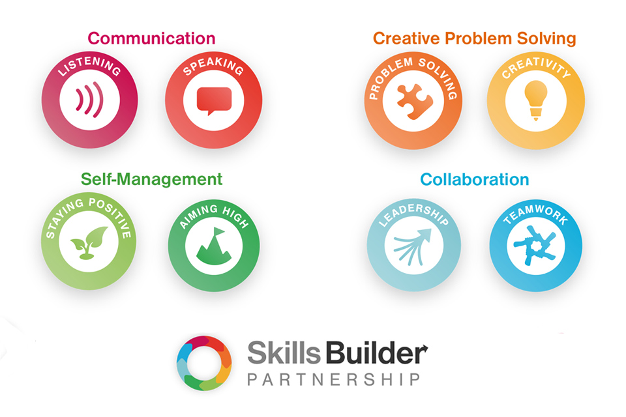
Skills Builder

Learning for our FE students is delivered in line with Skills Builder. The Skills Builder partnership was set up by a wide range of education providers and employers to help provide a framework of key skills that all people need in order to access an ambitious future and undertake purposeful employment. These skills are:
- Listening
- Speaking
- Teamwork
- Leadership
- Staying Positive
- Aiming High
- Creativity
- Problem Solving
All learning opportunities at Campus are delivered with these skills in mind and students have the opportunity for their achievements in each area to be recognised and rewarded each week. By supporting the students to develop these core, transferable skills, we can be confident that we are best preparing them for whatever opportunities their future may hold.

KS3 Scheme of Work
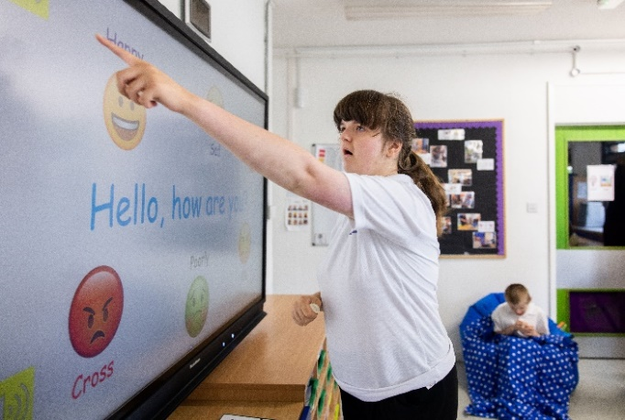
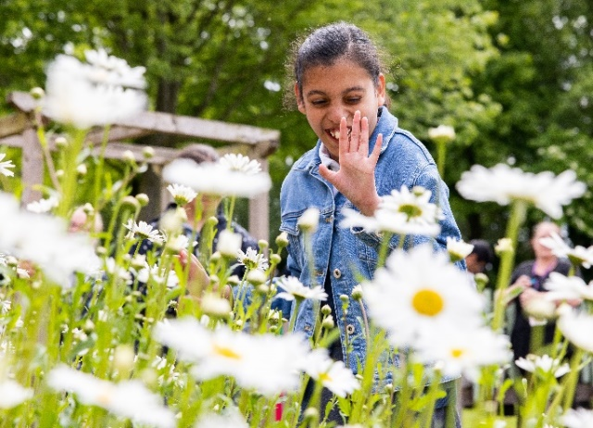
At St Andrews we recognise the need for our KS3 students to have a wide range of experiences and chances to build on their skills, so they can make informed decisions about their lives in the future. This is essential as students move through the key stages and into adulthood. The KS3 scheme of work allows students to have a broad, balanced and aspirational education with the end in sight. Students are introduced to the world of work, develop key academic skills, including reading, and deepen their understanding and subject knowledge of the world around them.

The KS3 scheme of work supports the transition of students from primary to secondary education, as well as into KS4. This is done through a topic-based approach. Subject knowledge and functional skills are taught, as well as the skills and attitudes defined by the World Health Organisation, which are needed to deal with the demands and challenges of life. The topics and intended learning are progressive and ambitious for all, and allow students to build on their prior knowledge. Planning teaching and learning with a thorough understanding of where the students are currently at in their learning is essential to this progressive and ambitious vision for all students. Therefore, a focus on baselining as students enter the school is crucial to the teaching and learning within KS3. This in-depth knowledge of prior learning sets students up to thrive, achieve and build on their individual skills at an appropriate level.
In KS3, most students follow a 1-year programme in year 7 to enable them to settle in and build on essential basic skills. They then move to a 2-year rolling programme in years 8 and 9.
Students in our ASC and Personal Learner classes, named collectively as ‘The Glens’, follow a 3-year rolling programme, with each year starting with a ‘Me and My School’ topic. This allows for any new students into the department to be baselined thoroughly and establishes clear routines and building of new relationships. Topic choices are taken from the KS3 national curriculum and adapted in order to be relevant, interesting and allow the teaching of knowledge, skills and attitudes.

 | Year 7 | Year 8/9 (1) | Year 8/9 (2)
Autumn | Me and My School  Why: To support transition and building of new relationships. The topic allows Year 7s to find their way around school, know more about themselves and become a part of the St Andrews community. Students learn about the local area of the school as well as the origins of their class name (Scottish Island). ‘Me and My School’ allows for a thorough baseline so that a students learning journey is properly assessed and tracked. | Farming Through the Years  Why: To deepen the understanding of chronology and changes over time, using skills they have learnt in year 7. Students can deepen their understanding and awareness of how technology has changed and shaped our lives. Students can develop farming and agricultural skills in order to develop an awareness of and experience of this career. This will support them in future decisions about their life after St Andrews. | WW2  Why: To support students understanding of a significant point in time that changed the way people live, with some of these changes still seen today. World conflict is a well-covered topic in the news today, students can make comparisons and come to their own, informed opinions about what they see around them.
Spring | Medicine Through the Years  Why: To support the teaching of chronology and changes over time. The Black plague features on the KS3 national curriculum, this has been adapted to suit the needs of our students. Students are living through a pandemic, this topic will support students in their recovery as well as support their understanding of then and now. This topic will support desensitisation work as well as knowledge on personal hygiene, personal safety and healthy living. | Welcome to Africa  Why: In the national curriculum for KS3 students are required to study and compare a location in Africa. Students will develop their awareness of the world and extend their experience out of the UK and Europe. Students will further develop their map skills from previous years. | Welcome to China  Why: In the national curriculum for KS3, students are required to study and compare a location in Asia. China has been chosen due to its technological advances and influence on the world. Students will develop their awareness of the world and extend their experiences out of the UK and Europe.
Summer | Extreme Earth  Why: On the KS3 national curriculum for geography students are required to learn about geographical terms such as volcano, earthquake, tsunami, tectonic plates and layers of the Earth. Students can also further their understanding of weather and climates that they are introduced to in primary school. Students now begin to study the wider world and the effects the weather and natural disasters have on people and places. | Enough for Everyone  Why: In the national curriculum for KS3 students are required to consider changes in the environment and land and what impact this has had on people and places. A green way of living is a hot topic for students aged 13 upwards with many young people striving for a greener way of life. This topic gives students the knowledge and attitudes in order to make their own opinions on this topical issue. | 20th Century Inventions  Why: Inventions created in the 20th century have had a huge impact on the lives we live today. Using meaningful and relatable experiences students can compare and contrast inventions past and present as well as discuss the impact they have on the lives of everyone.

KS4 Scheme of Work
Key Stage 4 builds on the learning and knowledge that students acquire in Key Stage 3, as they continue to have a broad, balanced and aspirational curriculum to prepare them for the future. Key academic skills, especially English (with an emphasis on Reading), Maths and all areas of PSHE, continue to be a key focus. Moving into key stage 4 gives our students the opportunity to apply the skills they have been taught in a wider context, either throughout school, within the local community, or on residential trips. All learning opportunities seek to maximise pupils’ independence skills, problem solving abilities and independent thinking as they move to becoming young adults, also taking into account their individual EHCP targets, laying the foundations for their long term goals.
Enrichment activities are also integrated so students can develop their knowledge and understanding of the world and their place in it, but also to excite and engage them in developing any particular interests they may have. There is also a large emphasis on RSE and PSHE, ensuring our pupils know how to stay safe. Teachers maximise all opportunities for pupils to make links in their learning by setting ambitious learning intentions; the skills curriculum has been designed to facilitate this. The curriculum also has a strong focus on online safety during each unit of work, with a specific focus during Safer Internet Day. This ensures that students feel confident in using computers and the internet safely, and know what to do if they encounter inappropriate content. Students also start working towards their Duke of Edinburgh Award, which gives them the opportunity to serve their communities, experience adventure, and develop and learn outside the classroom. It works alongside our Learning for Life curriculum, creating opportunities and supporting the development of essential skills and attributes for work and life, such as resilience, problem solving, team-working, communication and developing a sense of self.
The Key Stage 4 scheme of work offers a balanced, accessible, purposeful and relevant range of learning experiences for all students in an attempt to help them to reach their potential. We aim to create confident, resilient and well-rounded adults who have an aspiration for self-improvement and are able to navigate the world beyond school life. We recognise that all students need to develop spiritually, morally, socially and culturally. This development allows them to make sense of their world. The scheme of work supports students in developing an informed and balanced view on world events, beliefs and value of others.
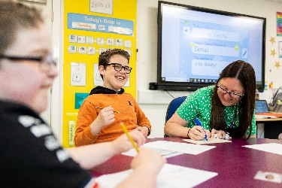
The aim of our two-year scheme of work is to prepare our young people for the transition into Post-16 education and subsequently into the next part of their lives and adulthood. Our purpose is to develop our students not just as learners, but as well-rounded young adults who are able to lead safe, healthy and fulfilling lives, make great individual progress and become responsible citizens who can make productive contributions to society.

 | Autumn 1 | Autumn 2 | Spring 1 | Spring 2 | Summer 1 | Summer 2
Year 1 | Entertainment in our society and culture-  Why:  - Wider awareness of what is available away from their usual.  - Experience different cultures promoting inclusion  - Understand what is real and what is fake  - Develop understanding of reality TV culture and how this can sometimes be a false portrayal of reality  - To find ways they can relax that act as a stress relief  - Teach about the past  - Discuss social issues  - Preserve cultural heritage and traditions | Hobbies and Interests-  Why:  - Develop self-occupying skills  - Developing their knowledge of likes and dislikes  - Development of fine and gross motor skills  - Develop their sense of self.  - To learn about and carry on traditions  - Students to have new experiences  - Links to mental and emotional wellbeing  - Develop social interaction skills | Our Mental Health and Wellbeing  Why:  - Promote awareness of what mental health is  - Improve relationships  - Understand themselves and develop/recognise strategies to help them regulate  - Enhance self-care  - To know their needs  - To link in hobbies and interests to things that make them feel good  - Develop vocabulary and comprehension around emotional literacy | Exploring-  Why:  - To expand their horizons  - Enhance communication skills and develop vocabulary  - Encourage independence  - Encourages curiosity  - Support them in developing skills to prepare them for their future  - Links in reading for pleasure | Fantasy and Adventure  Why:  - Develop imagination linked to creative thinking skills  - Develop speaking and listening skills and storytelling techniques  - Promote discussion  - Escapism and entertainment- give them experience of imaginary worlds  - Speaking and listening | Local Events  Why:  - Community awareness  - Citizenship  - Learn about local history and develop appreciation of where they live  - Diversity awareness  - Community engagement
Year 2 | The World Around Us  Why:  - Global citizenship  - Conservation  - Develop understanding of climate change, poverty and what they can do to help  - Experience and appreciate different cultures  - Learn and understand what is important to them and their world | Leisure opportunities  Why:  - See what they can access outside school and within their local community  - Promote them looking after their health and wellbeing  - To learn about stress reduction and regulation  - Support their personal development  - Link opportunities in their local community to their likes/hobbies and interests  - Developing knowledge of what is available to them  - Give them a place in society | Change and Growth  Why:  - Awareness of their changing needs  - Understanding of puberty and how it will affect them  - Develop strategies to be able to embrace change  - Be provided with opportunities for self-improvement  - Develop independence skills  - Develop self-awareness skills  - To know what to do if they feel uncomfortable with change | Heroes and Justice  Why:  - Moral and ethical development  - Discuss their inspirations and recognise qualities that they admire in people  - Develop understanding of their social responsibility  - Support them in learning conflict resolution strategies  - Development of empathy and compassion  - Right and wrong and consequences- know what it looks like in our current culture | Adventure and travel  Why:  - Understanding of the wider world  - Support travel training  - To build up bravery  - Develop courage to try something new  - Expand the way they see and interact with the world  - Spend time outdoors  - Forge new friendships  - Create excitement in exploring  - Encourage students to try something outside their comfort zone | Current Affairs and Events  Why:  - Connect their learning to the real world  - Take opportunities to help others and feel the benefits from doing this  - Develop planning skills  - Develop their own opinions  - Expand their world view  - Encourage curiosity

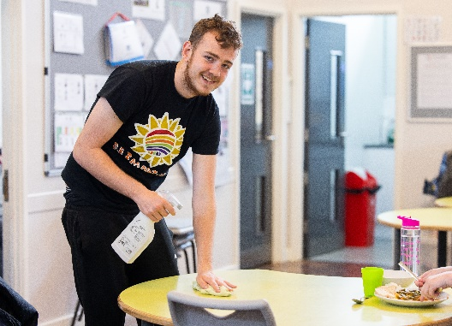
KS5 Scheme of Work
The key feature of the Further Education scheme of work at St Andrew’s Academy is the understanding that the students will eventually leave full time education and as such our role during the time they are with us is to prepare them to live their future lives as independently as they can. What this future may look like will be different for each student and so it is important that our curriculum offer is reflective of this. As such, our curriculum is designed with each individual student at the centre of their own bespoke offer. Through consideration of each individual young person’s specific needs and their personal life aspirations we are able to create ambitious learning intentions which challenge their development and provide opportunities for personal development. Once these learning intentions have been determined we are then able to tailor a specific curriculum offer around the individual needs and choices of each student.
After determining the focus of our curriculum approach it is important to consider the fundamental skills, knowledge and opportunities that all FE students should experience during their remaining time in statutory education. Developing this knowledge will promote independence and a positive attitude towards life and learning.

Personalised Curriculum Offer

Individual Learning Intentions

Personal Aspirations and Individual Needs

Student
Our Student Focused Curriculum Model

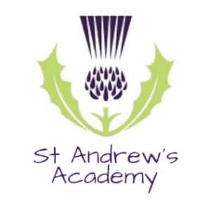
Health and Wellbeing
First Aid, Healthy diet, medication, RSE, lifestyle choices, Exercise, physical and mental health

Personal Appearance
Personal hygiene and upkeep, care needs, personal presentation, fashion awareness and choices

Self-Development
Strengths and Limitations, priorities, time management, balanced lifestyle, adapting to change, resilience, Self-confidence and belief

Technology
Types, Responsibilities, Social Media, Phone/internet settings, Cyber presence and safety, Information validity, knowledge of and ability to use hardware/software

Employability
Communication, inter/intrapersonal skills, personal qualities, work ethic, problem solving, academic skills and accreditation/qualifications, resource and time management, desire to learn

Citizenship
Voting, Laws and rules, Environmental responsibilities, Community activities

Household Skills
Housing options, utility bills, phone/internet usage, basic maintenance, day to day jobs, emergency procedures (in case of power outage, leaks etc)

Financial Autonomy
Understanding of pay/income, budgeting, banking (online and physical), ATMS, payment types/systems, accessing money, savings, documentation

Food Skills
Planning, Shopping, Preparation, dietary requirements and differences, food storage and rotation, kitchen hygiene, recipes, use of appliances

Social and Recreation
Opportunities, hobbies and interests, healthy friendships and relationships

Beyond St Andrew’s
Post 19 options and provisions, decision making, online and in person research, CV’s and applications, interview skills

Creative Expression
Exploration of mediums, Self-occupation, hobbies and interests, Self-esteem and confidence
Me and My Independence
My Future

Being the best I can be
My Lifelong Learning

Community Engagement

Accessibility
Choices, Maps, location orientation, landmarks

Transport
Own vehicle costs, requirements and logistic, public transport – schedules, routes, mode, cost

Inspiring Futures
Skills and Knowledge to promote independence

Literacy and Numeracy
Reading, Writing, Interpreting information, preferred communication, Analytical skills, supportive technologies
Personal Awareness
Positive and Negative Relationships, Identity, Sex and Intimacy, Risk, Roles and Responsibilities, Personal Safety

Employability | Lifelong Learning | Community Engagement | Skills for Life | Personal Awareness
Student Photography  Students to study Photography techniques and run cross school enterprise taking student photos and creating photo packages to sell to families and friends. Students also to capture photographs for the school website and to document any events for social media.  Social Media  Students may have the opportunity to provide content for the school social media platforms in order to develop online digital literacy skills and improve the schools online presence. Students will learn about the processes, risks and safety aspects of using social media and will provide a more individualised presence that is reflective of the students at St Andrew’s.  St Andrew’s Academy Online Shop  Students to research, run and stock an online shop offering a variety of student made items. Students will research different products that they can make and sell, create an online portfolio/catalogue of potential items and then make these on a ‘made to order’ process. Examples of the items that students may create and sell includes:  - Student photographs  - Greeting Cards  - Badges  - Keyrings  - Seed Balls  - Bath Bombs  - Seasonal Sweet bags  External Placements  Students to be supported to attend a range of external work placements, applying learnt skills in real, employment opportunities. Work placement opportunities are tailored to the needs of each individual student to reflect their own individualised ambitions for their future. Placements may include:  - Hospitality  - Retail  - Land Management | Functional Communication  Students to utilise preferred methods of communication to express opinions, make choices, provide informed contribution to discussions and demonstrate understanding and knowledge in a wide range of scenarios, with a variety of familiar and unfamiliar people.  Financial Independence  Students to develop skills in money management including budgeting, utility bills, housing choices, saving and accessing money and using different methods for paying or withdrawing their money. Parents to be encouraged to set up a bank account in order to provide a prepaid card for their young person. This allows students/parents to track what is being spent and where, promoting greater financial independence.  Everyday English  Students to develop reading and writing skills at an ambitious level. Students may follow academic programmes to develop their literacy skills alongside following existing Academy frameworks in order to ensure a continuation of skill development from lower school, through FE and beyond. Students will focus on the practical implementation of their skills in a wide range of functional situations.  Everyday maths  Students will develop numeracy skills that can be utilised to complete everyday tasks with maximum independence. Students may follow academic programmes to develop their numeracy skills alongside following existing Academy frameworks in order to ensure a continuation of skill development from lower school, through FE and beyond. Students will focus on the practical implementation of their skills in a wide range of functional situations.  Computing  Students will be supported and encouraged to access technology that can assist with day to day tasks throughout all learning opportunities. | Community Accessibility  Students to learn and develop skills in navigating around their local and wider area using a variety of different supporting tools. Students will develop skills and confidence in undertaking journeys with minimal support and will utilise a range of different modes of travel.  Leisure and Recreation  Students to access a range of different leisure and recreational activities in order to support choice making and provide hobbies and interests which can transfer to post 19 choices. Students may have the option of attending evening based activities supported by staff in order to broaden their understanding of what is available and when.  Social Contribution  Students will be supported to volunteer in line with community led initiatives aimed at improving the local area around the FE campus building. Project ideas may include litter management or horticultural development. Students will play an active role in encouraging community pride and accountability.  Post 19 Transition  Students to take an active role in researching and applying to post 19 provisions. Students will be supported to create a visual database of provisions, including video and audio explanations of what each provision offers. Students will also support the delivery of an annual ‘futures fair’ to help provide information and advice to prospective young people and their families. | Household Maintenance  Students will demonstrate basic skills linked to household upkeep and maintenance. This will include developing cleaning and basic DIY skills, simple repairs and understanding why, when and how to perform household safety checks.  Food skills  Students to develop skills in meal planning, budgeting, shopping and food storage and preparation. Emphasis will be placed on developing knowledge of balanced diets and recipes which support a healthy lifestyle. Students may also undertake nationally recognised accreditation in food hygiene.  Creative interest and expression  Students will be encouraged and supported to develop their creative skills through a variety of different mediums including 2D and 3D art, digital art, drama, music and dance. These may be on site activities or may involve utilising local providers to offer bespoke packages based on individual interest. Students will also have the opportunity to attend performances and events to broaden their experiences of the arts.  Physical and Mental Health  Students to undertake daily tasks promoting fine and gross motor skill development. Students may access community based provisions such as gyms, sports clubs and swimming in order to broaden their awareness of leisure activities and improve their health, fitness and wellbeing. Students will also be supported to access therapeutic programmes where appropriate. | Sex and Relationships  Students to expand their understanding of different relationships, taking into account positive and negative signs to consider, safety (physical and online), develop their awareness of sex and its associated implications and be able to identify and explain the process of seeking help or guidance if required.  Citizenship  Students will develop their understanding of the wider community and their place and value within it. Students will consider a range of factors which underpin society (law and order, fairness, justice, rights and responsibilities, democracy) and consider how this impacts on their identity, both as an individual and as a member of society.  Personal Hygiene and Appearance  Students will be encouraged to take an active role in planning and styling their appearance. They will be supported to plan and personalise outfits and to develop an understanding of own style and fashion preferences. Students will also learn the processes involved in shopping for non-food items including trying on, returning and exchanging items.  The Wider World  Students to develop their knowledge of local, national and international issues.

Complex Learners Scheme of Work

Our most complex learners at St Andrew’s have a very unique learner profile- complex ASC and sensory processing difficulties, along with other co-morbid conditions and often behaviours that challenge. We are very mindful that the scheme of work we offer this cohort of learners is bespoke and personalised to their individual needs and interests. Students follow a broad and balanced curriculum, based on the national curriculum but adapted to meet individual needs, interests and to support the development of executive functioning skills. The curriculum needs to focus on specific aspects of learning which can be barriers for our most complex learners; communication, social relationships and sensory processing.
The complex learners’ scheme of work aims to support our students’ aspirations for employment, independent living, friends, relationships, community participation and good health. (Preparation for Adulthood – PfA) The curriculum supports PfA outcomes by offering bespoke learning opportunities that encompass cognitive, emotional and functional development.
What does high quality provision look like in each key stage?
Key Stage 3 - The Glens learners follows an informal model; with the overall intent to provide a motivating and creative curriculum delivered through a thematic based approach. Focus is placed on covering the curriculum through interconnected activities and recognises that learners will need to be taught to transfer or generalise skills. Contextualised learning is prioritised with opportunities given for real world experiences in and out of school.
Key Stage 4 & 5 – The Highlands –This scheme of work aims is designed to provide pupils with portable skills for life, living and work that are developmental, skill- and context-based and encourage active engagement in learning. It is communication focused and Autism Specific. The curriculum focuses on developing executive functional skills of Personal, Social and Emotional development, Community and the Wider World, Physical Development, Expressive Arts, and Communication. Having a curriculum based around the development of these executive functioning skills will support our students for life beyond our school. We strive to be responsive to each learner, and build on individual strengths and interests. A rolling plan is in place, which supports a balance of stimulating contexts for learning through different learning experiences, themes and subjects.
How is the scheme of work delivered?
The scheme of work is delivered through a variety of pedagogical approaches that best meets the individual needs of the students. Our students have a variety of complex needs and as our curriculum is person-centred, so are the teaching approaches to overcome barriers to learning. All of our students, from those with ASC and SPD to those with Trauma and Attachment, need to be regulated and ‘ready to learn’ with a person-centred approach to individual programmes to support regulation. We also use a range of therapeutic inputs to support our students to regulate and be ready to learn.
Engaging our most complex students in their learning is key. At St Andrew’s we aim to facilitate learning and engagement within the curriculum by:
- Developing learners’ levels of engagement by finding out what interests and motivates them and using learner interests and motivation within lessons.
- Using learner preferences (sensory).
- Providing an irresistible opportunity to learn, providing meaningful contexts for learning that use real life materials and experiences, and providing opportunities for real life application of knowledge and skills to prepare students for increased independence.

How is the curriculum sequenced?
The thematic and sequential approach to the curriculum across the Key Stages allows for repetition and consolidation of skills. It is recognised that our most complex learners can find it difficult to transfer newly learnt knowledge and skills. In order to ensure generalisation of skills, focus on delivering the curriculum is centred on students applying the skills and ideas they are learning into a range of situations.
The curriculum is sequenced to allow opportunities for students to develop executive functioning skills and demonstrate these skills across a wide range of functional activities; planning, problem solving, working memory, attention, reasoning and initiation.
S.P.I.T (Student Planned Individualised Target) Sheet
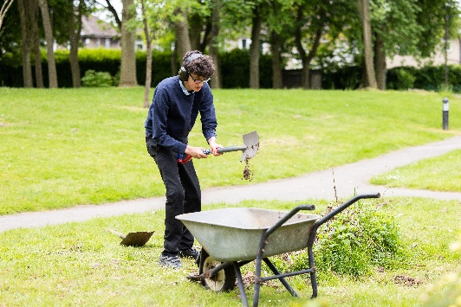
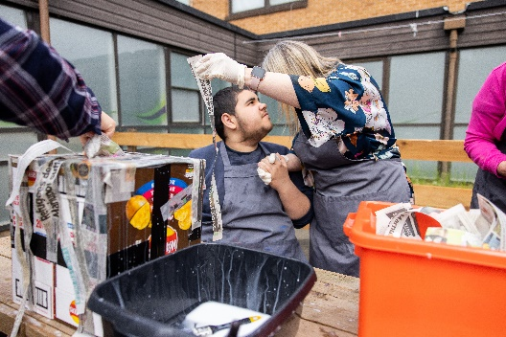
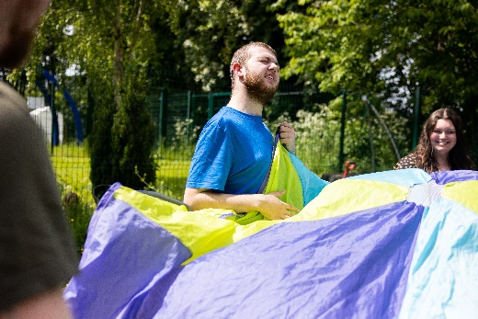
The S.P.I.T sheets are introduced when students reach year 10 to focus on essential skills and knowledge needed for life after St Andrews. These use a person-centred approach which forms the foundation of the Highlands scheme of work, giving the learners opportunities to achieve their EHCP outcomes.

Science and Environmental
Community Participation
Well-Being and Emotional Understanding
Maths and Technology

Religion and Cultural Understanding
Community and the Wider World
‘Critical Thinking and Problem Solving’
Personal, Social and Emotional Development
‘Coping with Stress and Emotion’
‘Empathy’

Independent Living skills

Complex Learners Scheme of Work
Relationship and Sex Education
Sensory Integration

Physical and Sensory Development
‘Self-Awareness’

Sports and Exercise

Communication
‘Decision Making’
‘Self-Awareness’

Social Communication
Fine and Gross Motor
Co-Ordination

Expressive Arts
‘Creative Thinking’

Expressive Communication
Receptive Communication
Art
Drama and Dance
Music

Community and the Wider World
- Understanding and following instructions
- Understanding how to keep ourselves safe
- Participate in shared activities
- Accepting variety
- Understanding the use and function of objects and materials
- Develop understanding of beliefs and cultures
- Acquire a set of moral values such as honesty, sincerity personal responsibility, tolerance, acceptance and respect.

Expressive Arts
- Share space and resources with others
- Accepting and enjoying new experiences
- Use equipment appropriate to its function
- Expanding interests and building on existing interests
Physical and Sensory Development
- Showing a preference for their sensory needs
- Organise self and own belongings
- Accept an activity or favoured item has finished
- Develop fine and gross motor skills
- Regulate sensory processing difficulties
- Develop agility, physical co-ordination and confidence in movement
The adaptive approach promotes the Executive Functioning and Self-Regulation skills, the essential mental processes that enable us to: plan, focus attention, remember instructions, and juggle multiple tasks successfully. They are cognitive processes which help individuals to organise themselves when carrying out various activities.
Communication
- Interacting with others and forming relationships
- Making requests
- Making and communicating choices
- Follow social rules
- Identifying a problem and asking for help
- Understand sequences and chronology
- To express and ask for help
Personal, Social and Emotional Development
- Expressing own emotions
- Understanding the emotions of others
- Understanding routines
- Understanding and accepting a change will happen
- Persisting with tasks
- Developing skills for personal care and independence
Community and the Wider World
In order to live a full, active and happy life, learners need to develop a solid understanding of their place in the world. Learners with autism typically develop a limited sense of central coherence and we aim to provide varied and weekly learning opportunities to develop the understanding of the world we live in and their place within the community.
Working on problem solving skills will help our students to deal constructively with problems or choices they may face in their lives and it will give them a voice.
Developing Critical thinking skills can contribute to our students’ health by helping them to recognise and assess the factors that influence them.

Expressive Arts
In order to think creatively and expressively, flexible thinking is crucial. This skill is vital for learners with autism to develop. It is our aim that by developing understanding and appreciation of expressive arts, it can open doors to new experiences and offer our students more opportunity to communicate their likes and dislikes. It also means our learners can continue enjoying and participating actively in the arts into their adult lives. We aim for our students to explore expressive arts numerous times a week through a variety of lessons on the curriculum, as this can help manage behaviours, regulate emotions, develop self- awareness and offers an alternative way to communicate.
Physical and Sensory Development
Sensory issues can affect the emotional and physical wellbeing of learners with autism and this is actively addressed in our curriculum. In order to keep healthy, exercise is encouraged as part of a weekly curriculum offer and our curriculum offers a wide variety of experiences with outside agencies and in a variety of different ways (dance, swimming, gym etc.). With physical development we aim increase coordination, strength, endurance, and body awareness. Sensory needs are met on a daily basis through a sensory diet approach and sensory activities will also be offered daily to stimulate the brain, helping our students to process new sensory information which in turn can help to develop language and communication skills.

How this scheme of work meets the needs of our Complex learners
Communication
Communication, particularly the social aspects of communication can be a barrier for learners with autism. Constantly and consistently working on developing this skill can help students express their needs and wants. When they can do this (verbally or with symbols or other AAC devices), it helps them with behaviour, learning and socialising. It forms a core element of our curriculum and we work on developing communication skills in every aspect of the school day. Wherever possible teachers will make cross curricular links to all subjects so that pupils have the opportunity to practice these skills daily and in a wide variety of contexts.

Personal, Social and Emotional Development
Personal and social skills are important for developing relationships, understanding emotions and for learning itself. Being able to be adaptable, responsive and understand personal needs is an important skill for learning and living with independence. It is an area where autistic learners can experience significant challenge therefore it is as a core part of the Key Stage 4 curriculum. All students will work towards individual targets set out by the Education and Health Care Plan and individual education targets set by class teams as well as take part in a minimum of 2 sessions of PSHE and RSE a week. Wherever possible teachers will make cross curricular links to all subjects so that pupils have the opportunity to practice these skills daily and in a wide variety of contexts.

Other considerations
At St Andrew’s Academy we are committed to improving the health, wellbeing and ability to learn of our vulnerable young people. Trauma-informed practice supports those students who: have a diagnosis of a disability; have had lots of medical procedures or physical health problems; live in poverty; have suffered abuse, neglect and/or have mental health problems or attachment issues.
We embrace a wider definition of trauma to encompass any event that is experienced as frightening, painful or out of their control. Day-to-day exposure to events such as divorce, hospital appointments, loss of a loved one or pet, illness within the family, or moving to a new house can be experienced as traumatic for our young people.
The bespoke schemes of work we have developed through research at St Andrew’s, recognises the prevalence of trauma and the affect it can have on our young people and families. Our awareness of trauma-informed practices integrates our knowledge about trauma into policies, procedures and practices, aiming to help our young people to heal and to build resilience, as well as seeking to avoid re-traumatisation.
Key principles of safety, trust, choice, collaboration, equity and empowerment are embedded throughout our practices and woven into the classroom environment every day. Our vision is to promote a trauma-informed and compassionate school environment, which nurtures positive relationships and help to build resilience for our young people and their families. To help achieve this, we need all our young people (Alexander, 2019):
- to feel safe (physically and emotionally)
- to be able to regulate / self-regulate (emotional / sensory needs)
- to be connected (positive and attuned relationships)
- so that they can be ready to learn (skill building and resiliency)

At St Andrew’s we take a person-centred approach to ensure these key principles are met. Please see information below to see how we apply trauma based practices for the benefit of each young person to support their development.
Growth Mindset
Each week students take part in ‘Growth Mindset’ sessions, enabling them to reflect on the Learning For Life skills and how they have applied them during the week. In Key Stage 3 students join weekly assemblies reflecting on the skills used.
Our goal is to help students become increasingly growth-orientated. We aim for them to persist with challenges a little bit longer, reflecting on how they have applied the skills outlined in the Learning for Life curriculum and used them to enable them to regulate and be ready to learn. It will develop their confidence in being able to take on a bit more of a challenge, create and work towards personal goals, and respond more positively to any mistakes.
Students across the continuum have different world views and experiences, meaning each student requires different teaching strategies-a student with a currently fixed mind set will respond and act differently to a student with a low growth mind set. Therefore, teachers adapt their teaching methods accordingly throughout the week, in order to support students’ individual needs.
Growth Mindset is a journey. It is about believing in the potential for development and that learning a new skill comes from practice and perseverance. It involves small progressive shifts in thinking that are linked to the Learning for Life skills. The session at the end of each week allows students to celebrate and reflect on what they have achieved and how.
The aim of Growth Mindset allows our pupils to value what they're doing, regardless of the outcome. They are tackling problems, charting new courses, and working on issues important to them. This will support them in increasing their independence in attempting everyday tasks, communicating with others, and thus preparing them for adulthood.

Assessment
All students entering St Andrew’s Academy undertake baseline assessments, using the St Andrew’s Frameworks, which have been written by the Teachers and adapted to meet the needs of each student. These assessments are used to inform teaching, planning and levels of challenge for each student from Years 7-14.
They monitor progress of a skill through six stages:
1 = Independent  I | The question was read, understood and completed independently by the student
2 = Assisted Reading  A/R | An adult helped the student read the question but thereafter the question was understood and completed independently by the student
3 = Indirect Prompts Used  I/P | An adult used indirect prompts (verbal and non-verbal) to help the student progress through the question- e.g. “What should we do?”, “Now what?” expectant facial expression, questioning with hand and body gestures.
4 = Direct Prompts Used  D/P | An adult used direct prompts (verbal and non-verbal) to help the student progress through the question- e.g. “Shall we use a number line?” “Do you think we need to count?”, pointing to, tapping on focal point
5 = Direct Model  D/M | An adult used direct modelling to help the student progress through the question-e.g. “this one matcher the number”, “Now we add together”, “We put our answer here.”
6 = Demonstrated  DEm | An adult demonstrated how to answer the question with little or no input from the student.

Teachers use these stages to set and review targets throughout the school year and to record progress. This data is then analysed to show trends. In addition, students are closely tracked against their EHCP Outcomes and any additional individual targets. When students go into our Further Education Department in Year 12, they use the St Andrew’s Frameworks to inform their personalised curriculum offer within the FE scheme of work, which is distinct and different from Key Stages 3 and 4.
Executive functioning- The complex learners scheme of work is assessed against our executive functioning skills frameworks. Students have individual learning outcomes linked to all areas of the curriculum and to their individual EHCP outcomes. Progression is assessed against the acquisition and adaptably of being able to demonstrate executive functioning skills, not only against a wide range of curriculum based activities and learning, but also where students demonstrates the ability to transfer these skills to learning in the local and wider community.

Throughout the Academy, individual targets and learning objectives are shared with all students, using accessible communication approaches. All targets set are clear, measurable and personalised for each student. Teachers moderate their assessments on the Evidence for Learning App, to ensure a fair, consistent and accurate approach is being carried out. Targets are regularly monitored by Teachers in collaboration with the Senior Leadership Team.
Collecting Evidence
1. Evidence of the learning journey for each student may be recorded in exercise books or individual work folders.
2. Evidence of progress across all subjects, in addition to individual outcomes from students’ Education, Health and Care Plans, is captured and recorded on the Evidence for Learning App and shared with parents.
3. At the end of each school year, each student receives an End of Year Report which summarises their experiences, achievements and progress through the year in all areas of school life.

