St Andrews’ Reading Curriculum
‘Everyone a Reader’
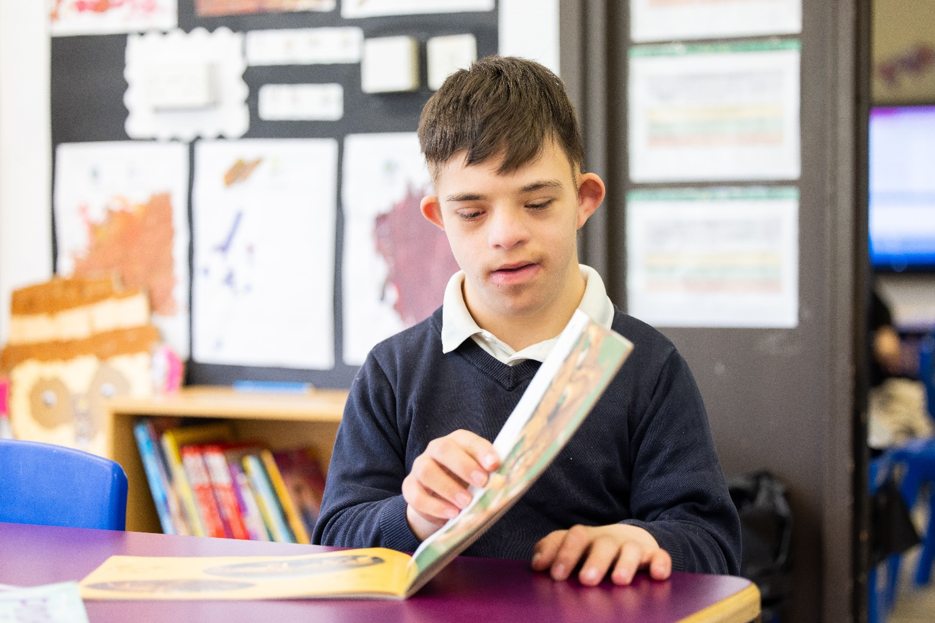

At St Andrew’s Academy, we believe that the ability to read is fundamental to students’ development as independent learners, during their time at school and beyond. Reading is central to our ability to understand, interpret and communicate with each other and the world around us. We acknowledge that reading at text level is not appropriate for all students and therefore the teaching of reading can look different from student to student e.g. objects of reference, reading social signs, reading symbols, recognising sounds and reading at word or text level.
We teach students the skills they need to read depending on their individual needs, so offer a person-centred approach to teaching reading. We are determined to teach our students reading skills no matter their background, needs or abilities. We therefore foster the belief “Everyone a Reader” and promote a love of reading for all.
Phonics Approach
All students who are able to access phonics follow the Read Write Inc Phonics scheme. Students are baselined on entry into school and then at the beginning of each year. We aim, where appropriate, to group students based on their phonemic awareness and reading skills. These sessions are led by teachers and TAs trained in the delivery of RWI strategies, to enable groupings to be small, so that all students can be targeted and supported effectively. Sessions follow the RWI structure as much as possible. Staff adapt and add additional resources, such as using communication boards where appropriate, to support the understanding and progress of all students.
Students are asked Blank Level Questions linked to the RWI texts they have read. These questions are selected based on the students’ current comprehension skills and aim to deepen their understanding of a text they have read. Blank Level Questions are used throughout the curriculum to enable further practice and the transfer of skills to other subjects.
Reading Vipers & Free Readers
This approach is aimed at students who have moved through the RWI process and are now reading fluently the majority of the time. This approach focusses on the understanding and comprehension of what they have read, as well as increasing a student’s vocabulary. Specific, discreet reading sessions for “Free Readers” take the form of a guided reading session and have a VIPERS focus. Students are given age-appropriate texts and are supported in developing their vocabulary, retrieval and inference skills. It is essential to note that while these students are able to read mostly fluently they may still need to continue to practice the speed reading of familiar, high frequency words.

Reading Vipers sessions focus on the following skills:
Vocabulary: Know the meaning of new and unfamiliar words.
Infer: Using information from the text as well as what they already know, students come up with an opinion and come to a conclusion.
Predict: Predict what might happen using pictures or details that are stated or implied
Explain: Explain how the choice of words and structure of a text enhance the meaning. E.g. what is the author’s point of view? What is the purpose of this text feature?
Retrieve: Retrieve information from the text to answer questions
Summarise: Summarise main point or ideas from more than one section or paragraph, this includes putting events in the order that they happened.
Even though students who are classed as free readers focus on these skills, it is important to note that all students experience and are taught the essential aspects of reading through adapted and person-centred approaches during their English sessions.
See and Learn Approach
Students who are unable to access phonics follow the See and Learn Approach. This focuses on increasing vocabulary and students’ understanding of pictures, words and symbols. This approach works on a sight recognition process, rather than blending and segmenting sounds. Students work through the suggested See and Learn vocabulary, which includes the first 100 high frequency words. The lists are arranged into sets for students to progressively work through. The vocabulary is taught explicitly during reading sessions, but staff also plan for opportunities across the curriculum for students to transfer their reading skills e.g. during a topic session, on a shopping list etc. Students are regularly encouraged to practice vocabulary they know in order to maintain knowledge and skills.
On entry into St Andrews, usually Year 7, students are baselined against the list of words and then taught appropriate vocabulary based on their individual knowledge. Students can be taught by teachers and/or TAs in class groups, small groups, in pairs or 1:1. This is determined by teachers and ensures students’ individual needs are accommodated. Staff take a person-centred approach to teaching See and Learn and use a variety of resources in a set order to support the teaching and learning of the vocabulary e.g. objects of reference, photos, symbols, words, sensory stories, poems and video.

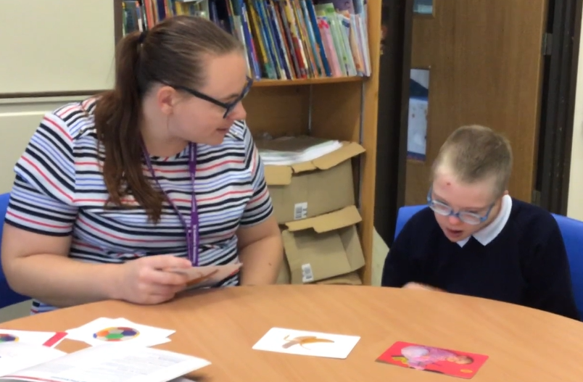
At St Andrews, we recognise that the ideal way to learn to read is through developing a phonemic awareness and using skills such as blending to read words. Because of this, we have built in specific activities for students to engage in exploring and using sounds around them. The activities follow the seven principles to getting students attuned to different sounds around them. This eventually leads to oral blending and segmenting in preparation for phonics. We understand that not all students will reach this point.
- General Sound Discrimination-Environmental
Raise students’ awareness of sounds around them and develop listening skills.
Activities: listening walks, drumming on different items outside, comparing sounds outside, playing sound bingo and making shakers.
- General Sound Discrimination- Instrumental Sounds
Develop an awareness of sounds make by instruments and noise-makers.
Activities: comparing and matching instrument sounds, playing music, playing instruments alongside a story.
- General Sound Discrimination-Body Percussion
Develop an awareness of sounds and rhythms.
Activities: singing sounds, action rhymes, listening to music.
- Rhythm and Rhyme
Develop, appreciate and experience rhythm and rhyme in speech.
Activities: rhyming stories, poetry, rhyming bingo, clapping out syllables of words.
- Alliteration
Focus on initial sounds of words.
Activities: I Spy games, matching objects that begin with the same sound.
- Voice Sounds
Distinguish between different vocal sounds, begin oral blending and segmenting.
Activities: sounding out /c/-/a/-/t/ cat, sing in different voices, listen to different voices, copy sounds people make.
- Oral Blending and Segmenting
Develop oral blending and segmenting skills.
Activities: sounding out What’s In The Box, sound out different CVC words in and around the environment e.g. c-a-t, d-o-g, p-e-n

Students are required to consistently orally blend and segment CVC words in order to transfer to a phonics approach. This ensures the students are given the skills necessary to move on to a phonics approach and are able to be successful in their new ‘learning to read’ journey.
For students who engage in learning through objects of reference, focus is placed on matching objects to photos or pictures. Students are supported to develop their recognition that a two-dimensional photograph/picture can represent a three-dimensional object. Once this fundamental skill is established, students can progress to developing their visual discrimination skills by beginning to match photos/pictures of these objects of reference. The objects of reference are selected for their relevance to the students.
Reading within English Lessons
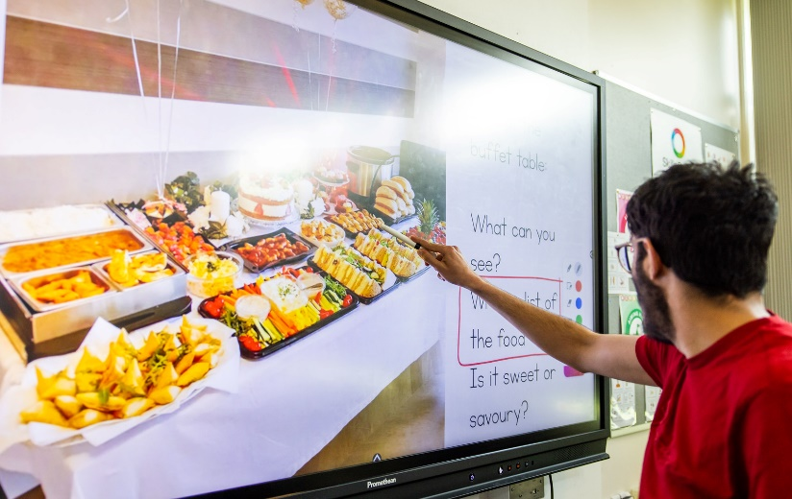
During English lessons, students access age-appropriate stories and texts relevant to topics they are exploring. In these sessions, teachers plan for and encourage the use of sound recognition, blending skills, symbols and word recognition. This supports the transfer of skills and deepens the students understanding of letters, sounds, words and symbols. During English sessions, students learn and experience a wide range of carefully chosen texts including poetry, non-fiction, traditional tales and sensory stories. They learn about the structure, features, function and meaning of different words, symbols and texts. Teaching reading in this way deepens students' understanding of their topic, as well as providing opportunities to learn about the fundamentals of reading in an interesting and engaging way. Texts are carefully chosen by subject leaders to support the skills being taught, as well as providing an age appropriate text experience. Suggestions of lower and higher level texts are offered as part of the topic planning, as well as recommended reads for that year group. All students work on the skills of learning vocabulary, inferencing, predicting, explaining, retrieving and summarising in an adaptive and person-centred approach e.g. via video, audio recording or adapted texts.

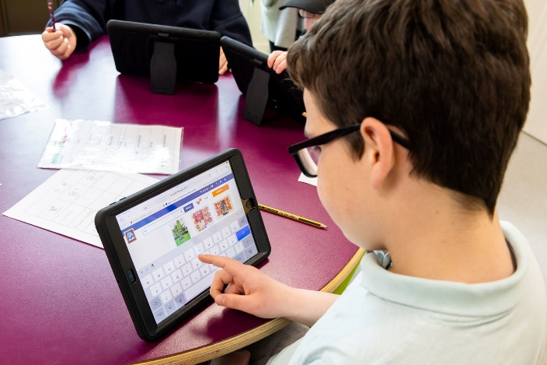
All students work on their specific reading and phonics targets in other areas of the curriculum. This could be, for example, whilst out shopping in the local community, finding the letter sound they have been learning or recognising a symbol or high frequency word when exploring favoured items in a familiar shop. Staff plan and provide opportunities to practice and work on reading skills throughout the curriculum and school day.

Reading to Support Writing
At St Andrews, we recognise the importance of embedding good reading practices in order to support the development of a student’s writing abilities. It is widely known that reading expands a young person’s concentration and vocabulary. However, having a rich reading environment also exposes students to different writing styles, syntax, grammar and punctuation, which are all essential parts of writing successfully.
Students are supported in their letter formation during phonics sessions, as this forms part of the RWI approach. This is intertwined with learning sounds and their written code in an appropriate way for the individual e.g. mark making in sensory materials, hand over hand support or writing over a model.
Colourful Semantics is used throughout school to support a student’s comprehension of what they have read but also to build upon their sentence writing. This is again delivered in a variety of ways to support the individual e.g. writing using symbols, pictures or words.

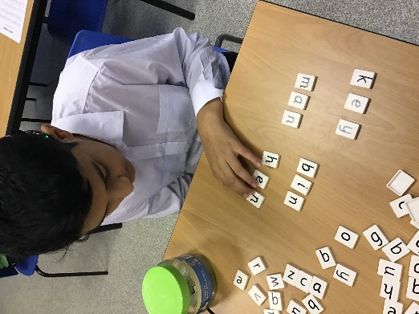
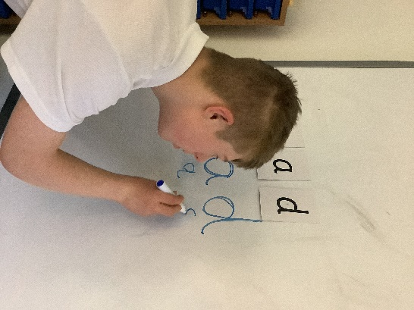

Assessment and planned interventions
Reading is assessed regularly in both RWI and See and Learn, as well the reading framework. General reading development is assessed and monitored using the St Andrews Framework for reading. This is done termly by the students' class team and alongside the English lead if deemed appropriate. Students identified as not meeting their expected level of progress in either RWI, See and Learn or reading in general, are provided with interventions delivered by familiar staff on a 1:1 or small group basis, depending on the needs of the student.
Drop Everything And Read (DEAR) Sessions and Recommended Reads (The St Andrews Reading Spine)
In order to promote a love of reading in all our students, Drop Everything And Read (DEAR) sessions are delivered on a daily basis across school. These sessions are tailored to allow students to listen and experience texts and stories that they would not be able to read themselves, with the aim to develop their vocabulary. The texts shared are selected from the St Andrews Reading Spine. However, they may also address specific interests and needs of the students in the group.
The St Andrews Reading Spine
The St Andrews Reading Spine has been developed to enable students to have access to a wide range of texts, including poetry and non-fiction. The Spine includes high quality texts that build on imagination and equips our students with relevant, but challenging vocabulary. They have memorable characters, places and events to help develop the ability to think in the abstract as well as draw upon own life experiences. The St Andrews Reading Spine aims to bring our school community together in promoting reading for pleasure as well as reading for information. Our Reading Spine allows students to see themselves, to see the lived experiences of others, and to be transported into the world of the story, including feeling empathy for the characters.
As a result, our books are selected with the following criteria in mind to ensure that a broad and balanced choice of simply amazing texts are offered to our pupils to develop their passion for reading and create a lifelong love of books
- World-Renowned Authors and Poets
- Prize-Winning Books
- The 5 Plagues of Reading: archaic language, non-linear time sequences, narratively complex, figurative/symbolic text, resistant texts.
- Diversity
- Inclusivity
- Emotional Response
- Cultural Capital
Our reading spine includes a suggested list of texts to study and/or share with students, according to their age. These texts are recommended from English specialists including Pi Corbett, as well as the

National Curriculum, the texts can be covered as part of the English Curriculum (as stated on the English overviews) and through daily reads in Drop Everything and Read sessions. It is important to recognise that new texts may become available and the Reading Spine is reviewed annually to ensure the reading offer for students is up-to-date and relevant.
The chosen texts have been split into Key Stage groups and then shared further into 2 stages. Stage 1 includes texts that are easily adapted and accessed by our most complex learners and stage 2 includes more difficult texts with more challenging vocabulary and themes. Some texts may fit both stages, meaning that they can be accessed by all through adaptation and a person-centred approach.
Further texts are available in the school library that are similar to the texts on the reading spine. This will enable students to express interest in specific authors, genres and text types.
 | Stage 1 | Stage 2
Year 7 (KS3) | - Marshal Armstrong is New to Our School: David Mackintosh  - New Kid: Jerry Craft  - Belonging Street: Mandy Coe (poetry)  - Please Mrs Butler: Alan Ahlberg (poetry)  - Can I Build Another Me?: Shinsuke Yoshitake  - George’s Marvellous Medicine: Roald Dahl  - Mrs Armitage on Wheels: Quentin Blake  - All Fall Down (immersive fiction): Sally Nicholls, adapted by St Andrews Academy  - Tales from Beyond the Rainbow: Pete Jordi Wood  - The Umbrella Mouse: Anna Fargher  - You are a Champion (NF): Marcus Rashford | - Wonder: R.J Palacio  - Boy at the Back of the Class: Onjali Q. Raúf  - The Goldfish Boy: Lisa Thompson  - Can You See Me? Libby Scott and Rebecca Westcott  - Holes: Louis Sachar  - Belonging Street: Mandy Coe (Poetry)  - Fearless! How to be your true, confident self!: Liam Hackett (NF)  - All Fall Down: Sally Nicholls  - Invasion of crooked Oak: Dan Smith  - Running out of time: Simon Fox  - The Girl Guide: 50 lessons in learning to love your changing body: Marawa Ibrahim (NF)  - You are a Champion (NF): Marcus Rashford
Years 8/9 (KS3) | - War Horse (picture book copy): Michael Morpurgo  - When Stars are Scattered: Omar Mohamed and Victoria Jamieson  - Love That Dog (poetry): Sharon Creech  - When Hitler Stole Pink Rabbit: Judith Kerr  - The Island: Armin Greder  - The Viewer: Gary Crew  - A Midsummer Night’s Dream: William Shakespeare  - Ethel & Ernest: Raymond Briggs  - Charlie and The Chocolate Factory: Roald Dahl  - The Seven Chinese Sisters: Kathy Tucker  - Boy and Going Solo: Roald Dahl  - This Book Will Save the Planet: Dany Sigwalt (NF)  - The Lion, the Witch and the wardrobe: Lewis Carol | - The Arrival: Shaun Tan  - Diary of a Young Girl: Anne Frank  - War Horse: Michael Morpurgo  - When the Sky Falls: Phil Earle  - A Long Walk to Freedom: Nelson Mandela  - Underground Railroad: Colson Whitehead  - Love That Dog (poetry): Sharon Creech  - A Midsummer Night’s Dream: William Shakespeare  - Ethel & Ernest: Raymond Briggs  - Goodnight Mr Tom: Michelle Magorian  - Windrush Child: Benjamin Zephaniah  - The Missing: The True Story of My Family in World War II: Michael Rosen
Years 10 + 11 (KS4) | - An Inspector Calls (adapted version): J.B Priestly  - Famous Five: Enid Blyton  - Rivet Boy: Barbara Henderson  - Can You Feel The Noise?: Stewart Foster  - You Can Do It (NF): Marcus Rashford  - Smile: Raina Telgemeier  - Heart Stopper Collection: Alice Oseman  - Funky Chickens (Poetry): Benjamin Zephaniah  - Journey: Aaron Becker  - Caged: Duncan Annand  - Watership Down: Richard Adams  - The Explorer: Katherine Rundle  - Romeo and Juliet: William Shakespeare  - The Lion Above the Door: Onjali Q. Raúf | - An Inspector Calls (adapted version): J.B Priestly  - Let the Light Pour In (Poetry): Lemn Sissay  - Swallows and Amazons: Arthur Ransome  - Treasure Island: Robert Louis Stevenson  - Dracula: Bram Stoker  - Armistice Runner: Tom Palmer  - The Shark Caller: Zillah Bethell  - No Ballet Shoes in Syria: Catherine Bruton  - My Life on Fire: Cath Howe  - Papergirls: Brian K. Vaughan and Cliff Chiang  - Romeo and Juliet: William Shakespeare  - Animal Farm: George Orwell  - The Boy in the Striped Pyjamas: John Boyne  - The Book Thief: Markus Zusak  - You Can Do It (NF): Marcus Rashford
Years 12, 13 and 14 (KS5) | - Hatchet: Gary Paulson  - Twilight: Stephanie Meyer  - Twilight saga; New Moon: Stephanie Meyer  - Twilight Saga; Eclipse: Stephanie Meyer  - Twilight Saga; Breaking Dawn: Stephanie Meyer  - Thief: Malorie Blackman  - The Giver: Louis Lowry  - Apollo: Matt Fitch, Chris Baker & Mike Collins  - Anya’s Ghost: Vera Brosgol  - Managing your Money: Jane Bingham and Holly Bathie (NF)  - Hunger Games Trilogy: Suzanne Collins | - The Balloon Thief: Aneesa Marufu  - Let’s Play Murder: Kesia Lupo  - You’ll Be The Death Of Me: Tik Tok Made me Buy it: Karen M. McManus  - Lionheart Girl: Yaba Badoe  - The old Man and the Sea: Anthony Smith  - To Kill a Mockingbird: Harper Lee  - Sweeney Todd: The Demon Barber of Fleet Street, Quick Text: The Graphic Novel: Clive Bryant  - What is Gender? How Does It Define Us? And Other Big Questions: Juno Dawson (NF)  - The Hate U Give: Angie Thomas  - Habibi: Craig Thompson

