 

**STUDENT ATTENDANCE POLICY**

**Date of this version of policy : 15 January 2025**

|  |  |
| --- | --- |
| **Author** | Sadie Hampton, DSL |
| **Legislation** | Keeping Children Safe in Education, Working Together to Improve School Attendance, Children Missing in Education, Supporting Pupils with a medical condition and SEND Code of Practice |

|  |  |
| --- | --- |
| **Date Original Written** | 13 December 2021 |
| **Date Original Adopted by GB** | 14 December 2021 |

|  |  |
| --- | --- |
| **Date Reviewed by AC** | 15 January 2025 |
| **Dated Adopted by AC** | 15 January 2025 |
| **Next Review Date by AC** | January 2028 |
| **Date Reviewed by AC** |  |
| **Date Adopted by AC** |  |
| **Next Review Date by AC** |  |
| **Date Reviewed by AC** |  |
| **Dated Adopted by AC** |  |

# STUDENT ATTENDANCE POLICY

**INTRODUCTION**

St Andrew’s Academy is a successful school and your child plays their part in making it so. We aim for an environment which enables and encourages all members of the community to reach out for excellence. For our students to gain the greatest benefit from their education it is vital that they attend regularly and your child should be at school, on time, every day the school is open, unless the reason for the absence is unavoidable. It is very important therefore that you make sure that your child attends regularly and this policy sets out how together we will achieve this.

# WHY REGULAR ATTENDANCE IS SO IMPORTANT

**Learning:** Any absence affects the pattern of a student’s schooling and regular absence will seriously affect their learning. Any student’s absence disrupts teaching routines so may affect the learning of others in the same class.

Ensuring your child’s regular attendance at school is **your** legal responsibility and permitting absence from school without a good reason creates an offence in law and may result in prosecution.

**Safeguarding:** Your child may be at risk of harm if they do not attend school regularly. Students with SEN are some of the most vulnerable in society. Safeguarding the interests of every student is everyone’s responsibility and within the context of this, school promoting the welfare and life opportunities for your child encompasses:

* Attendance.
* Behaviour Management.
* Health and Safety.
* Access to the Curriculum.
* Anti-Bullying.

Failing to attend this school on a regular basis will be considered as a safeguarding matter.

# PROMOTING REGULAR ATTENDANCE

Helping to create a pattern of regular attendance is everybody’s responsibility: parents/carers, students and all members of school staff. To help us all to focus on this we will:

* Report details on attendance in our regular home/school letters.
* Report to you through the home/school diary on how your child is performing in school, what their attendance and punctuality rate is and how this relates to their attainments.
* Celebrate good attendance by displaying individual and class achievements.
* Celebrate our St Andrews community with parents/carers, students and siblings.
* Run promotional events when parents/carers, students and staff can work together on raising attendance levels across the school.

# THE LAW RELATING TO ATTENDANCE

**The law states that:** - “the parent of every child of compulsory school age shall cause him/her to receive efficient full time education suitable:

1. to his/her age, ability and aptitude
2. to any special educational need(s) he/she may have, either by regular attendance at school or otherwise.

# Section 444 of the Education Act, 1996 says:

“If a child of compulsory school age who is a registered pupil at a school fails to attend regularly at the school, his parent is guilty of an offence.” If the reasons given for your child’s irregular school attendance are not satisfactory, then the Local Authority may take legal proceedings against you for failure to comply with the law.

Where parents/carers decide to have their child registered at school, they have an additional legal duty to ensure their child attends that school regularly. This means their child must attend every day that the school is open, except in a small number of allowable circumstances such as being too ill to attend or being given permission for an absence in advance from the school.

This is essential for pupils to get the most out of their school experience, including their attainment, wellbeing and wider life chances. The pupils with the highest attainment at the end of Key Stage 2 and Key Stage 4 have higher rates of attendance over the key stage compared to those with the lowest attainment. Put simply, the more a child attends school, the more they learn.

For the most vulnerable pupils, regular attendance is also an important protective factor and the best opportunity for needs to be identified and support provided. Research has shown associations between regular absence from school and a number of extra familial harms, including crime.

# WORKING TOGETHER TO IMPROVE ATTENDANCE

Successfully treating the root causes of absence and removing barriers to attendance, at home, in school or more broadly, requires schools and local partners to work collaboratively in partnership with, not against families. All partners should work together to:

Expect > Monitor > Listen > Facilitate Support > Formalise Support > Enforce.

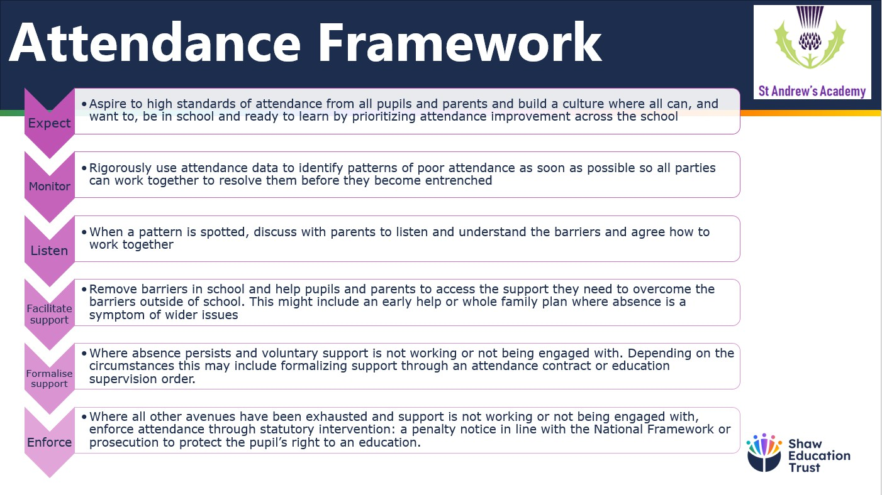

# WHAT TO DO IF YOUR CHILD IS ABSENT

* You must phone the office before 9am with a reason for absence. Main site 01332 832746, Campus site 01332 833678.
* If your child is on transport, you must contact your child’s transport provider to let them know (NST on 01159 300 400 or Derby Home School Travel on 01332 642716 or

Derbyshire Transport on 01629 580000 ext 36725.

* Please note you must always inform the school if your child is absent, we cannot accept messages from Transport assistants.

**48 HOUR SICKNESS RULE**

If your child has a bout of sickness or diarrhoea (either before school or sent home from school ill) they must have been clear for 48 hours before returning to school. If your child suffers from any medical condition where side effects may involve these illnesses, please ring and speak to your child’s class team as soon as possible to ensure we know all relevant medical information.

**APPOINTMENTS**

Where possible, please arrange routine appointments for outside of school hours. We do, however, recognise that there will be times where your child is too ill to attend school or has an appointment that cannot be rearranged.

* If your child is absent due to a medical appointment, school need to see confirmation of the appointment before the date of absence (eg. an appointment letter or text confirmation).
* Please complete a yellow form in advance (found in the back of your child's Home/School Diary) if your child has an arranged medical or professional appointment. You are welcome to pick up/drop off your child from school to minimise their absence from school. Again, please remember to contact your transport provider in advance.

**UNAUHTORISED ABSENCES**

All unauthorised absences will be followed up. A member of school staff will be in contact with parents/carers if your child is absent and the school has not been informed.

* Once registers are complete, if a child is absent and school have not been informed, a text reminder will be sent to the parent/carer for them to let us know why their child is absent from school.
* If parents/carers have not contacted the school after the text message has been sent, the absence is recorded as unauthorised.
* To work together, if there are regular absences, the school will invite parents/carers in for a meeting to discuss the situation and any barriers there are to attendance.
* If there is a pattern of no contact or regular absence, the school will inform Education Welfare and/or Social Care.

# UNDERSTANDING TYPES OF ABSENCES

Every half-day absence from school has to be classified by the school (not by parents/carers) as either **AUTHORISED** or **UNAUTHORISED**. This is why information about the cause of any absence is always required, preferably in writing.

**Authorised** absences are mornings or afternoons away from school for a good reason like illness, medical/dental appointments which unavoidably fall in school time, emergencies or other unavoidable cause.

**Unauthorised** absences are those which the school does not consider reasonable and for which no ‘leave’ has been given. This type of absence can lead to the Local Authority using sanctions and/or legal proceedings. This includes:

* Parents/carers keeping children off school unnecessarily.
* Truancy before or during the school day.
* Absences which have never been properly explained.
* Children who arrive at school too late to get a mark.
* Children who leave school early before the end of the school day, without prior agreement/revised hours agreement in place, unless in an emergency.
* Shopping, looking after other children or birthdays.
* Day trips and holidays in term time which have not been agreed.

Whilst any child may be off school because they are ill, sometimes they can be reluctant to attend school. Any problems with regular attendance are best sorted out between the school, the parents/carers and the student. If your child is reluctant to attend, it is never better to cover up their absence or to give in to pressure to excuse them from attending. This gives the impression that attendance does not matter and usually makes things worse.

# HOLIDAYS DURING TERM TIME

Taking holidays in term time will affect your child’s schooling as much as any other absence and we expect parents/carers to help us by not taking children away in school time. Remember that

any savings you think you may make by taking a holiday in school time are offset by the cost to your child’s education. There is **no** automatic entitlement in law to time off in school time to go on holiday.

Amendments to the registration regulations, which came into force on 1 September 2013, remove references to family holidays and extended leave as well as the threshold of ten school days. The amendments make it clear that Headteachers may not grant any leave of absence during term time unless there are exceptional circumstances. The school considers each application for term-time absence individually, taking into account the specific facts, circumstances and relevant context behind the request. A leave of absence is granted entirely at the Headteacher’s discretion.

Any period of leave taken without the agreement of the school will be classed as unauthorised and may attract sanctions such as but not limited to a fixed Penalty Notice, Court fines of up to

£2,500, a Community Order or three months’ imprisonment.

# PERSISTENT ABSEENTEEISM (PA)

A student becomes a ‘persistent absentee’ when they miss 20% or more schooling across the school year **for whatever reason**. Absence at this level is doing considerable damage to any child’s educational prospects and we need your fullest support and co-operation to tackle this.

We monitor all absence thoroughly. Any case that is seen to have reached the PA mark **or** is at risk of moving towards that mark is given priority and you will be informed of this immediately.

All students are tracked and monitored carefully through our pastoral system and we also combine this with academic mentoring where absence affects attainment. Attendance is reported to the Governors and Trust Leaders every half term and attendance is monitored every two weeks. Strategies and interventions are identified by the pastoral team to alleviate any barriers to attendance. Cases are referred to the Education Welfare Officer, when all reasonable adjustments have been made.

# TELEPHONE NUMBERS

There are times when we need to contact parents/carers about lots of things, including absence, so we need to have your correct contact numbers at all times. Please help us to help you and your child by making sure we always have an up-to-date number – if we don’t then something important may be missed.

# EDUCATION WELFARE OFFICER

Parents/carers are expected to contact school at an early stage and to work with the staff in resolving any problems together. This is nearly always successful. If difficulties cannot be sorted out in this way the school may refer the child to the Education Welfare Officer. They will also try to resolve the situation by agreement but, if other ways of trying to improve the child’s attendance have failed and unauthorised absences persist, these officers can use sanctions such as Penalty Notices or prosecutions in the Magistrates Court.

# This may result in:

* A **Penalty Notice** payable up to **£160** per child, per parent/carer, reduced to **£80 if paid within 21days.** From August 2024, only two fines can be issued to the same parent/carer for the same child within a three-year rolling period. Any second notice

will automatically be charged **£160**. Any further offences (within a three-year rolling period) will be referred straight to the Magistrate Court.

* Prosecution under s444 (I) Education Act 1996, where if convicted you may be fined up to **£1,000.**
* Prosecution under s444 (I) (a) Education Act 1996, where if convicted you may be fined up to **£2,500** and/or **12 weeks imprisonment**.

Alternatively, parents/carers or children may wish to contact the Education Welfare Officer themselves to ask for help or information. They are independent of the school and will give impartial advice. Their telephone number is 01332 641124.

# SCHOOL TARGETS, PROJECTS AND SPECIAL INITIATIVES

The school has targets to improve attendance and your child has an important part to play in meeting these targets.

Our aim is to achieve better than the targets because we know that good attendance is the key to successful schooling and we believe our students can be amongst the best in the city.

Throughout the school year we monitor absences and punctuality to show us where improvements need to be made. Information on any projects or initiatives that will focus on these areas will be provided in our home-school letters and we ask for your full support.

We know that attendance rates for special schools are generally below those of mainstream schools because of the complex nature of some of our students’ special needs, including associated medical needs. As a result of this some of our students are more prone to illness and hospitalisation. We also fully understand the value of a close home-school partnership.

# SUMMARY

The school has a legal duty to promote and monitor attendance. Equally, parents/carers have a legal duty to make sure that their children attend. Student attendance figures are reported to Shaw Education Trust and to the school Academy Council half termly.

All school staff are committed to working with parents/carers and students as the best way to ensure as high a level of attendance as possible and that every child’s welfare and life opportunities are promoted.