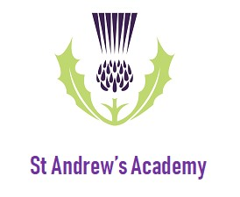
St Andrew’s Academy
FE College

Work Placement
Information and Expectations

Contents

About Us Page 3

Gatsby Benchmarks Page 4

Work placement Format Page 5

Expectations Page 5

Contact Details Page 9

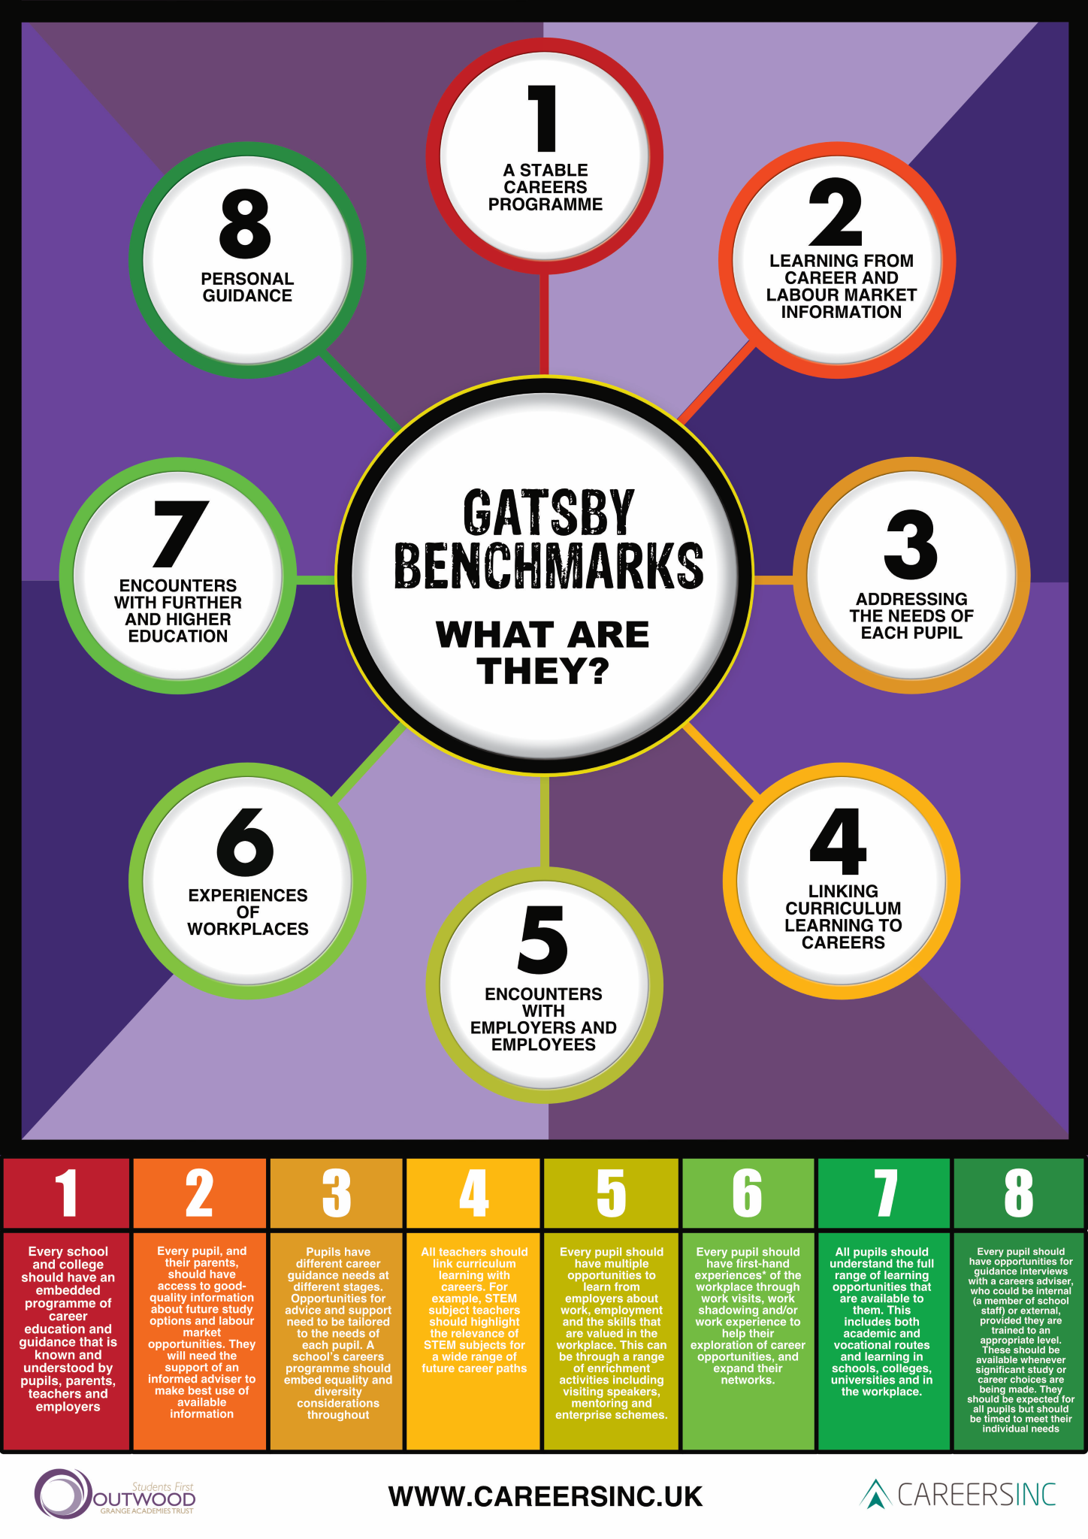
About Us

St Andrew’s Academy
St Andrew’s Academy is a secondary school for learners aged between 11 and 19 who have a wide range of special educational needs and disabilities. We have a focus and passion for supporting our young people to be independent, confident and ready to overcome any challenges they may face. It is our genuine pleasure to witness the determination and successes that our young people demonstrate every day.

Our dedicated and highly effective staff work alongside our young people to ensure the best outcomes for all. We have a particular desire to engage our school and wider community as a whole in order to best demonstrate our school motto; ‘Learning Together, Achieving Together’.

St Andrews Academy FE College

St Andrew’s Academy FE College Campus accommodates over 30 learners, all of whom are undertaking our Post 16 ‘Inspiring Futures’ programme of study. As part of this programme students are exposed to and engage with a range of different employers in order to develop their understanding of the workplace and to learn about the skills they require to support their transition into being valued, purposeful members of society.

Preparing the students to play an ambitious, active role in society upon completion of their time at school is one of the most crucial aspects of their learning journey at St Andrew’s Academy. A key intention of the Inspiring Futures programme of study is that it seeks to provide opportunities to highlight all of the wonderful things that our students can do, ensuring that they are able to apply the skills they have learnt in a wide variety of contexts and situations. Participating in a variety of different work based experiences is fundamental to generate an employer/employee awareness, helping our students develop their understanding of what employment entails and providing employers the opportunity to reflect on the inclusivity of their workplace.

Our curriculum is designed to provide opportunities for our young people to undertake a range of worthwhile, ambitious work placements in order to develop their understanding of the world of work and highlight to employers all of the fantastic skills and attributes they are able to provide.

The Gatsby Benchmarks

The Gatsby Benchmarks of Good Career Guidance were published in 2014. The aim is to highlight 8 core aspects of careers and enterprise education which should be undertaken by all students in order to develop their knowledge and understanding of the workplace. Not only are the benchmarks aimed at raising aspirations for young people and their schools, they also provide a framework for establishing lasting working relationships with local employers. We feel that it is important that the employers with whom we work have a working understanding of the Gatsby Benchmarks in order to better understand the role that their provision holds within our students learning..

Work Placement Format
Students at St Andrew’s Academy are supported to access a wide range of work based learning during their time at school. FE students follow a rolling timetable over a 3 year programme and are offered the opportunity to participate in a wide range of different experiences. Placements will typically run for 6 – 8 weeks for a small, supported group of students. Groups will then rotate and a new group of students will continue the placement.
The students at St Andrew’s Academy have a wide range of severe learning difficulties. In certain respects this can make certain tasks and experiences more difficult for them to access and as such appropriate staffing support is provided by school to ensure that students are able to get their needs met and excel in the workplace. Our students can however be ideal candidates to support your workforce. They are hardworking, passionate, have a keen eye for detail and show a strong motivation towards task completion.
Nationally, the employment rate for adults with severe learning difficulties is 17.6%, a number which falls to 6% for those in paid employment. For this reason it is vital that our students are provided with the opportunities to develop their skills in order to maximise their chances of accessing paid employment in the future.
Our aim is to work with individual employers to determine the specific skills and attributes that they require in their employees, and then work to develop these skills in our students. We recognise that each placement is different, providing unique opportunities for development and so by tailoring the learning for each student we are able to maximise the benefits to both the students and the employer.
Expectations
We feel it is important to provide clear guidance to employers outlining our expectations for how placements may be facilitated for our young people, and in turn provide assurances as to how we as a school will support our young people to bring worth and purpose to your workplace. In this way we can ensure that all placements are mutually beneficial. The expectations for work placements – before, during and after – are set out here for the following groups:

- St Andrew’s Academy
- St Andrew’s Young People
- Employers

Equality

It will be the responsibility of all parties to address the issue of equality. While this standard is expressed as a universal entitlement for young people to gain experience of work, it needs to be clear that not all young people enjoy the same advantages, nor face the same challenges. Their backgrounds and circumstances must never limit their potential and all parties will seek to develop practice which ensures improved outcomes for all young people. All those involved in any work placement should provide advice, guidance and opportunities that contribute to:

- Eradicating discrimination;
- Promoting mutual respect and equality of opportunity across genders, social background, disabilities, ethnicities, sexual orientation and religions.

St Andrew’s Young Person

Prior to commencing a placement I will:
- Be provided with the opportunity to participate in work placements at a time that is mutually suitable for my needs, the employer and my school;
- Be supported in my work placement in such a way that takes account of any challenges I may face in relation to my physical, social and emotional wellbeing and any specific support needs;
- Agree the duration of my work placement with my employer.
- Agree with my school and employer which goals I aim to achieve during the placement;
- Understand the conditions of the placement regarding the period of time, the expectations of the employer and the location along with dress and behaviour codes. This information will be available through my school/local authority and I will also be supported to conduct my own research. I will also know who my main employer contact is and take every opportunity using my main contact within the organisation and with my school, before embarking on my work placement, to acquaint myself with any hazards that may potentially occur when I am there.
During a placement I will:
- Complete the relevant aspects of my learning CV and work toward achieving my agreed goals and targets.
- Demonstrate the behaviours and attitudes that my employer would expect to see in an exemplary employee.
- Follow training and instructions provided by my employer and wear any PPE provided (where appropriate).
- Take full advantage of the opportunities available to me to develop my skills, gain knowledge and develop a positive attitude to work.
- Reflect on the support provided by my employer and other partners to allow for adjustments to my participation if required.
After a placement I will:
- Reflect on my learning as I continue with my studies – using my placement experience to support my ongoing learning.
- Reflect on feedback from my employer.
- Add relevant details of my work placement to my Learning CV.
- Share information about my placement experience with school staff and my peers, highlighting the skills I have acquired and opportunities that were available to me within my specific work context.
- Provide feedback on my experience to my employer in order to support potential future developments.

St Andrew’s Academy

Prior to commencing a placement, we will:

- Initiate a pre-planning meeting with potential placements to register interest for all parties.
- Meet with potential employers to establish what the placement will look like.
- Plan pre-placement meetings to take place between the school, the employer, and the students
- Carry out thorough environmental and individual risk assessments.
- Have robust record keeping in place which monitors and tracks where and when each young person participates in a work placement. (Compass +)
- Ensure that the duration and timing of the placement will be mutually agreeable to the Academy and the employer.
- Identify how the placement aligns with the young person’s studies, career aspirations, abilities, and capabilities. Define learning outcomes and differentiate accordingly.
- Ensure we pass on any information on the young person relating to their physical, social and emotional wellbeing and specific support needs (in compliance with Data Protection).
- Note that the goals and targets the young person will be working towards during his/her placement are appropriate and productive and liaise with the employer until this is achieved.
- Be satisfied that the employer/placement provider has arrangements in place to manage health and safety risks.
- Prepare young people for their placement, ensure they have an understanding of expectations. This will include information on health and safety in the workplace and how to deal with any issues which may arise whilst on placement.
- Practice key essential skills with the students in preparation for placement, identifying progress and recording it through the Skills Builder Framework.

During a placement we will:

- Monitor and track the success of the placement in collaboration with the young person(s) and employer, taking account of the length and nature of the placement, and the needs of the young person(s).
- Work with the young person(s) and employer to resolve any issues that may hinder a successful placement.
- Provide appropriate staffing to support young people whilst undertaking their placement. This support will be reviewed with employer in line with safe working practices.

After a placement we will:

- Support the young person(s) in maximising the learning from the placement learning and retain evidence to support relevant accreditation.
- Ensure the work placement quality assurance process is contributed to by constructive feedback from the young person(s) and the employer.
- Provide feedback to the employer on any aspects of the placement that were particularly strong or might be enhanced – from both the young person’s view and the Academy’s.
- Explore ways for the whole school community to gain maximum benefit from the placement, enabling the young person to continue developing their skills to further enhance learning and teaching.
- Identify ways of sharing knowledge of the workplace with staff and young people.
- Continue to develop relationships with the employer alongside our school’s self-evaluation processes.

Employer

Prior to commencing a placement we will:

- Liaise with the school to promote our opportunities.
- Ensure that risks are controlled before the placement starts and share all control measures with the school.
- Ensure that the placement will take place at a time that is mutually suitable for our organisation, the school and young person.
- Identify key member(s) of staff from our organisation to support the young person(s) during their placement.
- Know who the school link person is to support the young person.
- Be provided with, and consider, any information relating to age and stage details of the young person undertaking our work placement (in compliance with Data Protection) along with his or her career ambitions, particular interests and skills including any specific support needs.
- Have agreed learning targets with the school and the young person(s) and provide materials to support induction into the workplace.

During a placement we will:

- Support the young person by providing appropriate training and guidance, including a health and safety briefing, to enable them to both undertake essential tasks and explore areas of particular interest as we would with any new employee.
- Provide ongoing feedback to the young person(s) and their support staff.
- Offer a rich and varied experience which enables the young person to both understand our organisation’s culture and practices, and to develop practical skills whilst undertaking meaningful tasks.
- Take stock of the young person’s knowledge and skills, and their views about our organisation in relation to our ethos and the way we work;
- Invite the young person to suggest ways in which our approach to work placements could be enhanced.

After a placement we will:

- Take the opportunity to share our views on the young person’s performance relating to their personal goals/targets with the school and young person.
- Receive and reflect on feedback from the young person and the school regarding the placement and experience.
- Take the opportunity to participate in a quality assurance survey of the work placement in order to support the development of future working partnerships.

Contact Details

If you would like any further information or advice, or would like to discuss any employment opportunities in more detail then we would love to hear from you. Please contact:

St Andrew’s Academy  St Andrews View  Breadsall Hilltop  Derby  DE21 4EW | St Andrew’s FE College Campus  Fieldsway Drive  Breadsall Hilltop  Derby  DE21 4EW

St Andrew’s Academy Careers Team:

Tracy Fisher (Academy Careers Lead)
01332 832 746
tcorden@standrews.derby.sch.uk

Claire Ward
01332 833678
cward@standrews.derby.sch.uk

St Andrew’s FE College Campus:

Bill Buckingham (Head of Further Education)
01332 833 678
bbcukingham@standrews.derby.sch.uk

Employer Information
Employer:
Contact Name: |  |  | Phone:
 |  |  | Email:
Workplace Address:
Time/date of initial contact:
Documentation sent:
Planning Meeting Date:
Students:  1.  2.  3.  4.  5.  6. | Profile shared:  YES/NO  YES/NO  YES/NO  YES/NO  YES/NO  YES/NO | Risk Assessment completed date:
Staffing:

Workplace Risk Assessment:  (See Appendix 1) | Date of completion:
Proof of Public Liability:  (See Appendix 2) | YES/NO
Summary of responsibilities:

Arrival/Departure Procedure:

Transport:
Uniform Requirements:

