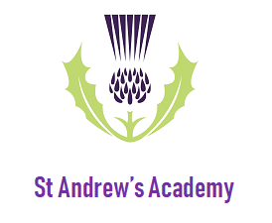
Evidence for Learning – Family App
How to guide
The Evidence for Learning Family App is available to download for free from the App Store (Apple Devices) and Play Store (Android Devices).
- Download the App:
Go to your app store and search for Evidence for Learning Family App. The app should look like this:

- Log In:
Once downloaded, upon opening the app you will be asked to log in via the below screen:

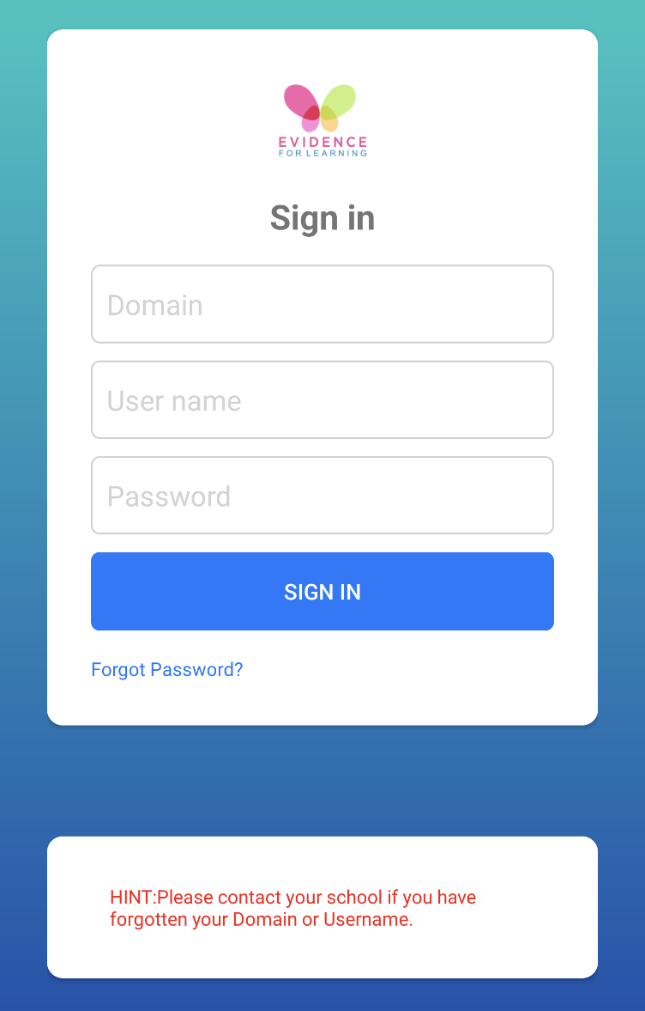
Log In Screen

The domain name is standrewsacademy (please note that this is case sensitive). Your username is your email address and you will have received an email containing your password. You should not need to re-enter your details when opening the app in the future.

- App Navigation:
Once logged in you will be able to see the home screen (below).

Home Screen

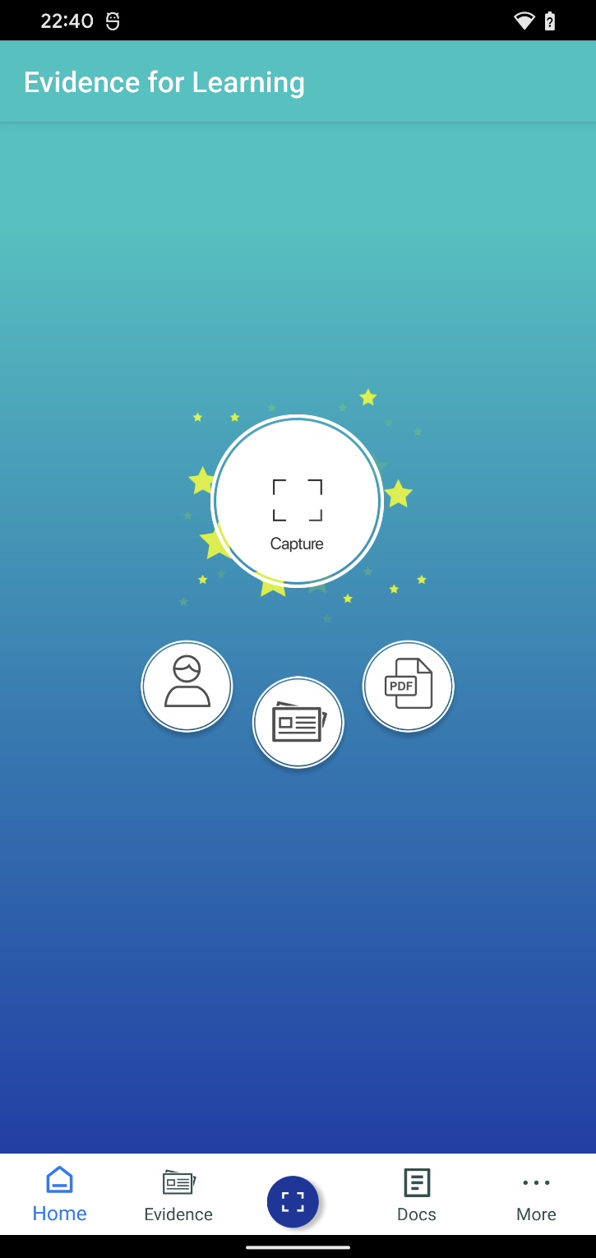

Docs Button
Use this button to view any End of Year Reports
Capture Button
Use this button to quickly add any evidence you would like to share with us.

Student Button
Use this button to select which student you would like to see.

Evidence Button
Use this button to quickly view any evidence that school have shared with you or that you have shared with school.
More Button
Use this button to view your profile settings. Here you can add a passcode, change your password and personalise the app.

It is recommended that you update your password the first time you use the app using the More Button option. Please select ‘remember these details’ when prompted.
- Setting a default learner:
Tapping the Student button will reveal all student accounts to which you have access. Families with numerous students will be able to see all of their relevant accounts. For those families with only one student we would recommend setting your young person as the ‘Default Learner’. To do this tap on the Student button and then click on the student’s name. A blue tick will appear at the right hand side of the box to show who has been selected.

- Capturing Evidence at home:
Tap on the Capture button. The below screen will appear:
Evidence Screen
Evidence Status
Evidence will be saved as ‘Draft’ when the box is orange.
Evidence will be visible to staff and saved on the cloud when the box is green.
Learners
Tap on the + icon to select which learner you would like. The app will automatically select a learner if you have set them as the default learner. Multiple learners can be selected if appropriate.
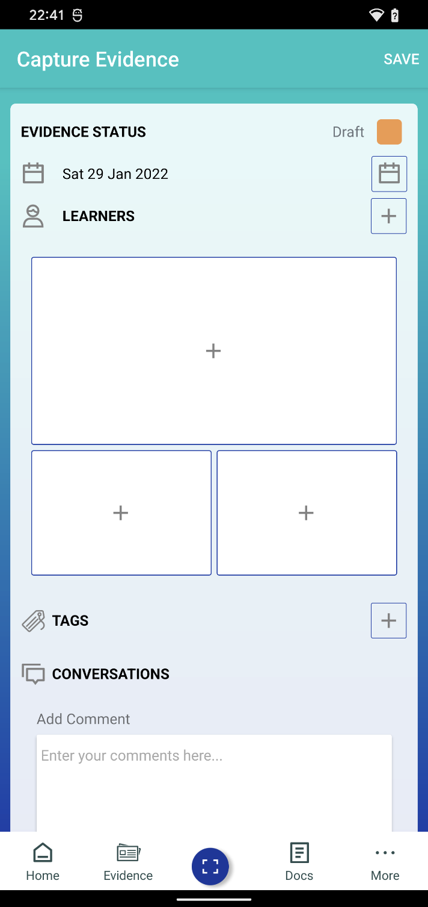
Tags
Tap on the + icon and then select the ‘Home Learning’ tag before tapping save.

Photographs / Videos
Tapping on the + icon will give you 2 options: Take a Photo/Video or Photo/Video Library. Select the option you require and then select the photo/video.
You can select up to 3 photos or videos. Videos cannot be longer than 1 minute long.
Conversations
In this box you can add a comment to give further detail about the photos/videos you have chosen.

Once you selected the learner, uploaded your selected photos/videos and written any accompanying comments you will need to tap on the orange box to change the evidence status to ‘Published’ (the box will turn green). Tap save in the top right hand corner to upload the evidence to your young person’s cloud account. This will then be visible to staff too.
Example Evidence
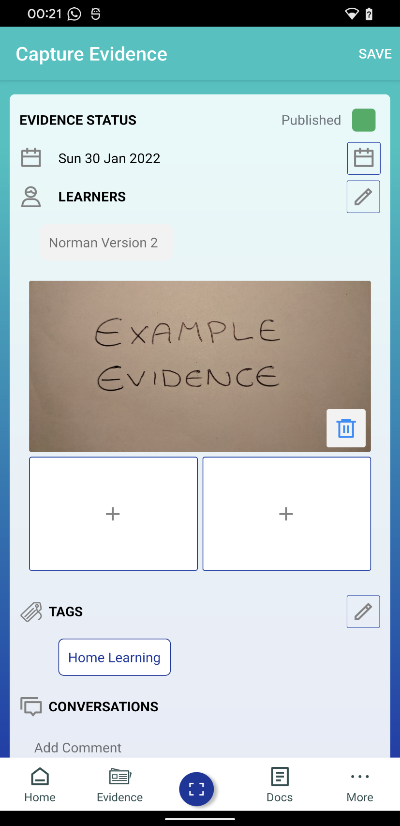
Evidence Status
Make sure the box is green and as changed from Draft to Published.

Evidence Status
Click save and the evidence will sent to your young person’s cloud account.

- Viewing evidence:
Tap on the Evidence button at the bottom of the screen or on the home screen. This will load up all of the evidence that is linked to your young person(s) and allows you to quickly see what learning opportunities they have been undertaking. Evidence can be viewed in either Tile View (Allows a snapshot of content) or Journal View (Shows all content for each piece of evidence). Please select whichever option you would prefer. It is also very clear to see which pieces of evidence have been uploaded from School, and which have come from the home environment.

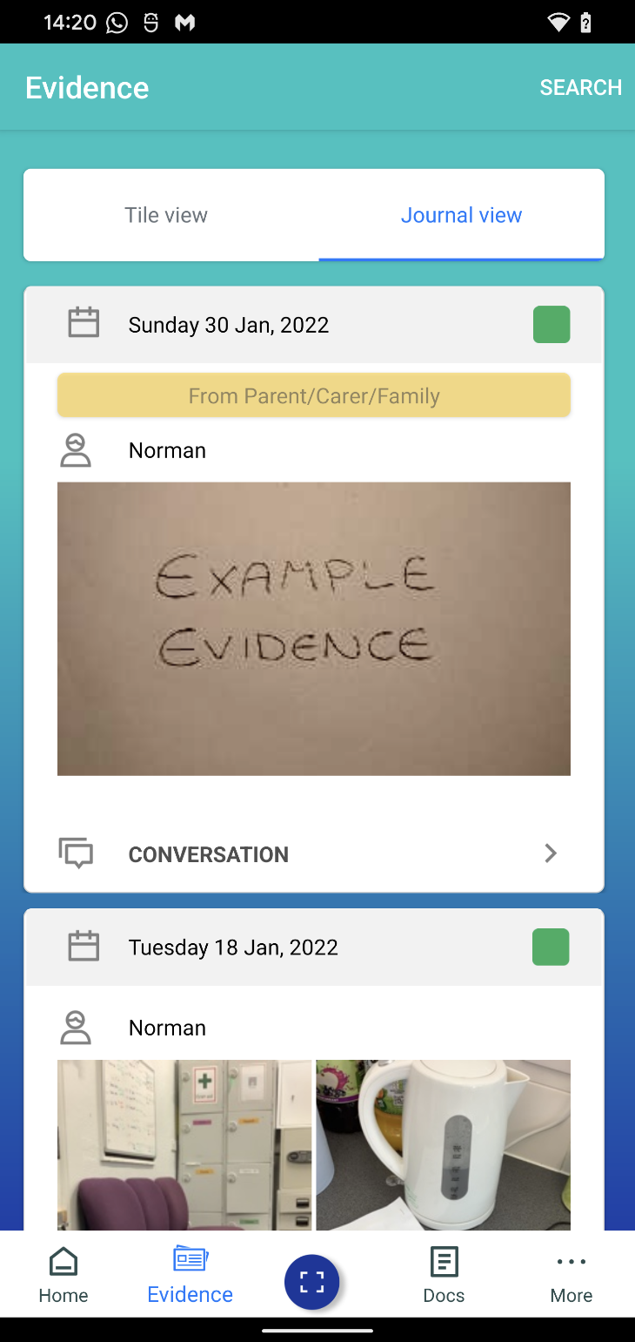
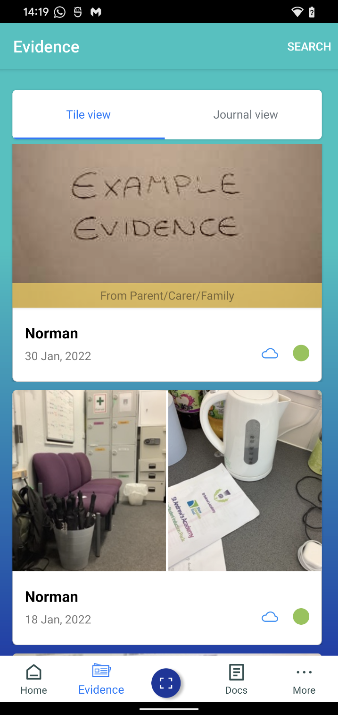
Tile View Journal View

Evidence for Learning (EfL)
Frequently Asked Questions

I have forgotten my log in details. What should I do?
Please notify your young person’s class teacher who will arrange for your details to be reset. Please be aware that this will be done remotely and you will be sent an email with your new credentials.

I have more than one young person attending school. Do I need a separate account for each one?
You only need one EfL account. Evidence will be clearly named, so if you have more than one young person at school then you will easily be able to see which student a piece of evidence relates to.

Do I need to select a student each time I upload a piece of evidence from home?
You can select a default learner by following point 4 of the how to guide. This means that this student will automatically be selected when you create a new piece of evidence. You may not wish to do this if you have more than one young person attending school.

How often will I receive updates from school?
Class teachers will ensure that a minimum of 1 piece of evidence per student is made available for you to view each week.

Will I be notified when evidence is available to view?
Please tap on the More button and select Notification Preference. You can set this to Never; Daily or Weekly. Please select the option that works best for you.

Can I use EfL Family app to have discussions with my young person’s classroom team?
Whilst the EfL Family app provides a fantastic opportunity to share learning experiences between home and school, it is not intended to replace the current diary/class email set up. Staff may not always be able to check EfL comments regularly so it is important that any messages continue to be passed on directly to your young person’s teacher.

I am not receiving a notification when evidence has been added?
Tap on the More button and check the notification preferences are not set to ‘None’. If this is not the case, close the app and open your device’s settings app. Locate the notifications menu and check to ensure you have enabled notifications for the Evidence for Learning Family App.

I have been informed that a report related to my young person’s progress is available to view. Where can I find this?
Any reports that are compiled through EfL can be viewed by tapping the Docs button. Your young person’s class team will inform you if/when any reports have been created and are ready to view.

The EfL Family app won’t open or evidence will not upload.
Check to ensure that you device is up to date. You may need to update the app or your phone/tablet in order to ensure the most current version of the app is running. You can check for system updates in your devices settings menu.

