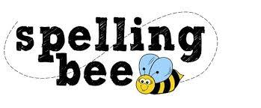



|  |  |
| --- | --- |
| eight | increase |
| enough | important |
| exercise | interest |
| experience | island |
| experiment | knowledge |
| extreme | learn |
| famous | length |
| February | library |
| forward | material |
| fruit | medicine |
| grammar | mention |
| group | minute |
| guard | natural |
| guide | naughty |
| heard | notice |
| heart | occasionally |
| height | often |
| history | opposite |
| imagine | ordinary |

**Please practise these spellings if you would like to enter the TSSMAT Spelling Bee. Your class teacher will be running heats in your classroom at the end of the Autumn Term. Good luck!**