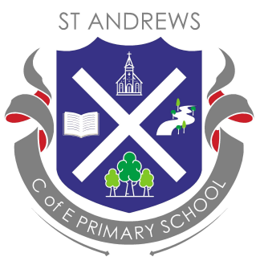
Dear Families

We are excited to announce the upcoming TSSMAT Spelling Bee for the 2024-2025 academic year! This termly competition aims to promote high standards in spelling across our school and encourages children to learn their key spelling words in a friendly and supportive environment among their peers.

What to Expect
During the summer term, we will host a MAT Spelling Bee Competition, where our school will compete against other schools within our academy to win the coveted MAT Spelling Bee trophy.

How Will It Work?
We kindly ask you to assist your child in learning the key spelling words, which will soon be available on our website. This preparation will help them compete confidently in a supportive atmosphere where every child is encouraged to achieve their best. At the end of each term, class teachers will conduct heats within their classes to determine the year group winners. The final MAT competition will take place during the summer term, where we will find out which school will be crowned the Spelling Bee Champion. All participants will receive a Spelling Bee certificate during our Values/Vision Assembly.

Important Dates
Termly School Spelling Bee: Held at the end of each term to celebrate the children’s efforts in mastering their spellings.
Testing Schedule: Children will have until the final week of each term to learn their spellings. Class teachers will quiz all students, and every child will have the opportunity to celebrate their achievements. Regular practice at home will help build their confidence.
At the end of the summer term, a selection of children will be chosen to represent our school in the Cross-MAT Spelling Bee Competition, with hopes of winning the MAT Spelling Bee trophy.

How Can You Support Your Child?
Here are some tips to help your child prepare:
- Read the words together – say them out loud.
- Identify similar words or word families.
- Break words into syllables.
- Be a word detective – look for smaller words within longer ones.
- Make it fun – incorporate games or activities.
- Praise their efforts – encouragement goes a long way.
- Keep sessions short – avoid overwhelming them.
Should you have any questions or require further assistance, please do not hesitate to contact your child’s class teacher.

Thank you for your support, and we look forward to a fantastic Spelling Bee season!

Best regards,
Miss Mills

