St. Andrew’s C.E. Primary School
Chinnor

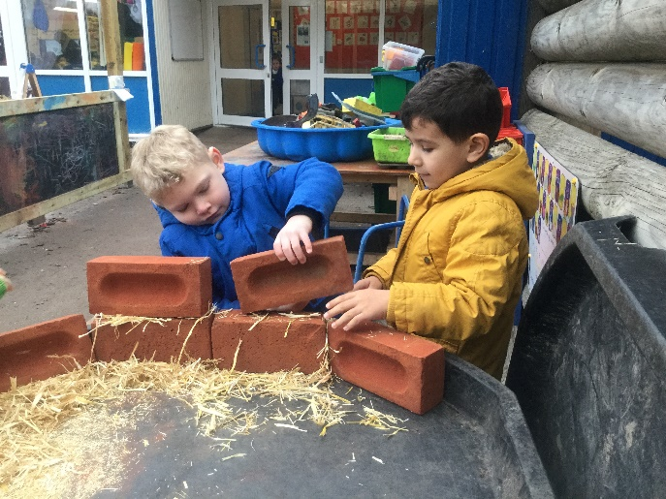
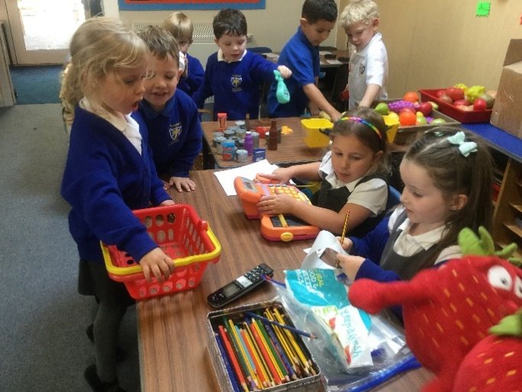
‘Learning together, we achieve great things’
Admissions Information for Parents
2022 - 2023

Contents
Welcome to St. Andrew’s CE Primary School
- Welcome from the Headteacher: Mrs Annette Mashru
- Governors: Welcome from the Chair of Governors
- Welcome from Revd. Jacky Barr: Rector of St. Andrew’s Church
- The Early Years Leader: Mrs Julie Thompson
- Welcome from St Andrew’s School Association (SASA)

About St. Andrew’s CE Primary School
Please view the school website www.st-andrews.oxon.sch.uk
- Mission statement
- Ofsted report (May 2013)
- SIAMS (Statutory Inspection of Anglican and Methodist Schools) report (October 2015)

Useful Information
Please access via our school website, go to ‘School Information’ then ‘Admissions’ or use link below:
https://www.st-andrews.oxon.sch.uk/teaching-and-learning/admissions
- Welcome Videos
- Term Dates for the Academic Year 2022 – 2023
- Useful information and what does my child need for school? Suggested ‘Kit List’
- School Gateway – how to set up
- Uniform policy and purchase
- Milk scheme
Key Policies, Procedures and information
Please view the school website www.st-andrews.oxon.sch.uk
- Safeguarding Policy
- Settling in policy
- Late collection of a child procedure
- Attendance Policy
- Missing child policy
- Medication policy
- School Lunches
- Wrap Around Care

Welcome from the Headteacher…

Our Vision:
At St Andrew’s CE Primary School, we aim to bring children to a place where they can realise their full potential. Our Christian values are the foundation of all we do and each one is a facet of the central value, love, which ‘always protects, always trusts, always hopes, always perseveres.’ (1 Corinthians 13:7) Protect, Trust, Hope and Persevere

May 2022
Dear Parents and Carers,
It is my pleasure to welcome you to St. Andrew’s C.E. Primary School.
Everyone at St Andrew’s believes the children are central to all we do. All of the staff work hard and encourage the children to develop a love of learning and achieve their full potential. Our Christian values are delivered through our vision and guide us all to be the best we can be. The school is filled with laughter and there is buzz of discovering new things and working together.
We see our parents as the primary educators of our children and with that in mind; we aim to work closely in partnership with you. All that we do in school requires support from home if we are to maximise your child’s learning opportunities. Therefore, effective communication is essential. Should you have any worries or concerns, please do not hesitate to bring them to the attention of your child’s class teacher. Equally, we are always delighted to receive comments when your child is particularly happy or has been excited and enthused by an aspect of school life.
Please visit our website which has lots of information and will give you a feel of our school.
I do hope that you have had the opportunity to read our last Ofsted report in which the school was judged to be Outstanding in every area. This is an achievement of which we are all very proud. In addition to that you may like to read our Outstanding SIAMS report. Both reports are available on our school website.
We shall continue to drive forward to improve the quality of education for our children and we hope that you will become part of that vision. Please take the time to visit us at St. Andrew’s. A warm welcome will greet you.

Mrs Annette Mashru
Headteacher

Welcome from the Chair of Governors…

On behalf of the whole Governing Body, I’d like to welcome you to St Andrew’s.

Many of us on the Governing Body are either parents or relatives of pupils at the school, or members of staff. We’re proud of our school and its place at the heart of the village, and we hope you enjoy finding out more about our ambition to provide an outstanding environment for every pupil to achieve their full potential.

We are fortunate to have a committed and enthusiastic team of teachers, support staff, governors, school association and parents. The school’s motto is “Learning together we achieve great things” and the whole team connected with St Andrew's continuously strives to provide the very best facilities and opportunities possible for our children’s learning, which in turn improves achievement. This has never been more important than as we all recover from the disruption caused by the pandemic, and the staff and governors are working closely together to ensure all the children at the school are supported and challenged through appropriate interventions.

St Andrew's has a long and proud history of success recognised by 'Outstanding' accreditations from Ofsted and the Church of England SIAM (Statutory Inspection of Anglican and Methodist Schools). But we never rest on our laurels, and the school is at the forefront of the highly successful Thame Partnership of schools, leading curriculum developments for pupils across the local area.

As Chinnor continues to grow, the Governors take seriously our responsibility to ensure that the school has the capacity to comfortably accommodate all the pupils who wish to join us. In 2021 we were delighted to officially open the Heritage Block, named after a former headteacher, and comprising our new Year 6 classrooms.

Our Christian values and ethos are central to all that we do as a school, and we work closely with St. Andrew's church where our pupils also attend services.

We have a very active school association (SASA), run by parents, which organises events and activities throughout the year in order to raise funds to enhance the educational experiences for our pupils. The community swimming pool is also within our grounds, giving valuable access to this life-skill for every pupil, and we encourage sporting interaction with our partnership schools in the local area.

We look forward to welcoming you to the school in the near future and hope that if you do choose St Andrew’s for your child, that you will also feel able to get fully involved in the life of the school.

Seb Hearmon

Chair of Governors

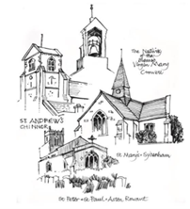
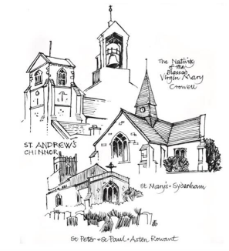

Welcome Letter from the Rector of St. Andrew’s Church…

Dear Parents and Carers,
As Rector of the United Parish of Chinnor, Aston Rowant, Sydenham and Crowell, and Foundation Governor of St. Andrew’s Primary School, I offer you a warm welcome as your child begins his or her time as a pupil here. We all hope and trust that your child will settle in well, be very happy and will look back on his or her years at St Andrew’s with real affection and gratitude.
The parish church, its members and ministry team are pleased to support the children, families and staff of the school in every way they can.
We provide three Foundation Governors (Church of England appointed). The Foundation Governors also monitor Religious Education and Collective Worship on behalf of the governing body and as part of the Church of England Self Evaluation Framework. Children from the school visit the church as part of the RE curriculum and we enjoy hosting school services once a term and on special occasions such as the Leavers Service, Harvest Festival, the St Andrew’s Day Service and to welcome Foundation Stage pupils and their parents. We love to display children’s work in the church. It should come as no surprise that the school was awarded ‘Outstanding’ by a recent SIAMS inspection.
Members of the church, including the clergy, visit the school regularly:
- To lead weekly assemblies in the school in the form of Open The Book, an interactive, accessible and enjoyable way of bringing Bible stories and their messages to life.
- To engage with the children in an annual event called Prayer Spaces, an opportunity for each child to explore different ways of praying,
- To deliver the REInspired Project, which involves teaching the children different aspects of the Christian faith through multi- presentations, art, craft, drama and small group discussions.
- To support the school in the introduction of an initiative called the Contemplative Toolkit, calming and meditative techniques rooted in the Christian tradition
We support the inclusive nature of the school as a place. Our prayer for the school is that every child and member of staff is valued. And, whatever their background or beliefs, will be given opportunities to flourish and develop their own unique gifts and potential, all within a safe and caring environment that is informed by its Christian values and ethos.

Please do not hesitate to contact me, either by ‘phone or email, if I can provide any support to you as a parent of a child in the school.
With all best wishes and blessings

Jacky
The Rev’d Dr Jacky Barr

The Rectory, High Street, Chinnor OX39 4DH

Tel 352027 email: revd.jackybarr@gmail.com

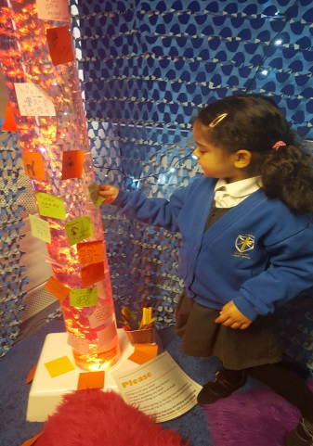

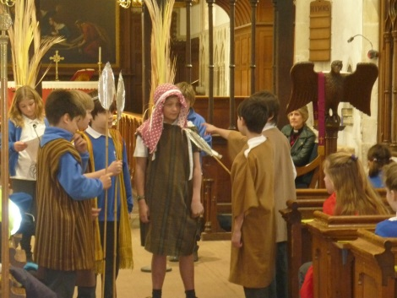

Welcome from the Early Years Leader…
Welcome to Reception at St Andrew’s! We are thrilled and we look forward to meeting you and working with you as partners in your child/ children’s education.
We are just the beginning! As you will already know, the Local Education Authority has informed the school that your child is due to join our Reception year in September 2022. You and your child/children will be part our school community, for the next 7 years and we are delighted.

As the Early Years Leader here at St Andrew’s School, I work alongside a fantastic team of teachers and teaching assistants. My role is to educate, support and advise children and adults in any way I can. Please don’t hesitate to speak to me if you have any concerns. If you need to contact me, please send an email to the office and I will always try to respond as soon as possible. We appreciate that you are busy too!

Children are encouraged to learn at their own pace and are surrounded and supported by an enthusiastic, nurturing and highly motivated team. Through peer teaching, following individual interests, small group lessons, some whole class teaching, and a curriculum based upon the needs of our children, each individual is encouraged to be a resilient, active learner. We want each child to gain a strong academic foundation, to be an independent thinker and to reach their true potential.
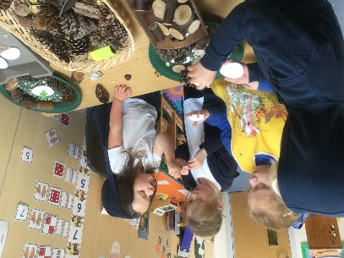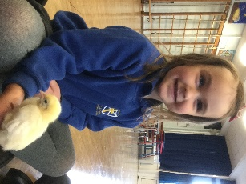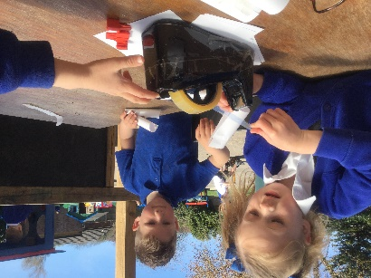

School and parents want the best for each child; as a team we want to hear about your child’s interests and achievements and we want to help you to help your child/children-it’s about working together, being part of a community.

I hope you find the information on the website useful. If you have concerns or suggestions as to other materials you would find useful, please don’t hesitate to contact me.

Julie Thompson.
Early Years Leader

Welcome from SASA - ST ANDREWS SCHOOL ASSOCIATION…
Hello, and a very warm welcome to St Andrew’s C.E Primary School from the SASA team. You will no doubt hear SASA quite a lot on your journey through St Andrew’s!
We are St Andrew’s School Association, (a Parent, Teacher & Friends Association) and we have the pleasure of working alongside the school and our Governors to provide additional funds to financially support school trips, music lessons, and new equipment for our children.
All money raised goes to the school, and we aim to reach around £6,000 a year so you can see already that we really need parental support to achieve this.
We appreciate that time and money are precious, so we plan our events annually and we plan our meetings accordingly and try to keep these brief and to the point where we can, although we do like to have a bit of a chat occasionally! Events are detailed on the calendar which can be seen on the school website.
We are currently recruiting for a new chairperson / or co-chairs which works very well, if this is something that you are interested in, let us know and we will support a transition to make this as easy as possible.
If you feel that you have something to add, however big or small, we would really love to hear from you. Maybe you have an exciting skill or talent, or perhaps you would just like to offer an hour or so to man a stall at the carnival or to help to tidy up afterwards. Maybe you work for a company that could donate raffle prizes or perhaps you are an ideas person who could come up with some new and fantastic ways for us to engage our families and children into getting involved. You do not need to join the committee if you feel that this is not for you, however, please consider joining our Helpers of SASA Facebook group where you will see details posted advertising all events and you can help without joining the committee itself.
We are all here for the same reason and we are all very approachable so please ask around and your year representative would be delighted to have a chat with you.
Warmest regards, SASA
Please feel free to get in touch https://www.facebook.com/sasachinnor
Please join the SASA Facebook Page to keep up to date with what is going on.

