Year

**Literacy**

Poetry: Ourselves

Non-fiction: Instruction texts

Narrative: Traditional stories with a twist. Inspired by Teresa Heapy

**Computing**

We will be learning how to code simple games and debug algorithms. We will then be using the design, code, test process to create our own games for others to play.

**PE**

We will be learning how to express ourselves through dance, following instructions as well as being creative with our own ideas and interpretations. The dances will be inspired by Autumn and harvest.

**Topic**

Geography - Contrasting localities

This term we will be learning about some of the key physical and human features in Morocco, tasting Moroccan food and finding out what it is like to live in there. We will compare a Moroccan village, Amizmiz, to Chinnor, finding key similarities and differences.

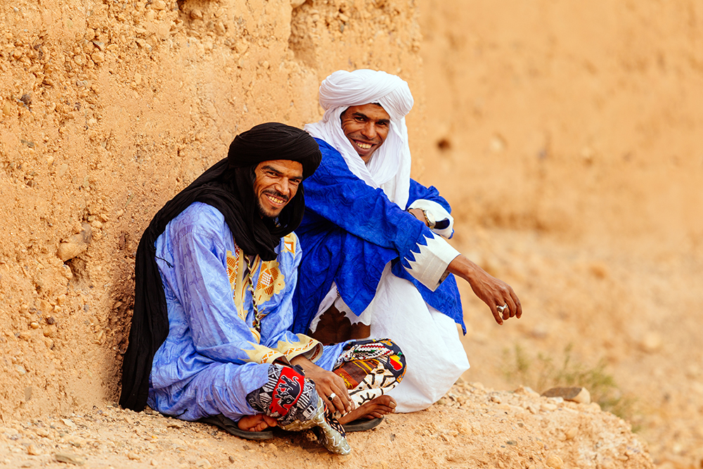

**Morocco**

**Year 2**

**Autumn Term 1 – 2020**

Mrs Talbot, Mrs Perryman

Miss Parsons



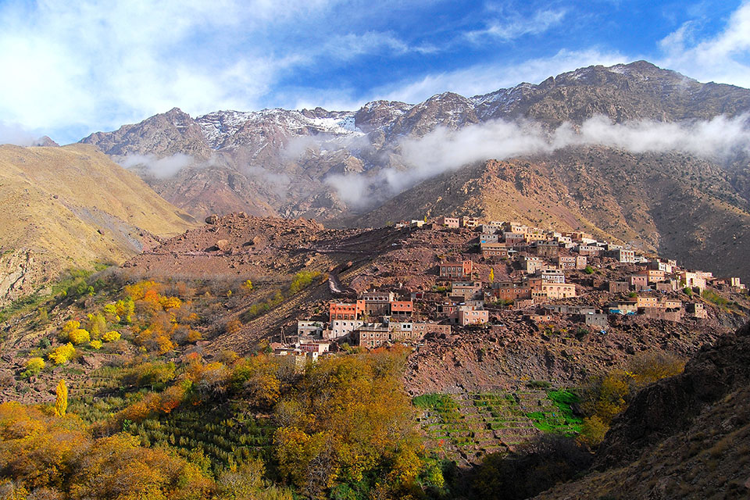

**Science**

Animals including humans

We will be learning about the basic needs of animals and humans and their life cycles. We will also be learning about what it means to eat and be healthy.

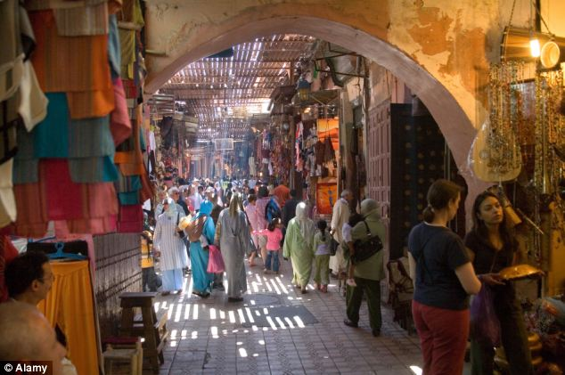

**RE**

We will be learning Bible stories that show kindness, and explore how they influence Christians to behave towards other people.

**French**

This term we will be learning farm animals and pets in French.

**Collective Worship**

Whole school Collective Worship will be on a Friday and KS1 Collective Worship on Tuesday, they will focus on our value.

**Maths**

Number: Place value

We will be learning to recognise the place value of the digits that make up numbers. We will develop our recognition and sequencing of numbers up to 100 and find different ways to represent and compare them.

Number: Addition and subtraction

We will be learning to recall addition and subtraction facts to 20 and beyond with concrete and pictorial representations. We will use our reasoning and problem-solving skills to answer lots of number problems.

**How you can help**

Please continue to encourage your children to complete all set homework.

This year we also need children to become fluent in their 2s, 3s, 5s and 10s times tables.

Regular reading – either listening to or reading with your child each night will continue to build their fluency and enjoyment for reading.

**Music**

This term we will be focusing on composition, creating African safari soundscapes using body percussion and instruments.

**Values**

Our value this term is generosity.

**DT**

We will be finding out about where our food comes from, food from around the world and eating healthily. We will design and make some Moroccan inspired couscous salads.

**PSHCE**

This term we will be learning about our feelings, emotions and relationships.