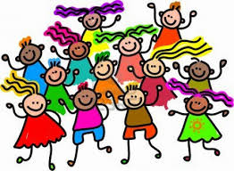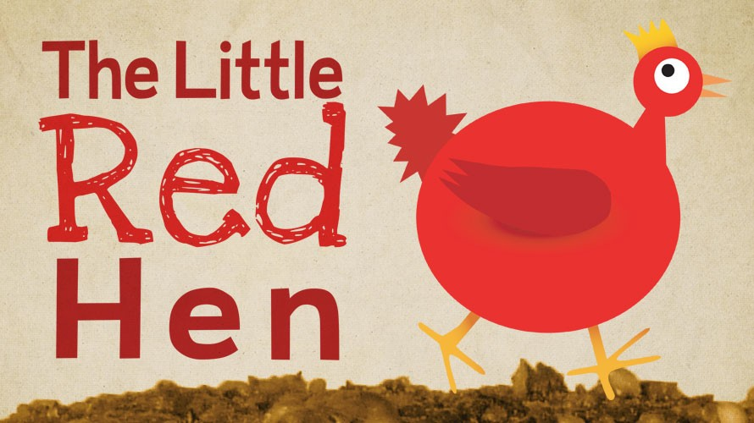

**Physical Development**

We will be using cooking equipment and different resources and tools to create pictures and models.

**Communication & Language**

We will be learning to express opinions, listen to each other and to show understanding of stories from other countries.

**Personal, Social & Emotional Development**

We will be learning to co-operate, become aware of our own needs and learning to respect others.

**Literacy**

We will be learning to read labels, write recipes and we find information in books.

**Communication and Language**

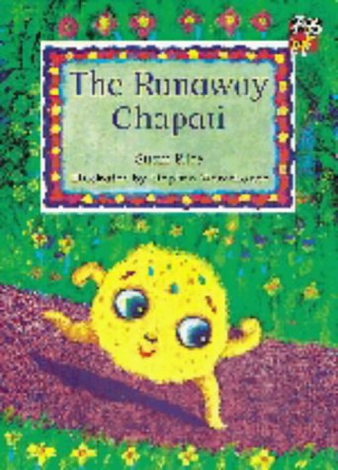

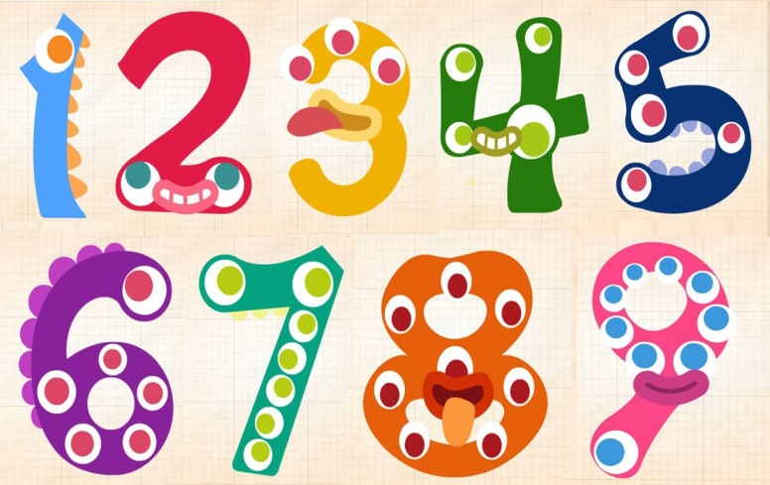 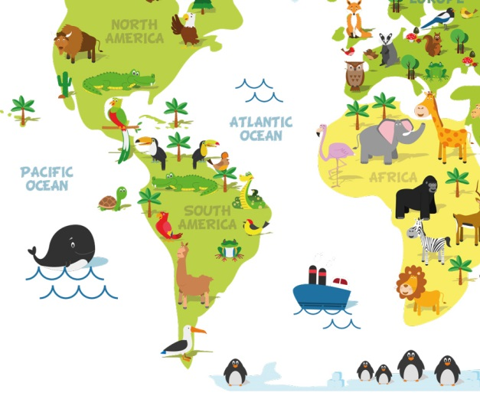

**Mathematics**

We will learn how to read, write and calculate using numbers 1 to 5 and we will introduce shape, money and measurement.

**EYFS**

**Autumn Term 1**

**2020**

**How you can help**

Please encourage your child to be independent

Regular reading – either listening to or reading with your child each night will continue to build their fluency and enjoyment for reading.

**Understanding of the World**

We will be learning to find similarities and differences between ourselves and others and to respect other cultures.

**Collective Worship**

Whole school Collective Worship will be on a Wednesday and Friday and EYFS Collective Worship will take place each day in the classroom. This term the value is Generosity.

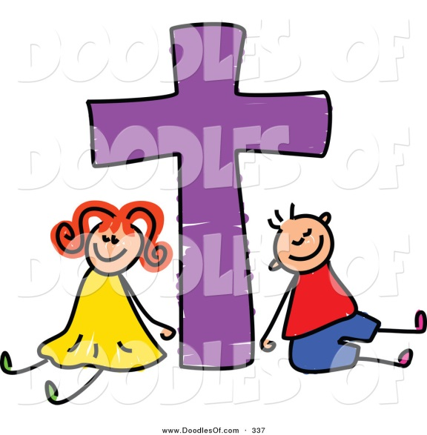

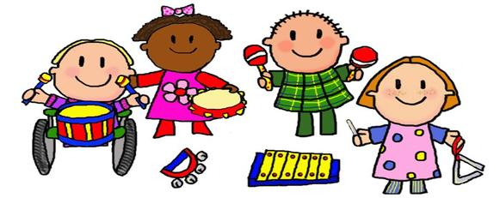

**Expressive Arts & Design**

We will be learning to mix colours and to paint pictures of ourselves. We will learn new songs and explore different types of dance.