What is the Phonics Screening Test?
- It is a statutory assessment for all Year 1 children.
- It is taken during the week beginning 12th June 2017.
- Class teachers will administer the check with one child at a time in a quiet room.
- There is no time limit.
- It is designed to confirm whether individual children have learnt phonic decoding to an appropriate standard.
- Any children who do not achieve the required standard will then be expected to retake the test at the end of Year 2.
- It is make up of real and pseudo words, for example

fuel, quigh, voisk, keb, snarl, moist

- The children can sound button the words, which helps them to read them
voisk

- There are 40 words, the required standard is not published until the children have all been tested, but previously it has been 32.
- Parents will be informed whether their child met the required standard.

Year One Phonics
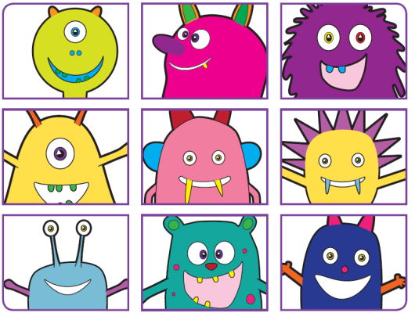

- Help your child to recognise each of the phonemes.
- Practise reading words with these by asking your child to add sound buttons to the words.
- There are many apps for mobile phones and tablet computers you can use to help your child practise their phonics skills.

What is Phonics?
- Phonics is the skill of decoding words when reading. It is one of many strategies used when teaching children to read.
- A phoneme is the sound that the letter/s make and a grapheme is how the sound is written.
- The alphabet contains only 26 letters. Spoken English uses about 42 sounds (phonemes). These phonemes are represented by letters (graphemes).
- A sound can be represented by a letter (e.g. ‘s’ or ‘h’) or a group of letters (e.g. ‘th’ or ‘ear’).
- To learn to read well children must be able to smoothly blend sounds together.
- Segmenting is a skill used in spelling. In order to spell the word ‘cat’, it is necessary to segment the word into its constituent sounds: c --- a—t.

- The same phoneme can be represented/spelled in more than one way. This is very common, particularly among the vowels for example:

rain, may, lake

- The same spelling may represent more than one phoneme:
mean, deaf

- During Year One each child has been taught many alternative graphemes for the same phonemes. This means they will be able to read a wider range of words and need to make a choice between the alternatives when spelling.

