The 7C’s Learning Portfolio
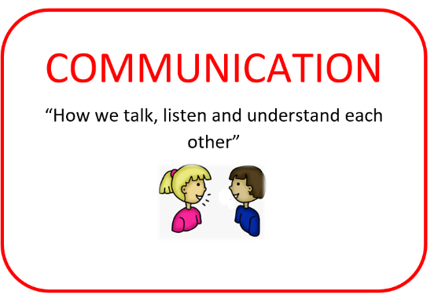
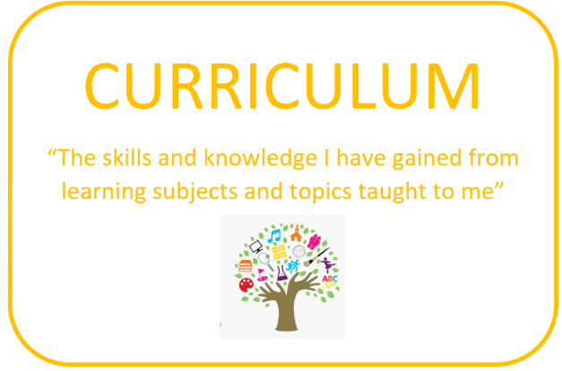


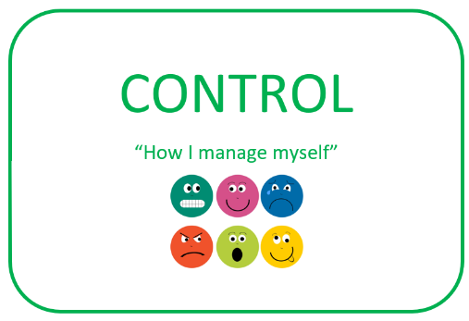
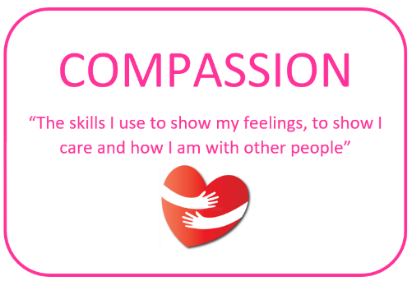
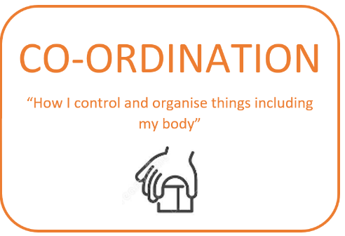
At St Andrew’s School, we are using the 7C’s Learning Portfolio by Judith Carter as a language of SEND assessment. This provides a language of assessment that we can all use. In each of the seven areas there are seven elements. We use these elements to identify a pupil’s strengths and barriers to learning, so we can put in place the right provision of adjustments, support and interventions.

