***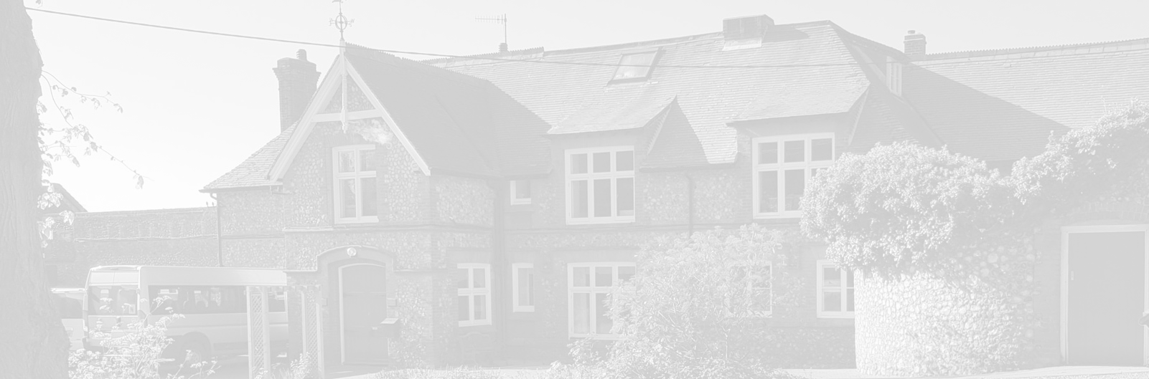*St** Andrew’s School

A school with Quaker values

Aylmerton Hall ⬩ Holt Road

Aylmerton ⬩ Norfolk ⬩ NR11 8QA

Telephone: 01263 837927

Email: [head@standrewsschool.co.uk](mailto:head@standrewsschool.co.uk)

Executive Head: Julie Jackson

Head of School: Jim Collin

**The St Andrew’s School Trust is a Registered Charity No. 1129232**

Accessibility

Plan

2023-2026

Last reviewed date: Summer Term 2024

Adopted by Trustees date: 15th July 2024

Next review date: Spring Term 2026

**Improving the Physical Environment**

|  |  |  |  |  |  |
| --- | --- | --- | --- | --- | --- |
|  | **Targets** | **Actions** | **Timescale** | **Responsibility** | **Outcome** |
| **Short Term** | Increase DDA compliance throughout the school and grounds | Carry out a thorough review of the building to ensure DDA Compliance | 1 – 3 Years  Site walk undertaken a list of work needed to make all areas wheelchair accessible has been devised and will be programmed into Site Manager’s work scheme | SMT/Site Manager/Resources Committee | To ensure that all areas of the school grounds are DDA compliant and fully accessible (except for the upstairs in the main school building, College mezzanine and Gym areas).  **Work complete** |
| **Short Term** | Ensure school site accessible for those with impaired vision | Carry out thorough review of site to ensure any potential trip hazards are clearly highlighted | 1 year- 3years | SMT/Site Manager | All potential trip hazard areas marked with luminescent paint and tape on both internal and external areas.  **Work complete** |
| **Medium Term** | Ensure that adaptions to improve accessibility at the school remain in good working order | Continue regular monitoring and maintenance as necessary to DDA ramps, adaptations etc. | 1 – 3 Years  Site walk undertaken a list of work needed to make all areas wheelchair accessible has been devised and will be programmed into the Site Manager’s work scheme | SMT/Site Manager/Resources Committee | Ensure that all current accessible areas remain so.  **Reviewed under regular maintenance checks** |
| **Long Term** | Ensure all areas of the school and grounds are DDA compliant | To investigate and price up for stair lifts, lifts, ramps etc. to make all areas accessible for people with limited mobility | 3 - 7 years  To locate suitable contractors to make all areas DDA compliant and obtain quotations for work | SMT/Site Manager/Resources Committee | Ensure all areas of the school grounds are fully accessible including gym area, and upstairs areas in main and stable block buildings |
| **Long Term** | To replace remaining mobile building | To ensure a percentage of any surplus funds are earmarked for new building project | 3- 7 years  To obtain quotations once sufficient funds are obtained | SMT/Site Manager/Resources Committee | Ensure new build is fully DDA compliant. |

**Improving Access to the School Curriculum**

|  |  |  |  |  |  |
| --- | --- | --- | --- | --- | --- |
|  | **Targets** | **Actions** | **Timescale** | **Responsibility** | **Outcome** |
| **Short Term** | Improve student outcomes in all areas of the curriculum | Staff to monitor and update student IEP’s on a half termly basis | Ongoing | Teaching Assistants/Teachers | Students will be making individual progress in all areas of the curriculum |
| **Short Term** | Ensure all staff are aware of and able to use curriculum interventions | Curriculum Leads to ensure that all staff can use intervention efficiently | Ongoing  Various intervention programs are in place for English and Maths and are monitored regularly | Curriculum Leads | Staff will be able to successfully deliver suitable interventions |
| **Short Term** | Identify students who may need extra help to be able to access the curriculum | Staff to be aware of and highlight any students that they feel may need extra screening e.g. for dyslexia | Ongoing  Students are now assessed on a regular basis, so any issues are picked up earlier | Teaching Assistants/Teachers | Students will be identified earlier if they need additional help to access the curriculum |
| **Short Term** | Identify students who are having issues accessing the curriculum due to behaviours etc. | SMT/SEN Administrator to arrange professional reports (Ed Psych., OT, ASD specialist) | Ongoing | SMT/Teachers/Teaching Assistants/SEN Administrator | A range of strategies from professional reports will mean that students can engage with the curriculum |
| **Long Term** | All staff to be trained in TEACCH | A programme will be devised to ensure that a minimum of 4 staff per year will receive TEACCH training | 1-5 Years  TEACCH training has now resumed following the pandemic. All Teachers who wished to access the training have done so and the training has now been rolled out to support staff. | SMT/Teachers/Teaching Assistants | All staff will be trained in TEACCH which will have a positive impact on the students |

**Improving the Delivery of Written Information to Students, Staff, Parents and Visitors with Disabilities**

|  |  |  |  |  |  |
| --- | --- | --- | --- | --- | --- |
|  | **Targets** | **Actions** | **Timescale** | **Responsibility** | **Outcome** |
| **Short Term** | Individualised timetables for all students | Staff to ensure that each student has a timetable that they can access be it in written or picture form | Ongoing | Teaching Assistant/Teachers | Students will be able to access their own timetables and develop independence |
| **Short Term** | Review information sent to parents/carers to ensure it is accessible | Administration Team to ascertain access needs of parents/carers when student is admitted into school | Ongoing  The school now subscribes to a parent text and email service following requests from parents. Investigating the possibility of allowing forms to be submitted remotely for permissions etc | Administration Team | All parents/carers will receive information in a format that is accessible to them e.g. large print, verbal etc. |
| **Short Term** | Review of website | SMT to investigate how information on the website can be more accessible to all e.g. use of google translate, audio clips etc. | 1 Year  New website now in place which is easier to navigate but more needs to be done to make it accessible to all. | SMT | All visitors to the website will be able to access the content |
| **Long Term** | Review school signage | Replace all written signs with signs which also include symbols | 1 – 3 Years  This work has been started in some areas. | SMT/Maintenance Team | All students, staff and visitors will be able to understand all signage |