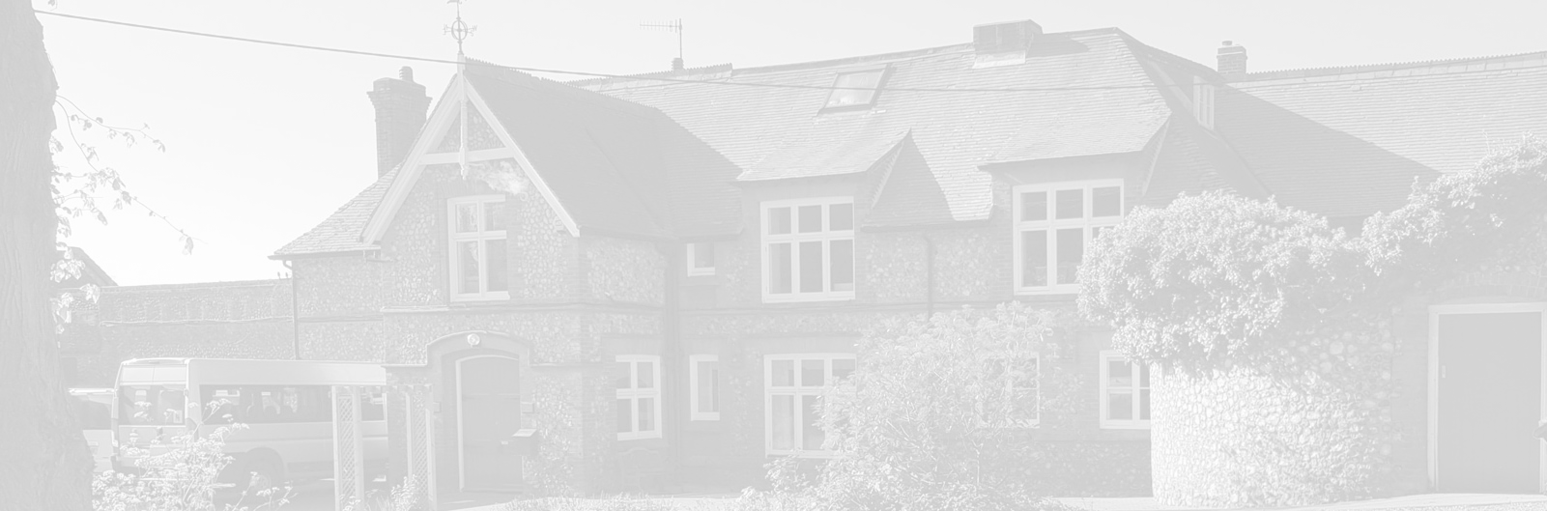
St Andrew’s School
A school with Quaker values

Aylmerton Hall Holt Road
Aylmerton Norfolk NR11 8QA
Telephone: 01263 837927
Email: head@standrewsschool.co.uk
Head: Carol Keable B.Sc. (Hons), NASCO, M.Ed, P.G.C.P.S.E, UCert Autism.
The St Andrew’s School Trust is a Registered Charity No. 1129232

Accessibility
Plan
2023-2026

Last reviewed date: 9th February 2023
Adopted by Trustees date:
Next review date: Spring Term 2024

Improving the Physical Environment

 | Targets | Actions | Timescale | Responsibility | Outcome
Short Term | Increase DDA compliance throughout the school and grounds | Carry out a thorough review of the building to ensure DDA Compliance | 1 – 3 Years  Site walk undertaken a list of work needed to make all areas wheelchair accessible has been devised and will be programmed into Site Manager’s work scheme | SMT/Site Manager/Resources Committee | To ensure that all areas of the school grounds are DDA compliant and fully accessible (except for the upstairs in the main school building, College mezzanine and Gym areas).
Medium Term | Ensure that adaptions to improve accessibility at the school remain in good working order | Continue regular monitoring and maintenance as necessary to DDA ramps, adaptions etc. | 1 – 3 Years  Site walk undertaken a list of work needed to make all areas wheelchair accessible has been devised and will be programmed into the Site Manager’s work scheme | SMT/Site Manager/Resources Committee | Ensure that all current accessible areas remain so.
Long Term | Ensure all areas of the school and grounds are DDA compliant | To investigate and price up for stair lifts, lifts, ramps etc. to make all areas accessible for people with limited mobility | 3 - 7 years  To locate suitable contractors to make all areas DDA compliant and obtain quotations for work | SMT/Site Manager/Resources Committee | Ensure all areas of the school grounds are fully accessible including gym area, and upstairs areas in main and stable block buildings
Long Term | To replace remaining mobile building | To ensure a percentage of any surplus funds are earmarked for new building project | 3- 7 years  To obtain quotations once sufficient funds are obtained | SMT/Site Manager/Resources Committee | Ensure new build is fully DDA compliant.

Improving Access to the School Curriculum

 | Targets | Actions | Timescale | Responsibility | Outcome
Short Term | Improve student outcomes in all areas of the curriculum | Staff to monitor and update student IEP’s on a half termly basis | Ongoing | Teaching Assistants/Teachers | Students will be making individual progress in all areas of the curriculum
Short Term | Ensure all staff are aware of and able to use curriculum interventions | Curriculum Leads to ensure that all staff are able to use intervention efficiently | Ongoing  Various intervention programs are in place for English and Maths and are monitored regularly | Curriculum Leads | Staff will be able to successfully deliver suitable interventions
Short Term | Identify students who may need extra help to be able to access the curriculum | Staff to be aware of and highlight any students that they feel may need extra screening e.g. for dyslexia | Ongoing  Students are now assessed on a regular basis so any issues are picked up earlier | Teaching Assistants/Teachers | Students will be identified earlier if they need additional help to access the curriculum
Long Term | All staff to be trained in TEACCH | A programme will be devised to ensure that a minimum of 4 staff per year will receive TEACCH training | 1-5 Years  TEACCH training has now resumed following the pandemic. Two more Teachers were trained in Jan 23 with the hope of booking a further two onto June 2023 training. | SMT/Teachers/Teaching Assistants | All staff will be trained in TEACCH which will have a positive impact on the students

Improving the Delivery of Written Information to Students, Staff, Parents and Visitors with Disabilities

 | Targets | Actions | Timescale | Responsibility | Outcome
Short Term | Individualised timetables for all students | Staff to ensure that each student has a timetable that they can access be it in written or picture form | Ongoing | Teaching Assistant/Teachers | Students will be able to access their own timetables and develop independence
Short Term | Review information sent to parents/carers to ensure it is accessible | Administration Team to ascertain access needs of parents/carers when student is admitted into school | Ongoing  The school now subscribes to a parent text and email service following requests from parents. Investigating the possibility of allowing forms to be submitted remotely for permissions etc | Administration Team | All parents/carers will receive information in a format that is accessible to them e.g. large print, verbal etc.
Medium Term | Review of website | SMT to look in to how information on the website can be more accessible to all e.g. use of google translate, audio clips etc. | 2 Years  New website now in place which is easier to navigate but more needs to be done to make it accessible to all. | SMT | All visitors to the website will be able to access the content
Long Term | Review school signage | Replace all written signs with signs which also include symbols | 1 – 3 Years  This work has been started in some areas. | SMT/Maintenance Team | All students, staff and visitors will be able to understand all signage

