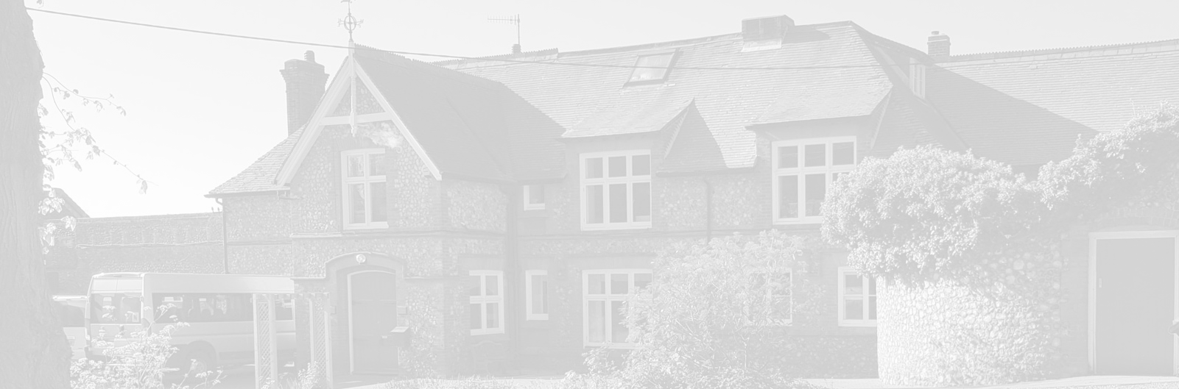
St Andrew’s School
A school with Quaker values

Aylmerton Hall Holt Road
Aylmerton Norfolk NR11 8QA
Telephone: 01263 837927
Email: head@standrewsschool.co.uk
Head: Carol Keable B.Sc. (Hons), NASCO, M.Ed, P.G.C.P.S.E, UCert Autism.
The St Andrew’s School Trust is a Registered Charity No. 1129232

Accessibility
Policy

Last reviewed date: 9th February 2023
Adopted by Trustees date:
Next review date: Spring Term 2024

Aims of the Policy

1. To fulfil the school’s obligations under the Disability Discrimination Act 1995 and the Special Educational Needs and Disability Act 2001(SENDA)

2. To ensure that no student or adult in the school suffers discrimination because of a disability

3. To improve, where possible, access to the school curriculum and school premises for any person suffering from a disability

Introduction

The Accessibility Policy and Plan are drawn up in compliance with current legislation and requirements as specified in Schedule 10 relating to Disability under the Equality Act 2010. Trustees are responsible for ensuring the implementation, review and reporting on progress of the Accessibility Plan over a prescribed period.

A disabled person is:
"someone who has a physical or mental impairment which has a substantial and long-term adverse effect on their ability to carry out normal day-to-day activities" Equality Act 2010.

An impairment has a long-term effect if it has lasted or is expected to last for at least 12 months or for the rest of the life of the person concerned.

The definition covers:
- people with physical, sensory, or mental impairments, including learning disabilities;
- people with progressive conditions (such as cancer, multiple sclerosis, muscular dystrophy, and HIV infection) from the moment the condition leads to an impairment which effects the ability to carry out normal day-to-day activities, even if it is not a substantial effect, if the effect is likely to become substantial eventually
- people with severe disfigurements

St Andrew’s School is a special school for children with communication difficulties and as such most students have been, or are likely to be, deemed disabled under this definition. The school aims to include all students in all school activities as far as it is possible for individuals to manage this in a safe manner, through the implementation of all its policies.

St Andrew’s School is actively committed to providing an accessible environment which values and includes all students, staff, parents and visitors regardless of their education, physical, sensory, social, spiritual, emotional and cultural needs. We are committed to challenging negative attitudes about disability and accessibility and to developing a culture of awareness, tolerance and inclusion.

This policy covers the three main strands of the Accessibility Plan:

- improving access to the physical environment
- improving access to the school curriculum
- improving the delivery of written information to students, staff, parents and visitors with disabilities

Improving Access to the Physical Environment

There is a duty to improve access to the physical environment of the school, adding specialist facilities as necessary. This covers reasonable adjustments to the physical environment of the school and physical aids to access education.

Improving Access to the School Curriculum

There is a duty to increase access to the curriculum for students with a disability, expanding and making reasonable adjustments to the curriculum as necessary to ensure that students with a disability are as equally prepared for life as are the able-bodied students; (if a school fails to do this they are in breach of the DDA). This covers teaching and learning and the wider curriculum of the school such as participation in lunch time clubs, leisure and cultural activities or school visits. It also covers the provision of specialist aids and equipment, which, may assist these students in accessing the curriculum.

Improving the Delivery of Written Information to Students, Staff, Parents and Visitors with Disabilities

There is a duty to provide information, which is usually provided in writing or by spoken language, in an alternative form for those who have difficulty accessing the written or spoken word.

Monitoring/Making it Happen

An Accessibility Plan will be drawn up to cover a three year period. This will be reviewed annually by the Senior Management Team and the Board of Trustees.

The Plan will be monitored through the Resources Committee and will be discussed at each meeting.

It may not be feasible to undertake some of the actions on the Plan which relate to Physical Accessibility improvements during the life span of the current Accessibility Plan due to time/monetary constraints and therefore some items may roll forward into subsequent plans.

