
St Andrew’s School
A school with Quaker values

Aylmerton Hall Holt Road
Aylmerton Norfolk NR11 8QA
Telephone: 01263 837927
Email: office@standrewsschool.co.uk
Headteacher: Adrian Crossland
The St Andrew’s School Trust is a Registered Charity No. 1129232

Administering
Medicines
Policy

Summary of changes

Page Ref | Section | Amendment | Date of change

Date adopted by Trustees: 28th September 2026

Next review date: Summer Term 2029

Aims and Objectives
At St Andrew’s School, our administration of medicine requirements are achieved by establishing principles for the safe practice in the management and administration of:
- Prescribed medicines (including controlled drugs)
- Non-prescribed medicines
- Maintenance drugs
- Emergency medicine.
From time to time, students get ill and may need time off, a visit to the doctor and a prescription to help them recover. Generally, they begin to feel better before the prescription has finished and are well enough to continue with their education. There are also students who may be on long term medication due to conditions e.g.: asthma, eczema, diabetes, allergies etc. At St Andrew’s School we recognise the need to enable students to take prescribed and over the counter medication during the school day.
The aims of this policy are to:
- Provide clear guidance on the roles and responsibilities of all parties
- Provide clear guidance to all staff on the administration of medicines
- Ensure there are sufficient numbers of appropriately trained members of staff to manage and administer medicines
- Ensure that students are supported appropriately with their medications
- Ensure that arrangements are in place to support students with medical conditions to regularly attend school
- Fully support the health and wellbeing of all students

Roles and Responsibilities
No student will be given medicines without their parent’s written consent. (see Appendix A)
When a member of staff administers medicine, they will check the student’s Administration of Medication Permission and Record Form (Appendix B) against the medication, to ensure that the dose and timings are correct. They will then administer the medicine as required, and record this on the form.
If in doubt about any procedure, staff should not administer the medicine but check with the parents or a health professional before taking further action. However, in the event of an emergency, and particularly for those pupils who have a care plan, the procedure outlined in the care plan will be followed.

Each time a medicine is given to a student, the member of staff administering the medicine must record it. Each student has an individual administration of medication record that is stored in the black box in the office, directly under the medicine cabinet.
All medicines, apart from asthma inhalers and other medicines which have been identified as being necessary for the pupil to have with them at all times, will be handed in to the school office and signed in by a member of SLT or a designated member of staff. Unless medication needs to be stored in the refrigerator, medication will be locked away in the medicine cupboard in the main office. Medicines which need to be refrigerated will be kept in the refrigerator with restricted access. All medicines will be stored in their original containers and clearly labelled. The exception to this is insulin which must still be in date but will generally be available to school inside an insulin pen or a pump, rather than in its original container.
The parent of the student taking the medicine will be asked to complete a parental consent form in order for the medicine to be taken at the school, (see Appendix A). Parents should tell the school about the medicines that their children need to take and provide details of any changes to the prescription, or the support required. Changes should always be made in writing.

Managing Prescription Medicines
Medicines should only be brought into the school when it is essential and when it would be detrimental to a child’s health if the medicine was not administered during the school day. Many students will need to be able to take medicines at some time during the day. This will usually be for a short period only, e.g. to finish a course of antibiotics or to apply a lotion and will minimise the time that they need to be absent.
We will not accept medicines which have been taken out of the container as originally dispensed nor make changes to dosages on parental instructions. This includes cutting tablets in half.

It is helpful, where clinically appropriate, if medicines can be prescribed in dose frequencies which enable them to be taken outside school hours. Parents will be encouraged to ask the prescriber about this. Medicines that need to be taken three times a day could be taken in the morning, after school and at bedtime.
All emergency medicines, such as asthma inhalers and adrenaline pens, should be readily available to students and should not be locked away.

Managing Prescription Medicines on Trips and Outings
Since we would always wish our students with medical needs to participate in visits whenever possible, we need to consider for each visit what reasonable adjustments will have to be made to enable the students with medical needs to take part in safely managed visits. The risk assessment form which is completed prior to the visit (where relevant) will need to include the necessary steps to include students with medical needs, together with any particular risk assessments for those students. It may be necessary for additional safety measures to be taken for outside visits. Arrangements for taking any necessary medicines will also need to be taken into consideration. In the event of a medicine needing to be kept in a fridge and if the student learning off-site, an individual risk assessment will be completed.
Staff supervising excursions should always be aware of any medical needs and the relevant emergency procedures if appropriate.
A copy of any health care plan should be taken on visits in the event of the information being needed in an emergency. It will be the responsibility of the parents to ensure that any medication students take with them on trips and outings is available and in date.
Travel Sickness
Tablets can be given with written consent from a parent but the student’s name, dosage, time of dose and any possible side effects (the student must have had the travel sickness preventative at home before the trip in case of side effects) should be clearly marked on the container, which must be the original packaging. Parents will need to complete an Administration of Medication Permission and Record Form (Appendix A and B).

Sporting Activities
At the school, most students with medical conditions can, and indeed are positively encouraged to, participate in physical activities and extra-curricular sport. However, any restrictions on a student’s ability to participate in P.E. should be recorded in their individual health care plan.
Some students may need to take precautionary measures before or during exercise and may also need to be allowed immediate access to their medicines such as asthma inhalers. Health care plans are completed and updated regularly for students who have conditions such as asthma, epilepsy, diabetes or anaphylaxis.

Emergency Inhalers
In line with “Guidance on the use of emergency salbutamol inhalers in schools” March 2015, the school will keep emergency reliever (blue) inhalers for the emergency use of students whose own inhaler is not available for any reason. They will be stored in the main office, along with appropriate spacers. Parents must sign a “Consent form: use of emergency salbutamol inhaler” or tick the relevant permissions on the school asthma form (Appendix B) to consent to their child being allowed to use the emergency inhaler. These will be kept in the Asthma File in the main office. (see Asthma Policy for further information).

EpiPens
Parents are required to provide the school with up-to-date information relating to their child’s allergies, as well as the necessary action to be taken in the event of an allergic reaction, such as any medication required.
Where a student has been prescribed an Adrenaline Auto-Injector (AAI), this will be written into their individual healthcare plan. A Register of Adrenaline Auto-Injectors will be kept of all the students who have been prescribed an AAI to use in the event of anaphylaxis. A copy of this will be held in each classroom for easy access in the event of an allergic reaction and will be checked as part of initiating the emergency response.
Students who have prescribed AAI devices should keep their device in their possession and they should not be locked away.
In line with the statutory guidance ‘Allergy safety in schools’ all members of staff will be trained on how to administer an AAI, and the sequence of events to follow when doing so. The nearest staff member will administer the AAI.
The school will keep a pair of spare AAI for use in the event of an emergency which will be checked to ensure that it remains in date and will be replaced before the expiry date. The spare AAI will be stored in the main office ensuring that it is protected from direct sunlight and extreme temperatures. The spare AAI will only be administered to students at risk of anaphylaxis and where written parental consent has been obtained. Where a student is having a severe allergic reaction, the emergency services will be contacted and advice sought as to whether administration of the spare AAI is appropriate.
Where a student is, or appears to be, having a severe allergic reaction, the emergency services will be contacted even if an AAI device has already been administered (see Allergy Policy for further information).

Self-Management of Medicines
The school encourages young people to take responsibility for managing their own medicines. The age at which young people are ready to take care of, and be responsible for, their own medicines, varies.
Following discussion with parents, students who are competent to manage their own health needs and medication will be encouraged to take responsibility for self-managing their medicines and procedures. Agreed practice in relation to self-management of medicines will be included in the student’s individual healthcare plan (see appendix D).

Where possible, students will be allowed to carry their own medicines and relevant devices. Where it is not possible, medicines and devices will be held in suitable locations that can be accessed quickly and easily. If a student refuses to take their medication, they will not be forced to do so. Instead, the procedure in the individual healthcare plan will be followed. Following such an event, parents will be informed so that alternative options can be considered.

The students may carry, and administer (where appropriate), their own medicines, providing the person with parental responsibility has given consent on the Administering Medicine Form (Appendix A).

Older students with a long-term illness should, whenever possible, assume complete responsibility, under the supervision of their parent. Under these circumstances, it will be important for the parent to liaise with the school to provide information regarding any changes in the medical condition or the medication itself.

Self-Management of Controlled Drugs
Where students have been prescribed controlled drugs, staff must be aware that these should be kept in safe custody. Controlled drugs have a “street value” and they must be accounted for, particularly in relation to transporting them in and out of the setting. Controlled drugs must be transported to and from school by the person with parental responsibility and must be stored by the school (see Storage of Medication). Young people can self-medicate if the person with parental responsibility has agreed in writing that it is appropriate (see Controlled Drugs).

Refusing Medicines
If a student refuses to take medicine, staff must not force them to do so but should note this in the records and inform the parents of the refusal as soon as practicable and the refusal should be recorded on the Medication Administration Record (Appendix E). If a refusal to take medicines results in an emergency, the school or setting’s emergency procedures should be followed.

Failure to take medication at specified time
If a parent has given consent for the student to be responsible for self-administering their medication when required, the responsibility for taking medication at the time of day specified on the parental consent form rests with the student unless specified otherwise in a health care plan.

Parental Responsibilities in Respect of Their Child’s Medical Needs
Parents should tell the school about the medicines that their child needs to take and provide details in writing of any changes to the prescription, or the support required (see Appendix A for proforma). However, staff will also make sure that this information is the same as that provided by the prescriber and are consistent with the instructions on the container. Parents will also need to provide the school with any information relating to predisposed conditions which the school needs to be made aware of.

Medicines must always be provided in the original container as dispensed by a pharmacist and include the prescriber’s instructions. In all cases it is necessary to check that written details include:
- child’s name
- name of the medicine
- dose
- method of administration
- time/frequency of administration
- any possible side effects
- expiry date

Non-Prescriptive Medicines (Over the Counter medication)
In general, non-prescription medicines should not normally be administered. However, examples may include analgesics (Paracetamol/Calpol) for pain relief if parental permission prior to administration is sought. Parents will need to complete a consent form for the administration of non-prescribed medication and provide some to be kept in school (see Appendix C). If a student needs pain relief during the school day, a member of staff will call and speak directly to the student’s parent before administering even if consent has been given. They will only be able to administer if they have had contact with a parent and the contact and time will be recorded on the administration record.
Staff will only administer one dose of non-prescription medication during the school day whilst the student is on school premises. If the student continues to be in pain or discomfort, then the parent must be informed and taken home/to the family GP.

MEDICINES CONTAINING ASPRIN SHOULD NEVER BE GIVEN UNLESS PRESCRIBED BY A DOCTOR. THEREFORE, WE WILL NOT BE ABLE TO ADMINISTER THESE MEDICINES WITHOUT A DOCTOR’S PRESCRIPTION.
Controlled Drugs
The supply, possession and administration of some medicines are controlled by the Misuse of Drugs Act and its associated regulations. A Pharmacist will give advice as to whether a medication is a controlled drug or not. To keep up to date with the medications classified as a controlled drug, information can be viewed on the Home Office website http://www.homeoffice.gov.uk/documents/cdlist.html
Controlled drugs are prescription medicines that are controlled under the Misuse of Drugs Regulations 2001 and subsequent amendments, such as morphine or methadone.

Controlled Drugs Register
A separate record of controlled drugs should be maintained to include the receipt, administration and possible disposal of controlled drugs. These records must be kept in a bound book or register with numbered pages. The book will include the balance remaining for each product with a separate record page being maintained for each student. The balance of controlled drugs will be checked at each administration and also each half-term. The book should be locked away when not in use.
Administration of Controlled Drugs
Any authorised member of staff may administer a controlled drug to the child for whom it has been prescribed and they should do so in accordance with the prescriber’s instructions in the presence of another member of staff as a witness.
The administration of controlled drugs is recorded using individual administering medication records. These are photocopied on coloured sheets to make them identifiable.
Staff MUST NOT sign the record of administration unless they have been involved in the administration of the medication.
The recommended procedure for the administration of controlled drugs is as follows:
- Check the student’s Parental Consent Form for details of dosage required etc.
- Verify the quantity of medication as stated on the controlled drug register to ensure that the dose has not already been given.
- Ensure two members of staff are present; one member of staff must witness the other administer the medication to the young person.
- Both staff must sign the Medication Administration Record sheet and controlled drug register to confirm that the dose was given and the amount remaining. If medication is refused or only partly taken, both staff must witness the disposal of the remaining medication and record the details and sign to that effect. If a dose of medication is refused or only partly taken. then the parents/carer should be contacted for advice on any adverse reactions and risk to the young person.

Return or Discontinued Controlled Drugs
A controlled drug, as with all medicines, should be returned to the parent/carer when no longer required to arrange for safe disposal (by returning the unwanted supply to the local pharmacy).

Long Term Medical Needs
It is important to have sufficient information about the medical condition of any student with long-term medical needs. An individual healthcare plan for these children, involving the parents and the relevant health professionals, will enable the appropriate support to be provided.
The healthcare plan will include:
- details of the student’s condition
- any special requirements e.g. dietary needs, pre-activity precautions
- any side-effects of any prescribed medication
- what constitutes an emergency
- what action to take in an emergency
- what not to do in the event of an emergency
- who to contact in the event of an emergency
- the role staff can play.

For further information, see Medical Needs Policy.

Staff Training
Staff regularly have training in a variety of health issues, including the use of EpiPens, the treatment of general injuries, diabetes awareness etc. First Aid training is also available to staff.
Staff are also aware of the procedure for cleaning a wound, the type of dressing to apply and understand the need to contact parents in an emergency.
Where a student has a specific long-term medical condition, identified staff will receive specific training, where relevant.

First Aid
These are checked and updated regularly and are in clearly marked positions around the school.

Monitoring & Review
The implementation and impact of this policy will be monitored, and the policy reviewed every three years.

Links to Other Policies and Guidance
- Attendance Policy
- Safeguarding Policy
- Health and Safety Policy
- Medical Needs Policy
- DfE Guidance on Use of Emergency Inhalers
- Asthma Policy
- Allergy Policy

Appendix A – Parental Agreement for Setting to Administer Medicines (including controlled drugs)
St Andrew’s School Parental Agreement to Administer Medicine
At St Andrew’s we will not give your child medication unless you complete and sign this form.
Student Information
Name of Student
Date of Birth
Class/ Year Group
Medical condition or illness

Medicine
Name/ type of medicine
(as described on the container)
Expiry date
Dosage and method
Timing
Special precautions/ other instructions
Are there any side effects the school needs to know about?
Self-administration – Yes or No
Does the student need to carry their own medication?
Procedures to take in an emergency
GP name and telephone number
NB: Medicines must be in the original container as dispensed by the pharmacy
Contact Details
Name
Daytime telephone number
Relationship to student
Address

The above information is, to the best of my knowledge, accurate at the time of writing and I give consent for school staff to administer medicine in accordance with the school policy. I will inform the school immediately, in writing, if there is any change in dosage or frequency of the medication or if the medicine is stopped.
Signature
Date
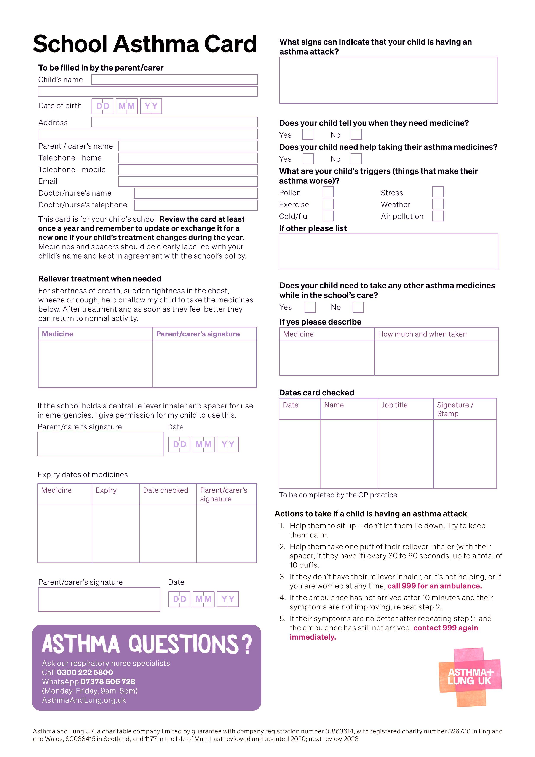
Appendix B – School Asthma Card to be completed by Parents and GP
Appendix B – Permission for use of Emergency Inhaler (if student does not have a completed School Asthma Card)

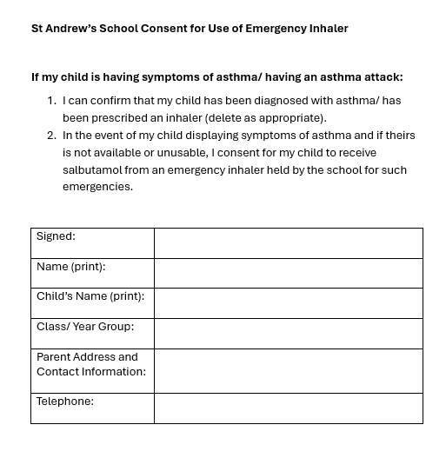
Appendix C – Parental agreement for setting to administer Paracetamol/ Ibruprofen as required by students
St Andrew’s School parental agreement to administer non-prescribed medicines such as paracetamol/ ibruprofen when required by students
At St Andrew’s we will not give your child medication unless you complete and sign this form.
Student Information
Name of Student
Date of Birth
Class/ Year Group
Possible reasons for needing medication

Medicine
Name/ type of medicine
(as described on the container)
Dosage and method
Self-administration – Yes or No?
Any other information…

Contact Details
Name
Daytime telephone number
Relationship to student
The above information is, to the best of my knowledge, accurate at the time of writing and I give consent for school staff to administer non-prescription medicine in accordance with the school policy and when required by my child. I will inform the school immediately, in writing, if there is any change in dosage or my child is no longer able to take the medication.
Signature
Date

Administration of Non-Prescribed Medicines Record
Name: | D.O.B: | Class:

Name of Medication: | Dosage:

Date medication received: | Total signed in: | Staff Signature:
Date medication returned: | Number returned: | Staff Signature:

Date | Time | Number administered | Administered by (Name) | Total Stock Left | Staff Signature | Staff Signature | Parent informed  By who? How?

Appendix D – Individual Healthcare Plan
St Andrew’s School Individual Healthcare Plan
Student Information
Name of Student
Date of Birth
Class/ Year Group
Student Address
Medical diagnosis or condition

Family Contact Information
Name
Relationship to student
Phone number (work)
Phone number (home)
Phone number (mobile)
Name
Relationship to student
Phone number (work)
Phone number (home)
Phone number (mobile)

Clinic/ Hospital Contact
Name

Phone number

GP
Name

Phone number

Member of staff responsible for providing support in school

Describe medical needs and give any additional details relevant to the condition

Name of medication, dose, method of administration, when to be taken, side effects etc.

Administered by/ self-administered with/without supervision

Daily care requirements

Specific support for the student’s educational, social and emotional needs

Arrangements for school visits/ trips etc.

Other information

Describe what constitutes an emergency, and the action to take if this occurs

Staff members responsible in an emergency (state if different for off-site activities)

Plan developed with

Staff training needed/ undertaken – who? What? When?

Form copied to

Additional documents

In the event of an emergency during school hours, I give permission for this form to be given to NHS emergency care staff.
Parent/ Carer signature
Date

Individual Healthcare Plan Agreed by
Parent/ Carer signature
Date
Headteacher/ SLT signature
Date

Administration of Prescribed Medicines
Name: | D.O.B: | Class:

Name of Medication: | Dosage:
Reason Prescribed: | Route Administered:

Date medication received: | Total signed in: | Staff signature:
Date medication returned to parent: | Number returned: | Staff signature:

Date | Time | Number Administered | Administered by (Name) | Total Stock | Staff Signature | Staff Signature

