

St Andrew’s School
A school with Quaker values
Aylmerton Hall Holt Road
Aylmerton Norfolk NR11 8QA
Telephone: 01263 837927
Email: office@standrewsschool.co.uk

Headteacher: Adrian Crossland
The St Andrew’s School Trust is a Registered Charity No. 1129232

Allergy
Policy

Summary of changes

Page Ref | Section | Amendment | Date of change

Adopted by Trustees date: 28th September 2026

Next review date: Autumn 2027

Contents

- Introduction
- Roles and responsibilities
- Allergy action plans
- Emergency treatment and management of anaphylaxis
- Supply, storage and care of medication
- ‘Spare’ adrenaline auto-injectors in school
- Staff training
- Inclusion and safeguarding
- Catering
- School trips
- Allergy awareness and nut bans
- Risk assessment
- Useful links

This policy sets out how St Andrew’s School will support students with allergies, to ensure they are safe and are not disadvantaged in any way whilst taking part in school life.

Section 34 of the Children’s Wellbeing and Schools Act 2026 requires that LA-maintained schools, academies and PRUs must have an allergy safety policy.

1. Introduction

An allergy is a reaction of the body’s immune system to substances that are usually harmless. The reaction can cause minor symptoms such as itching, sneezing or rashes but sometimes causes a much more serious reaction called anaphylaxis.

Anaphylaxis is a serious, life-threatening allergic reaction. It is at the extreme end of the allergic spectrum. The whole body is affected often within minutes of exposure to the allergen, but sometimes it can be hours later. Causes can include foods, insect stings, and drugs.

Most healthcare professionals consider an allergic reaction to be anaphylaxis when it involves difficulty breathing or affects the heart rhythm or blood pressure. Anaphylaxis symptoms are often referred to as the ABC symptoms (Airway, Breathing, Circulation).

It is possible to be allergic to anything which contains a protein, however most people will react to a fairly small group of potent allergens.

Common UK Allergens include (but are not limited to):-
Peanuts, Tree Nuts, Sesame, Milk, Egg, Fish, Latex, Insect venom, Pollen and Animal Dander.

2. Role and responsibilities

Trustee Responsibilities
The trustees have delegated the responsibilities of implementing this policy to the Headteacher.

Senior Leader Responsibilities
- A named member of the senior leadership team in each school should have responsibility for allergy safety, including driving the implementation of the allergy safety policy and contributing to or leading review of the policy.

Parent Responsibilities
- On entry to the school, it is the parent’s responsibility to inform the office of any allergies. This information should include all previous serious allergic reactions, history of anaphylaxis and details of all prescribed medication.
- Parents are to supply a copy of their child’s Allergy Action Plan (BSACI plans preferred) to school. If they do not currently have an Allergy Action Plan this should be developed as soon as possible in collaboration with a healthcare professional e.g. School nurse/GP/allergy specialist (see appendix A).
- Parents are responsible for ensuring any required medication is supplied, in date and replaced as necessary.
- Parents are requested to keep the school up to date with any changes in allergy management. The child’s Allergy Action Plan will be kept updated accordingly.

Staff Responsibilities
- All staff will complete anaphylaxis training. Training is provided for all staff on a yearly basis and as required for any new members of staff joining the school.
- Staff must be aware of the students in their care (regular or cover classes) who have known allergies as an allergic reaction could occur at any time and not just at mealtimes. Any food-related activities must be supervised with due caution.
- Staff leading school trips will ensure they carry all relevant emergency supplies. Trip leaders will check that all students with medical conditions, including allergies, carry their medication. Students unable to produce their required medication will not be able to attend the excursion.
- The office administrator will ensure that the up-to-date Allergy Action Plan is kept with the student’s medication.
- It is the parent’s responsibility to ensure all medication in in date however the office administrator will check medication kept at school on a termly basis and send a reminder to parents if medication is approaching expiry.
- The office administrator keeps a register of students who have been prescribed an adrenaline auto-injector (AAI) and a record of use of any AAI(s) and emergency treatment given.

Student Responsibilities
- Students are encouraged to have a good awareness of their symptoms and to let an adult know as soon as they suspect they are having an allergic reaction.
- Students who are trained and confident to administer their own AAIs will be encouraged to take responsibility for carrying them on their person at all times.

3. Identification
Following completion of the medical forms and school being made aware of a student allergy, parents will be contacted so arrangements can be put in place for individual students including the completion of an Individual Healthcare Plan.

All staff will be made aware of students who have an allergy, their known allergens and whether they carry medication (for example adrenaline autoinjector (AAI) devices). A record of students who have an allergy plan will also be kept in medical files in the office.

Individual Healthcare Plans
Children and young people should have an Individual Healthcare Plan (IHP) if:
• they have an allergy which has a functional impact on them in their school, college or setting;
• they are at risk of harm as a result of their allergy and
• they require arrangements which are additional to or different from those made generally.

The IHP will set out the additional and/or different arrangements that will be in place in the school, college or early years setting for supporting the child or young person with their medical condition or allergy, including in emergency situations.

Set out how children and young people with allergy who require specific support arrangements will have them documented through an Individual Healthcare Plan. This includes children and young people whose allergies require flexibility and “reasonable adjustments”, as well as those who require medication (either proactively or in an emergency situation).

Where children and young people have an Allergy Action Plan and/or Asthma Action Plan issued by a healthcare professional, the IHP should refer to or attach it. Whenever an updated Action Plan becomes available, the child or young person’s Individual Healthcare Plan should be reviewed to incorporate it.

4. Allergy Action Plans

Allergy action plans are designed to function as individual healthcare plans for children with food allergies, providing medical and parental consent for schools to administer medicines in the event of an allergic reaction, including consent to administer a spare adrenaline autoinjector.
St Andrew’s School recommends using the British Society of Allergy and Clinical Immunology (BSACI) Allergy Action Plans to ensure continuity. This is a national plan that has been agreed by the BSACI, Anaphylaxis UK and Allergy UK.

It is the parent/carer’s responsibility to complete the allergy action plan with help from a healthcare professional (e.g. GP/School Nurse/Allergy Specialist) and provide this to the school.

5. Prescribed adrenaline
Children and young people who are prescribed adrenaline devices have rapid access to their devices at all times, noting that in a case of anaphylaxis, adrenaline should be administered within five minutes. This includes in the lunch area, playground and sports fields or when on visits or trips.
A spreadsheet is in place with the dates of adrenaline devices and this is checked by the office team. Individual arrangements for children, young people and parents to take individually prescribed adrenaline devices home (for example at the end of the day for the journey home) are in place and this is included on individual healthcare plans.

6. Emergency Treatment and Management of Anaphylaxis

What to look for:
Symptoms usually come on quickly, within minutes of exposure to the allergen.

Mild to moderate allergic reaction symptoms may include:
- a red raised rash (known as hives or urticaria) anywhere on the body
- a tingling or itchy feeling in the mouth
- swelling of lips, face or eyes
- stomach pain or vomiting.

More serious symptoms are often referred to as the ABC symptoms and can include:
- AIRWAY - swelling in the throat, tongue or upper airways (tightening of the throat, hoarse voice, difficulty swallowing).
- BREATHING - sudden onset wheezing, breathing difficulty, noisy breathing.
- CIRCULATION - dizziness, feeling faint, sudden sleepiness, tiredness, confusion, pale clammy skin, loss of consciousness.

The term for this more serious reaction is anaphylaxis. In extreme cases there could be a dramatic fall in blood pressure. The person may become weak and floppy and may have a sense of something terrible happening. This may lead to collapse and unconsciousness and, on rare occasions, can be fatal.

If the student has been exposed to something they are known to be allergic to, then it is more likely to be an anaphylactic reaction.

Anaphylaxis can develop very rapidly, so a treatment is needed that works rapidly. Adrenaline is the mainstay of treatment, and it starts to work within seconds.

What does adrenaline do?
- It opens up the airways
- It stops swelling
- It raises the blood pressure

As soon as anaphylaxis is suspected, adrenaline must be administered without delay.
Action:

- Keep the child where they are, call for help and do not leave them unattended.
- LIE CHILD FLAT WITH LEGS RAISED – they can be propped up if struggling to breathe but this should be for as short a time as possible.
- USE ADRENALINE AUTO-INJECTOR WITHOUT DELAY and note the time given. AAIs should be given into the muscle in the outer thigh. Specific instructions vary by brand – always follow the instructions on the device.
- CALL 999 and state ANAPHYLAXIS (ana-fil-axis).
- If no improvement after 5 minutes, administer second AAI.
- If no signs of life commence CPR.
- Call parent/carer as soon as possible.

Whilst you are waiting for the ambulance, keep the child where they are. Do not stand them up, or sit them in a chair, even if they are feeling better. This could lower their blood pressure drastically, causing their heart to stop.

All students must go to hospital for observation after anaphylaxis even if they appear to have recovered as a reaction can reoccur after treatment.

7. Supply, storage and care of medication

Depending on their level of understanding and competence, students will be encouraged to take responsibility for and to carry their own two AAIs on them at all times (in a suitable bag/container).

For younger children or those not ready to take responsibility for their own medication, there should be an anaphylaxis kit which is kept safely, not locked away and accessible to all staff.

Medication should be stored in a suitable container and clearly labelled with the student’s name. The student’s medication storage container should contain:
- Two AAIs i.e. EpiPen® or Jext® or Emerade®
- An up-to-date allergy action plan
- Antihistamine as tablets or syrup (if included on allergy action plan)
- Spoon if required
- Asthma inhaler (if included on allergy action plan)

It is the responsibility of the child’s parents to ensure that the anaphylaxis kit is up-to-date and clearly labelled, however the office administrator will check medication kept at school on a termly basis and send a reminder to parents if medication is approaching expiry.

School will try inform parents when the AAIs their child is prescribed is due to expire, to make sure they can get replacement devices in good time.

Older children and medication
Older children and teenagers should, whenever possible, assume responsibility for their emergency kit under the guidance of their parents. However, symptoms of anaphylaxis can come on very suddenly, so school staff need to be prepared to administer medication if the young person cannot.

Storage
AAIs should be stored at room temperature, protected from direct sunlight and temperature extremes.

Disposal
AAIs are single use only and must be disposed of as sharps. Used AAIs can be given to ambulance paramedics on arrival or can be disposed of in a pre-ordered sharps bin. Sharps bins to be obtained from and disposed of by a clinical waste contractor (PHS). The sharps bin is kept in the staff toilets in mobile 1.

8. ‘Spare’ adrenaline auto-injectors in school

St Andrew’s School has purchased spare AAIs for emergency use in children who are risk of anaphylaxis, but their own devices are not available or not working (e.g. because they are out of date).
These are stored in a container clearly labelled ‘Emergency Anaphylaxis Adrenaline Kit’, kept safely, not locked away and accessible and known to all staff.

St Andrew’s School holds spare pens which are kept in the main office near the medication cupboard and in the THRIVE room. Schools should ensure that no child or young person is more than five minutes from adrenaline devices. Spare adrenaline pens should be stored in pairs so that if a second one is necessary it is on hand rather than needing to be obtained from elsewhere on site.

The Office Administrator is responsible for checking the spare medication is in date on a monthly basis and to replace as needed.

Written parental permission for use of the spare AAIs is included in the student’s allergy action plan.

If anaphylaxis is suspected in an undiagnosed individual call the emergency services and state you suspect ANAPHYLAXIS. Follow advice from them as to whether administration of the spare AAI is appropriate.

9. Staff Training

The named staff members (at least 2) responsible for co-ordinating staff anaphylaxis training and the upkeep of the school’s anaphylaxis policy are:- Carole Ashby and Carol McKean.

All staff will complete Anaphylaxis Awareness Training at the start of every new academic year. Training is also available as required for any new members of staff. All staff present during times when students are scheduled on site should receive allergy awareness training. This includes permanent staff, temporary staff, supply teachers, peripatetic staff, agency workers and regular volunteers.

Allergy Awareness Training should ensure all staff:
• Have an awareness of allergy, the risks it poses, how allergic reactions can occur and how to manage it;
• Understand that allergy includes multiple conditions (food allergy, asthma, eczema, hay fever, others), which can co-exist;
• Understand the difference between food allergy, coeliac disease and food intolerance;
• Know where to find information on allergy triggers;
• Can identify the range of symptoms of allergic reactions;
• Understand and can recognise anaphylaxis;
• Know how to respond in an emergency, including:
o calling emergency services and informing parents;
o how to locate and administer emergency medication (adrenaline for anaphylaxis, asthma reliever inhaler for an asthma attack).
o training on how to use the medication/device in an emergency (whether prescribed to a given person or a school’s “spare” adrenaline devices);
• Understand the impact allergy can have on a child or young person’s wellbeing;
• Understand the school, college or setting’s allergy safety policy;
• Know how to check whether an individual is on the record of those with known allergy and how to use an Allergy or Asthma Action Plan;
• Understand their responsibilities in reducing the risk of individuals with known allergy coming into contact with their known allergens;
• Understand how to report an allergic reaction or case of anaphylaxis (whether an incident or a “near miss”).

Training will be delivered to all staff by Anglian Training.

10. Wellbeing

St Andrew’s School is committed to ensuring that all children with medical conditions, including allergies, in terms of both physical and mental health, are properly supported in school so that they can play a full and active role in school life, remain healthy and achieve their academic potential.

The wellbeing of children and young people with an allergy will be supported on an individual basis. For some students, the risk posed by allergy (and the possibility of anaphylaxis) can be a significant cause of anxiety and they will need reassurance and the opportunity to express their anxiety in a safe way.

Any bullying of children and young people with allergy will be addressed in line with the school behaviour plan and students will be given a greater awareness of allergies and the impact if needed.

11. Catering
The school does not provide on site catering. Students bring in packed lunches from home. However, all students will access the Food Technology room as part of their curriculum.

The school adheres to the following Department of Health guidance recommendations:

- Bottles, other drinks and lunch boxes provided by parents for students with food allergies should be clearly labelled with the name of the child for whom they are intended.
- Where food is provided by the school, staff should be educated about how to read labels for food allergens and instructed about measures to prevent cross contamination during the handling, preparation and serving of food. Examples include: preparing food for children with food allergies first; careful cleaning (using warm soapy water) of food preparation areas and utensils. For further information, parents/carers are encouraged to liaise with the Food Technology Lead.
- Food should not be given to primary school age food-allergic children without parental engagement and permission (e.g. birthday parties, food treats).
- Use of food in crafts, cooking classes, science experiments and special events (e.g. fetes, assemblies, cultural events) needs to be considered and may need to be restricted/risk assessed depending on the allergies of particular children and their age.

12. Food Allergies and the Curriculum
• Measures to manage the risks of exposure to a food allergen through food brought in by others (for example parents, children and young people or staff) are in place and communication is shared with relevant parties - this can be the whole school community.
• Where children and young people have known allergy to airborne or contact allergens, the school puts in place individual risk assessments manage the risk of the child or young person being exposed to such allergens.
• An expectation that staff planning any activity should consider the risk of exposure to allergens, for example in craft, science, musical or cooking activities, or where activities involve animals.
• Specific risk assessments to manage the risks of exposure to allergens in individuals with an allergy when planning external visits or trips.

13. School Visits and Trips

Staff leading school trips will ensure they carry all relevant emergency supplies. Trip leaders will check that all students with medical conditions, including allergies, carry their medication. Students unable to produce their required medication will not be able to attend the excursion.

All the activities on the school trip will be risk assessed to see if they pose a threat to allergic students and alternative activities planned to ensure inclusion.

Overnight school trips should be possible with careful planning and a meeting for parents with the lead member of staff planning the trip should be arranged. Staff at the venue for an overnight school trip should be briefed early on that an allergic child is attending and will need appropriate food (if provided by the venue).

Sporting Excursions
Allergic children should have every opportunity to attend sports trips to other schools. The school will ensure that the P.E. teacher/s are fully aware of the situation. The school being visited will be notified that a member of the team has an allergy when arranging the fixture. A member of staff trained in administering adrenaline will accompany the team. If another school feels that they are not equipped to cater for any food-allergic child, the school will arrange for the child to take alternative/their own food.

Most parents are keen that their children should be included in the full life of the school where possible, and the school will need their co-operation with any special arrangements required.

14. Allergy awareness and nut bans

St Andrew’s School supports the approach advocated by Anaphylaxis UK towards nut bans/nut free schools. They would not necessarily support a blanket ban on any particular allergen in any establishment, including in schools. This is because nuts are only one of many allergens that could affect students, and no school could guarantee a truly allergen free environment for a child living with food allergy. They advocate instead for schools to adopt a culture of allergy awareness and education.

A 'whole school awareness of allergies' is a much better approach, as it ensures teachers, students and all other staff are aware of what allergies are, the importance of avoiding the students’ allergens, the signs & symptoms, how to deal with allergic reactions and to ensure policies and procedures are in place to minimise risk.

15. Risk Assessment

St Andrew’s School will conduct a detailed individual risk assessment (see appendix B) for all new joining students with allergies and any students newly diagnosed, to help identify any gaps in our systems and processes for keeping allergic children safe.

16. Serious Incidents and “Near Misses”

The school will record, report and respond to serious incidents or “near misses” involving allergy safety. This is reported by the Headteacher.

In some cases, the impact of exposure to an allergen while in an education setting may not be recognised the child or young person is back at home. It is therefore important that the child or young person, their parents or others (for example healthcare professionals) can report that there has been an incident. This can be reported by emailing the Headteacher and school office.

17. Information Sharing
Information will be shared to all staff through the individual allergy/ healthcare plans.
A child or young person’s health information is considered special category data under UK GDPR, which means it is highly sensitive and has additional legal protections. Schools have a lawful basis to hold, use and share a child’s special category health data when this is necessary, but it should always be done in a controlled and respectful way, because unnecessary sharing can reduce children’s confidence in practitioners and can be embarrassing for children and young people who may not want to be singled out.

18. Awareness of the allergy safety policy
The policy is shared with all staff as part of the induction process. All staff should be aware and understand the policy as part of annual allergy awareness training.

Allergy awareness will be integrated into the curriculum. Where children and young people are prescribed adrenaline devices, it may be appropriate for their friends to be made aware of how to seek help in an emergency. Any wider awareness or training will be considered carefully and discussed with the child or young person and their parents, and should not replace staff emergency response arrangements.

19. Useful Links

Anaphylaxis UK - https://www.anaphylaxis.org.uk/

- Safer Schools Programme - https://www.anaphylaxis.org.uk/education/saferhttps://www.anaphylaxis.org.uk/education/safer-schools-programme/schools-programme/

- AllergyWise for Schools online training - https://www.allergywise.org.uk/p/allergywise-for-schools1

Allergy UK - https://www.allergyuk.org

- Resources for managing allergies at school - https://www.allergyuk.org/living-withhttps://www.allergyuk.org/living-with-an-allergy/at-school/an-allergy/at-school/

BSACI Allergy Action Plans - https://www.bsaci.org/professionalhttps://www.bsaci.org/professional-resources/resources/paediatric-allergy-action-plans/resources/resources/paediatric-allergy-action-plans/

Spare Pens in Schools - http://www.sparepensinschools.uk

Department for Education Supporting students at school with medical conditions - https://assets.publishing.service.gov.uk/government/uploads/system/uploads/attachment_ data/file/803956/supporting-students-at-school-with-medical-conditions.pdf

Department of Health Guidance on the use of adrenaline auto-injectors in schools - https://assets.publishing.service.gov.uk/government/uploads/system/uploads/attachment_ data/file/645476/Adrenaline_auto_injectors_in_schools.pdf

Food allergy quality standards (The National Institute for Health and Care Excellence, March 2016) https://www.nice.org.uk/guidance/qs118

Anaphylaxis: assessment and referral after emergency treatment (The National Institute for
Health and Care Excellence, 2020)
https://www.nice.org.uk/guidance/cg134?unlid=22904150420167115834

Allergy Safety in Schools Statutory Guidance (July 2026)
Allergy safety in schools statutoryguidance

Allergy Safety Policy - template
Allergy safety policy – template

The Allergy Safety Policy should be reviewed at least annually. However, it may be reviewed more frequently, particularly where incidents or ‘near misses’ suggest areas for improvement.

Appendix A – Allergy Action Plan Templates
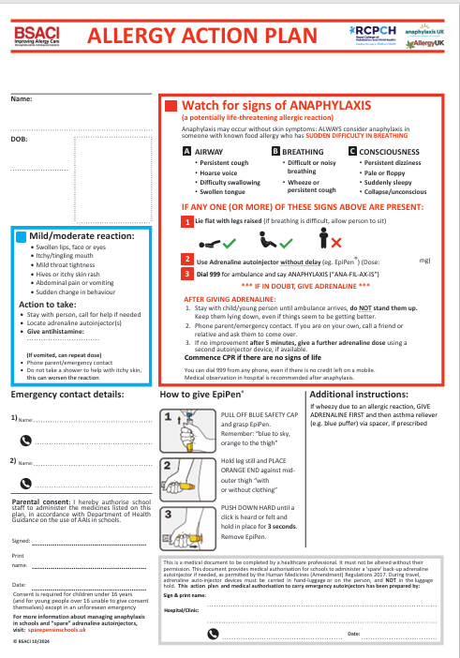
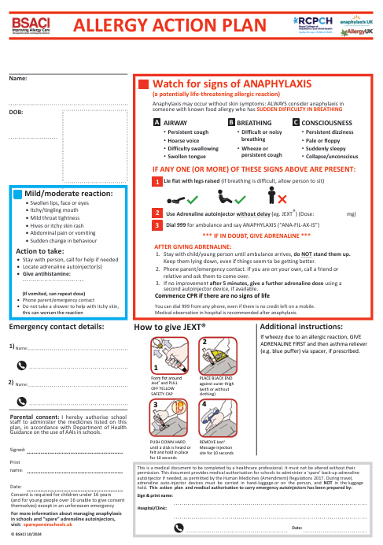
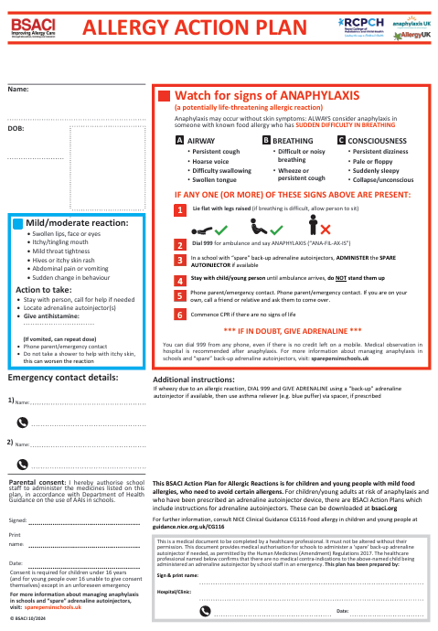

Appendix B – Anaphylaxis Risk Assessment

St Andrew’s School Anaphylaxis Risk Assessment
This form should be completed by the setting in liaison with the parents/carers and the child, if appropriate. It should be shared with everyone who has contact with the child/young person.
Child/Young Person Name: |  | Date of Birth:
Year Group: |  | Key members of staff:
Name and role of other professionals involved in this Risk Assessment (i.e. Specialist Nurse or School Nurse):

Date of Assessment: | Reassessment due (this would usually be annually, unless there is an incident, at which point the risk assessment should be reviewed):
I give permission for this to be shared with anyone who needs this information to keep the child/young person safe:
Signatures:
Headteacher: Date

Parents/Carers Date

Child/Young Person Date
What is this child/young person allergic to?

Allergen exposure risks to be considered Ingestion Direct contact Indirect contact
Does this child already have an Allergy Action Plan or an Individual Healthcare Plan? YES NO

Is the child prescribed adrenaline auto-injectors (AAIs)? YES NO

Summary of current medical evidence seen as part of the risk assessment (copies attached)

Key Questions - Please consider the activities below and insert any considerations than need to be put in place to enable the child to take part.
Activities
Crayons/painting:
Creative activities: i.e. craft paste/glue, pasta
Science type activity: i.e. bird feeders, planting seeds, food
Musical instrument sharing (cross contamination issue):
Cooking (food prep area and ingredients):
Meal time:
kitchen prepared food (is allergy information available):
packed lunches:
Snacks (is allergy information available):
Drinks:
Celebrations: e.g. Birthday, Easter:
Hand washing (secondary school how accessible is this for the child):
Indoor play/PE (AAIs to be with the child):
Outdoor play/PE (AAIs to be with the child):
School field (AAIs to be with the child):
Forest school (AAIs to be with the child):
Offsite trips (are staff who accompany trip trained to use AAI?):

Allergy Management
Does the child know when they are having an allergic reaction?
What signs are there that the child is having an allergic reaction?

What action needs to be taken if the child has an allergic reaction?

If the medication is stored in one secure place are there any occasions when this will not be within 5 minutes reach if required? Yes No
If Yes state when and how this can be adjusted:
If the child is trained and confident can the medication be carried by them throughout the day? Yes No
If No state reason:
Does the child have two of their own prescribed AAIs?
How many staff need to be trained to meet this child’s need?
Are there backup spare AAIs available and where are they located?
Outcome of Risk Assessment
New Allergy Action Plan/Individual Healthcare Plan required? YES NO
Existing Allergy Action Plan/Individual Healthcare Plan to be updated? YES NO

Appendix B – Anaphylaxis Risk Assessment Template

