Head’s Note

As I compile this Easter newsletter, I am deeply proud of our wonderful school and the wealth of opportunities our students have embraced this term. There is so much to celebrate - thank you to everyone for their role in helping to make St Andrew’s School a great place to learn and flourish. I hope you all have a very happy Easter break.

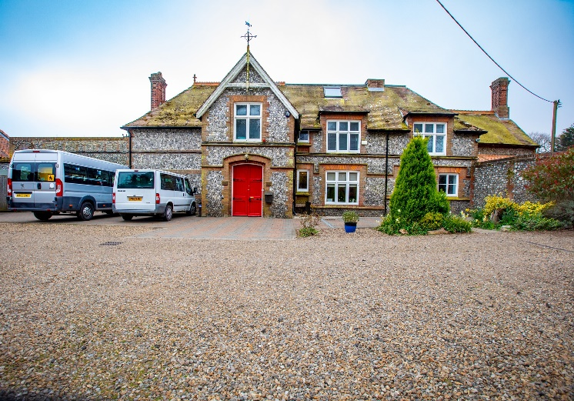
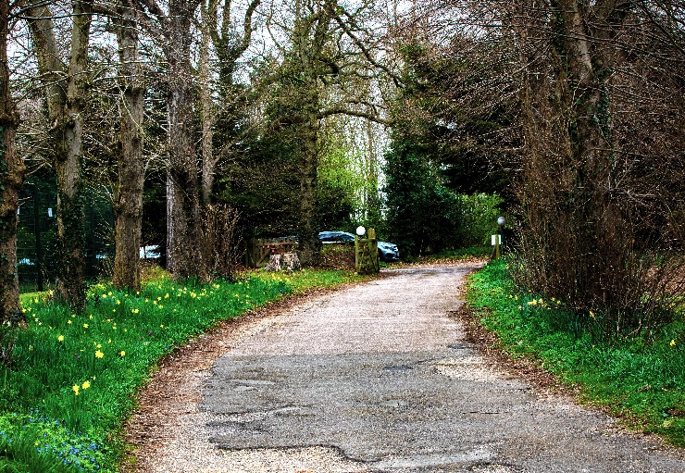

The photographs above were taken by Ellis and can be seen on the school website.

Key Dates

Friday 4th April – Last day of term
Wednesday 23rd April – Students return to school
Thursday 24th April - 22nd May – Cricket coaching
Monday 5th May – Bank Holiday
Friday 23rd May – Last day of term
Monday 2nd June – Students return to school
Monday 2nd June – Work Experience Pre-visits for Year 10 students
Bikeability
After a lengthy time in the planning, we were able to start the national Bikeability scheme at St Andrew’s. The first session was held on Friday 7th March and a second on Friday 21st March enabling some students to obtain their level 1 certificates. The sessions have been a real hit, and I aim to offer more dates in the remainder of the academic year to give all students the opportunity to participate in the scheme, should they wish.
Bikeability offer varying levels, from 'Learn to ride' all the way through to level 3, which teaches riders how to be safe on the roads. I hope to be able to offer some Learn to Ride lessons in the very near future, along with some possible level 2 lessons for our more confident riders.
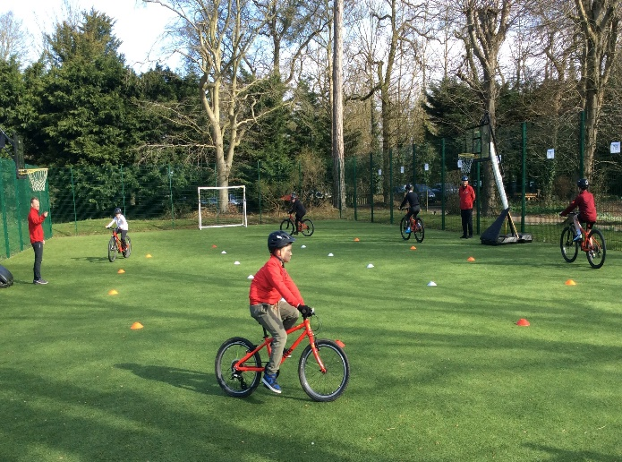
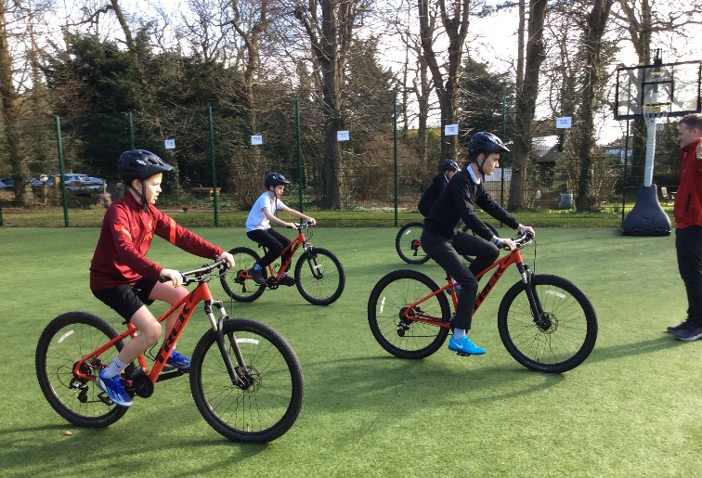
Football Tournament
On Wednesday 12th March, we had the opportunity to attend the re-arranged football tournament at the FDC in Norwich to partake in a series of football games with similar schools from around the area. Due to the level of interest, we were able to enter two teams, playing a total of eight games. The day offered a wonderful opportunity to be part of a wider sporting event outside of the school environment, with a particular focus on teamwork and sportsmanship. We all had a great day and enjoyed being part of the event.
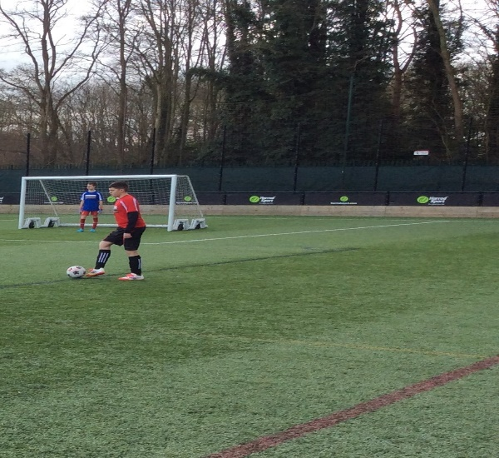
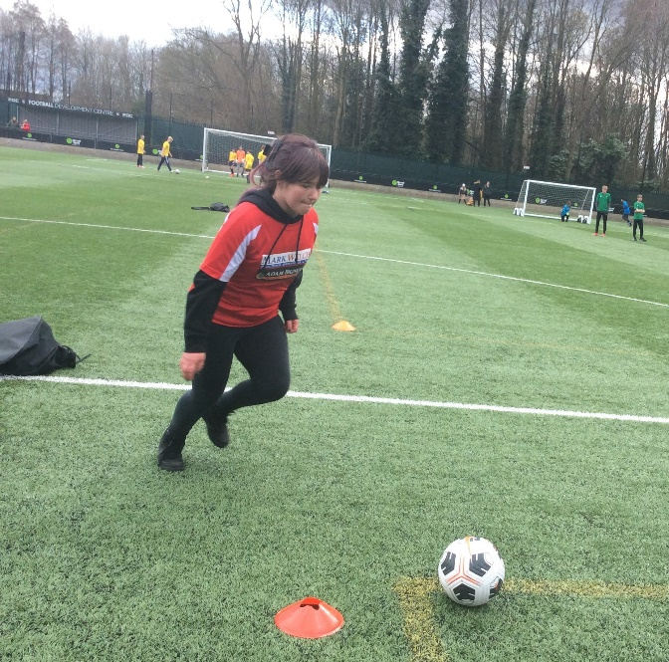
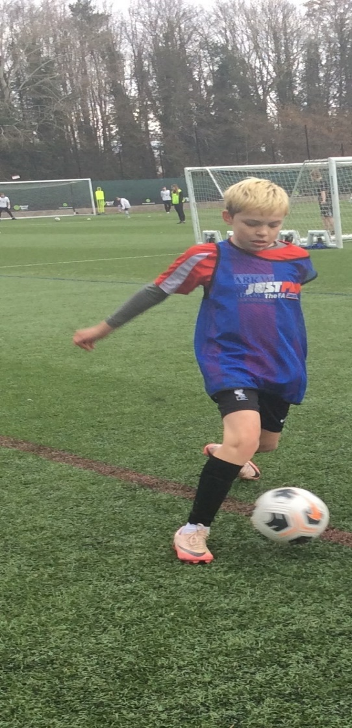
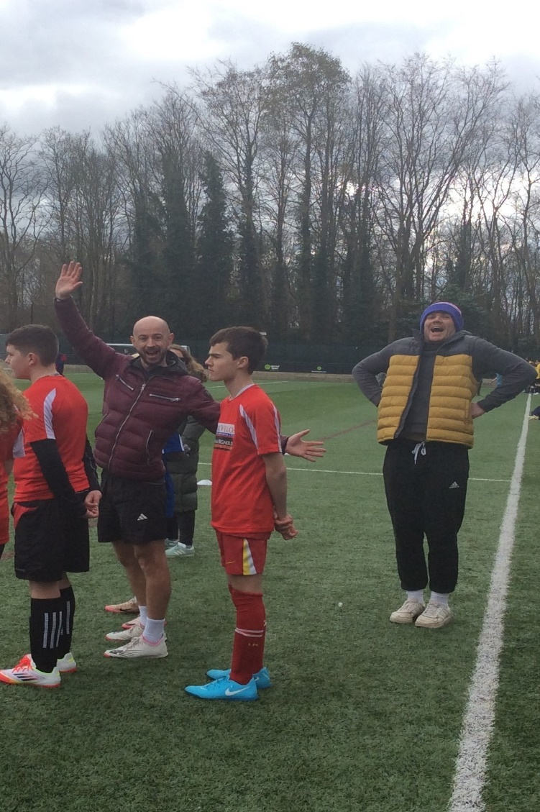
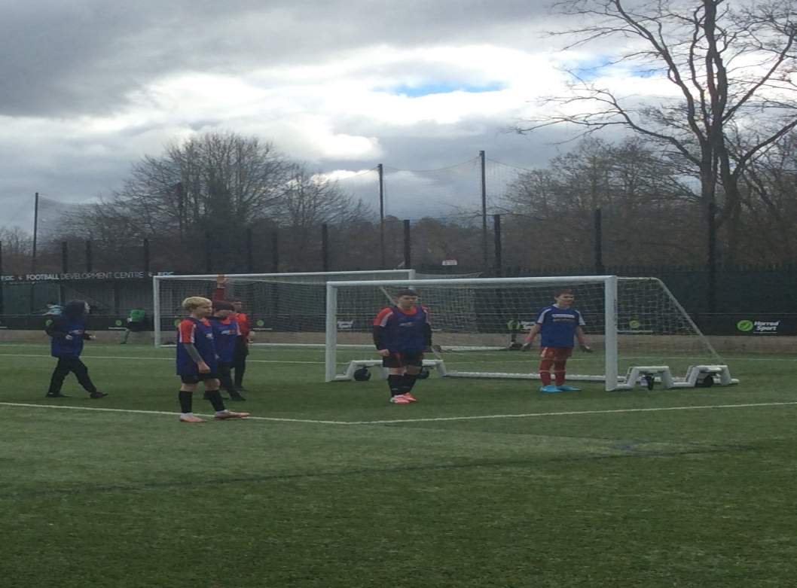

Vassy Stamatov – PE Teacher

Comic Relief Day
St Andrew’s School was challenged to complete a marathon by either walking, jogging or running. The distance was completed by using a running machine or around the school’s running track to raise money for Comic Relief. The students went above and beyond with their effort and collaboratively completed not just one marathon, but an amazing 3.7 marathons! We are proud to have raised £360.81 for this charity. Thank you for all your on-going support.
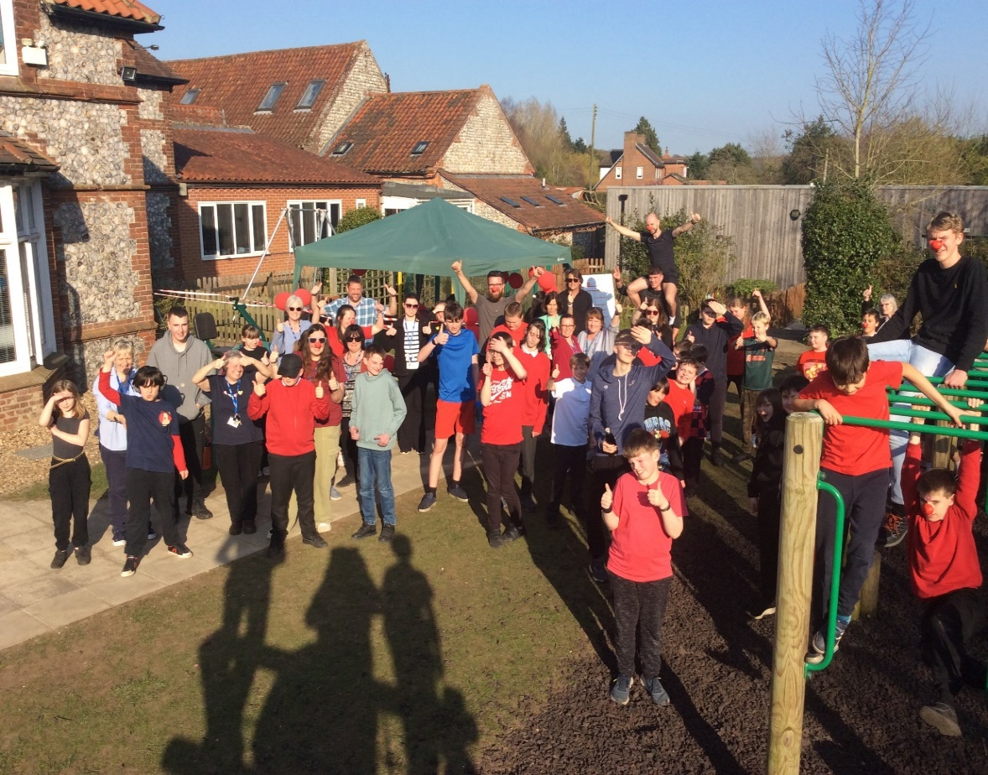
Lauren Burdett – Class Lead

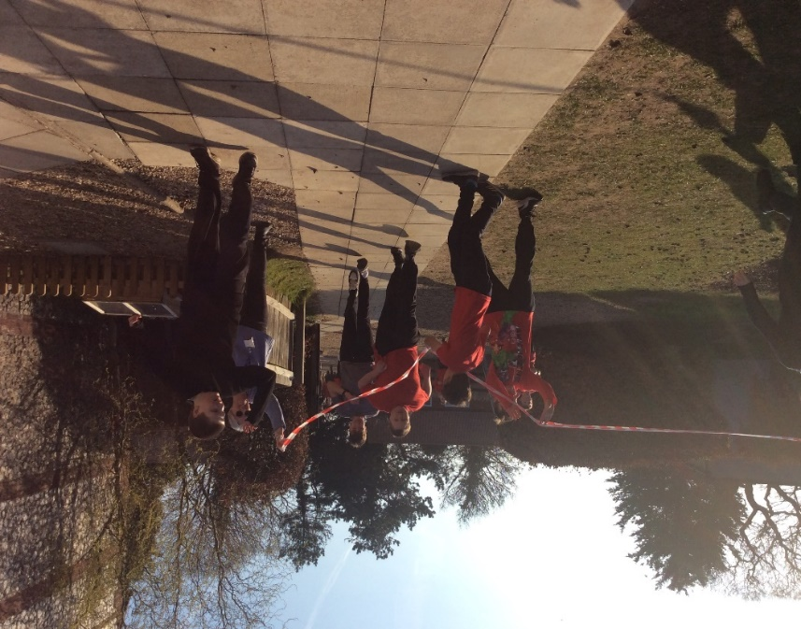
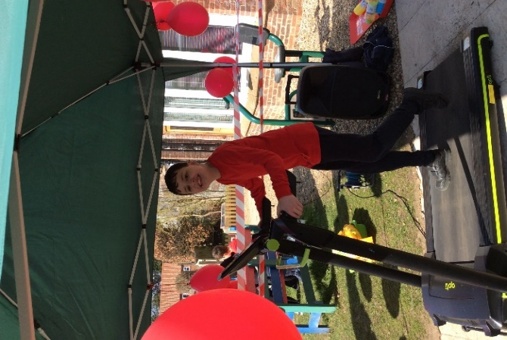

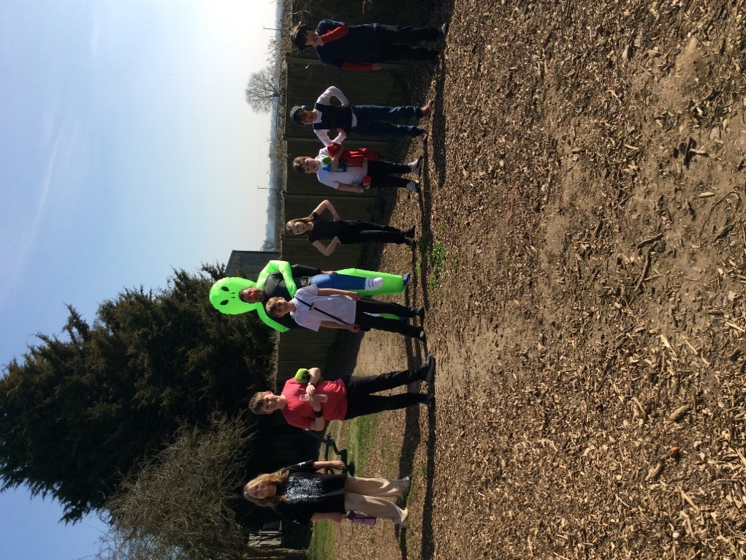
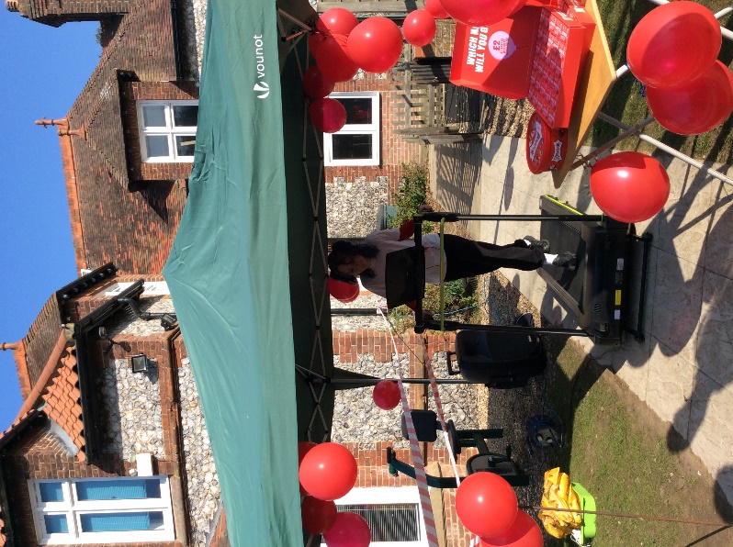

Springtime Mischief!
This year World Book Day has again proved to be a celebration of reading, our students here at St Andrew’s School dressed up as their favourite characters and explored books with characteristic curiosity and a sense of fun. The diversity of characters at school was to be marvelled at: Jeremy Clarkson from ‘Diddly Squat, a Year on the Farm’ was seen on the climbing frame with Circe from ‘The Odyssey’. A marriage made in Heaven?
Chris from the Norfolk Children’s Book Centre returned to distribute free World Book Day books and sell the latest top reads. We were lucky enough to listen to him read stories to Key Stage 2 in the morning, when peals of laughter could be heard around the school.
We have continued to maintain momentum with a whole school ‘Drop Everything and Read’ and our annual Readathon. Our children have embraced the power of a good book and taken it to their hearts.

Emma Clark – Head of English

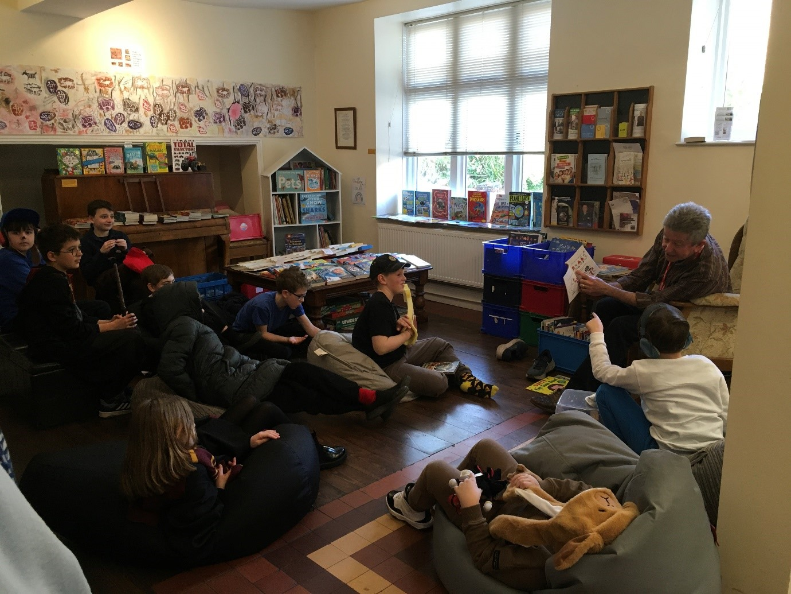
Readathon
Thank you to all who took part in this year’s ‘Readathon’. We have raised over £260 in sponsorship, which will help to provide a regular supply of brand new books to every major children’s hospital in the UK. We will also receive free books worth 20% of our grand sponsorship total to add to our school library, encouraging pleasurable reading for all of our students.
Sophie Watson – KS2A Class Teacher

KS2-4 Students Take Part in First Aid Training with Mini Medics
Recently, our KS2-4 students participated in a hands-on First Aid course with the incredible Mini Medics team! This exciting opportunity allowed students to learn essential life-saving skills, including how to make an emergency call, perform CPR, use a defibrillator, and place a casualty in the recovery position.
The training was engaging, practical, and tailored to the children's age and abilities, making sure they understood the importance of staying calm in emergencies and acting quickly. Not only did the students gain valuable knowledge, but they also gained the confidence to assist in real-life situations should they ever need to.
The trainer was so impressed with the students' enthusiasm, attention and willingness to learn that she has asked to come back next year for another training session! We’re incredibly proud of how well our students performed. They are now even better prepared to help others in emergencies. Well done!
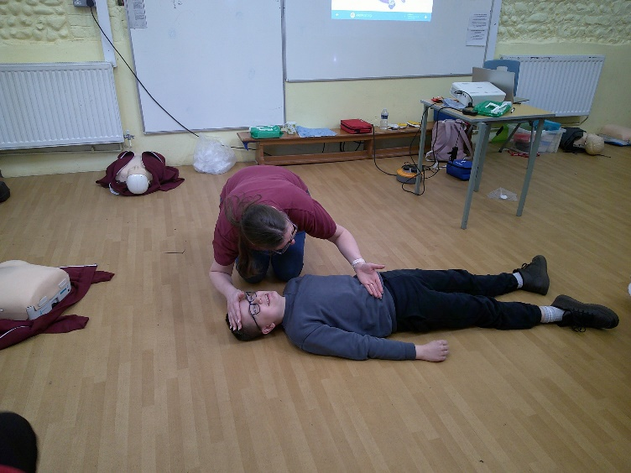
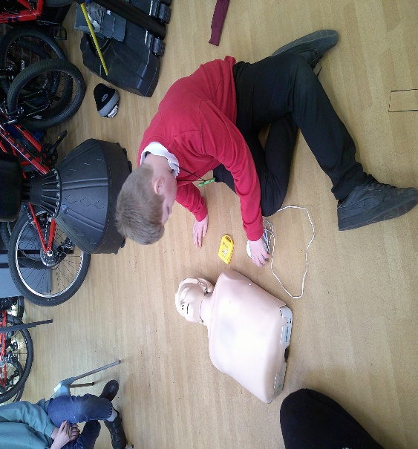
Paula - PSHE Lead

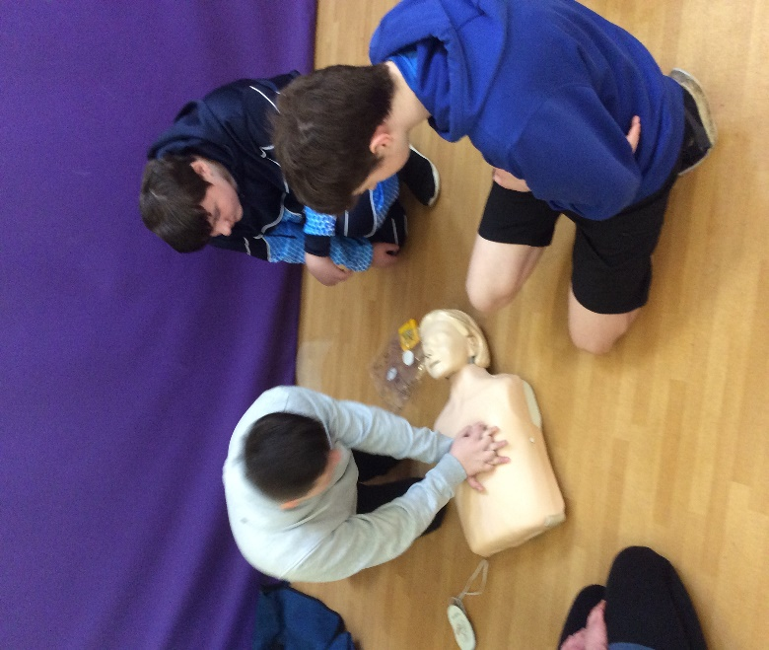
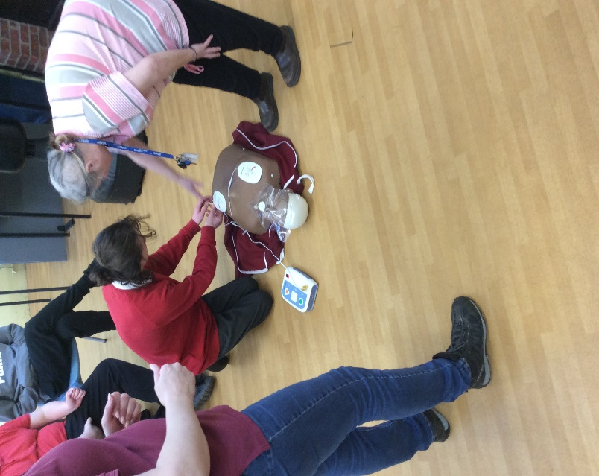

Careers Fairs
Festival of Knowledge
Festival of Knowledge
Norfolk Showground hosted the Norfolk Festival of Knowledge for the second year. The event gave the Year 10 students the opportunity to visit a wide range of businesses and educational providers stalls. A variety of sectors offering opportunities around Norfolk were present, including construction, agri-tec and food, hospitality and tourism, the public sector (including the police, prison service and the army), technology and digital, creative marketing and media and a range of apprenticeships and colleges.
Although this was a different learning environment which challenged our students, they chose which stalls to visit and listened to the advice given. Well done to everyone!
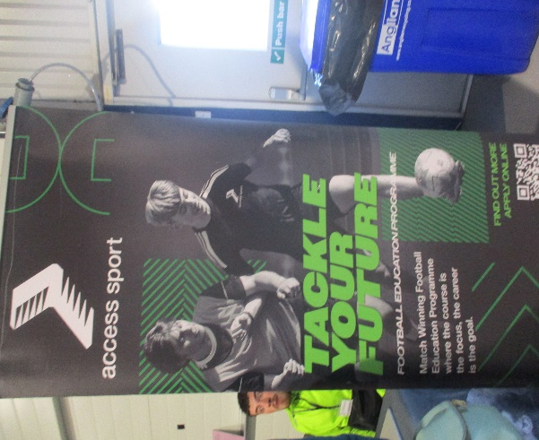
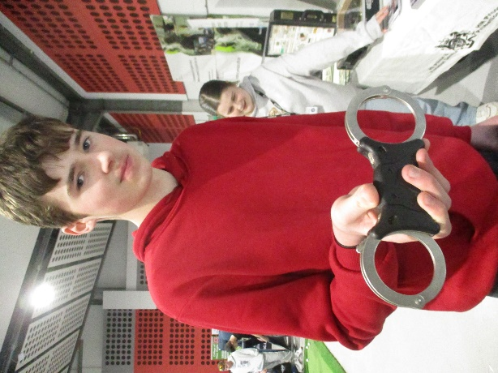

Moving On Event
The Year 10 students visited the ‘Moving On’ event, hosted by Sheringham Woodfield’s School, allowing them the opportunity to visit a range of college, day centres and other post 16 options in a smaller setting. For example, City, Paston and Easton College, East Coast College, Thornage Hall (day and residential provision) TITAN, Norfolk County Council Able2be Gym and Independence Matters.
One student in particular felt confident asking questions at numerous stalls independently, following staff support. Overall, the students found the event useful and a good opportunity to practise their social skills.
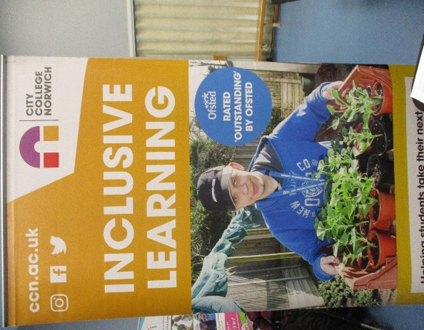
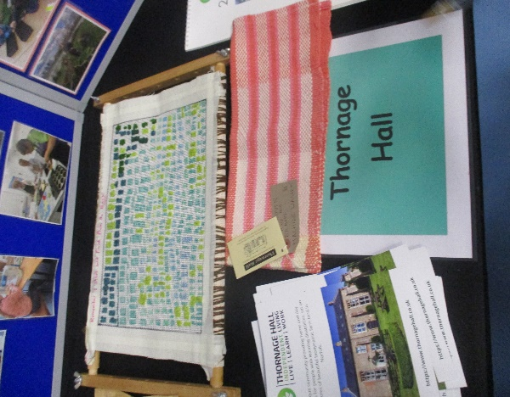

Norfolk County Council
Sophie and Pam from Norfolk County Council taught the Year 10 and 11 students about Apprenticeships and supported internships. The Year 10 students learnt what these training courses provide and the differences between the schemes, whilst the Year 11 students participated in mock apprenticeship assessment activities which applicants might undertake when applying for the schemes.
Apprenticeships
Apprenticeships are available for 70% of careers, offering apprentices the opportunity to train on the job (80% on the job and 20% studying), whilst being paid. Apprenticeships are available at degree level and beyond.
The Year 11 students undertook two teamwork challenges, involving building a freestanding tower out of balloons and a making a tower from paper cups without touching the cups. (They had an elastic band and some string). The students worked hard on the tasks, demonstrating the importance of problem solving, teamwork and communication.
Much fun, giggles and learning had by all!
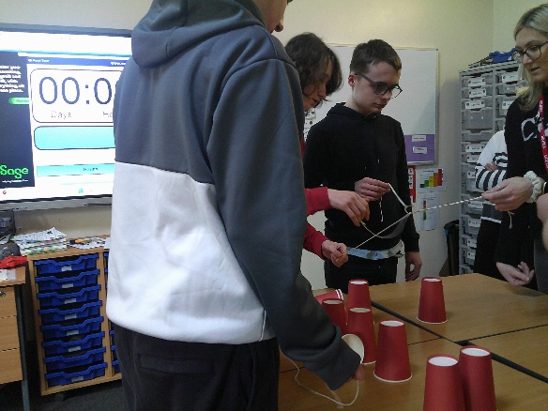

Supported Internships
Supported internships are more suitable to young people near the end of their college courses and who are getting ready to start work. The young people are accompanied by a job coach from their college, with 70% of the time being work based and 30% being spent in college. The placements are unpaid, and they include covering CV writing and help applying for jobs.
Norfolk offers a vast range of apprenticeships and supported internships with companies such as Aviva, NHS and Norfolk County Council.
For more information on apprenticeships and supported internships
www.apprenticeshipsnorfolk.org
www.ndti.org.uk/resources/publication/what-are-supported-internships

Juanita Burrows – Head of Careers

Careers trips
7A visited Kelling Heath and KS2 and Year 8 visited Cromer Library and Redwings Horse Sanctuary, participating in a tour and talk about careers within their weekly trip time. The students enjoyed the interactive sessions, asking questions and exploring the premises of the organisations. Our students showed increasing social skills and confidence throughout the visits. Well done!

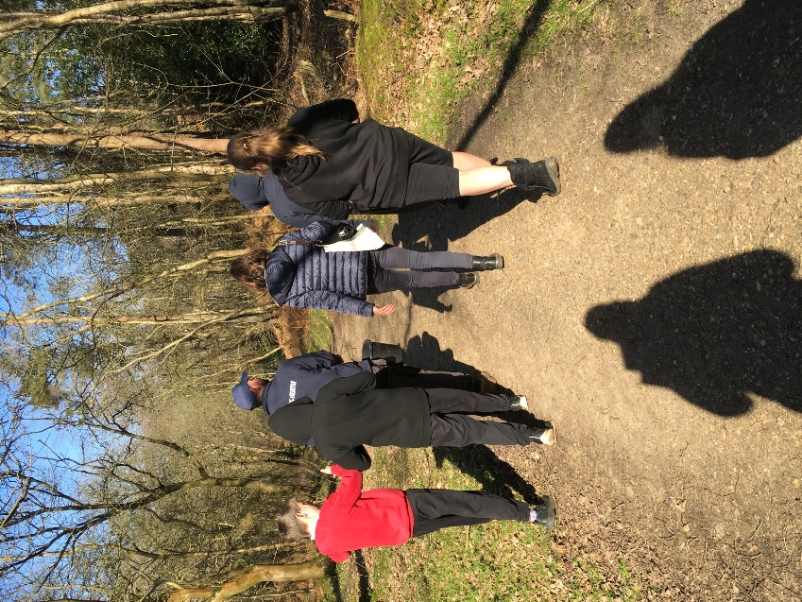
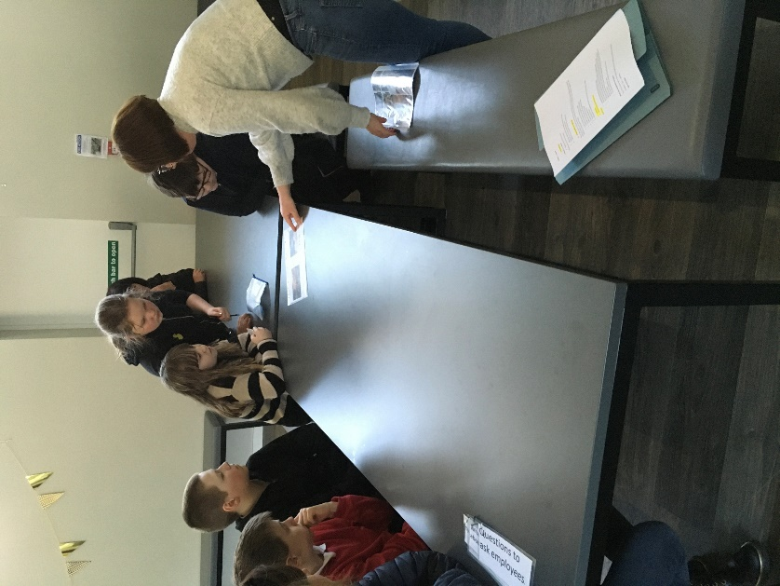

The students of 7A were able to ask different questions about the park, different job roles and what they do. They were shown how the park has developed over the years and when it first opened. Ben then took the students on a tour of the park, finishing off with feeding the sheep and some time on the playpark.
Kelly Holloway – 7A Teaching Assistant

‘The Gem of Autism’ Drama Production
Congratulations to the incredible students – Harry, Louis, Enid, Ruben, Marcus, Charlie, Josh, Arthur, and Dylan - who brought our drama production ‘The Gem of Autism’ to life with their passion, dedication and talent! Their hard work and commitment to Drama Club each week really shone through as they performed to their parents on Thursday 3rd April. Over the past 8 weeks, they not only worked collaboratively to produce the script but also supported one another when improvising, each playing a pivotal role in ensuring that the show was a success. Well done!
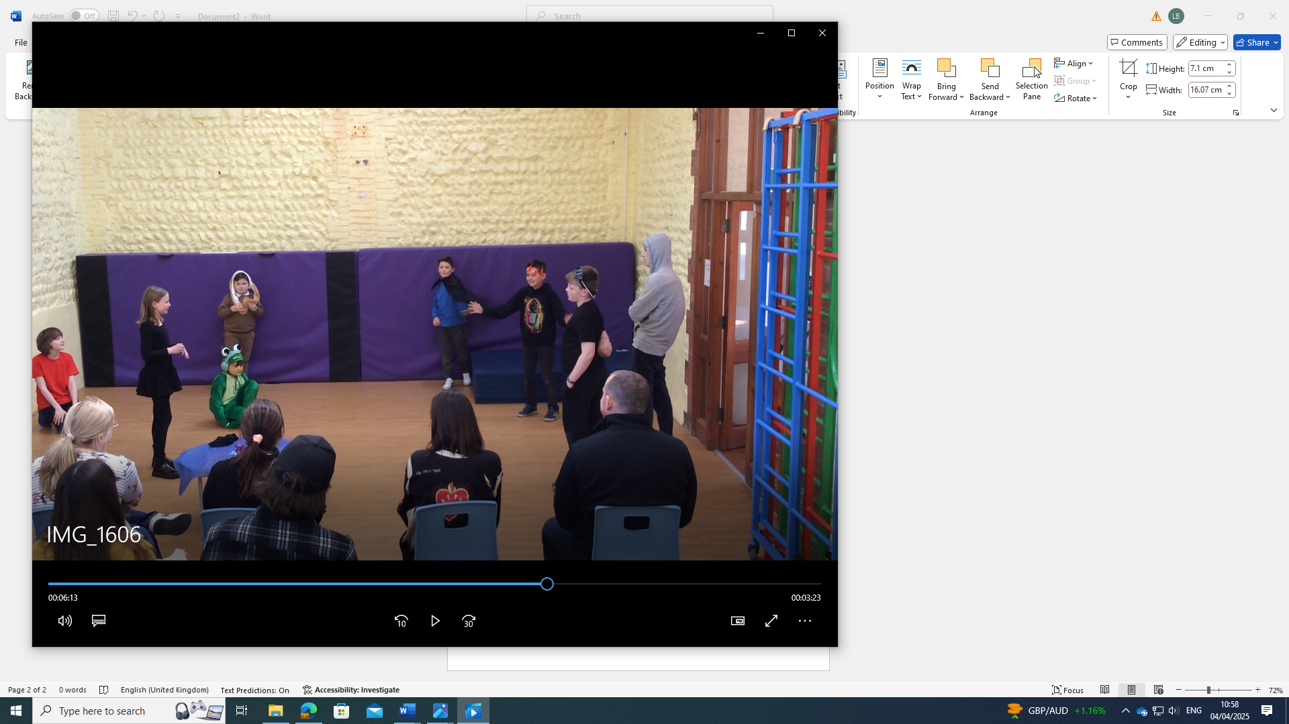
Sarah Knights – Class Teacher

Easter Code Cracking
On Friday 4th April, the students enjoyed an Easter code cracking trail which involved looking for clues around the school grounds to reveal letters corresponding to emojis. Once revealed, they needed to locate 4 numbers to unlock a code to reveal when the Easter Bunny will arrive at school. The students enjoyed receiving an Easter treat whilst at the Easter disco from the Easter Bunny.
Lauren Burdett – Class Lead

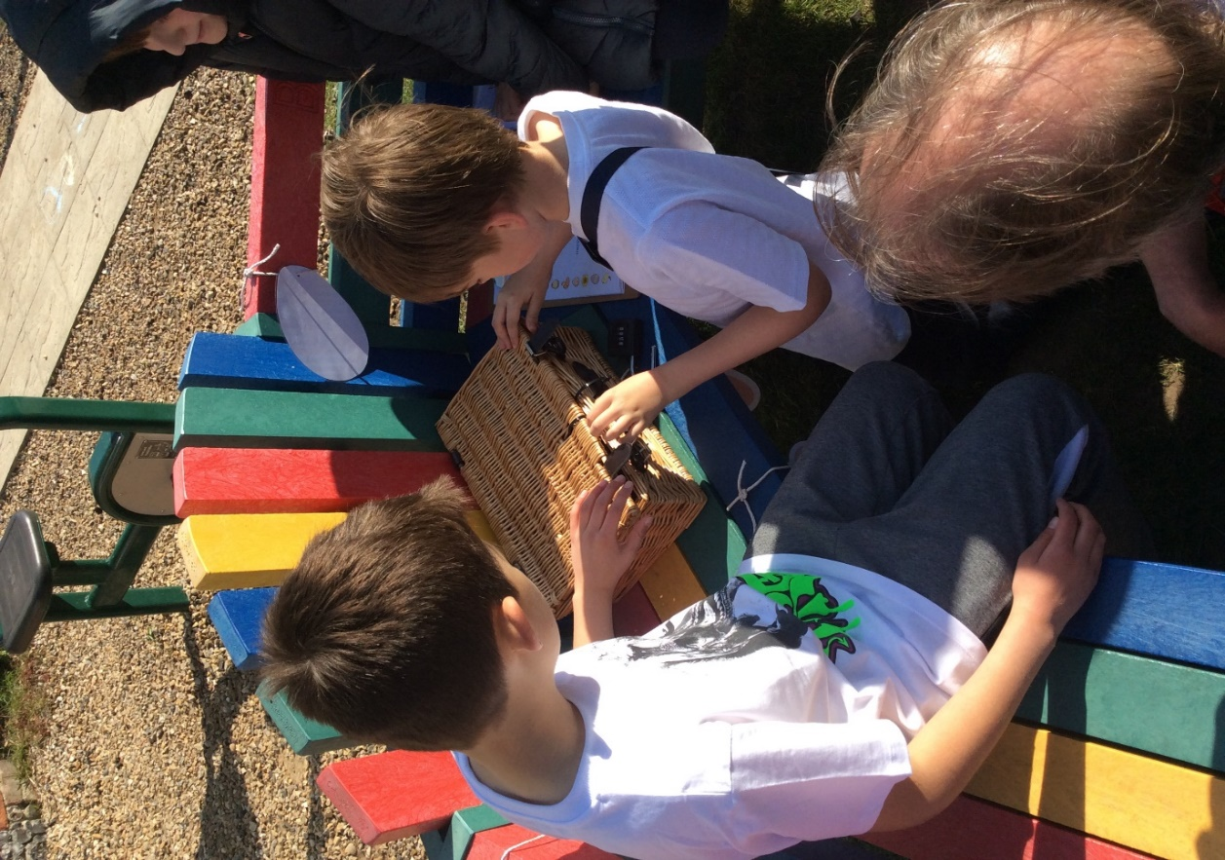
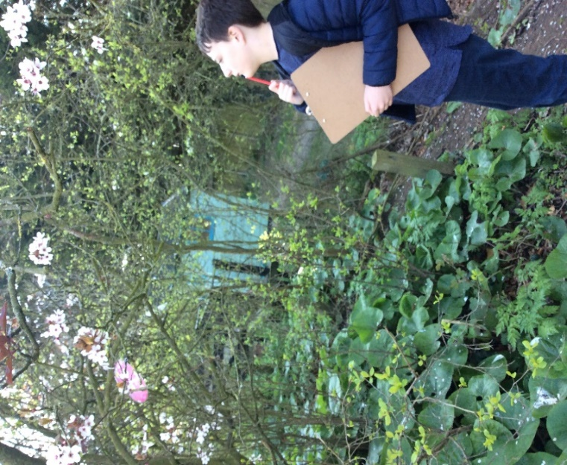

Gentle Reminder

All absences should be reported to the school on 01263 837927 before 8.30am please.

