
St Andrew’s School
A school with Quaker values

Aylmerton Hall Holt Road
Aylmerton Norfolk NR11 8QA
Telephone: 01263 837927
Email: office@standrewsschool.co.uk
Headteacher: Adrian Crossland
The St Andrew’s School Trust is a Registered Charity No. 1129232

Attendance
Policy

Summary of changes

Page Ref | Section | Amendment | Date of change

Date adopted by Trustees: 28th September 2026
Next review date: Autumn Term 2027

1.Introduction
At St Andrew’s School we recognise that positive behaviour and good school attendance are essential in order for students to get the most of their school experience, including their attainment, wellbeing and wider life chances. Missing out on lessons leaves children vulnerable to falling behind and can put them at risk of wider harm. There is a wide range of evidence as to the health and wellbeing benefits of school-age education.
The law entitles every child of compulsory school age to an efficient, full-time education suitable to their age, aptitude, and any special educational need they may have. It is the legal responsibility of every parent to make sure their child receives that education either by attendance at a school or by education otherwise than at a school. Where parents decide to have their child registered at school, they have an additional legal duty to ensure their child attends that school regularly and on time. This means their child must attend every day that the school is open, except in a small number of allowable circumstances such as being too ill to attend or being given permission for an absence in advance from the school.
The Department for Education (DfE) has produced statutory guidance for maintained schools, academies, independent schools, and local authorities. It is called “Working together to improve school attendance” and it includes a National Framework in relation to absence and the use of legal sanctions. Our School Attendance Policy reflects the requirements and principles of that guidance including the importance of understanding the potential vulnerabilities of children who are missing education or absent from school.
This policy is written with the above guidance in mind and underpins our school ethos to:
- Work with families to identify the reasons for poor attendance and try to resolve any difficulties at the earliest opportunity.
- Promote children’s welfare and safeguarding.
- Ensure every pupil has access to the suitable, full-time education to which they are entitled.
- Ensure that students succeed whilst at school.
- Ensure that students have access to the widest possible range of opportunities at school, and when they leave school.

Our policy outlines the school’s commitment to attendance. Our policy aims to provide clear guidance to all staff, parents and carers, students and trustees about the responsibilities and the procedures in place to promote and monitor pupil attendance.
Our policy aims to raise and maintain levels of attendance by:
- Promoting a positive and welcoming atmosphere in which students feel safe, secure, and valued.
- Raising and maintaining a whole school awareness of the importance of good attendance and punctuality.
- Ensuring that attendance is monitored effectively and reasons for absences are recorded promptly and consistently.
For our students to gain the greatest benefit from their education it is vital that they attend regularly and on time, every day the school is open unless the reason for the absence is unavoidable.
We recognise that attendance is a matter for the whole school community. Our Attendance Policy should not be viewed in isolation; it is a strand that runs through all aspects of school improvement, supported by our policies on safeguarding, anti-bullying and behaviour. This policy also considers the Human Rights Act 1998, the Equality Act 2010, UN Convention on the Rights of the Child, and other relevant legislation.
2.Promoting Regular Attendance

At St Andrew’s School, we believe in developing good patterns of attendance and set high expectations for the attendance and punctuality for all our students from the outset. It is a central part of our school’s vision, values, ethos, and day-to-day life. We recognise the strong connections between attendance, attainment, safeguarding and wellbeing.

Role | Name | Contact details
Senior Leader responsible for strategic approach to Attendance | Adrian Crossland  Headteacher | 01263 837927  adriancrossland@standrewsschool.co.uk
Member of staff to contact for more detailed attendance support | Carol McKean  Safeguarding and Welfare Manager | 01263 837927  carolmckean@standrewsschool.co.uk
Members of staff to contact about attendance on a day-to-day basis | Julie Vincent  SEN Administrator  Carole Ashby  Administrative Administrator | 01263 837927  office@standrewsschool.co.uk
Named Trustee for Attendance | Sue Brisbane | 01263 837927  office@standrewsschool.co.uk

Improving school attendance is everyone’s business, it is a shared responsibility by trustees, all school staff, parents, students, and the wider school community.

To help us all to focus on this, we will:

- Build strong relationships and work collaboratively with families.
- Give parents/carers information about attendance.
- Promote the benefits of high attendance.
- Accurately complete admission and attendance registers and have effective day-to-day processes in place to follow-up absence as required by law.
- Celebrate excellent attendance and individual achievements.
- Report to parents/carers regularly on their child’s attendance and the impact on their progress.
- Contact parents/carers should their child’s attendance fall below the school’s target for attendance.

2.1 Roles and Responsibilities

The trustee board of St Andrew’s School recognises the importance of school attendance and promotes it across the school’s ethos and policies. They take an active role in attendance improvement by:

- Setting high expectations of all leaders, staff, students and parents so that children attend school every day and are safeguarded from harm.
- Identifying a member of the trustee board to lead on attendance matters and ensuring that there is an ‘Attendance Team’ in place with clear roles and responsibilities.
- Ensuring school leaders fulfil expectations and statutory duties by rigorously evaluating the effectiveness of the school’s attendance procedures so that consistent attendance support is provided for all students.
- Ensuring the school engages and works effectively with the local authority Attendance Team, when required, and wider local partners and services to address barriers to school attendance.
- Regularly reviewing attendance data, discussing, challenging trends, and helping school leaders focus improvement efforts on the individual students or cohorts who need it most.
- Ensuring high aspirations are maintained for all students and processes for support are adapted to the individual needs of students, including those with long term illnesses, special educational needs and disabilities, students with a social worker or youth justice worker and students from cohorts with historically lower attendance such as those eligible for free school meals.
- Ensuring all school staff receive adequate training on attendance and that relevant staff have access to opportunities to share and learn from good practice in other schools.
- Ensuring that attendance data is shared with the Local Authority and/or Department for Education as required and on time.
- Reviewing the school’s Attendance Policy on at least an annual basis, ensuring that the required resources are available to fully implement the policy.

The Attendance Team at St Andrew’s School will:

- Actively promote the importance and value of good attendance to all students and their parents.
- Form positive relationships with students and parents.
- Ensure that there is a whole school approach which reinforces good school attendance, with good teaching and learning experiences that encourage all students to attend and to achieve.
- Monitor the implementation of the Attendance Policy and ensure that the policy is reviewed annually.
- Ensure that all staff are aware of the Attendance Policy and adequately trained to address attendance issues.
- Ensure that the regulations and other relevant legislation are complied with.
- Ensure that there are named members of staff to lead on attendance and allocate sufficient time and resource.
- Return school attendance data to the Local Authority and/or the Department for Education as required and on time.
- Report the school’s attendance and related issues through half termly reporting to the trustees.
- Ensure that systems to report, record and monitor the attendance of all students, including those who are educated off-site are implemented.
- Ensure that attendance data is collected and analysed frequently to identify causes and patterns of absence.
- Interpret the data to devise solutions and to evaluate the effectiveness of interventions.
- Develop a multi-agency response to improve attendance and support students and their families.
- Document interventions used to a standard required by the local authority should legal proceedings be instigated.
- Set out how Pupil Premium (if relevant) will be used to support students with irregular attendance.

All staff at St Andrew’s School will:

- Actively promote the importance and value of good attendance to all students and their parents.
- Form positive relationships with students and parents.
- Contribute to a whole school approach which reinforces good school attendance; with good teaching and learning experiences that encourage all students to attend and to achieve.
- Comply with the regulations and other relevant legislation.
- Implement systems to report, record and monitor the attendance of all students, including those who are educated off-site.
- Ensure that registers are recorded accurately and in a timely manner.
- Contribute to the evaluation of school strategies and interventions.
- Work with other agencies to improve attendance and support students and their families.

The member of staff responsible for attendance will work to further develop relationships with families to bring about improved attendance. This may involve seeking multi-agency support. The member of staff responsible for attendance will support good attendance, respond to concerns, and promote improvement in attendance by:

- Monitoring and analysing student attendance data.
- Raising any concerns with the Designated Safeguarding Lead, SENCO, and other relevant staff members.
- Implementing the identified strategies for promoting excellent whole school attendance.
- Implementing the identified strategies for tackling unsatisfactory attendance.
- Managing individual student casework files.
- Coordinating individual action plans for students causing concern including the instigation of an Early Help Assessment and Plan and/or the implementation of an Attendance Contract if appropriate.
- Ensuring first day calling procedures are adhered to if a student is absent from school without contact from parents.
- Taking an active lead in delivering whole school initiatives such as awards, assemblies and any reward schemes.
- Making referrals to appropriate external agencies.

St Andrew’s School requests that parents:
- Ask the school for help if their child is experiencing difficulties with any aspect of their schoolwork or home and family life so that we can offer support at the earliest opportunity.
- Take a positive interest in their child’s work and educational progress.
- Ensure their child has regular attendance at school.
- Instil the value of education and regular school attendance within the home environment.
- Contact the school if their child is absent to let them know the reason why and the expected date of return, following this with a note wherever possible.
- Avoid unnecessary absences; for example, by making medical and dental appointments for outside of school hours.
- Inform the school of any change in circumstances that may impact on their child’s attendance.
- Support the school by becoming involved in their child’s education, forming a positive relationship with school, and acknowledging the importance of children receiving the same messages from both school and home.
- Maintain effective routines at home to support good attendance.
- Attend all meetings requested to discuss attendance issues.

Students will:

- Be aware of the school’s Attendance Policy and when and where they are required to attend. Th.
- Speak to their class teacher or another member of staff if they are experiencing difficulties at school or at home which may impact on their attendance.
- Attend all lessons ready to learn, with the appropriate learning tools requested and on time for the class.
- Follow the school procedure if they arrive late.

3.Understanding Types of Absence

Any absence affects the routine of a child’s schooling and regular absence will seriously affect their learning journey and ability to progress. Any student’s absence or late arrival also disrupts teaching routines and may affect the learning of other students. Ensuring a child’s regular attendance at school is parental responsibility and allowing absence from school, without a good reason, creates an offence in law and may result in prosecution.
Every half-day absence from school has to be classified by the school (not by the parents), as either authorised or unauthorised. This is why information about the cause of any absence is always required. Each half-day is known as a ‘session’. Absence will not be authorised unless parents have provided a satisfactory explanation, and it is accepted as such by the school. The decision to authorise absences is at the discretion of the Headteacher.
For the purpose of this policy, the school defines:

“Absence” as:
- Arrival at school after the register has closed
- Not attending school for any reason

“Regular” attendance as:
- Attendance at every session the school is open to students unless their absence has been authorised

Authorised absences are morning or afternoon sessions away from school for a genuine reason such as:
- An absence for sickness for which the school has granted leave
- Medical or dental appointments which unavoidably fall during school time, for which the school has granted leave
- Religious or cultural observances for which the school has granted leave
- An absence due to a family emergency or unavoidable cause

Unauthorised absences are those which the school does not consider reasonable and for which no ‘leave’ has been granted such as:
- Parents keeping children off school unnecessarily or without reason e.g. because they had a late night or for non-infectious illness or injury that would not affect their ability to learn.
- Absences which have never been properly explained.
- Arrival at school after the register has closed.
- Shopping, looking after other children or birthdays.
- Day trips and holidays taken during term-time, not deemed ‘for exceptional purposes’ by the Headteacher, including any arranged by other family members or friends.
- Leaving school for no reason during the day.
- Any other absence in term time which has not been agreed.

This type of absence can lead to the school referring to the Local Authority for legal proceedings.
3.1 Persistent and Severe Absence
A pupil is defined by the Government as a ‘persistent absentee’ (PA) when they miss 10% or more schooling across the school year for any reason; this can be authorised or unauthorised absence. Over a full academic year this would be 19 school days (38 sessions) missed. Absence at this level will cause considerable damage to any pupil’s education and we need the full support and co-operation of parents to resolve this.
A pupil who has missed 50% or more schooling is defined by the Government as ‘severely absent’ (SA). Students within this cohort may find it more difficult to be in school or face bigger barriers to their regular attendance and, as such, are likely to need more intensive support.
The attendance of all students at our school is monitored to identify children who are PA, or are on track to becoming PA. Where emerging concerns are identified we will instigate appropriate and timely interventions as outlined in our policy. Referrals may also be made to external agencies for targeted support.
If parents fail to engage with support and their child continues to have unsatisfactory attendance/ punctuality, a request may be made to the Local Authority to pursue legal proceedings either through a penalty notice for parentally condoned absence, consideration of an Education Supervision Order or prosecution in the Magistrates’ Court.
Parents found guilty in a Magistrates’ Court of failing to secure their child’s regular attendance at school under the provisions of the Education Act 1996, will receive a criminal record and a maximum penalty of a £1000 fine under a Section 444 (1) offence or a £2500 fine or up to a 3-month prison sentence, under a Section 444 (1a) offence.

3.2 Leave of Absence

We believe that children need to be in school for all sessions so that they can make the most progress possible. However, we do understand that there are times where a parent may legitimately request leave of absence for a child due to ‘exceptional circumstances'. At St Andrew’s School, leave of absence is only granted at the discretion of the Headteacher and shall not be granted unless there are ‘exceptional circumstances’. St Andrew’s School will respond to all applications for leave of absence in writing.
Parents wishing to apply for leave of absence during term time must apply in writing to the Headteacher at least a month before the planned leave (see Appendix 2). St Andrew’s School will treat each application individually and discuss with you (as necessary) the circumstances of the application before a decision is made. Parents will also receive a written response with the outcome (see Appendix 3). If a written request for leave of absence is not completed and the leave is taken without a request being submitted, it will be marked as unauthorised. Retrospective requests will not be considered and will also result in the absence being categorised as unauthorised. In such cases the school may make a referral to the Local Authority to request that they consider prosecution.
When absence is granted by the Headteacher, the parents will need to agree a date of return. If a pupil fails to return on the expected date and contact is not received from, or made with the parents, school will seek advice from the Local Authority. This could result in possible children missing from education procedures being instigated.

3.3 Medical Appointments and absence due to illness

Parents should try to make appointments outside of school hours wherever possible. Where appointments during school time are unavoidable, we ask that the parent notifies the school in advance of the appointment wherever possible. The pupil should only be out of school for the minimum amount of time necessary for the appointment. In most circumstances, a child should not miss a whole day at school for an appointment. If a pupil must attend a medical appointment during the school day, they must ensure that they are collected by a parent/carer, signed out by a staff member and that the office is notified. No pupil will be allowed to leave the school site without parental confirmation.

In most cases, absences for illness which are reported following the school’s absence reporting procedures will be authorised without the need for parents to supply medical evidence. Where a medical condition may be contributing to absence or difficulty engaging in the life of the school communications will be timely, supportive and clearly signpost the help available.

In line with Department for Education guidance, if we do have a genuine concern about the authenticity of the illness, we will speak to parents/carers regarding our concerns and look at what support can be put in place to ensure their child’s regular attendance at school. If the school is not satisfied about the authenticity of the illness, the absence will be recorded as unauthorised.

Where a child has an emerging pattern of non-attendance, we will discuss the reasons for absence with the child’s parent/carer. We will invite parents to discuss any wellbeing and attendance concerns and work together to see if we can support or identify an appropriate early intervention strategy. As part of this support, we may seek consent from parents and the pupil as appropriate to make a referral to the Just One Norfolk and/or to liaise with the child’s healthcare professional.

Where a pupil has a verified and chronic health condition, we will aim to work with parents to ensure children have access to education and provide appropriate support in line with Supporting students with medical conditions at school and Norfolk County Council policies. We will also consider whether an Individual Healthcare Plan is required.

3.4 Pupil Absence for the purposes of Religious Observance

St Andrew’s School acknowledges the multi-faith nature of British society and recognises that, on some occasions, religious festivals may fall outside school holiday periods or weekends and is recognised as such by a relevant religious authority. Where this occurs, the school will consider either authorising the pupil absence or making special leave for religious observance. Parents are requested to give advance notice to the school.

3.5 Gypsy, Roma and Traveller students

Gypsy, Roma and Traveller (GRT) students are among the lowest achieving groups of students at every key stage in education, although some GRT students achieve very well at school. We recognise that there are many complex and interwoven factors that may influence the educational attainment of GRT students. At our school, we have high expectations of all students, regardless of their background whilst recognising the lifestyle and cultural traditions of GRT communities. In line with The Education Act 1996, Section 444(6) the school will authorise the absence of a pupil who is a mobile child and is unable to attend school because:
- the parent is engaged in a trade or business of such a nature as to require him to travel from place to place,
- that the child has attended at a school as a registered pupil as regularly as the nature of that trade or business permits, and
- if the child has attained the age of six, that he has made at least 200 attendances during the period of 12 months ending with the date on which the proceedings were instituted

This provision applies only when the family has no fixed abode and are engaged in a trade or business that requires them to travel and when the child is attending school as regularly as that trade permits. In these circumstances, parents have a duty to ensure that their children are receiving suitable education when not at school.

When a family is trading or otherwise conducting their business in or around Norfolk, if a family can reasonably travel back to their base school (see below) then the expectation is that their child will attend full-time. St Andrew’s School will be regarded as the base school if it is the school where the child normally attends when he or she is not travelling. However, the pupil must have attended St Andrew’s School in the last 18 months. Parents can register their children at other schools temporarily while away from their base school; in such cases, the pupil’s school place at St Andrew’s School will be kept open for them whilst travelling. This is to protect them from unfairly losing their place at their school of usual attendance.

To ensure we can effectively support all our students, we ask that parents:
- Advise the school of their forthcoming travelling patterns as soon as these are known and before they happen; and
- Inform the school regarding proposed return dates.

4.Our Procedures
4.1 Register Keeping and Recording
The School Attendance (Pupil Registration) (England) Regulations 2024, require schools to take an attendance register twice a day, once at the start of the morning session and then again during the afternoon session. The register must record whether the pupil was:
- Present;
- Absent;
- Present at approved educational activity; or
- Unable to attend due to exceptional circumstances.

4.2 Expected absence procedure for parents:
A parent has a legal responsibility to ensure that their child attends school regularly. If a child is unavoidably absent from school parents are expected to contact school by telephone call on the first day of absence and each subsequent day, identifying the reason for absence and the expected date of return. If no contact is received, then absence protocols will be instigated.
If a child is absent from school the parent must follow these procedures:
- Contact the school on the first day of absence before 8.30 am.
- Please telephone the school office on 01263 837927. If you call before 8.00am please leave a message on the answer phone and one of our office team will pick this up at 8.00am. You may receive a call back from a member of staff for further clarification regarding your child’s absence.
- Contact the school on every further day of absence, again before 8.30am.
- Ensure that your child returns to school as soon as possible.

Member of staff to contact for more detailed attendance support | Carol McKean  Safeguarding and Welfare Manager | 01263 837927  office@standrewsschool.co.uk
Members of staff to contact about attendance on a day-to-day basis | Julie Vincent  SEN Administrator  Carole Ashby  Administrative Administrator | 01263 837927  office@standrewsschool.co.uk

If a child is absent but the school has not received a reason for absence, the following will be initiated by the school:

- The first day calling procedures will be activated for all students at 9.30am and where no reason for absence is known. We will telephone you on the first, and every subsequent day of absence, if we have not heard from you. However, it is your responsibility to contact us;
- If we are unable to make contact with parents by telephone or email, we will telephone emergency contact numbers. If there has been no contact or reason for absence, then an in-person welfare check may be undertaken.

We will also inform a pupil’s social worker and/or youth offending team worker if there are unexplained absences from school in line with statutory requirements. We will also inform a pupil’s social worker and/or youth offending team worker if their name is to be deleted from the school register.
In certain circumstances the school may also:
- Visit the home of the student or request a welfare check to be made by the police.
- Refer to the Local Authority for joint enquiries to be made to establish the whereabouts of the child through Children Missing Education procedures.
- Refer the matter to an appropriate external agency for multi-agency support, such as implementing a Family Support Plan or consulting with the Children’s Advice and Duty service (CADS) or the police, where there are safeguarding concerns.

4.3 Late Arrival at School

Poor punctuality is not acceptable and can lead to irregular school attendance patterns. Students who arrive late disrupt lessons and, if a child misses the start of the day, they can feel unsettled and embarrassed and risk missing vital work and important messages from their class teacher.

At St Andrew’s School all students are expected to arrive on time for every day of the school year. The school day begins at 9.00am. We advise all parents to ensure their child is on site prior to this. The school register will be taken at 9.15am. All students arriving after this time will be met by a member of staff and will be recorded as arriving late. A reason for lateness must be provided by the taxi company or parents. If their arrival is before 9.30am it will be recorded as late - L code (late before the close of register).

The school register will officially close at 9.30am. All students arriving on or after this time will be marked as having an unauthorised absence for the morning session - U code (Late after the close of register). This is categorised as an unauthorised absence for the session. Unauthorised lateness could result in the school referring to the Local Authority for sanctions and/or legal proceedings. If your child has a persistent lateness record, you may be asked to meet with the Attendance Team, but you can approach us at any time if you are having difficulties getting your child to school on time. We expect parents and staff to encourage good punctuality by being good role models to our students and, as a school, we celebrate good class and individual punctuality.

Please note: L or U codes will be used if a pupil arrives after the close of the afternoon register for the PM session.

4.4 Support Systems

At St Andrew’s School we recognise that poor attendance can be an indication of difficulties in a family’s life. This may be related to problems at home and/or in school. Parents are encouraged to inform school of any difficulties or changes in circumstances that may affect their child’s attendance and or behaviour in school, for example, bereavement, divorce/separation, incidents of domestic abuse, emerging health concerns. This will help the school identify any additional support that may be required.

We also recognise that some students are more likely to require additional support to attain good attendance. The school will implement a range of strategies to support improved attendance based on the individual needs and circumstances of the child.
Universal Strategies we may use to support you include:
- Student Voice Activities for your child centred around school attendance
- All students being met and welcomed by a familiar adult
- Helping your child to establish friendship groups in school
- Reward systems
- Additional learning support
- Behaviour support

If we have start to notice attendance patterns or that a student is missing a number of days from school then we will offer support to improve attendance and help identify any barriers. To plan the correct support, we will always invite parents and students to attend a meeting to discuss the concerns and devise a plan to support the child’s regular attendance. Support offered to families will be child-centred and planned in discussion and agreement with both parents and students.
Stage 1 - Welfare Phonecall
- Parents will be given a welfare call if a child’s attendance is causing concern and/or where punctuality is a concern.

Stage 2 – Phonecall from Safeguarding and Wellbeing Manager
- The safeguarding and welfare manager will phone parents/carers to see if any further support can be offered and identify any current barriers to attendance.
- Parents may also receive a letter following this call, showing their child’s record of attendance (see Appendix 4)

Stage 3 – Formal Meeting and Planning Record
- Parents/Carers will be invited to attend a meeting regarding a student’s attendance to discuss in detail any barriers and agree actions to support and improve attendance (see Appendix 5).
- A Support First Approach Planning Record will be completed and parents/carers will receive a copy of this (see Appendix 6).
- A reintegration support package may be created for a student.
- Offer signposting support to other agencies or services if appropriate or undertake an Early Help Assessment and Plan with you.

Stage 4 – Formal Attendance Meeting
- If attendance has not improved and the planning record has not had a positive impact, Parents/Carers will be invited to a formal meeting with the Headteacher and Safeguarding and Welfare Lead.
- An Attendance Contract may be completed at this stage.
- Request parental permission to access GP records if there are a high number of illness-related absences.
- Refer to an external agency/support service to offer support, guidance, and advice.
- The school will consult with the Local Authority if attendance continues to be an issue.

During a prolonged period of absence the school will maintain contact with the family and student including welfare and home visits.

Where persistent absence persists despite interventions being in place, the school will work with the local authority and EHCP co-ordinators to decide whether they are able to meet the needs of the child. This may ultimately result in cessation of the student’s place at St Andrew’s School.

4.5 Attendance Rewards & Interventions
DAYS ABSENT | Percentage of attendance | Support, Rewards, Interventions
  0 – 2  DAYS OFF | 99 – 100% | If a student receives 100% during a half-term they will receive a £5 Amazon Voucher.  If a student has 95%+ attendance they will receive an attendance certificate.  (students will not be penalised for attending medical appointments or LAC yearly assessments)
4 – 7.5  DAYS OFF | 96 – 98%
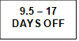   | 92 – 95% | At St Andrew’s School we will investigate any students who are on track to be persistently absent (PA) and will not wait until attendance is below 90%.  If a student’s attendance is causing concern then the school will follow the graded approach to supporting attendance. Agreed actions will be determined on an individual basis taking into account the individual students and families.
19+  DAYS OFF | Under 90%
80+  DAYS OFF | Under 50%

4.6 Part-time timetables
All schools have a statutory duty to provide full-time education for all students and we are committed to every child’s right to a suitable, full-time education offer. In very exceptional circumstances, we may decide to implement a temporary, reduced timetable where a pupil's individual needs indicate they cannot currently access a full-time education and it would not be in their best interest to do so. We will not use a part-time timetable to manage a pupil’s behaviour.

A part-time timetable will not be treated as a long-term solution and will have a time limit by which point the pupil is expected to attend full-time or be provided with alternative provision. We will never put a part-time timetable in place without written agreement from parent/carer and/or other professionals working with the family as appropriate. This intervention will only be used as part of a comprehensive package of support for the pupil where it is safe to do so; it will be reviewed regularly in partnership with the child, parent and any other relevant professionals working with the family.

Any transitional or part-time timetables in place will be reviewed every 2 weeks with parents with a view to the student attending full time as soon as possible (see Appendix 7).

In line with Norfolk County Council guidance, we will notify the Attendance Team of all part-time timetables as soon as a plan has been agreed.

5. School Attendance and the Law
The School Attendance (Pupil Registration) (England) Regulations 2024 introduced a National Framework in England. By law all children of compulsory school age must receive an appropriate full-time education (Education Act 1996). Parents have a legal duty to ensure their child attends school regularly at the school at which they are registered.
Parents may be recognised differently under education law, then under family law. Section 576 of the Education Act 1996 states that a ‘parent’, in relation to a child or young person, includes any person who is not a parent (from which can be inferred ‘biological parent’) but who has parental responsibility, or who has care of the child.
A person typically has care of a child or young person if they are the person with whom the child lives, either full or part time and who looks after the child, irrespective of what their biological or legal relationship is with the child.

5.1 National Framework for Penalty Notices
There is now a single consistent national threshold for when a penalty notice must be considered by all schools in England, of 10 sessions (usually equivalent to 5 school days) of unauthorised absence within a rolling 10 school week period. The 10 sessions of absence do not have to be consecutive and can be made up of a combination of any type of unauthorised absence (G, O and/or U coded within the school’s registers). The 10-school week period can span different terms, school years or education settings.
There is no entitlement in law for students to take time off during the term to go on holiday or other absence for the purpose of leisure or recreation, or to take part in protest activity in school hours. In addition, the Supreme Court has ruled that the definition of regular school attendance is “in accordance with the rules prescribed by the school.”

We will work with parents and the Local Authority to ensure that parents are supported to secure education for children of compulsory school age. Where required, we will formalise support and where necessary, work with the LA to use legal measures.
As an independent setting we are not able to access fixed penalty notices and therefore Department for Education and the Local Authority have advised us to instead use the single justice process for unauthorised term time holidays. This will broadly follow the same rules as fixed penalty notices but will be submitted straight to court for a legal decision to be made. If prosecution is instigated for irregular school attendance, each parent may receive a fine of up to £2500 and/or up to 3 months in prison. If a parent is found guilty in court, they will receive a criminal conviction.

6. Deletions from the Register
At St Andrew’s School we will add and will only delete students from our school roll in line with the Pupil Registration Regulations. In most circumstances, we will know in advance about students leaving our school; this will be planned and discussed with the parent in advance of the pupil leaving. At St Andrew’s School we will always work with families to gain information about the pupil’s next school and/or address before the pupil leaves to reduce the risk of students becoming a child missing education through lack of shared information.
We follow Norfolk County Council’s Child Missing Education procedures and will inform the Children Missing Education Team of all removals from our school roll no later than the date the child is removed in line with statutory responsibilities.
If a child is removed from roll to home educate, we can only de-register the child if we receive, in writing, the parent’s intention to educate their child other than at school and confirmation that permission to home educate has been granted by the Local Authority. The pupil will only be de-registered on receipt of such a letter and confirmation from the Local Authority that the request has been approved. Norfolk County Council will be informed of the removal from roll as outlined above.
St Andrew’s School will follow Norfolk County Council’s Children Missing Education procedures when a pupil’s whereabouts is unknown, the school will carry out joint enquiries with Norfolk County Council to establish the whereabouts of the child.

7. Related Policies

To underpin the values and ethos of our school and our intent to ensure that students at our school attend school regularly and reach their full potential the following policies are integral to this approach:

- safeguarding including child protection
- medical needs
- admissions
- anti-bullying
- behaviour
- special educational needs
- teaching and learning

8. Statutory Framework

This policy has been devised in accordance with the following legislation and guidance:

- Working together to improve school attendance, DfE (August 2024)
- The School Attendance (Pupil Registration) (England) Regulations 2024
- School attendance parental responsibility measures, DfE (January 2015)
- Children missing education, DfE (September 2016)
- Keeping children safe in education, DfE (September 2023)
- Working together to safeguard children, DfE (December 2023)

Appendix 1: Norfolk County Council: Legal Intervention regarding school absence for Independent Settings – Guidance for parents
Regular school attendance and parent’s legal responsibilities
At St Andrew’s School our aim is to collaborate with parents to ensure that all our students receive the most from their education and reach their full potential.
This guidance is to remind all parents about the law that requires them to ensure that their child attends school regularly. The Government is clear that no child should miss school apart from in exceptional circumstances and schools must take steps to reduce absence to support children’s attainment.
The important legal information
The Government have introduced a single national threshold of 10 sessions (usually equivalent to 5 school days) of unauthorised absence within a rolling 10 school week period. These sessions do not have to be consecutive and can be made up of a combination of any type of unauthorised absence. The period of 10 school weeks can span different terms or school years.
As your child attends an independent setting, please be aware that when addressing unauthorised absence from school a penalty notice will not be issued. However, in line with national guidance, the Local Authority (LA) retains the discretion to prosecute parents under section 444 of the Education Act 1996, which can result in a criminal conviction and fine of up to £2,500.
A parent includes any person who is not a natural parent but who has parental responsibility for the child or who has care of the child, as set out in section 576 of the Education Act 1996.

Requests for leave of absence
Working together to improve school attendance advises all schools that they should only grant a leave of absence during term time in exceptional circumstances, considering each request on a case-by-case basis. If a leave of absence is granted, it is for the headteacher to determine the length of time the pupil can be away from school. Although we recognise the value and benefits of family holidays, it is unlikely a leave of absence will be granted for a family holiday as the Government ‘does not consider a need or desire for a holiday or other absence for the purpose of leisure and recreation to be an exceptional circumstance.’
Requests for leave must be made in advance, otherwise schools will be unable to consider your individual circumstances and the absence will be recorded as unauthorised. Headteachers are not obliged to reconsider authorising leave if an application was not made in advance.
Support with ensuring regular school attendance
If you require any support with ensuring your child’s attendance, please contact the school office on 01263 837927 or by email at office@standrewsschool.co.uk.

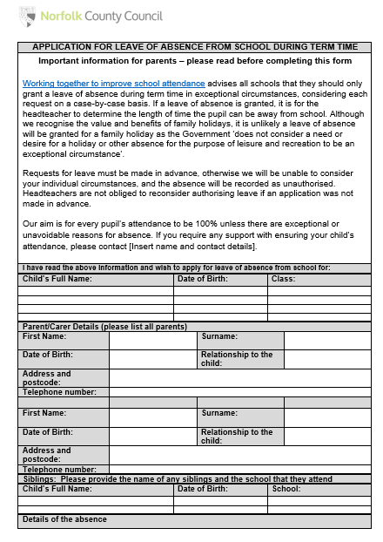
Appendix 2: Application for Leave of Absence from School During Term Time
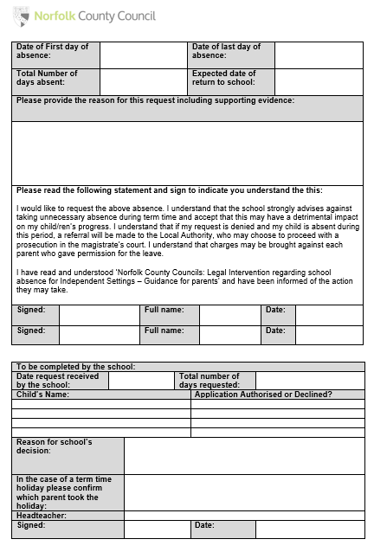
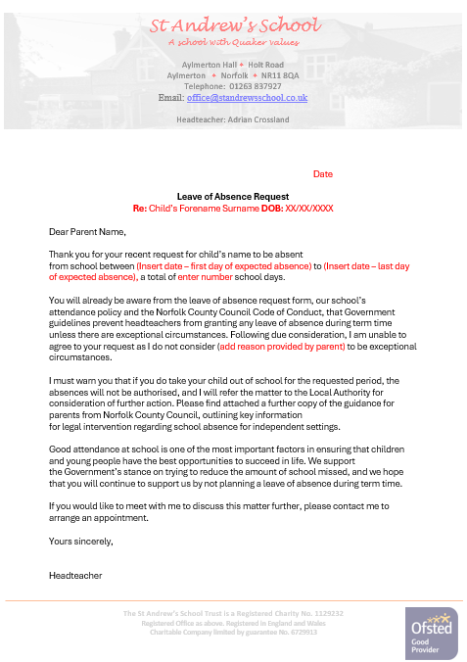
Appendix 3: Letter of response for leave of absence request
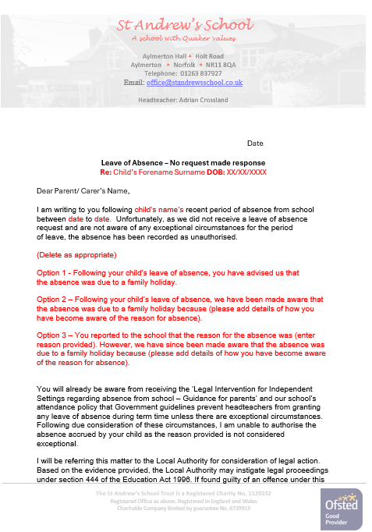
Appendix 3 - Letter of response following absence without request
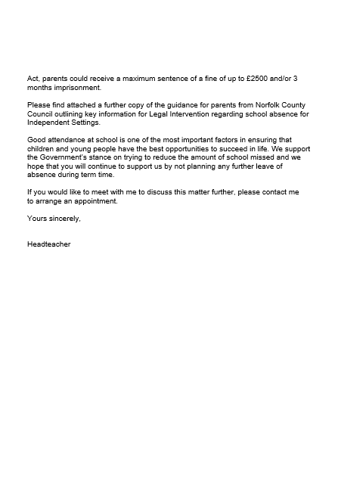
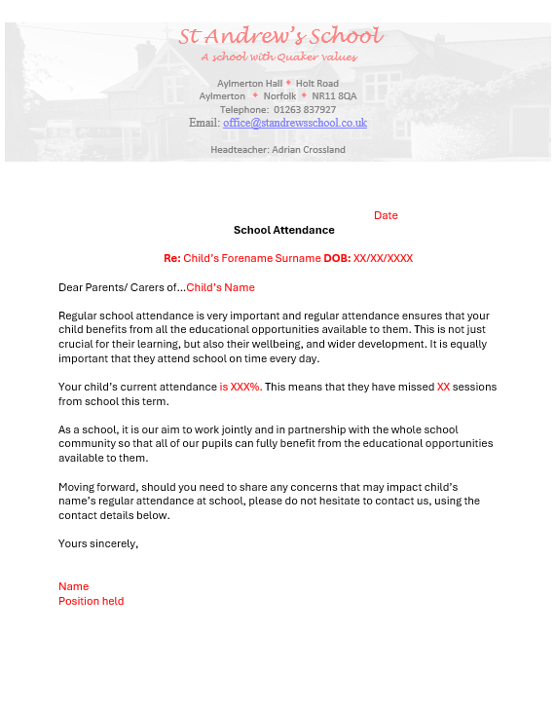
Appendix 4 – Letter informing parents of their child’s attendance

Appendix 5 – Invitation to attend attendance meeting
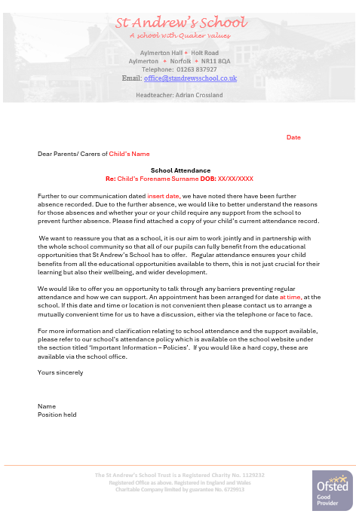
Appendix 6 – Support First Approach Planning Record
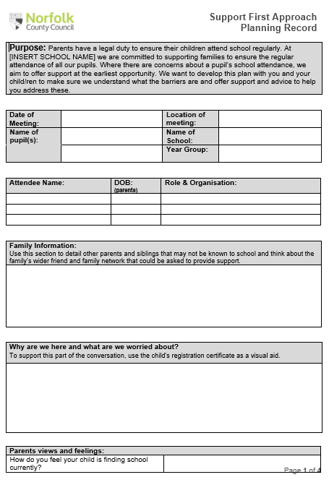


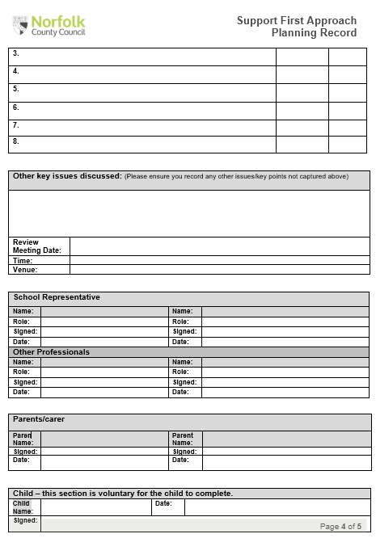
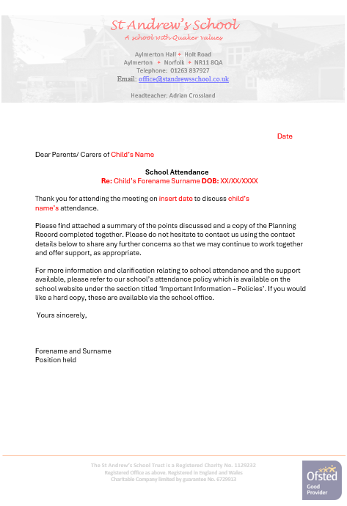
Appendix 6 – Letter sharing minutes of the attendance meeting

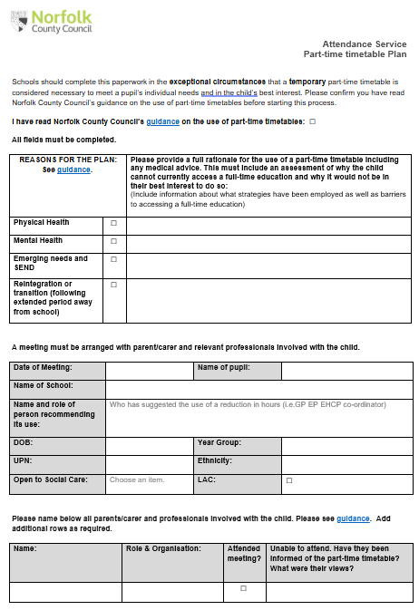
Appendix 7 – Part-time timetable paperwork
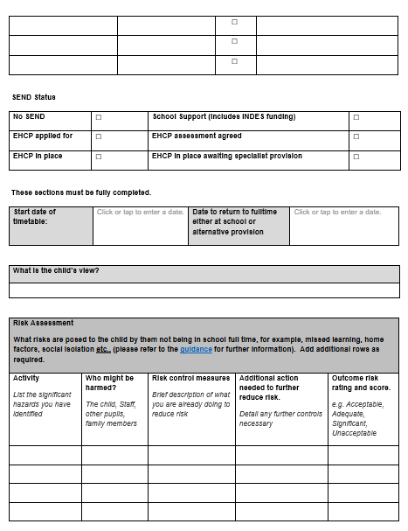
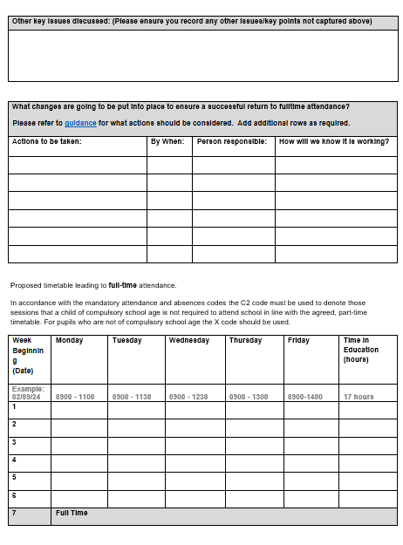
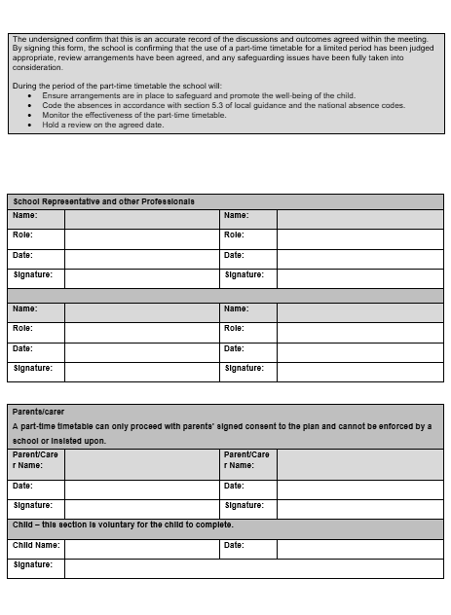

This is in accordance with the NSCP Joint Protocol between Health Services & Schools in respect of the management of pupil absence from school when medical reasons are cited
A mobile child is a child of compulsory school age who has no fixed abode and whose parent(s) is engaged in a trade or business of such a nature as to require them to travel from place to place.

