St Andrew’s School Newsletter

January 2025

Headteacher: Adrian Crossland

**Head’s Note**

First of all - Happy New Year!

I hope everyone had a fabulous Christmas.

We are starting 2025 with a very long newsletter, capturing all of the fabulous activities at St. Andrew’s School last term.

May I also take this opportunity to thank you all for your support in my first term at the school.

Best wishes,

Adrian

**Gentle Reminders**

**Inclement weather**

Please could we ask you to ensure that your child is sent in with appropriate clothing to cope with the changes in the weather.

**Sickness**

As the weather changes, the multitude of viruses and bugs seem to become prominent in the school environment. It is fine for your child to attend school if they have a cold or sore throat but please do keep them at home if they have a temperature, sickness, or diarrhea. We have a 48-hour clear policy for both sickness and diarrhea so please do not send your child to school during this period.

**All absences should be reported to the school on 01263 837927 before 8:30am please.**

**Key Dates**

Wednesday 29th January – SMSC Day

Friday 14th February – Last day of term

Monday 3rd March – Students return to school

**Christmas Fayre**

It was lovely to see so many of you at the Christmas Fayre. The students and staff worked extremely hard preparing for the school’s first Christmas Fayre in recent times and it made it even more special for everyone that the event was so well supported. This event raised £562.46 but most importantly it brought everyone together. I would like to thank all of the staff for putting so much energy into the event at the end of a very busy term but particularly Lauren for leading the arrangements.

**Christmas Tree Donation**

I am sure you will have seen the beautiful Christmas tree in the school foyer. This was very kindly donated by Country Cars, Cromer taxis. We are extremely grateful for this very kind donation and I am sure you will agree, it looked amazing!

**Christmas Trips**

The students were all given the opportunity to attend one of three options at the end of term: a trip to the theatre or cinema, or to watch a film in school. The employees at both the Regal Movieplex, where the students enjoyed watching Despicable Me 4, and Sheringham Little Theatre, where students were treated to a performance of Robin Hood, were very complimentary about our students. I was lucky enough to accompany the trip to the cinema and the behaviour was exemplary. We were all very proud of how the students represented St. Andrew’s School and we would like to say thank you to Carol M for organising all three experiences.

**Christmas Dinner**

Both students and staff were treated to a fabulous Christmas dinner, cooked by Jim and his team of willing volunteers. This year the meals were served across two days because of the increase in student numbers and so many people ordering a festive meal. The reviews were overwhelmingly positive, and I am so pleased that the students requested that the Christmas lunch be repeated. This will now be offered every year. After lunch, the students had the opportunity to sing Christmas carols around the tree. Thank you very much, Jim.

**The St. Andrew’s School Talent Show**

The St. Andrew’s School talent show was again an event requested through Student Voice and was a brilliant occasion. A full-house audience was treated to a wonderful array of performances from both students and staff. It was lovely to see our students encourage each other and celebrate everyone’s achievements and we were very proud of everyone who put themselves forward to make the morning so special.

**Alice in Wonderland Performance**

At the end of term, St. Andrew’s School students put on its first ever production: Alice in Wonderland. The cast performed twice on a very busy day, first performing to the whole school in the morning and then to family and friends in the afternoon. The cast were incredible, not only remembering all of their lines but also performing with such confidence so that every word could be heard. The cast included our youngest students, oldest students and many in between and we were very proud of them all. The set also looked amazing. This was created by students and staff at the school. This production would not have been possible without the fantastic support of our staff, especially Sarah who led this project. I would like to thank everyone involved.

**Science Trip to Hunstanton Sealife Centre**

Last term the students from Year 7 had the exciting opportunity to visit the Hunstanton Sealife Centre as part of their science curriculum. The trip, designed to enhance our students’ understanding of marine life and ecosystems, was a fantastic learning experience for everyone involved.

Throughout the day, the excitement was palpable, with students enthusiastically taking notes and asking insightful questions to the staff at the Sealife Centre. It was heartwarming to see the joy on the children’s faces as they observed the animals up close, truly immersing themselves in the experience. Their curiosity and eagerness to learn was evident, making the trip an unforgettable experience for both the students and teachers.

Upon returning to school, the students channelled their enthusiasm into creating presentations on the penguins and seals they had studied. The presentations were a wonderful display of the students’ hard work and creativity, and it was exciting to see how much they had learned during the trip.

We are incredibly proud of our students and grateful for the opportunity to provide them with such a valuable hands-on learning experience. The visit to Hunstanton Sealife Centre was not only educational but also a fun and memorable adventure that our students will treasure for years to come.

Paula Mayes – Science teacher

7A visited The Sticky Earth Cafe on Wednesday 4th December. The students were able to pick what they wanted to paint; the staff were very accommodating. The students all enjoyed themselves and their behaviour was amazing. They were a pleasure to take out and represented our school perfectly. Staff explained that they could not take their items home on the same day as they had to go in the kiln. I picked them up on the Saturday and they all looked fabulous!

Margaret Kendrick - Teaching assistant

**Educational Presentation on Gambling and Gaming Loot Boxes**

Last term, the students from Year 8 to Year 11 had the opportunity to attend an engaging and informative presentation delivered by Rod from *GamCare*, a charity organisation dedicated to supporting individuals affected by gambling-related harms. The presentation was an eye-opening experience that focused on the risks associated with gambling and gaming loot boxes, and how these can have serious consequences on both personal well-being and social relationships.

Rod shared valuable insights into what gambling is and explained how it is increasingly linked to the gaming world. He discussed how gaming loot boxes—virtual items purchased in video games for a chance to win prizes—can lead to behaviour similar to gambling, especially for young people. The session helped students understand how these practices can become addictive and the potential dangers they pose.

During the presentation, Rod provided strategies for recognising the signs of risky behaviour and highlighted the importance of knowing when to seek help. He also offered advice on how to protect oneself and others from the harms associated with gambling, emphasising the importance of making informed choices and understanding the consequences of impulsive actions.

Students found the session both engaging and enjoyable, with many commenting on how much they learned about the connections between gaming and gambling. The interactive nature of the talk encouraged students to ask questions, share their experiences, and reflect on how gambling-related behaviours can impact not only individuals but also families and communities.

We are grateful to Rod and GamCare for taking the time to visit and provide our students with such a crucial learning experience. The knowledge and advice shared will undoubtedly help our students make more informed choices and recognise the potential risks in today’s digital world.

We hope that this presentation serves as a stepping stone in fostering a greater understanding of the risks associated with gambling and gaming, empowering our students to make safer and more responsible decisions in the future.

Paula Mayes – PSHE Lead

**Writing Skills for Everyday Life**

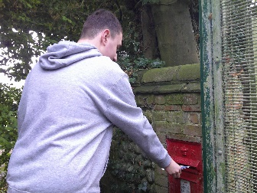 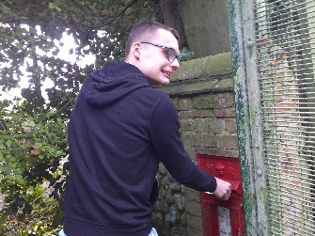 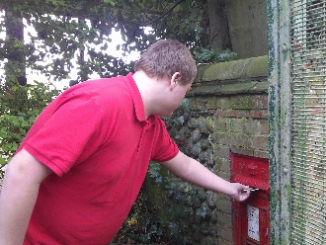 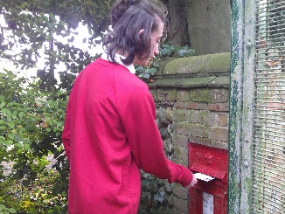

Last half term, one of the topics Year 11B were working on was their AQA Unit: Writing Skills for Everyday Life. The class enjoyed writing postcards to their relatives about the things they did during the half-term holidays and learned how to add an address, ensuring that their handwriting could be read by the Royal Mail team. They then posted most of the letters in the post box at the school gate. One letter couldn’t be posted in the post box as it was being sent all the way to Australia!

Sarah Knights – English teacher

**Weekly Trips – Careers**

Last term the Year 10 and Year 9B students visited JR Bowling Alley. As well as enjoying a game of bowling together, they asked the staff questions about their jobs as part of our careers programme. The students who volunteered to ask questions demonstrated confidence in practising their social skills and writing notes on the answers. The students learnt about an apprenticeship course they offer as well as the daily tasks and responsibilities involved in working in the various jobs, from customer service to kitchen duties.

The Year 10s have also participated in a range of outdoor activities, including an autumn scavenger hunt at Felbrigg and fossil hunting at West Runton. The students focused on the activities which challenged their observational and communication skills. Lots of fun and learning had by all - well done!

Juanita Burrows- Head of Careers

**ASDAN- PAT Dog**

We were delighted to have Patsy the greyhound and her handler David to visit as part of the Year 11 ASDAN lessons. Being able to walk and prepare Patsy as part of their practical assessment for the Caring for a Pet module, was an exciting learning opportunity for our students.  David explained Patsy’s history as a racing greyhound and the promotional work she does to help other greyhounds. The students were keen to communicate their knowledge of dogs and ask David questions. We now hope to welcome back both Patsy and David, later in the year.

Many thanks to David and Patsy.

Juanita Burrows- Head of Careers

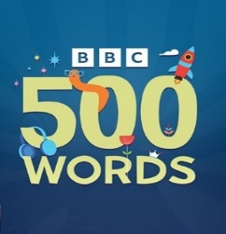

**St. Andrew’s School BBC’s 500 Words Winners**

“Write a story you would love to read!" This year our students were given the opportunity to enter the BBC's 500 Words, ​the UK's largest children's writing competition for children aged ​5-11. We also opened it up across the school for children​ to craft a good yarn.​ After much deliberation, our judges selected one winner and three runners-up, who were gifted book tokens.  Their use of originality, language, plot, characterisation and entertainment value shone out. Very well done to all those students who have taken part.

Winner of the St. Andrew’s School ‘500 words’ competition – Dylan

The three runners up were: Callum, Enid and Seren.

Huge congratulations to you all!

Emma Clark – English and Phase Lead