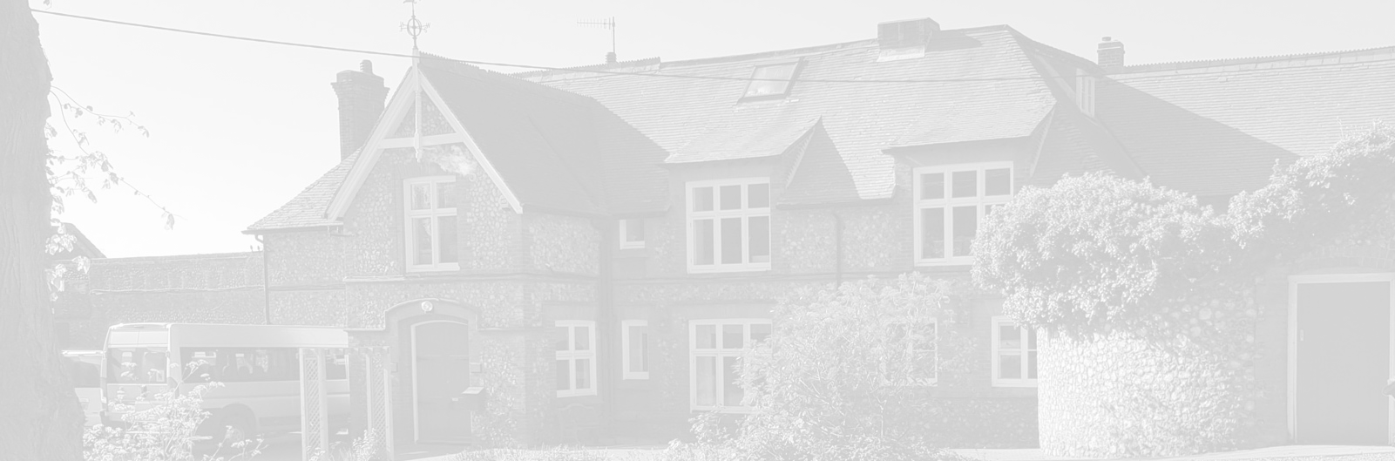
St Andrew’s School
A school with Quaker values

Aylmerton Hall Holt Road
Aylmerton Norfolk NR11 8QA
Telephone: 01263 837927
Email: office@standrewsschool.co.uk

Headteacher: Adrian Crossland
The St Andrew’s School Trust is a Registered Charity No. 1129232

Behaviour
Policy

Summary of changes

Page Ref | Section | Amendment | Date of change

Adopted by Trustees date: 13th October 2025
Next review date: Autumn Term 2026

Introduction
“Encouraging every student through learning, creativity and adventure to become a kind, respectful and independent young adult.”
At St Andrew’s School we believe that students need to be safe and that every member of our school community is accepted as a unique individual, feels important and is valued as such. In accordance with Quaker principles all members are valued as equals for the important contribution they make to the school and wider community.
- At St Andrew’s School, all students are given the chance to make a fresh start in their school life.
- We work in partnership with parents, other schools, agencies and the outside community to promote an inclusive education.
- We promote independence, encouraging intellectual, emotional, spiritual and healthy growth to develop lifelong learning.
- At St Andrew’s School we actively encourage ‘repairing the damage’ and offer meetings so that students can have an active role in the development of their own behaviour.
- We help to develop self-regulation and positive behaviours of students by supporting and encouraging them to be responsible for their own behaviour and understand that their actions have consequences which affect others.
- We appreciate and encourage in students and staff, positive qualities such as respect for others, honesty, hard work, effort, teamwork, creativity, humour, self-control, politeness, care and consideration for others and property.
- We work together to enhance learning and self-esteem.
- We expect staff to be effective role models for students by promoting positive behaviour in school.
St Andrew’s School believes that all behaviour communicates a need, emotion or wish and that at times other students or adults may experience this as challenging. Members of staff will treat each student as an individual and will develop a flexible approach to meeting their individual needs. Staff will involve students and important people in their lives in decisions about how to support and encourage appropriate behaviour.

We aim to prevent negative behaviour incidents by ensuring that adults interact positively with students, by providing engaging activities based on an understanding of students’ needs, teaching them how to behave appropriately and giving them the skills they need to interact well with others and self-regulate.

The culture and ethos of our setting should enable all staff to:
- Feel valued, confident and empowered
- Be better placed, and capable, to support students who display behaviours that challenge or harm
- Feel confident to raise concerns and be listened to
- Be able to seek help and support when necessary
- Know their voice is heard in decision making
- Be creative, innovative and take appropriate risks in responding to individual student needs

Positive Behaviour Support

Supporting our students to manage their behaviour is an integral part of our work at St Andrew’s School. All staff, regardless of their role, have a part to play in upholding this. When we support students with behaviour, we want our students to feel happy, valued, included, respected and safe through:
- Practising acceptance of emotions
- Accessing success and feeling included
- Developing positive, trusting relationships
- Celebrating differences
- Promoting positive wellbeing and behaviour
- Ensuring the voices of the students are heard

Positive and effective behaviour support at St Andrew’s School is dependent on the following:
- A range of positive reward strategies
- A therapeutic approach and attitude
- Explicit teaching of how to self-regulate and socially interact with others
- A blend of consistency and flexibility depending on the individual needs of students
- Teaching that is well planned, delivered, clear in its objectives and appropriate to the ability and interests of the students
- Open communication with parents and carers
- Meetings to involve everyone in the students’ development
- Appropriate verbal communication with students, taking into account their social communication needs

The Importance of Relationships

Due to a whole range of ‘adverse childhood experiences’, trusting adults may be a challenge for many of our students. For these students, it is our actions and not our words which help to build a relationship where students can begin to trust and make different behavioural choices. ‘Holding in mind’ is one such strategy we apply, where we remember a student over the weekend or holidays, and we reflect this back to them during the school day - e.g. ‘I was thinking about you on Sunday….’ Where undesirable behaviour is ‘low level’ staff may choose to acknowledge that they have noticed, but move swiftly on to positive ignoring, and then when appropriate, engage in an attuned conversation with the student. e.g. ‘I noticed you were ……., I wonder if you were feeling…….’. Expressing an interest in hearing what the child can communicate, verbally and non-verbally, without needing a response, also helps to build the possibility that we can be trusted adults.

Where behaviour may be suggesting an unmet need, staff will try to explore this creatively with the individual student. All students need some additional support at particular times and in particular ways. At St Andrew’s School we will endeavour to work creatively to provide an alternative narrative for each individual student.
- If lunchtime is a trigger, alternative arrangements can be made.
- Careful seating arrangements.
- Noise cancelling headphones can reduce the stimulation in noisy environments.
- Flexible timetables can provide opportunities for calm.
- Enrichment activities provide learning opportunities away from the classroom.
- Flexibly changing adults to provide an alternative relationship.

The Vital Relational Functions (VRFs)

In all interactions with students, staff endeavour to use the VRFs outlined in the Thrive Approach. These skills provide a relational basis for a child’s emotional, social and neurological development.
They are:
- Attune– demonstrating an understanding of how they are feeling by “catching and matching” their emotional state
- Validation– demonstrating that their feelings are real and justified
- Containment– Offering their feelings back to them, named and in small pieces
- Soothing– Soothing and calming their distress repeatedly
- Regulation– Communicating the capacity to regulate emotional states by modelling how to do it

The provision of emotional containment by the adult who is working closely and regularly with the student, is a significant contributing factor to the student’s developing capacity to contain and regulate their own emotions. The relationship between a student and a significant adult should not be under recognised or an under-used resource so using Thrive, this relationship is enhanced. It can help a student get ready to learn and enhance their learning, build positive relationships between a student and their peers and it can improve attainment.

Verbal and Body Language

Appropriate use of positive communication with staff and students is vitally important. Language is the main tool for learning and for positive behaviour management.

It is important to remember there is more than one type of language: ‘verbal and body’. Body language coveys 80% of the meaning and intention so our body language needs to reflect our positive approach as well as our words. Staff will:
- Model appropriate language for challenging behaviours
- Provide opportunities to teach emotional language through a structured social skills program
- Describe the behaviour – ‘This is what you are doing’
- Explain the effect of the behaviour and why it needs to stop
- Model and specify the correct behaviour
- Give positive feedback, this includes direct and indirect praise
- Use a combination of positive gestures and signals as well as language

The ‘How to Support Students in the Zones’ document offer examples of phrases that will be used at St Andrew’s School as well as ways staff can change and adapt their body language to meet the needs of students. Some of the common phrases used are, ‘I see…’ to notice the behaviour, ‘I understand…’ to validate the feeling and empathise and ‘Let’s go…’ to support students to use a different strategy.

How We Teach and Support Self-Regulation?

‘Zones of Regulation’ is a programme that supports students to understand their emotions and develop self-regulation. Staff and students have a shared language for communicating and understanding emotions. The ‘Zones of Regulation’ provide a tool for students to think and talk about how we feel on the inside and sort emotions into four different coloured zones. Students have the opportunity to explore those emotions and different strategies they can use to help self-regulate establishing their own ‘Regulation Toolkit’. All staff have been trained in the use of ‘Zones of Regulation’.

Students follow the ‘Zones of Regulation’ scheme of work in KS2 as part of their weekly social skills lessons. This will then be revisited throughout their time at St Andrew’s School in response to the individual needs of students and classes. Individual ‘Regulation Toolkits’ will be reviewed at least termly so students can identify any changes or additional tools/ strategies that need to be included.

Norfolk Steps Training

Two members of the Thrive Team are fully qualified Lead Professionals in ‘Step On’ and ‘Step Up’ and trained to deliver Norfolk Steps. Norfolk Steps ‘Step On’ training supports early intervention and prevention through a whole-school or setting approach, including managing behaviours that challenge or may risk harm. ‘Step On’ promotes positive behaviour strategies such as consistency, de-escalation, behaviour analysis and differentiated planning. It also supports safe and effective use of everyday non-restrictive physical interventions.

Individual Targets

A student’s Individual Educational Plan (IEP) is likely to have targets relating to social skills and communication skills to improve their ability to behave and communicate appropriately. These targets are chosen to relate to their individual strengths and barriers to learning and the desired outcomes in their Educational Health Care Plan (EHCP).

Staff are also trained to identify potential mental health issues in our students and will follow the school’s safeguarding procedures to alert the Designated Safeguarding Leads and Mental Health Lead in a timely manner. This will enable the appropriate support to be offered in collaboration with the parents/carers, other professionals and school staff. The Mental Health Lead will be able to signpost to relevant support.

The Risk Assessment Calculator (Appendix B) and Individual Positive Behaviour Support Plan (Appendix C) create a bespoke plan to support individual students. It will identify positive behaviours to look out for, which de-escalation techniques are appropriate when students are starting to display difficult behaviours and individual tools and strategies.

Home School Communication

There are good home/school links to ensure that progress is monitored and any other problems the student may be experiencing, either in school or at home, can be recognised and considered in relation to the student’s behaviour.

To support staff in their approach to behaviour, it is essential to work closely with parents/ carers. Staff communicate regularly with parents by:

- Using a home school communication book which is sent home daily. Some staff will use the messaging service on Class Dojo as an alternative method of communicating with parents/carers at home.
- A telephone call or email to discuss both positive and negative behaviour and any potential consequences.
- Arranging meetings to discuss any concerns or queries – it is important that issues are raised in a constructive and supportive environment.

When Students Make the Right Choice

St Andrew’s School recognises that the emphasis should be on the positive aspects of behaviour which can be encouraged in a variety of ways.
Our aim is that all students show positive behaviour by following the ‘3 Golden Rules’. These have been devised by students and describe the expectations for all in the school.

- Be Honest
- Be Respectful
- Be The Best You Can Be

Every day, students will have the opportunity to gain points linked to these rules. Students can also gain a bonus point if they have had a particularly good lesson. Students have the potential to gain 4 points every lesson.

Student points are collated, and then these translate into money. The total number of points is multiplied by three so if a student has achieved 50 points this will equate to £1.50 that can be spent on a therapeutic or educational object. Anything that is purchased must be agreed with SLT and parents/ carers.

Students track their points on a ‘Daily Points Card’, some students also prefer to collate their points in a visual way such as collecting counters/ discs for each point. In KS2, points are added on Class Dojo and the total number of points can be seen by both students and parents/carers.

There are also generic rewards designed to promote a team ethos and contribute towards the greater good of the school, such as a group ‘Gotcha’ reward. Students have the opportunity to participate in ‘Student Voice’ where suggestions can be made. There are also individual reward systems that can be designed around the young person’s specific interests to make it relevant to them. Some students dislike public recognition or praise, so staff will implement the reward system accordingly showing flexibility and understanding of individual student needs. Some examples of these incentives are:

- ‘Gotcha’- a post it note with details of positive behaviour, given to student with verbal praise and bonus point.
- Verbal encouragement and verbal private praise, if appropriate e.g. “Well done for staying on task” “It’s good to see you ready for learning.”
- Non-verbal acknowledgement; a discreet ‘thumbs up’ gesture or a smile.
- Proximity Praise.
- Certificates for progress or positive behaviour shared in the half-termly celebration.
- Group reward (earned by achieving 25 or 50 ‘Gotchas’) e.g. a visit to a zoo/ Sealife Centre/ theme park) is given when a whole group shows appropriate, positive behaviour.

When Students Make the Wrong Choice

There will be times when students will choose not to follow the expected behaviours at St Andrew’s School and prevent others from enjoying or feeling comfortable and safe in the learning environment. When students show disruptive behaviour then action must be taken.

When managing behaviour, it is important that there is a consistent approach throughout the school. All staff should adopt the following approach when managing behaviour which is challenging or disruptive, unless a specific strategy has been put in place by the Thrive Team. Staff also need to have knowledge of the student’s ‘Individual Positive Behaviour Support Plan’ (Appendix C) and the appropriate de-escalation techniques should be tried.

The classroom steps are:

Step 1 – Remind the student that they need to follow instructions, using visual reminder cards to support if appropriate.

Step 2 – Offer students a break or a tool/ strategy from their Regulation Toolkit. Refer to the ‘How to support students in the different Zones’ document (see appendix I) and ‘Universal Classroom Checklist’ (see appendix E).

Step 3 – If the behaviour continues, the student will receive a second reminder about the expected behaviour.

Step 4 – After three reminders, if the behaviour continues, call for a member of the Thrive team who will offer support. They will help the staff in providing intervention to support the student to regulate and be ready for learning. Students will have ‘restore, repair and reflect’ time during this step and depending on the severity of behaviour, further support may be offered by a member of the Thrive team or SLT. Depending on the severity of the behaviour, the Thrive team may liaise with SLT to agree next steps.

Step 5- The student then resets and has a fresh start.

Students do not show the expected behaviours when:
- Verbally unkind to other students or adults
- Use inappropriate language
- Fail to attend lessons without permission to do an alternative activity
- Ignore staff instructions
- Refuse to work

Instant Step 4 Behaviours:
- Physical aggression towards students or staff
- Spitting
- Damaging property

Consequences
St Andrew’s School applies a restorative approach, which prioritises the need for students to ‘restore, repair and reflect’ on what caused by the inappropriate behaviour rather than a need for blame or punishment. Knowing that someone cares enough to put boundaries in place for uncontrolled, unacceptable behaviour is an important concept for our students to learn.

There are two different types of consequences:
- Protective consequences – the removal of a freedom to manage the harm (foreseeable or actual)
- Educational consequences – the learning, rehearsing or teaching so the freedom can be returned.

Fundamental to the success of either of these is the need for CONSISTENCY from ALL staff.

Following inappropriate behaviour with another student/ staff member, we will endeavour to hold restorative meetings or support students to learn from the incident. This will be managed in a sensitive manner that supports both parties, whilst considering their individual needs.

Whilst we work within a framework of general rules and behaviour guidelines, we do understand that one size does not necessarily fit all. We aim to recognise the differences between emotional and behavioural difficulties and behaviours from emotional trauma and past experiences. Therefore, our approaches may be tailored to the individual to consider their prior experiences.

Consequences may include the following:

- Verbal or visual warning that a consequence will be incurred if the inappropriate behaviour continues
- Time out
- Students not achieving their reward points for that session
- Asking the student to leave the group for a short period of time to calm and reflect on their actions
- Asking the student to leave the group for a longer period of time, supported by an adult
- Carrying out a task e.g. mending something that has been broken during the incident, cleaning up (where appropriate) or washing off graffiti
- Making a contribution towards the cost of any loss or damage for which they are personally responsible
- Withdrawing students from a planned activity
- Internal exclusion
- Fixed term exclusion
- Cessation of placement

The ‘Post Incident Debrief’, where appropriate, should be used to reflect on the behaviour, identify the triggers and try to prevent the behaviour reoccurring (see appendix F).

Bullying

Every student is expected to behave in a manner that does not infringe the liberty of others, thus bullying (see Bullying Policy) whether physical, verbal or cyber, it is not tolerated.

We recognise that students can also be vulnerable to physical, sexual and emotional abuse by their peers. Staff will not tolerate or dismiss concerns relating to abuse; it will not be tolerated or passed off as ‘banter’, ‘just having a laugh’ or ‘part of growing up’.

At St Andrew’s School, all staff are trained so that they are aware that safeguarding issues can manifest themselves via child-on-child abuse. This is most likely to include, but may not be limited to:
bullying (including cyber bullying), physical abuse such as hitting, kicking, shaking, biting, spitting, hair pulling, or otherwise causing physical harm, sexual violence and sexual harassment, sexting (also known as youth produced sexual imagery), initiation or hazing (gang/group) type violence and rituals or gender- based violence or racism.

Individual Positive Behaviour Support Plans

An Individual Positive Behaviour Support Plan may be in place to support a student with their behaviour. Throughout the development and implementation of the plan, it is vital that the student is fully involved and understands that the school and family want them to be happy and learn, and that all children have a right to feel safe in school. It is the school’s responsibility to ensure this is a reality for every student at St Andrew’s School. The plan will include:
- Areas of strength
- Motivators
- Areas of need
- Student voice
- Presenting behaviours that challenge or cause harm
- Possible triggers
- Positive behaviours we are supporting
- Possible functions of behaviour
- Differentiated measures to proactively promote/ support positive behaviour.
- Positive behaviours and what we will say and do to regulate behaviours and reinforce positives.
- First signs of escalation and what we will say and do to de-escalate/ divert
- Behaviours that challenge and what we will say and do to de-escalate/ divert
- Behaviours that harm and what we will say and do to best ensure safety
- De-escalation and Restore/ Repair/ Reflect.

Individual Positive Behaviour Support Plans will be reviewed termly, or as the need arises. They will remain a working document, and successful and unsuccessful strategies will be adapted and changed accordingly.

Roots and Fruits Analysis

Roots and Fruits can be used as a tool to analyse behaviour situation by identifying the following information:
- Behaviours that challenge or harm
- Positive behaviour
- Uncomfortable feelings
- Comfortable feelings
- Negative experiences
- Positive experiences

Roots and Fruits can be used to help analyse the behaviour and support staff to write Individual Positive Behaviour Support Plans.

Report Cards and Zones of Regulation Tracker

Report cards may be used as a short-term measure to support behaviour. Students may have individual report cards to track and encourage positive behaviour throughout the day/ week. These report cards will be managed by the Thrive team/ SLT and will be shared with parents/carers.

The ‘Zones of Regulation Tracker’ can be used with students to monitor and graph a student’s Zone of emotion throughout the day. It will help identify patterns and guide the Individual Positive Behaviour Management Plan.

Exclusions

A student may be excluded, for a fixed term or a cessation of placement for behaviour which endangers the welfare of themselves or others. External exclusions may be for a fixed period of no more than five days. Actions, which will be dealt with in this most severe manner include:

- Smoking on the school premises or bringing in lighters or other smoking paraphernalia
- The use or possession of any illegal drug, legal substance with similar effect, or solvent
- The use or possession in school of any knives or weapons to threaten or harm others
- Acts of violent or threatening behaviour
- Unauthorised use or possession of alcohol
- Inappropriate sexual behaviour
- Bullying of other students
- Discriminatory behaviour
- Vandalism
- Theft
- Refusal to follow any relevant school policies
- Anti-social behaviour towards staff or other students

If a student is externally excluded (fixed term) parents/carers, Chair of Trustees and the Local Authority will be informed in writing. There will be arrangements made to ensure the student can continue their education at home. A record of these exclusions will be kept in school and added to the student’s individual file.

Any fixed term exclusion will be concluded with;
- A re-integration interview, usually with the student, their parents/carers, and a senior member of staff. The reintegration interview is not part of the consequence, but rather a process to draw a line under the misdemeanour, to make sure that all involved understand why the consequence was given and to agree strategies to support the student and to prevent any recurrence of behaviour.
- A student returning to school may be placed on report so that behaviour can be monitored for a set time agreed.
- If a student is not responding to the methods used to support a change in behaviour (risk plan, meetings etc.) it will be considered whether the placement is meeting the needs of the student and a meeting with EHCP co-ordinator and parents/carers may be arranged to discuss the suitability of the placement.

Cessation of Placement

Every effort is made to accommodate the needs of students who have been placed with us. However, where the placement may no longer be appropriate due to the student’s complex needs or where there is a persistent risk to themselves or to staff and other students, which cannot safely be controlled within the school environment a meeting with the Headteacher, EHCP Co-ordinator and parents/carers will take place. The Chair of Trustees will be informed immediately of all placement cessations.

If a decision is made to cease a placement, then the parent/carer of the student may appeal against this decision to the Trustees.

Appeals against exclusions or cessation of placement

- Any appeals must be made by the student’s parents/carers in writing to the Chair of the Trustees, at the school address, within one week of receipt of the letter notifying the parents/carers of the exclusion.
- The Chair of the Trustees will establish an Appeal Panel to consider the appeal. This Appeal Panel will consist of three members, including two Trustees and an independent person.
- The Appeal Panel will normally convene for a hearing within three weeks of the receipt of the letter requesting the appeal.
- The parents/carers may bring a representative to the meeting.
- The Headteacher will not be a member of the panel but will be asked to present the supporting facts and materials. All letters and documents relied on by the Headteacher shall be made available to the parents/carers prior to the hearing.
- The parents/carers or their representative may ask questions of the Headteacher or may raise any relevant matter for the consideration of the panel.
- The panel may call for any further information it requires.
- No evidence or argument shall be presented to the panel in the absence either of the parents /carers or their representative, or in the absence of the Headteacher.
- At the conclusion of the hearing, the panel shall retire to consider what recommendation it may make.
- The panel may recommend:
1. The exclusion/cessation of placement be confirmed.
2. The exclusion/cessation of placement is rescinded.

- The recommendation shall be communicated by the Chair of the Trustees, the parents/carers and the Headteacher.

We do not believe that our responsibility to an excluded student, or the family of an excluded student, ends at the point of exclusion. We will work to help the student find an alternative school, explore appropriate support or consider allowing the student to return as an external candidate to sit examinations.

Physical Intervention

Physical Intervention is anything from contingent touch, supportive side hugs through to non-restrictive physical interventions usually associated with challenging behaviour.

There are occasions when staff will have cause to have physical interventions with students for a variety of reasons, for example:

- To comfort a student in distress (so long as this is appropriate to their age)
- To gently direct a student
- For curricular reasons (for example in PE, swimming, drama etc.)
- First aid and medical treatment
- In an emergency to avert danger to the student or students
- In rare circumstances when Restrictive Physical Intervention is warranted

In all situations where physical contact between staff and students takes place, staff must consider the following:

- The student’s age and level of understanding
- The student’s individual characteristics and history (e.g. ASD, sensory intolerances, emotional stability, medical conditions)
- The location where the contact takes place (it should not take place in private without others present)

At St Andrew’s School, staff are trained by Norfolk Steps and the Headteacher holds a list of trained and authorised staff. Reasonable force can be used to prevent students from hurting themselves or others, damaging property or from causing disorder, and will always be recorded appropriately. Any use of reasonable force must be proportional to the circumstances and only used to maintain safety and prevent injury. Legal defence for the use of force is based on evidence that the action taken was:
- Reasonable, proportionate and necessary.
- In the best interest of the young person.

If physical intervention methods are required for any students, there is a further training course completed by staff ‘Step Up’ which provides guidance on the safe and effective use of restrictive physical interventions within current legislative frameworks. The school has two fully qualified and trained Lead Practitioners in ‘Step Up’ who will deliver the training. Staff are trained in using Norfolk Steps techniques that seek to avoid injury to the student; however, it is possible that accidental or non-intentional bruising or scratching can occur as an unfortunate outcome when trying to maintain safety. Such outcomes are not necessarily an indicator of misappropriation of the technique. Full evaluation and review of such outcomes will be undertaken by personnel from the senior leadership team.
Staff will always try to de-escalate the situation in a safe and supportive manner, however if it is used, a Restrictive Intervention Record must be completed within 24 hours (appendix G) or in the case of a Friday afternoon, this must be completed before leaving the school. Parents/ Carers will also be informed.

It is essential that any discussion of physical intervention is set in the wider context of education and behaviour management; it should not be seen as an isolated technique. If a student is identified for whom it is felt that physical intervention could be needed, then an Individual Positive Behaviour Support Plan will be completed. This Plan will help the student and staff to avoid challenging behaviour.

Searching, Screening and Confiscation

As stated in the Searching, Screening and Confiscation Advice for Schools (July 2022), Searching can play a critical role in ensuring that schools are safe environments for all students and staff. It is a vital measure to safeguard and promote staff and student welfare, and to maintain high standards of behaviour through which students can learn and thrive.

Headteachers and staff they authorise, have a statutory power to search a student or their possessions where they have reasonable grounds to suspect that the student may have a prohibited item listed in paragraph 31 or any other item that the school rules identify as an item which may be searched for
The list of prohibited items is:
- knives and weapons
- alcohol
- illegal drugs
- stolen items
- any article that the member of staff reasonably suspects has been, or is likely to be used:
- to commit an offence, or
- to cause personal injury to, or damage to property of any person (including the student)
- an article specified in regulations
- tobacco and cigarette papers
- fireworks
- pornographic images

Under common law, school staff, following discussion with SLT, have the power to search a student for any item if the student agrees. The member of staff should ensure the student understands the reason for the search and how it will be conducted so that their agreement is informed.

Recording and Monitoring of Incidents

Incidents are recorded for the protection of students and staff, and to monitor the behaviour of students. Where it is considered necessary, staff will monitor students using a Zones of Regulation Tracker to track behaviour patterns throughout the week (see Appendix J) and/or look at papers that have been transferred from the previous placement.
Any incident where injury has been sustained, whether accidental or the result of an incident, must be recorded in the Accident Book and a letter sent home to parents/carers (a copy to be kept in student’s file).
All written records must be completed within 24 hours of the incident occurring. If any physical intervention is used a Restrictive Intervention Record (Appendix G) must be filled in.

Student Conduct Outside of School

Students are expected to behave appropriately on their way to and from school and at any other time when they are out in the community. If a student’s conduct outside of school is witnessed by a member of staff, reported to the school by a member of the public and the student is identifiable as a student at our school, staff have a statutory power to discipline the students in line with the school consequences.

Appendix A
St. Andrew’s School
Home School Agreement 2025
School
The school will do its best to:
- Offer a safe, secure and caring learning environment
- Teach and encourage students to do their best and achieve their full potential
- Provide a balanced curriculum of the highest quality and meet the individual needs of every student
- Have a clear and consistent approach to rewards and sanctions to manage student behaviour
- Promote a healthy lifestyle
- Offer opportunities to develop independence skills and future economic wellbeing
- Communicate between home and school via home school books, texts, emails, newsletters and school website

Signed ………………………………… Date……………………………

Parent/Carer
To help my child at school, I will do my best to:
- See that my child attends school and timetabled lessons
- Inform the school each day of absence
- Raise any concerns or problems that might affect my child’s ability to learn or behave appropriately
- Support the school to make sure my child maintains good behaviour
- Attend parent meetings/review meetings to discuss my child’s achievements and progress
- Read all letters, messages and newsletters that are sent home
- Inform the school immediately of any changes to parent/carers emergency contact details
- If my child is ill at school, it is my responsibility to collect or arrange transport to collect my child

Signed……………………………………… Date………………………..

Student
I will do my best to:
- Come to school and attend timetabled lessons
- Behave well at all times in school and on transport
- Work hard and listen carefully to instructions
- Be polite, friendly and helpful to other children and adults
- Follow the school rules
- Tell somebody if there is something I am not happy about

Signed……………………………………….. Date………………………
Name of Student…………………………………………………………………………………

Appendix B– Risk Assessment Calculator

Name
DOB
Date of Assessment

Harm/Behaviour | Opinion  Evidenced  O/E | Conscious  Sub-conscious  C/S | Seriousness  Of Harm  A  1/2/3/4 | Probability  Of Harm  B  1/2/3/4 | Severity Risk  Score  A x B
Harm to self

Harm to peers

Harm to staff

Damage to property

Harm from disruption

Criminal offence

Harm from absconding
Other harm

Seriousness

1 | Foreseeable outcome is upset or disruption
2 | Foreseeable outcome is harm requiring first aid, distress or minor damage
3 | Foreseeable outcome is hospitalisation, significant distress, extensive damage
4 | Foreseeable outcome is loss of life or permanent disability, emotional trauma requiring counselling or critical property damage
Probability

1 | There is evidence of historical risk, but the behaviour has been dormant for over 12 months and no identified triggers remain
2 | The risk of harm has occurred within the last 12 months, the context has changed to make a reoccurrence unlikely
3 | The risk of harm is more likely than not to occur again
4 | The risk of harm is persistent and constant

Risks which score 6 or more (probability x seriousness) should have strategies listed on next page

Appendix C – Positive Behaviour Support Plan Guide
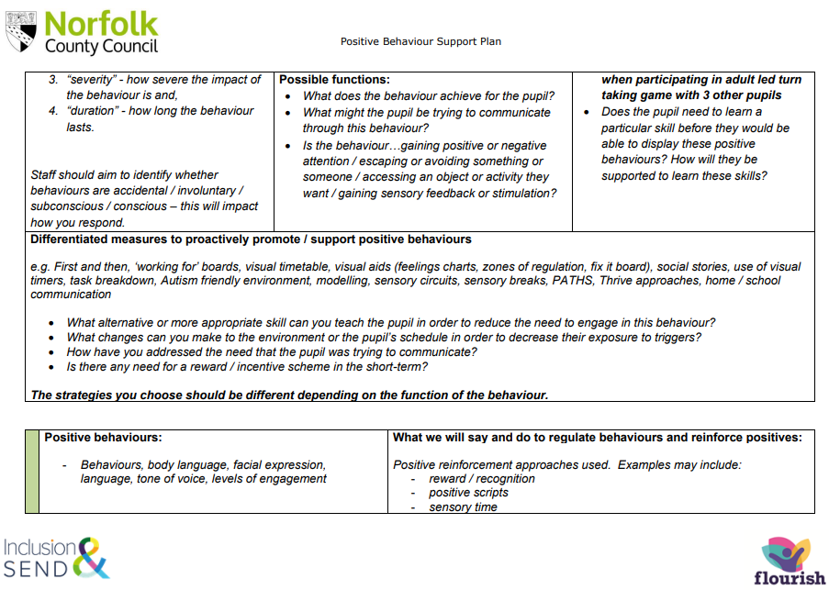
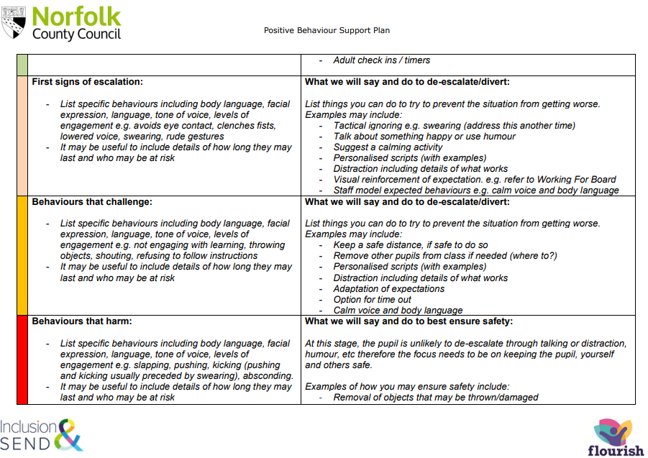

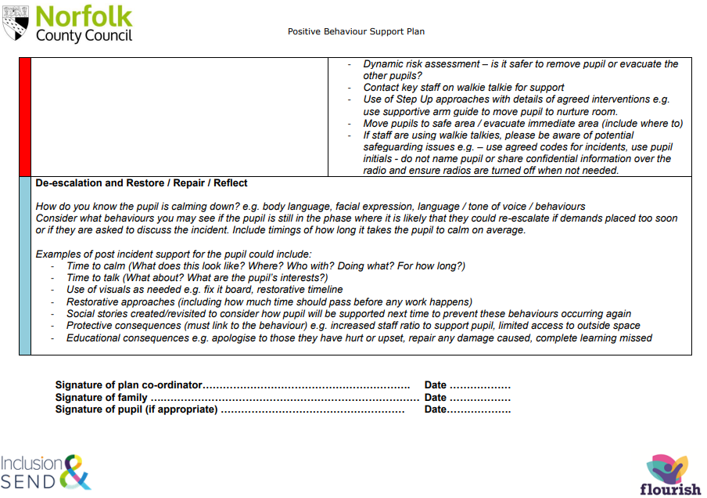
Appendix D – Roots and Fruits
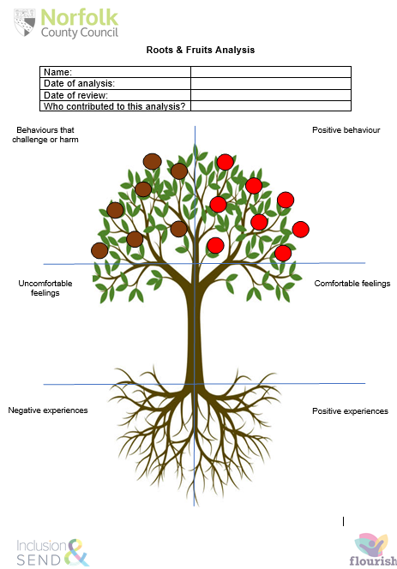
Appendix E – Norfolk Steps Universal Classroom Checklist
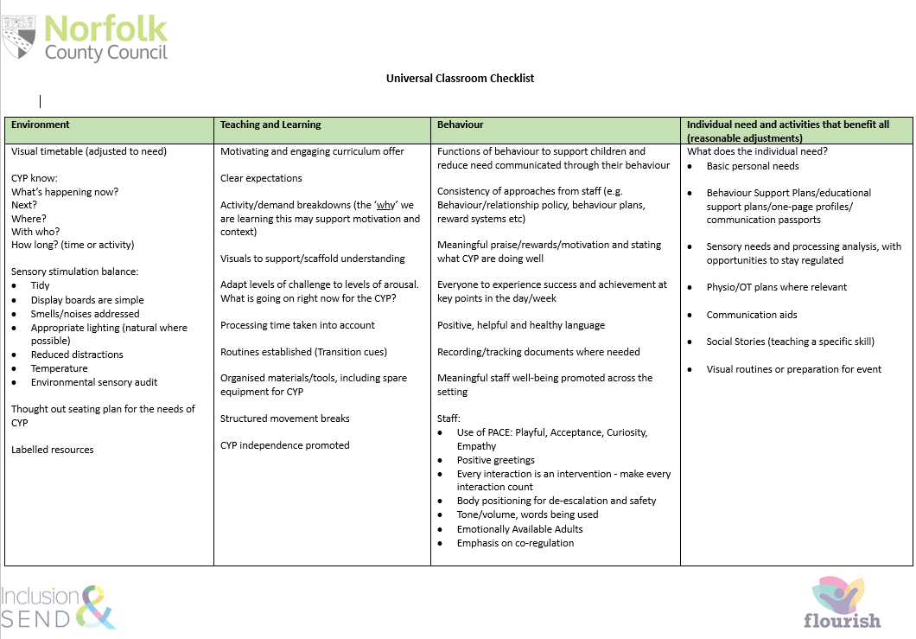
Appendix F – Post Incident Debrief for Staff and Students
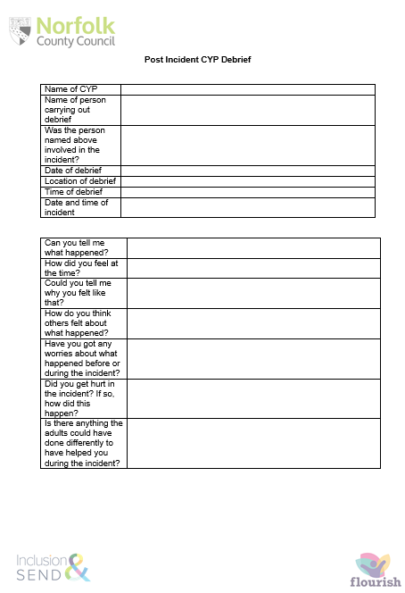
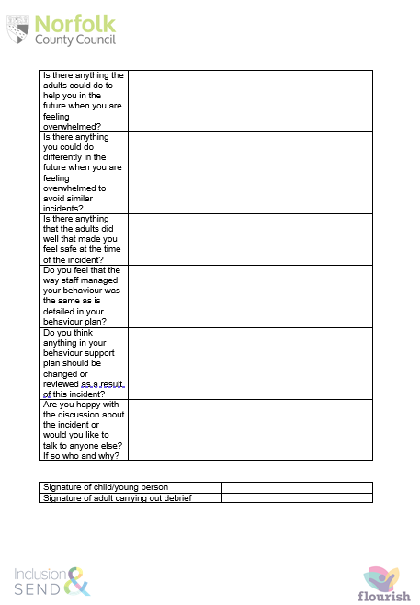
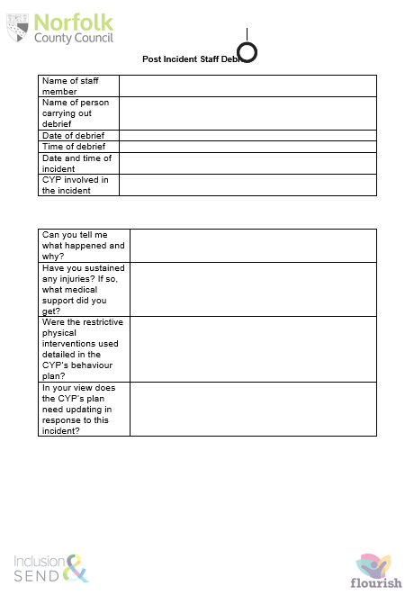
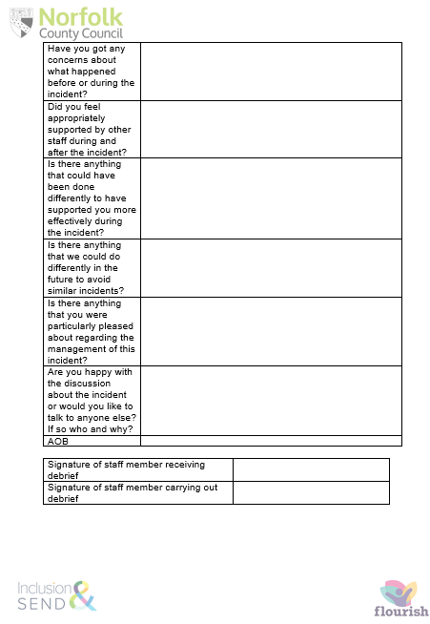
Appendix G – Restrictive Physical Intervention Record
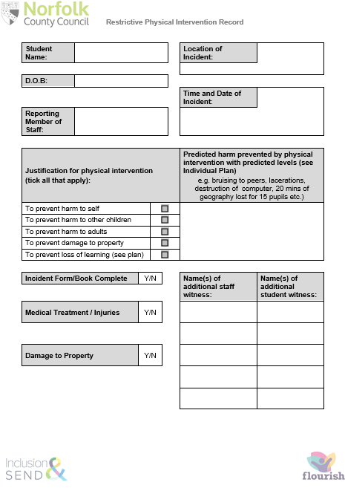
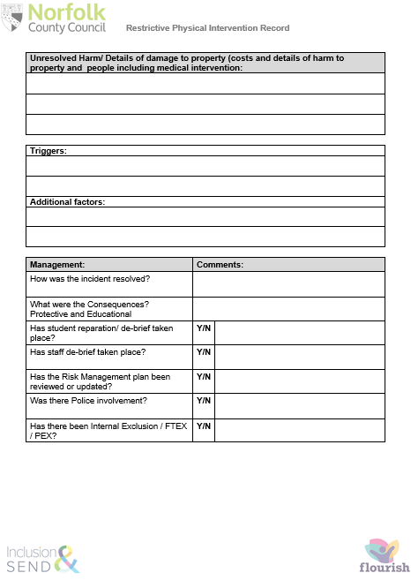
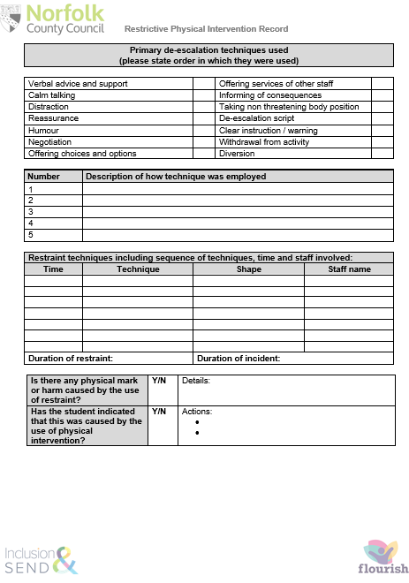
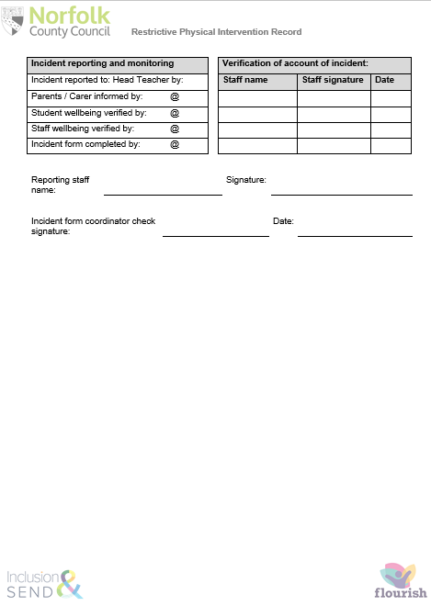
Appendix H – Audited Need for Restrictive Physical Intervention
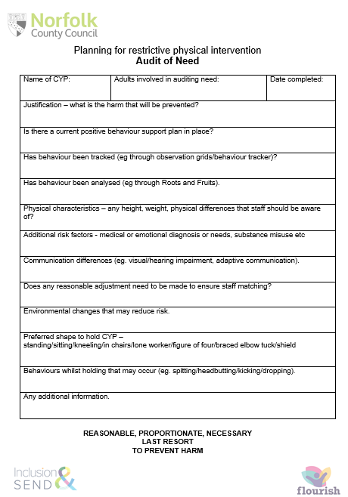
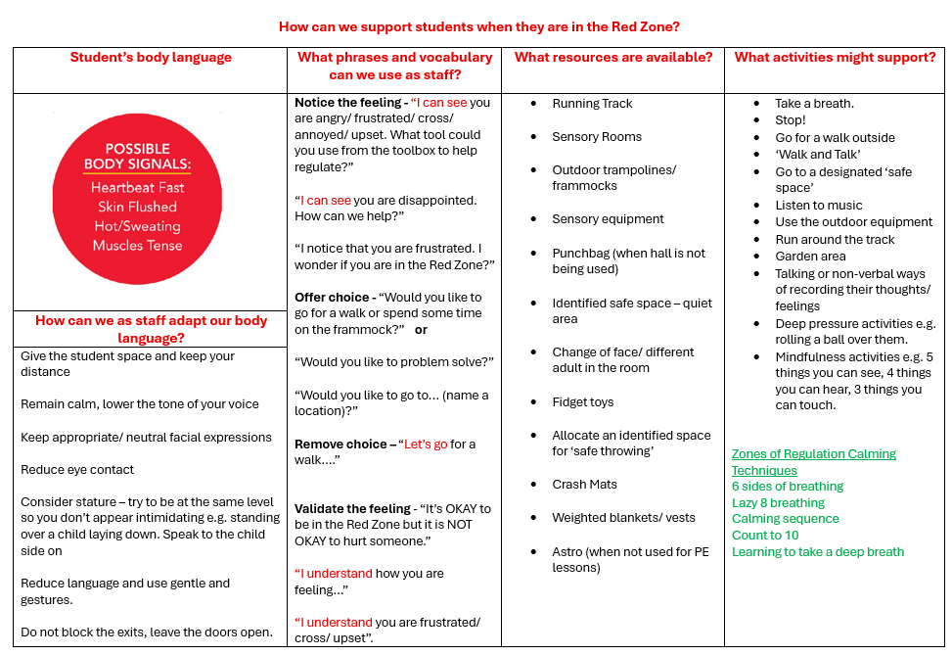
Appendix I – ‘How can we support students in different Zone

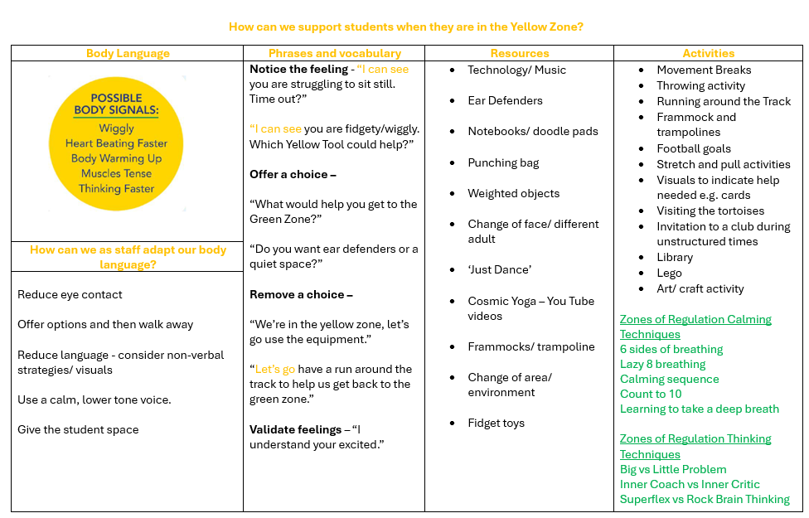
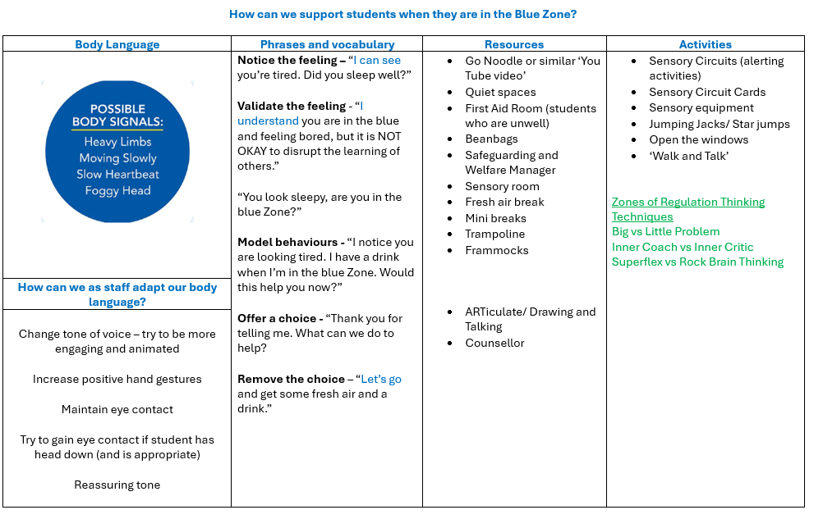

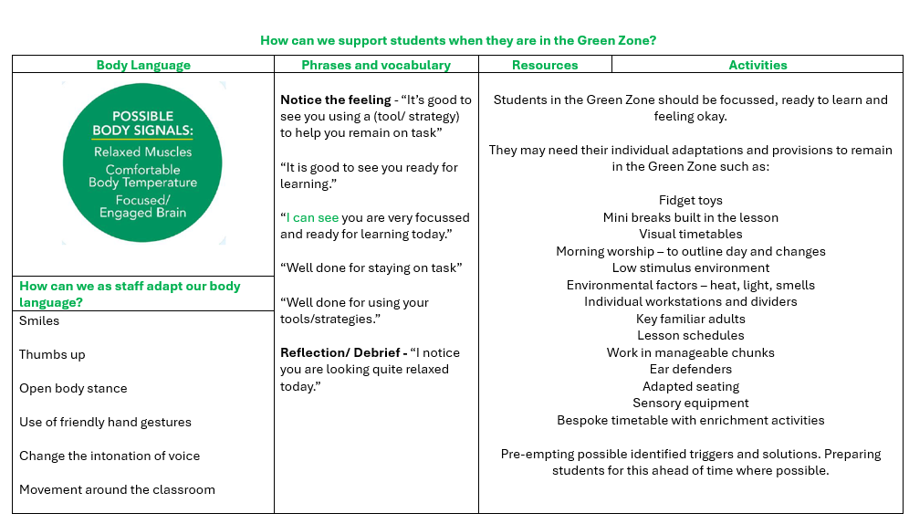
Appendix J – Zones of Regulation Tracker

