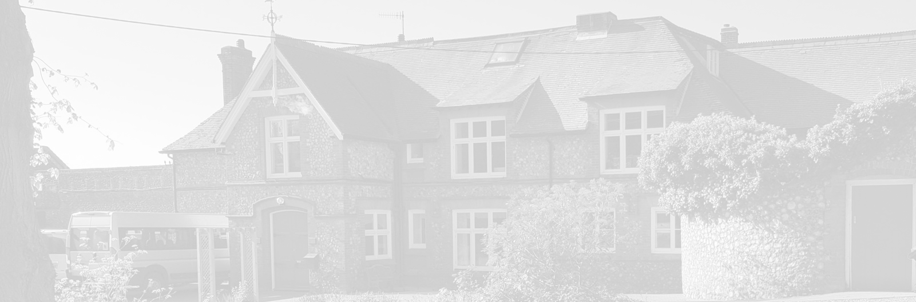
St Andrew’s School
A school with Quaker values

Aylmerton Hall Holt Road
Aylmerton Norfolk NR11 8QA
Telephone: 01263 837927
Email: head@standrewsschool.co.uk
Head: Carol Keable B.Sc. (Hons), M.Ed, NASCO, P.G.C.P.S.E, UCert Autism.
The St Andrew’s School Trust is a Registered Charity No. 1129232

Complaints
Policy

Last reviewed date: Autumn Term 2021
Adopted by Trustees date: 22nd November 2021
Next review date: Autumn Term 2023

COMPLAINTS POLICY

The procedures described in St. Andrew’s School Complaints Policy comply with the Independent Schools Standards Regulations (The Education (Independent School Standards) (England) Regulations 2014, as amended as from April 2019) also known as the registration standards or ISSRs. These regulations are laid down by the Department for Education.
In accordance with, and beyond the requirements of, these regulations, St. Andrew’s School makes all of its policies available to parents and prospective parents on the public area of the school’s website; printed copies can be made available on request to the Headteacher or viewed in school.

Introduction

St. Andrew’s School has long prided itself on the quality of the teaching and pastoral care provided to its pupils. However, if parents do have a complaint, they can expect it to be treated by the school in accordance with this policy. In all cases:

Stage 1 – Informal Resolution

• It is hoped that most concerns will be resolved quickly and informally.
• If parents, with a child at the school, have a complaint they should normally contact the relevant member of staff. In many cases, the matter will be resolved to the parents’ satisfaction. If the member of staff cannot resolve the matter alone at this stage, it may be necessary for him/her to consult a senior colleague.
• Complaints should be made in the first instance to the member of staff most closely involved with the issue causing concern, unless it is deemed appropriate that the matter should be considered by a senior colleague. It may be necessary for a colleague to re-direct the complaint to another colleague; in such circumstances the complainant will be kept fully informed about who is handling the complaint.
• The member of staff, or senior colleague, will make a written record of all concerns and complaints and the date on which they were received. Should the matter not be resolved within 10 working days or in the event that the member of staff and the parent fail to reach a satisfactory resolution then parents will be advised to proceed with their complaint in accordance with Stage 2 of this policy.

Stage 2 – Formal Resolution

- If the complaint cannot be resolved on an informal basis, then the parents should put their complaint in writing to the Headteacher. The Headteacher will decide, after considering the complaint, the appropriate course of action to take.
- In most cases, the Headteacher will arrange to meet with the parent(s) concerned, normally within 10 working days of receiving the complaint, to discuss the matter. If possible, a resolution will be reached at this stage.
- It may be necessary for the Headteacher to carry out further investigations.
- The Headteacher will keep written records of all meetings and interviews held in relation to the complaint.
- Once the Headteacher is satisfied that, so far as is practicable, all of the relevant facts have been established, a decision will be made and parents will be informed of this decision in writing. The Headteacher will also give reasons for the decision taken.
- If parents are still not satisfied with the decision, they should proceed to Stage 3 of this policy.
Stage 3 – Panel Hearing

- If parent(s) seek to invoke Stage 3 (following a failure to reach an earlier resolution), they should let the Headteacher know, or contact the Chair of the Trustees, at the school address. The complaint will be referred to a member of the Trustees who has been authorised by School Trustees to convene the Complaints Panel.
- The Convenor, in consultation with the Chair of Trustees, will appoint a Complaints Panel which will consist of at least two Trustees (who have not been directly involved in matters detailed in the complaint) and one additional person who shall be independent of the management and running of the school.
- The Convenor, on behalf of the Panel, will then acknowledge the complaint and schedule a hearing to take place as soon as practicable and normally within 10 working days.
- If the Panel deems it necessary, it may require that further particulars of the complaint or any related matter be supplied in advance of the hearing. Copies of such particulars shall be supplied to all parties not later than five working days prior to the hearing.
- The parents may be accompanied to the hearing by one other person. This may be a relative or friend. Legal representation will not normally be appropriate.
- If possible, the Panel will resolve the parents’ complaint immediately without the need for further investigation.
- Where further investigation is required, the Panel will decide how it should be carried out. After due consideration of all facts they consider relevant, the Panel will reach a decision and may make recommendations, which it shall complete within five working days of the Hearing. The Panel will write to the parents informing them of its decision and the reasons for it. The decision of the Panel will be final. The Panel’s findings and, if any, recommendations will be sent in writing to the parents, and, where relevant, the person complained of. Copies of the findings and recommendations (if any) will be kept on file and made available for inspection at the school by the Headteacher and the Chair of Trustees.

Parents can be assured that all concerns and complaints will be treated seriously and confidentially. Whilst we endeavour to resolve any complaint in the timescales indicated above, there may be cases, perhaps for reasons of holiday or illness, when a deviation from the normal timescale is necessary. In these circumstances the school commits to explain the reasons for any such deviation and, in all cases, to set an absolute time limit of 28 term-time working days to cover the period from the lodging of the complaint to its resolution.

A written record of all complaints, stating whether they are resolved at the preliminary stage or proceed to a panel hearing, will be kept by the school, along with action taken by the school as a result of these complaints (regardless of whether they are upheld)

Correspondence, statements and records relating to individual complaints will be kept confidential except where the Secretary of State or a body conducting an inspection under section 108 or 109 of the 2008 Act requests access to them.

Specific Complaints

If concerns relate to bullying or possible child abuse, parents should contact the St. Andrew’s School Child Protection Officer, Designated Safeguarding Lead at the school.
johannalewis@standrewsschool.co.uk
jimcollin@standrewsschool.co.uk

If the complaint is concerning the Child Protection Officer, the parent should contact the Headteacher at the school.
carolkeable@standrewsschool.co.uk

If the complaint is about the Headteacher, then parents should go directly to the Chair of Trustees at the school.
johngarner@standrewsschool.co.uk

If this complaint concerns a possible Safeguarding/Child Protection issue about the Headteacher, the Chair of Trustees will contact the Local Authority Designated Officer (LADO) and be guided by them.
------------------------------------------------------------------------------------------------------------------

There was zero (0) complaints registered under the formal procedure in the year 2020-2021

------------------------------------------------------------------------------------------------------------------

Who else can I contact if I have a Complaint?

First read through our complaints policy and follow through the suggested steps. If you still wish to contact someone outside the school the following maybe the appropriate contacts:

Norfolk County Council
www.norfolk.gov.uk

Department for Education
Piccadilly Gate
Store Street
MANCHESTER M1 2WD
Telephone: 0370 000 2288
www.education.gov.uk
www.gov.uk/complain-about-school/private-schools

For some types of complaint, you need to contact a different agency.
Complaint | Who to contact
Child protection | Local council
Criminal behaviour | Police
Data protection | Information Commissioner’s Office
Discrimination | Equality Advisory and Support Service
Employment | An employment tribunal
Exam malpractice or maladministration | Ofqual and the awarding body
Quality of education or leadership | Ofsted

Should you wish to speak to someone outside the school regarding bullying or possible child abuse, then, in addition to the DfE, you can contact the child protection unit of Norfolk’s Social Services Department.

If a child is in danger, contact the police.

