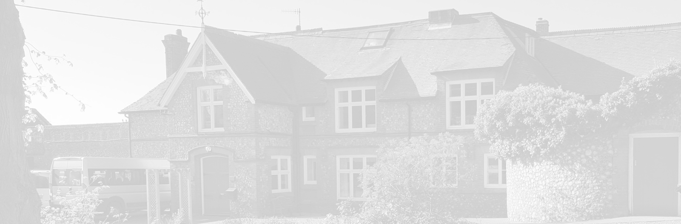
St Andrew’s School
A school with Quaker values

Aylmerton Hall Holt Road
Aylmerton Norfolk NR11 8QA
Telephone: 01263 837927
Email: head@standrewsschool.co.uk
Head: Mrs Carol Keable B.Sc. (Hons), NASCO, M.Ed, P.G.C.P.S.E, UCert Autism.
The St Andrew’s School Trust is a Registered Charity No. 1129232

Data Privacy
Notice
Workforce

Last reviewed date: 7th July 2021
Adopted by Trustees date: 12th July 2021
Signed by Chair of Trustees:
Next review date: 1st March 2024

St Andrew's School
Data Privacy Notice

[Version 2020 v2.0]

If you are reading a printed version of this document you should check the
Information Management pages on St Andrew’s School network to ensure that you
have the most up-to-date version.

If you would like to discuss anything in this privacy notice, please contact:
Data Protection Officer: Stuart Lee
Telephone: 0800 0862018
Email: dpo@dataprotection.education
If you would like a copy of any documentation please contact the school office: office@standrewsschool.co.uk

Document version control

ContentsDocument version control

Version | Author | Date | Approved by | Effective from
1.0 template | DPE - JE | 1/5/2018
1.3 update | DPE – JE  QA - TK | 24/5/2018  1/6/2018
1.5 update | DPE – JE | 2/10/2020
2.0 Update | DPE-JE | 06/12/2020

Content

Content 3
Purpose of this document 4
Why we collect and use this information 4
The Data Protection Principles 4
Your rights 5
The lawful basis on which we process this information 5
Collecting this information 5
Storing this information 6
Types of school workforce data 6
Personal information 6
Special categories of data 6
Contract and work record information 7
Financial 7
Who we share this information with 8
Why we share school workforce information 8
COVID-19 9
Concerns about how your personal data is handled 9

Purpose of this document
St Andrew’s School is a data controller and this document describes the workforce data that is collected and how it is processed. As a controller we are responsible for deciding what data is collected and how it is processed.
Under the Data Protection Act 2018 and the GDPR we must abide by the principle of transparency and the right of data subjects to be informed how their data is processed.
This document provides such information. It will be updated from time to time and updates communicated to the relevant data subjects.
It is your duty to inform us of changes.

Why we collect and use this information
We use school workforce data to:
- enable the development of a comprehensive picture of the workforce and how it is deployed;
- inform the development of recruitment and retention policies;
- enable individuals to be paid

The Data Protection Principles
We will comply with data protection law. This says that the personal information we hold about you must be:
- Used lawfully, fairly and transparently
- Collected and used only for the specific, explicit and legitimate purpose they have been collected for and not for any other purposes
- Adequate and relevant and limited only to what is necessary
- Accurate and kept up to date.
- Kept only as long as necessary
- Kept securely, using appropriate technical and/or organisation measures

Your rights
You have rights associated with how your data is collected and processed. Not every right is absolute, but under certain circumstances you can invoke the following rights:
- Right of access
- Right of erasure
- Right of rectification
- Right to object to processing
- Right to be informed
- Right to data portability
- Right to not be subject to decisions based on automated decision making
- Right to restrict processing
- Right to seek compensation for damages caused by a breach of the Data Protection regulations.
The Data Protection Officer (DPO) is in position to ensure your rights are supported. To contact the DPO use the contact details on the front of this notice.

The lawful basis on which we use this information
We collect and process school workforce information:
- under Article 6 of the General Data Protection Regulation (GDPR) to perform our official function (public task).
- classed as Special Category data, e.g. race, ethnicity etc under Article 9 of the General Data Protection Regulation (GDPR) to carry out tasks in the public interest.
- where it is necessary for the purposes of carrying out the obligations and exercising specific rights of the controller or of the data subject in the field of employment and social security and social protection law.
- where it is carried out as a task in the public interest such as equal opportunities monitoring, for child protection purposes or where otherwise authorised by law, such as Departmental Censuses as required in the Education Act 1996.
- under the terms of the contract of employment.
- as part of the recruitment process background checks will be done which may involve the collection of criminal convictions. We will process criminal conviction data as it is reported during employment/recruitment to assess suitability of continued employment/recruitment.
- where you have given us consent to do so.

Collecting this information
Whilst most of the workforce information you provide to us is mandatory, some of it is provided to us on a voluntary basis. In order to comply with the General Data Protection Regulation, we will inform you whether you are required to provide certain school workforce information to us or if you have a choice in this.
Information will be collected during the application and recruitment process, from you or your agency. Additional information may be requested from third-parties during the recruitment process including agencies undertaking background checks and former employers.

Storing this information
We hold school workforce data as documented in our Retention Schedule, which can be requested by contacting the school office.

Types of school workforce data
The categories of school workforce information that we may collect, process, hold and share include:

Personal information
Such as:
- Name
- Date of birth
- Gender/gender recognition certification
- National insurance number
- Nationality
- Contact details (home phone number, personal email address)
- Address
- Marital status
- Emergency contact / next of kin
- Facial image

Special categories of data
Such as:
- Racial / ethnic group
- Health data including:
  - Occupational health referrals and associated data
  - Pre-employment medicals
  - Disabilities
  - Access to work assessments and associated data
  - Absence when due to sickness
- Sexual orientation (if raised in discrimination issues)
- Criminal convictions
- Prohibition order check results
- Childcare disqualification check results
- Disclosure and Barring Service check results

Contract and work record information
Such as:
- Employee and/or teacher number
- Start dates
- Working hours
- History of posts held
- Contract offer
- Work history including:
  - Details of previous jobs and employers
  - Referees
  - Job application
  - CVs
  - Qualifications
- Absence record
- Disciplinary/grievance/complaint records
- Right to work information (passport, visa, indefinite leave to remain)
- Training records
- Performance review data
- Accident/incident reports
- Safeguarding data
- Data collected during execution of duties including:
- Information and communication system usage
- Location and usage of work mobile devices
- Internet usage

Financial
Such as:
- Bank details
- Salary, payroll and tax information
- Extraordinary payments (insurance, compensation)
- Pension deductions
- Salary sacrifice and statutory deductions

Who we share this information with
We routinely share this information with:
- Our local authority;
- The Department for Education (DfE);
- Third-party service providers (where a contract exists) in order to fulfil contractual obligations (such as payroll) or where a service is being used in the operations of the school (such as parent communication applications).
- HMRC
- Pension Providers
Only information required for the stated purpose is shared and all third-parties are required to ensure appropriate technical and organisational measures are in place to secure your data.

Why we share school workforce information
We do not share information about workforce members with anyone without consent unless the law and our policies allow us to do so.
Local authority
We are required to share information about our workforce members with our local authority (LA) under section 5 of the Education (Supply of Information about the School Workforce) (England) Regulations 2007 and amendments.
Department for Education (DfE).
We share personal data with the Department for Education (DfE) on a statutory basis. This data sharing underpins workforce policy monitoring, evaluation, and links to school funding / expenditure and the assessment educational attainment.
We are required to share information about our pupils with the (DfE) under section 5 of the Education (Supply of Information about the School Workforce) (England) Regulations 2007 and amendments.
Data collection requirements:
The DfE collects and processes personal data relating to those employed by schools (including Multi Academy Trusts) and local authorities that work in state funded schools (including all maintained schools, all academies and free schools and all special schools including Pupil Referral Units and Alternative Provision). All state funded schools are required to make a census submission because it is a statutory return under sections 113 and 114 of the Education Act 2005.
To find out more about the data collection requirements placed on us by the Department for Education including the data that we share with them, go to https://www.gov.uk/education/data-collection-and-censuses-for-schools.
The department may share information about school employees with third parties who promote the education or well-being of children or the effective deployment of school staff in England by:
- conducting research or analysis;
- producing statistics;
- providing information, advice or guidance.
The department has robust processes in place to ensure that the confidentiality of personal data is maintained and there are stringent controls in place regarding access to it and its use. Decisions on whether DfE releases personal data to third parties are subject to a strict approval process and based on a detailed assessment of:
- who is requesting the data;
- the purpose for which it is required;
- the level and sensitivity of data requested and;
- the arrangements in place to securely store and handle the data.
To be granted access to school workforce information, organisations must comply with its strict terms and conditions covering the confidentiality and handling of the data, security arrangements and retention and use of the data.
For more information about the department’s data sharing process, please visit:
https://www.gov.uk/data-protection-how-we-collect-and-share-research-data
To contact the department: https://www.gov.uk/contact-dfe

COVID-19
Data collected for the purposes of public health (including visitor contact data for COVID-19) will be kept as long as required. Contact data for visitors will be kept for 21 days after the most recent visit, with information on visitors kept as per standard retention requirements. Public Health data may be shared with third-parties as required including, but not limited to:
- National Health Service (including NHS Test and Trace)
- Public Health England
- Other local health authorities
Data collected and processed for public health purposes is done so under GDPR Article 9(2)(i) which states: (in part) "processing is necessary for reasons of public interest in the area of public health, such as protecting against serious cross-border threats to health..." and Recital 54 which includes: "The processing of special categories of personal data may be necessary for reasons of public interest in the areas of public health without consent of the data subject."

Concerns about how your personal data is handled
If you have a concern about the way we are collecting or using your personal data, we ask that you raise your concern with us in the first instance using the contact information on the first page of this document.

Alternatively, you can contact the Information Commissioner’s Office at https://ico.org.uk/concerns/

