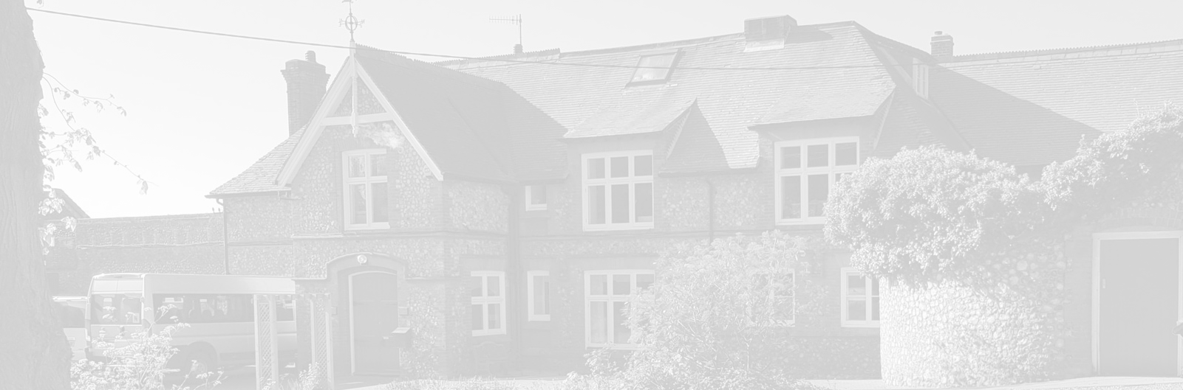
St Andrew’s School
A school with Quaker values

Aylmerton Hall Holt Road
Aylmerton Norfolk NR11 8QA
Telephone: 01263 837927
Email: head@standrewsschool.co.uk
Head: Mrs Carol Keable B.Sc. (Hons), NASCO, M.Ed, P.G.C.P.S.E, UCert Autism.
The St Andrew’s School Trust is a Registered Charity No. 1129232

Data Privacy
Notice
General

Last reviewed date: 7th July 2021
Adopted by Trustees date: 12th July 2021
Signed by Chair of Trustees:
Next review date: 1st March 2024

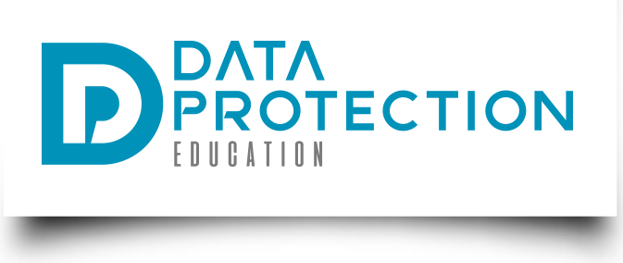
St Andrew's School
Data Privacy Notice

[Version 2020 v2.0]

If you are reading a printed version of this document you should check the
Information Management pages on St Andrew’s School network to ensure that you
have the most up-to-date version.

If you would like to discuss anything in this privacy notice, please contact:
Data Protection Officer: Stuart Lee
Telephone: 0800 0862018
Email: dpo@dataprotection.education
If you would like a copy of any documentation please contact the school office: office@standrewsschool.co.uk

Document version control

ContentsDocument version control

Version | Author | Date | Approved by | Effective from
1.0 template | DPE - JE | 1/5/2018 | Trustees | 23/7/18
1.3 update | DPE – JE  QA - TK | 24/5/2018  1/6/2018
1.5 update | DPE – JE | 2/10/2020
2.0 update | DPE – JE | 08/12/2020

Content

Content 3
Purpose of this document 4
The Data Protection Principles 4
Your rights 4
The lawful basis on which we process this information 5
Categories of data subject and the data we collect and hold 5
Parents’ and carers information 5
Visitor information 6
Trustees’ information 6
Collecting this information 7
Storing this information 8
Who we share this information with 8
COVID-19 8
Concerns about how your personal data is handled 9

Purpose of this document
St Andrew’s School is a data controller and this document describes the data that is collected and how it is processed to data subjects other than pupils and workforce. As a controller we are responsible for deciding what data is collected and how it is processed.
Under the Data Protection Act 2018 and the GDPR we must abide by the principle of transparency and the right of data subjects to be informed how their data is processed.
This document provides such information. It will be updated from time to time and updates communicated to the relevant data subjects.
It is your duty to inform us of changes.

The Data Protection Principles
We will comply with data protection law. This says that the personal information we hold about you must be:
- Used lawfully, fairly and transparently
- Collected and used only for the specific, explicit and legitimate purpose they have been collected for and not for any other purposes
- Adequate and relevant and limited only to what is necessary
- Accurate and kept up to date
- Kept only as long as necessary
- Kept securely, using appropriate technical and/or organisation measures

Your rights
You have rights associated with how your data is collected and processed. Not every right is absolute, but under certain circumstances you can invoke the following rights:
- Right of access
- Right of erasure
- Right of rectification
- Right to object to processing
- Right to be informed
- Right to data portability
- Right to not be subject to decisions based on automated decision making
- Right to restrict processing
- Right to seek compensation for damages caused by a breach of the Data Protection regulations.
The Data Protection Officer (DPO) is in position to ensure your rights are supported. To contact the DPO use the contact details on the front of this notice.

The lawful basis on which we process this information
We collect and process your information:
- Under Article 6 of the General Data Protection Regulation (GDPR) to perform our official function (public task).
- Classed as Special Category data, e.g. health etc under Article 9 of the General Data Protection Regulation (GDPR) to carry out tasks in the public interest.
- Where it is carried out as a task in the public interest such as equal opportunities monitoring, for child protection purposes or where otherwise authorised by law, such as Departmental Censuses as required in the Education Act 1996.
- Under the terms of a contract we hold with you.
- As part of your attendance in schools, background checks from the Disclosure and Barring Service may be done which may involve the collection of criminal convictions.
- Where you have given us consent to do so.

Categories of data subject and the data we collect and hold
The categories of other information that we collect, hold and share include:

Parents’ and carers information
Parent or carers information is collected so that:
- We can communicate with you about your child in relation to things such as education and attainment, health and well-being, attendance and behaviour and emergencies (task in a public interest or legal obligation)
- Send you important information about the school (task in a public interest)
- Provide you with access to tools and services we use in schools such as communication applications (task in a public interest or to fulfil a contract)
Data collected includes:
- Name
- Address
- Contact information
- Relationship to the child

Visitor information
Visitor information is collected so that:
- We have a record of who is and has been in the building, for health, safety and operational purposes (legal obligation)
- We have a record of official visits, such as inspections or maintenance (task in a public interest)
- Where needed, Disclosure and Barring Service checks can take place (task in a public interest or legal obligation)
Data collected includes:
- Name
- Associated business
- Purpose of visit
- Car registration (on occasion)
- Driving licence, passport or other official documentation for identity verification (in certain circumstances)
- Disclosure and Barring Service check results (in certain circumstances)

Trustees' information
Trustees’ information is collected so that:
- We can communicate with Trustees on school business (task in a public interest)
- There is a public record of Trustees and their business interests (task in a public interest)
- There is a record of Trustee attendance (task in a public interest)
- There is a record of Trustee training (task in a public interest)
- Disclosure and Barring Service checks can be carried out (task in a public interest or legal obligation)
Data collected includes:
- Name
- Address
- Contact information
- Business interests
- Financial interests
- Date of appointment and length of terms
- Driving licence, passport or other official documentation for identity verification
- Disclosure and Barring Service check results

Collecting this information
- Parents: whilst the majority of information you provide to us is mandatory, some of it is provided to us on a voluntary basis. In order to comply with data protection legislation, we will inform you whether you are required to provide certain information to us or if you have a choice in this
- Visitors: As a visitor the information that you provide to us is voluntary. However, we may restrict access to the school if the information is not provided
- Trustees: whilst the majority of information you provide to us is mandatory, some of it is provided to us on a voluntary basis. In order to comply with data protection legislation, we will inform you whether you are required to provide certain information to us or if you have a choice in this.

Storing this information
We hold your data as documented in our Retention Schedule, which can be requested by contacting the school office.

Who we share this information with
We routinely share this information with:
- Parents: we will share your information with members of staff, other agencies and, where you have agreed or to ensure the functioning of a contract, with third-party processors who provide services to the school;
- Visitors: your information will not be shared unless requested by an external agency in the course of a health and safety incident or in the investigation of a crime;
- Trustees: we will publish the names, business interests and financial interests of Trustees on the school website. Trustee information is also shared with the Local Authority and published on the DfE Get Information About Schools portal

COVID-19
Data collected for the purposes of public health (including visitor contact data for COVID-19) will be kept as long as required. Contact data for visitors will be kept for 21 days after the most recent visit, with information on visitors kept as per standard retention requirements. Public Health data may be shared with third-parties as required including, but not limited to:
- National Health Service (including NHS Test and Trace)
- Public Health England
- Other local health authorities
Data collected and processed for public health purposes is done so under GDPR Article 9(2)(i) which states: (in part) "processing is necessary for reasons of public interest in the area of public health, such as protecting against serious cross-border threats to health..." and Recital 54 which includes: "The processing of special categories of personal data may be necessary for reasons of public interest in the areas of public health without consent of the data subject."

Concerns about how your personal data is handled
If you have a concern about the way we are collecting or using your personal data, we ask that you raise your concern with us in the first instance using the contact information on the first page of this document.

Alternatively, you can contact the Information Commissioner’s Office at https://ico.org.uk/concerns/

