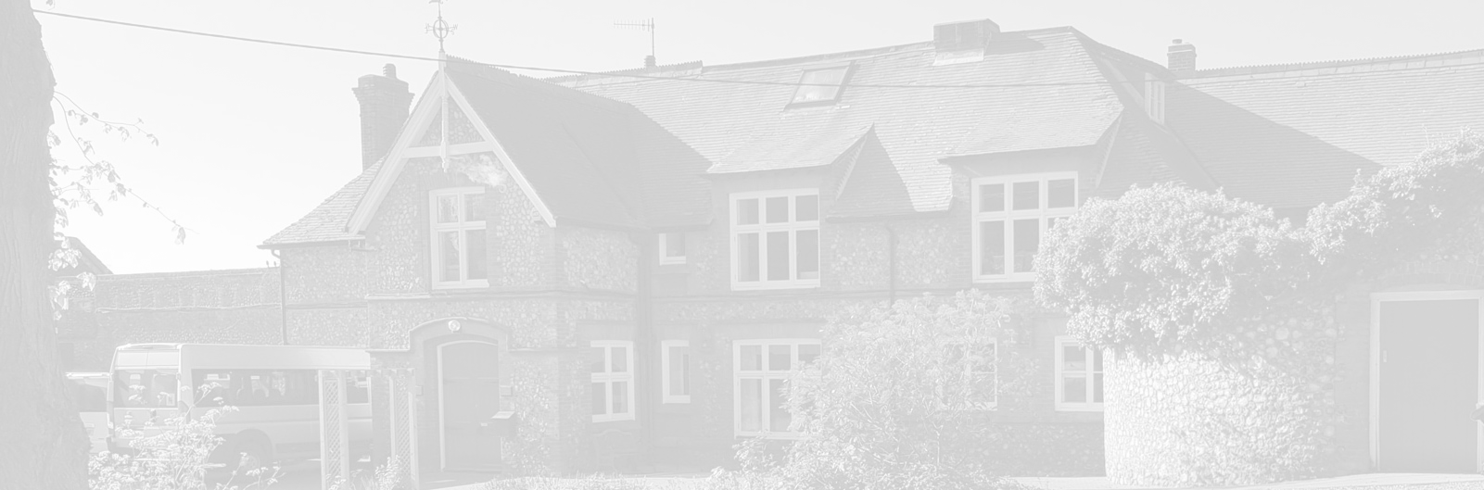
St Andrew’s School
A school with Quaker values

Aylmerton Hall Holt Road
Aylmerton Norfolk NR11 8QA
Telephone: 01263 837927
Email: head@standrewsschool.co.uk
Head: Mrs Carol Keable B.Sc. (Hons), NASCO, M.Ed, P.G.C.P.S.E, UCert Autism.
The St Andrew’s School Trust is a Registered Charity No. 1129232

Data Privacy
Notice
Students

Last reviewed date: 9th July 2021
Adopted by Trustees date: 12th July 2021
Signed by Chair of Trustees:
Next review date: 1st March 2024

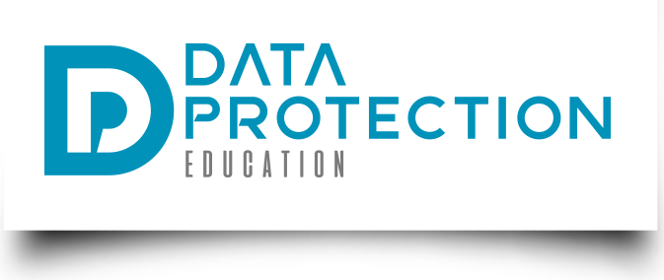
St Andrew's School
Data Privacy Notice

[Version 2020 v2.0]

If you are reading a printed version of this document you should check the
Information Management pages on St Andrew’s School network to ensure that you
have the most up-to-date version.

If you would like to discuss anything in this privacy notice, please contact:
Data Protection Officer: Stuart Lee
Telephone: 0800 0862018
Email: dpo@dataprotection.education
If you would like a copy of any documentation please contact the school office: office@standrewsschool.co.uk

Document version control

ContentsDocument version control

Version | Author | Date | Approved by | Effective from
1.0 template | DPE - JE | 1/5/2018
1.3 update | DPE – JE  QA - TK | 24/5/2018  1/6/2018
1.5 update | DPE – JE | 2/10/2020

Content

Purpose of this document 4
Why we collect and use this information 4
The Data Protection Principles 4
Your rights 5
The lawful basis on which we use this information 5
Collecting pupil information 6
Storing student data 6
The categories of student information that we collect, hold and share include: 6
Who we share student information with 6
Why we share student information 7
Data collection requirements: 7
Youth support services 7
The National Pupil Database (NPD) 8
Concerns about how your personal data is handled 10

Purpose of this document
St Andrew’s School is a data controller and this document describes the student data that is collected and how it is processed. As a controller we are responsible for deciding what data is collected and how it is processed.
Under the Data Protection Act 2018 and the GDPR we must abide by the principle of transparency and the right of data subjects to be informed how their data is processed.
This document provides such information. It will be updated from time to time and updates communicated to the relevant data subjects.
It is your duty to inform us of changes.

Why we collect and use this information
We use the student data:
- to support student learning;
- to monitor and report on student progress;
- to provide appropriate pastoral care;
- to assess the quality of our services;
- to comply with the law regarding data sharing.

The Data Protection Principles
We will comply with data protection law. This says that the personal information we hold about you must be:
- Used lawfully, fairly and transparently
- Collected and used only for the specific, explicit and legitimate purpose they have been collected for and not for any other purposes
- Adequate and relevant and limited only to what is necessary
- Accurate and kept up to date.
- Kept only as long as necessary
- Kept securely, using appropriate technical and/or organisation measures

Your rights
You have rights associated with how your data is collected and processed. Not every right is absolute, but under certain circumstances you can invoke the following rights:
- Right of access
- Right of erasure
- Right of rectification
- Right to object to processing
- Right to be informed
- Right to data portability
- Right to not be subject to decisions based on automated decision making
- Right to restrict processing
- Right to seek compensation for damages caused by a breach of the Data Protection regulations.
The Data Protection Officer (DPO) is in position to ensure your rights are supported. To contact the DPO use the contact details on the front of this notice.

The lawful basis on which we use this information
- We collect and use student information under a task performed in the public interest where it relates to a child’s educational progression;
- Some photographs and videos are used only after gaining explicit consent;
- Where medical data is being processed, this is processed under a legal obligation (Children and Families Act 2014 which includes a duty on schools to support children with medical conditions);
- Safeguarding data is processed under the legal obligation of The Education Act 2002. Sections 21 and 175 detail how Trustee bodies of schools must promote the wellbeing of students and take a view to the safeguarding of children at the school.
- We collect and process student information under Article 6 of the General Data Protection Regulation (GDPR) to perform our official function (public task).
- Where it is carried out as a task in the public interest such as equal opportunities monitoring, for child protection purposes or where otherwise authorised by law, such as Departmental Censuses as required in the Education Act 1996.
- Children and Families Act 2014 includes a duty on schools to support children with medical conditions;
- The Equality Act 2010 (England, Scotland and Wales) requires you to make reasonable adjustments to ensure that children and young people with a disability are not put at a substantial disadvantage compared with their peers;
- The Education Act 2002, Sections 21 and 175 detail how governing bodies of schools must promote the wellbeing of students and take a view to the safeguarding of children at the school;
- Section 3 of the Children Act 1989 places a duty on a person with the care of a child to do all that is reasonable in the circumstances for the purposes of safeguarding the child;
- Education Act 1996, relating to attendance at school.

Collecting student information
Whilst most of the student information you provide to us is mandatory, some of it is provided to us on a voluntary basis. In order to comply with the General Data Protection Regulation, we will inform you whether you are required to provide certain student information to us or if you have a choice in this.

Storing student data
We hold student data as documented in our Retention Schedule, which can be requested by contacting the school office.

The categories of student information that we collect, hold and share include:
- Personal information (such as name, unique pupil number and address);
- Characteristics (such as ethnicity, language, nationality, country of birth and free school meal eligibility);
- Attendance information (such as sessions attended, number of absences and absence reasons);
- Assessment information and education records;
- Special Educational Needs information;
- Behavioural information (such as, achievements, exclusions, internal exclusions and detentions);
- Health and medical information (such as dietary requirement and medication details);
- Safeguarding and Child Protection reports and disclosures;
- Photographs and video clips;
- Post 16 destinations and learning information.

Who we share student information with
We routinely share student information with:
- Schools that the students attend after leaving us;
- Our local authority;
- Other admissions authorities;
- The Department for Education (DfE);
- Suppliers that we have contracted with to provide educational services and those related to the operations of the school;
- Examination boards;
- The police when investigating or preventing crime;
- Health teams.

Why we share student information
We do not share information about our students with anyone without consent unless the law and our policies allow us to do so.
Where we share with third-party services, this will be in line with data protection law and specified in the agreements with those third-parties.
We share students’ data with the Department for Education (DfE) on a statutory basis. This data sharing underpins school funding and educational attainment policy and monitoring.
We are required to share information about our students with the (DfE) under regulation 5 of The Education (Information About Individual Pupils) (England) Regulations 2013.

Data collection requirements:
To find out more about the data collection requirements placed on us by the Department for Education (for example; via the school census) go to https://www.gov.uk/education/data-collection-and-censuses-for-schools.

Youth support services
Students aged 13+:
Once our students reach the age of 13, we also pass student information to our local authority and / or provider of youth support services as they have responsibilities in relation to the education or training of 13-19 year olds under section 507B of the Education Act 1996.
This enables them to provide services as follows:
- youth support services;
- careers advisers.
A parent or guardian can request that only their child’s name, address and date of birth is passed to their local authority or provider of youth support services by informing us. This right is transferred to the student once he/she reaches the age 16.
Students aged 16+:
We will also share certain information about students aged 16+ with our local authority and / or provider of youth support services as they have responsibilities in relation to the education or training of 13-19 year olds under section 507B of the Education Act 1996.
This enables them to provide services as follows:
- post-16 education and training providers;
- youth support services;
- careers advisers.
For more information about services for young people, please visit our local authority website.

The National Pupil Database (NPD)
The NPD is owned and managed by the Department for Education and contains information about students in schools in England. It provides invaluable evidence on educational performance to inform independent research, as well as studies commissioned by the Department. It is held in electronic format for statistical purposes. This information is securely collected from a range of sources including schools, local authorities and awarding bodies.
We are required by law, to provide information about our students to the DfE as part of statutory data collections such as the school census. Some of this information is then stored in the NPD. The law that allows this is the Education (Information About Individual Pupils) (England) Regulations 2013.
To find out more about the NPD, go to https://www.gov.uk/government/publications/national-pupil-database-user-guide-and-supporting-information.
The department may share information about our students from the NPD with third parties who promote the education or well-being of children in England by:
- conducting research or analysis;
- producing statistics;
- providing information, advice or guidance.
The Department has robust processes in place to ensure the confidentiality of our data is maintained and there are stringent controls in place regarding access and use of the data. Decisions on whether DfE releases data to third parties are subject to a strict approval process and based on a detailed assessment of:
- who is requesting the data;
- the purpose for which it is required;
- the level and sensitivity of data requested and;
- the arrangements in place to store and handle the data.
To be granted access to student information, organisations must comply with strict terms and conditions covering the confidentiality and handling of the data, security arrangements and retention and use of the data.
For more information about the department’s data sharing process, please visit: https://www.gov.uk/data-protection-how-we-collect-and-share-research-data
For information about which organisations the department has provided student information to, (and for which project), please visit the following website: https://www.gov.uk/government/publications/national-pupil-database-requests-received
To contact DfE: https://www.gov.uk/contact-dfe

COVID-19
Data collected for the purposes of public health (including visitor contact data for COVID-19) will be kept as long as required. Contact data for visitors will be kept for 21 days after the most recent visit, with information on visitors kept as per standard retention requirements. Public Health data may be shared with third-parties as required including, but not limited to:
- National Health Service (including NHS Test and Trace)
- Public Health England
- Other local health authorities
Data collected and processed for public health purposes is done so under GDPR Article 9(2)(i) which states: (in part) "processing is necessary for reasons of public interest in the area of public health, such as protecting against serious cross-border threats to health..." and Recital 54 which includes: "The processing of special categories of personal data may be necessary for reasons of public interest in the areas of public health without consent of the data subject.

Concerns about how your personal data is handled
If you have a concern about the way we are collecting or using your personal data, we ask that you raise your concern with us in the first instance using the contact information on the first page of this document.

Alternatively, you can contact the Information Commissioner’s Office at https://ico.org.uk/concerns/

