St Andrew’s School Newsletter
February 2026
Headteacher: Adrian Crossland
Head’s Note
It is always such a pleasure to read our newsletters and be reminded of some of the wonderful things that our students have been enjoying and achieving each half-term. I was very proud to show Ofsted around our wonderful school just before the holiday, and as usual, our students were an absolute credit. We expect to receive the report this half-term.
Thank you to yourselves and staff for all your continued support. I am very much looking forward to what this half-term will bring.

Key Dates

Monday 23rd February 2026 – Students Return
Thursday 26th February – Bikeability Lesson
Friday 27th February – KS2 Swimming Lessons begin
Thursday 5th March – Year 10, Festival of Knowledge, Norwich Showground
Thursday 5th March – Bikeability Lesson
Friday 6th March – World Book Day
Wednesday 11th March – Mini Medics for KS2, Years 7 & 8
Thursday 12th March – Bikeability Lesson
Friday 13th March – Mini Medics for Years 9, 10 & 11
Wednesday 25th March – RSHE Coffee Morning as below:
KS2 (09:15-10:15) KS4 (11:00-12:00) KS3 (14:00-15:00)
Friday 27th March – Last day of term

IT
RoboRace: Coding and Controlling Robot Cars with BBC Micro:bits
The students dived into the world of robotics and coding with RoboRace!
In this thrilling project, Year 9 students have designed, programmed, and raced their own robot cars using BBC micro:bits. The challenge is to create smart, responsive vehicles that can navigate an obstacle course autonomously. Students learnt essential programming skills by coding the micro:bit to control motors, sensors, and LED displays. Along the way, they have experimented with sensors to detect lines, obstacles, and distance, developing problem-solving and critical thinking skills. The project culminated in a competitive race where students showcased their robotic creations, demonstrating how coding and engineering work together to bring their robot cars to life. RoboRace not only enhanced STEM knowledge but also fostered teamwork, creativity, and innovation!

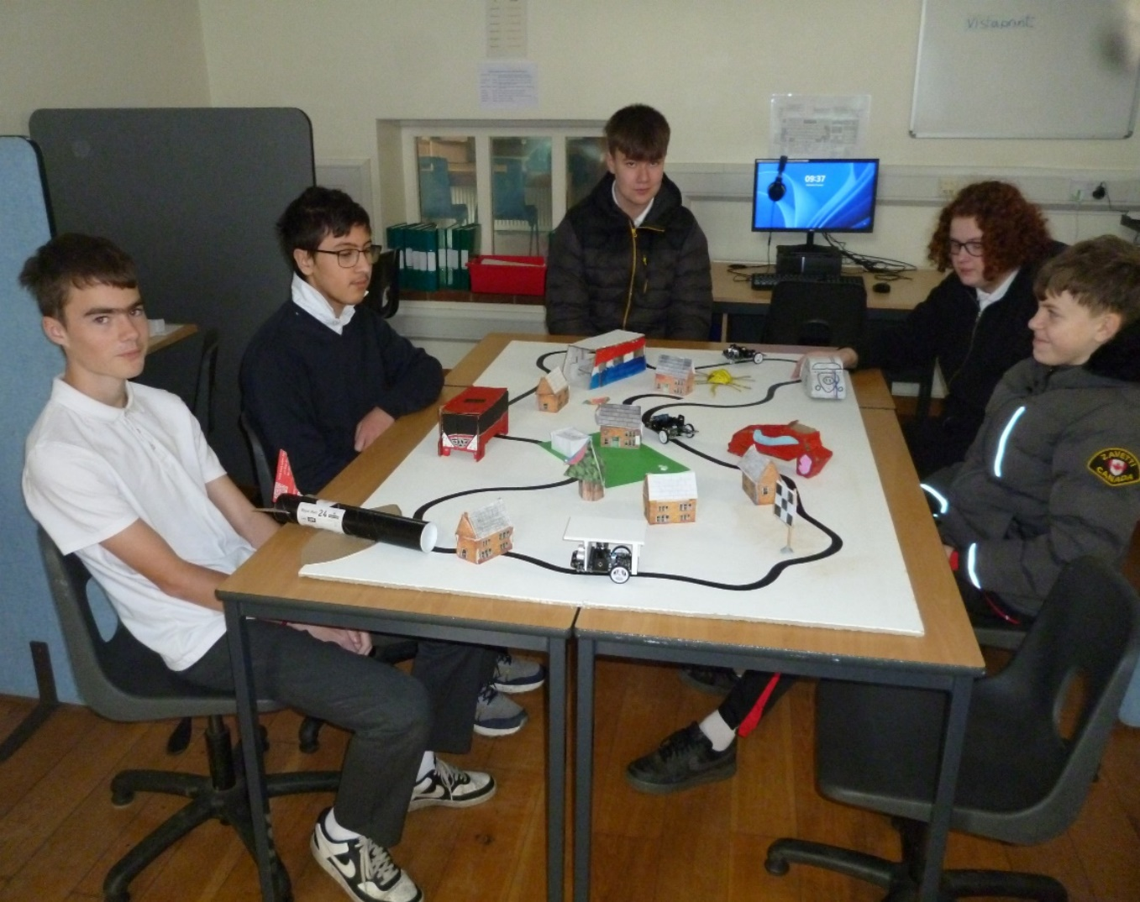

Tim Laurie – IT Teacher
Music
Thanks to our TA, Barney, Year 9 are now having informal guitar lessons as part of their Music Curriculum.
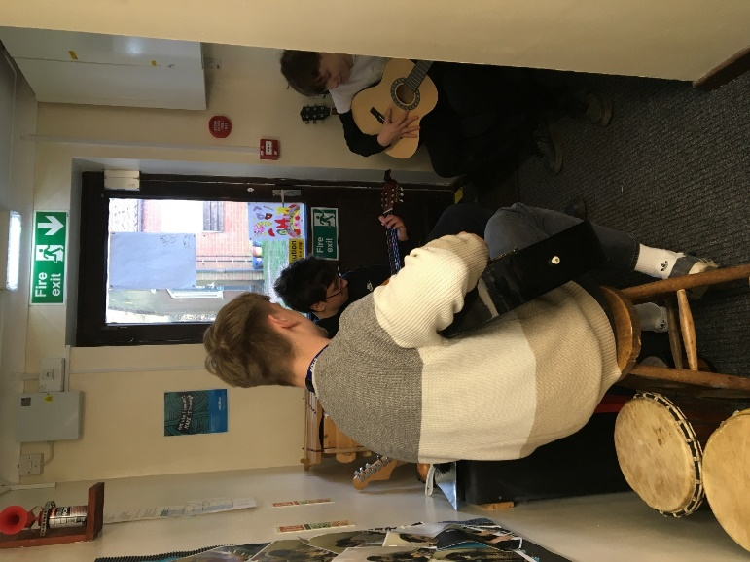

Our new iPad has been bought, apps are downloaded and we are nearly ready to start our new DJ topic in Music lessons and as a club to follow.
Judith Crass – Music Teacher

Fundraising Event
Our Year 10 students sold cupcakes on Friday 23rd January and raised a total of £76 for the Donkey Sanctuary in Dorset.
All the cupcakes were made by 10A for an English project. The students had the option to pay with their points money or money from home and the cakes were sold for £1 each. The staff also joined in by purchasing cupcakes. Thank you to everyone who supported the event.

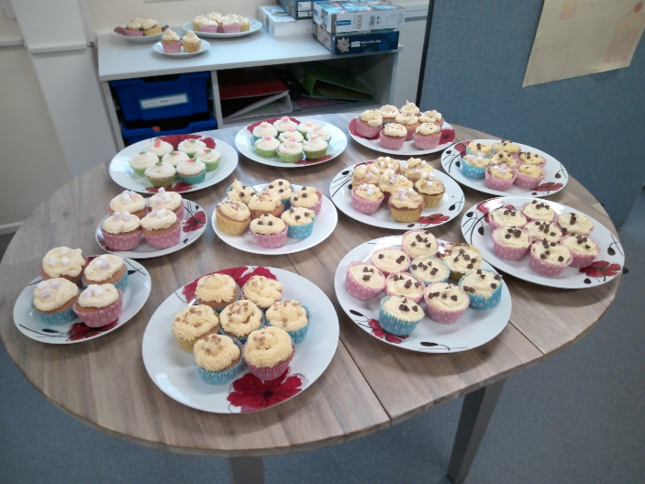

Yr 11 Social Trip
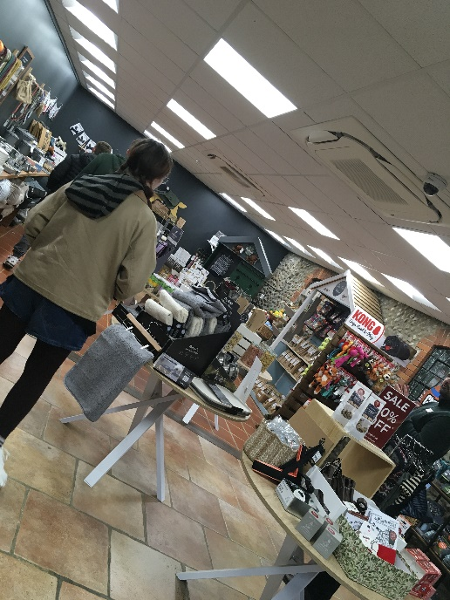
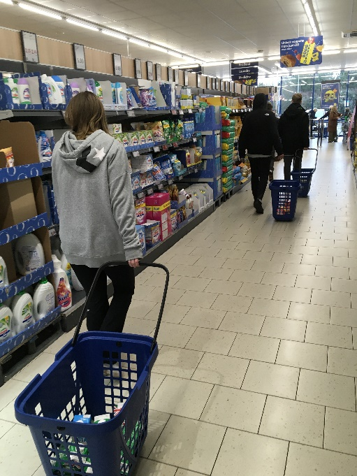
On the 19th January, Year 11 went to the Lidl supermarket in Cromer to develop life skills. Students had their own shopping list and trolley and looked for several items required for their Food Tech lessons, along with some additional ingredients for the school. Once the items were collected, they individually put the items on to the conveyor belt and packed and paid the cashier. A good experience promoting independence. Well done Year 11!

On 26th January, we visited Bakers & Larners of Holt for a ‘Tour and Talk’ as part of our careers curriculum with an insight into a local family-run business. We had a guided tour around the different departments and what there is to offer, along with some history of the shop. Students also had access to ‘staff only’ areas to see how the shop operates. This provided a snapshot of some roles in retail, along with a variety of products that are available to buy.
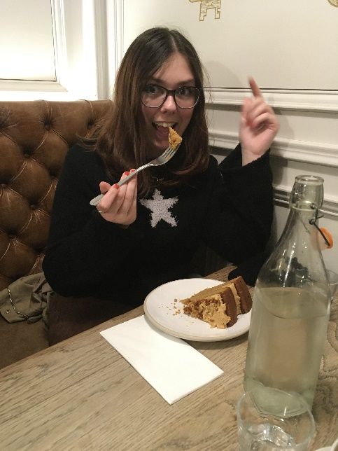
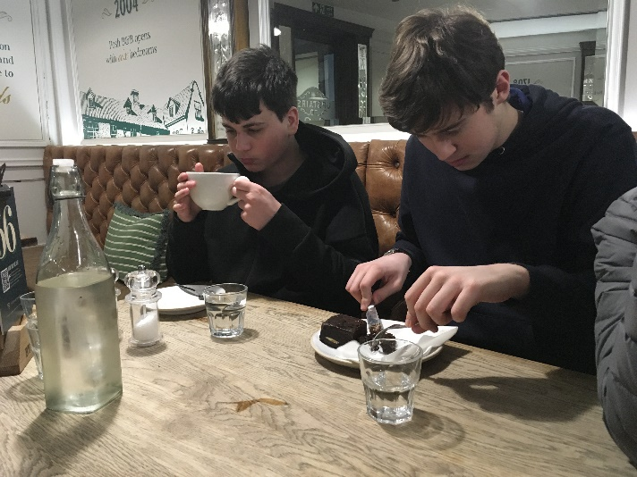

Lastly, we enjoyed a treat at Byford's Cafe on Monday 2nd February for our paid half-termly trip. Not only does this promote important life skills with money, budgeting and ordering, it is also promoting interaction in a social setting. It was a nice time to unwind and enjoy a little treat to celebrate the end of another half-term!
Cricket Trip to the UEA
On Friday 23rd January, a number of students joined me for a trip to the UEA for a day of cricket in the sports hall. Students had the opportunity to play against other SEN schools in friendly games of 'pairs cricket', taking turns in batting, fielding and bowling. We played against three other schools and finished the day playing a game amongst ourselves, before returning back to school for the end of the day. We all had a lot of fun, and a big thank you to Norfolk Cricket for organising and running the event and to all the students who represented the school - well done!
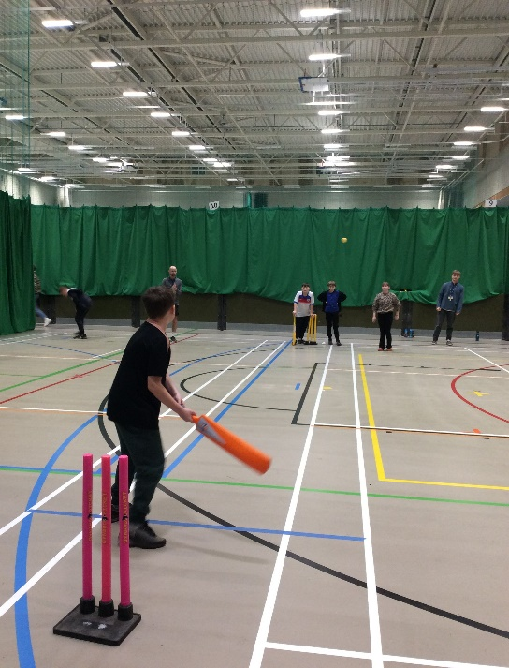
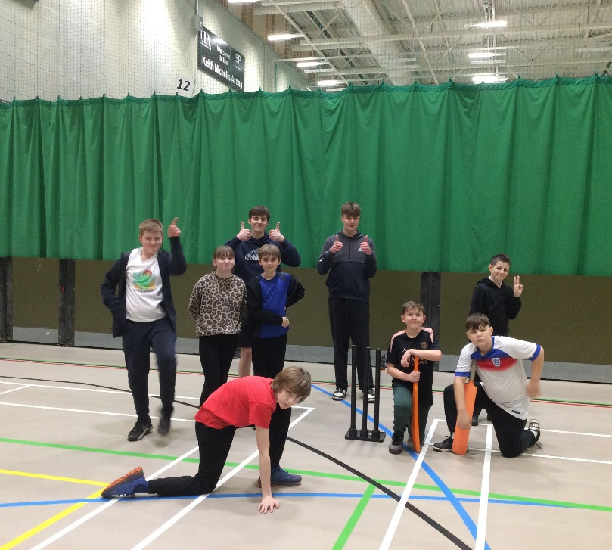

Vassy – PE Teacher

Year 8 Visit to Meadow Park
Year 8 students enjoyed a trip to Meadow Park, where they had the opportunity to explore the play equipment, socialise with friends, and practise important skills such as turn-taking, particularly on the zip wire! The visit was full of fun and laughter, and all students had an enjoyable time.
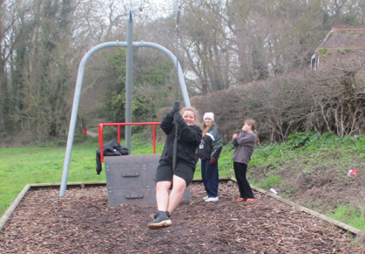

Year 8 Careers Visit to The Reef, Sheringham
Year 8 students recently enjoyed their careers visit to The Reef in Sheringham. The group was given a full tour of all the facilities and took part in a detailed and engaging talk from the sports centre manager. Students learned about the wide range of job opportunities available within the leisure industry, as well as the different training routes, including apprenticeships. It was a worthwhile and interesting visit that gave students valuable insight into potential future career pathways.
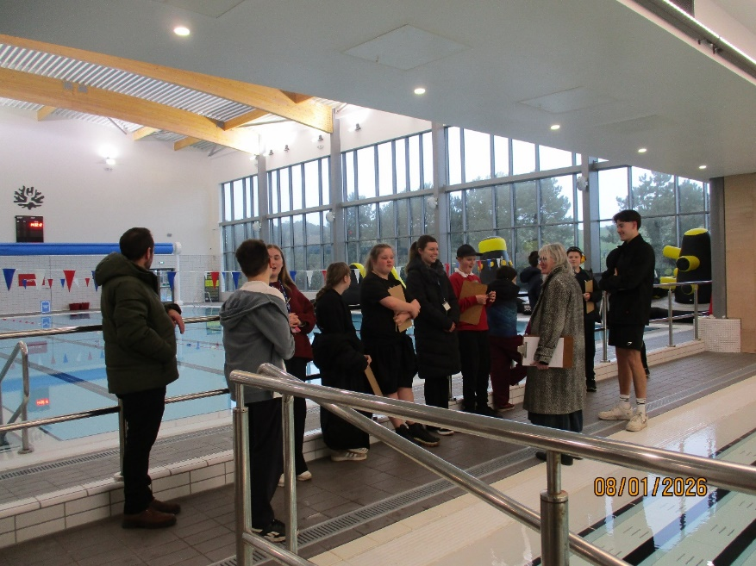
Paula Mayes – PSHE Teacher

Community Police Visit
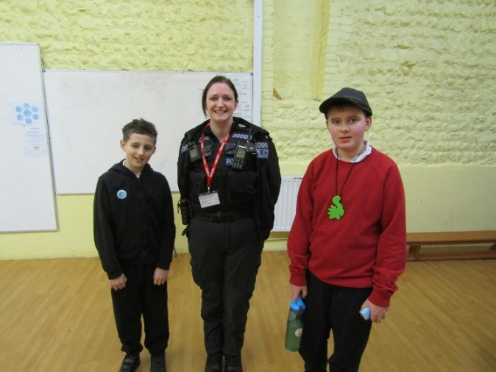
We were fortunate to have a visit from the Norfolk Police Locality Beat Manager, PC Keeley Smith, who came to talk to the whole school regarding the topic of Online Safety. She was very impressed with the engagement from students, who were keen to share their learned knowledge about keeping safe online. There were full discussions about not sharing personal details to unknown people, using blocking buttons for strangers, checking that any emails or information are from trusted sources and considering the increasing impact of AI on their digital lives. The importance of having positive communication was stressed, with a reminder that any online unkindness / bullying can be classed as a criminal offence. Some students shared their personal experiences and were reminded how to gain help and support from trusted adults, either at home, school or the police as necessary. A very useful learning experience for all involved.

Carol McKean – Safeguarding & Welfare Manager
Sainsbury Centre Art Trip
GCSE Art students from Years 10 and 11 enjoyed a visit to the Sainsbury Centre, UEA, where they explored inspiring modern and contemporary artworks. Students used the visit to collect ideas, sketches, and photographs to support their coursework and exam themes, bringing their projects to life through real-world research.
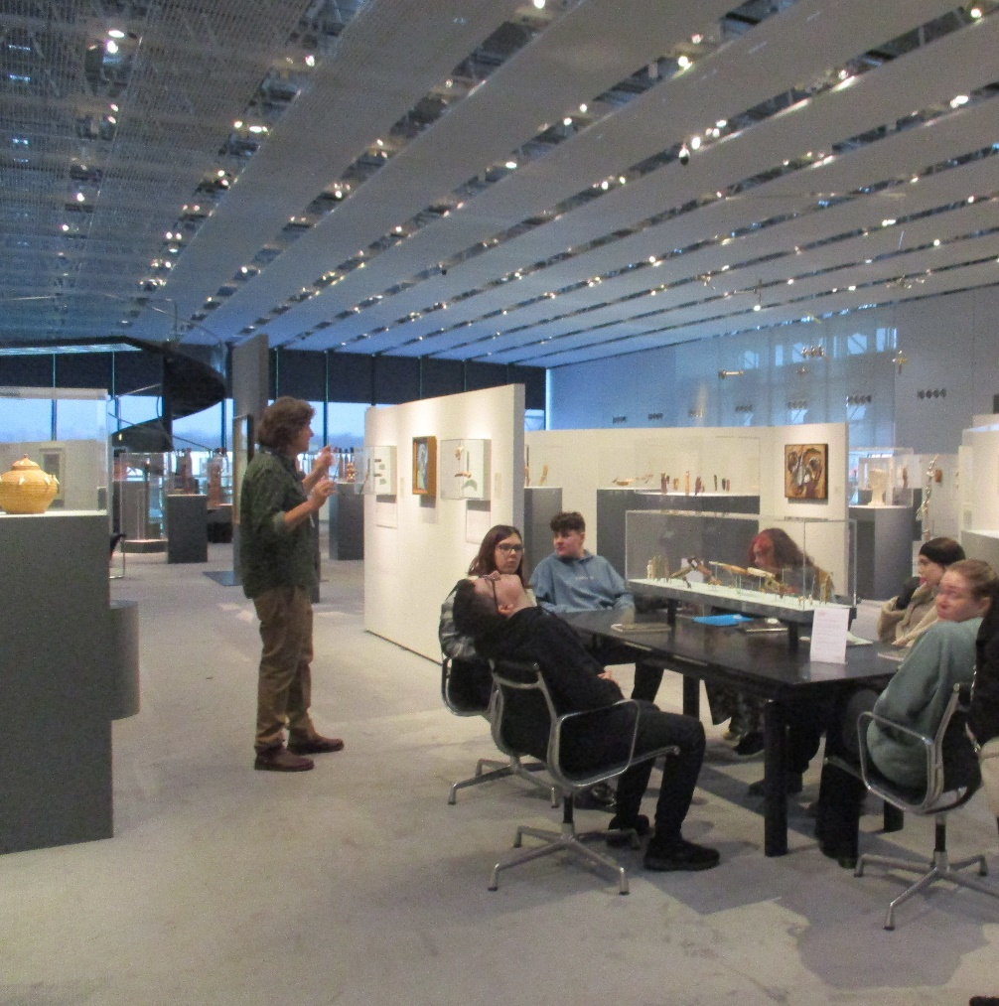


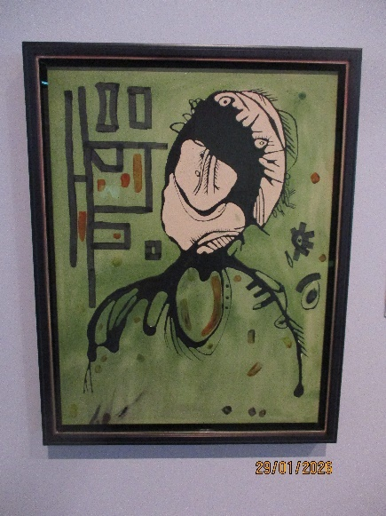
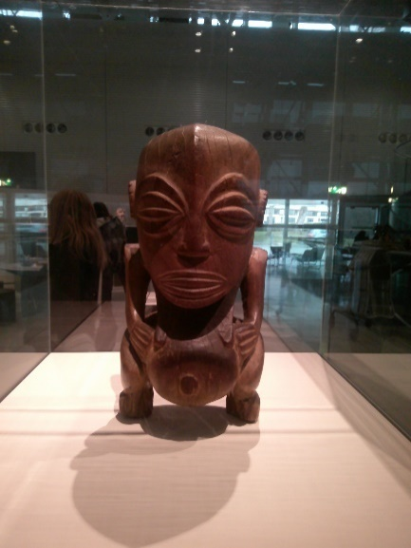

Mark Haywood – Art Teacher

Food Technology

Our Food Technology students recently completed a very successful “Come Dine with Me” themed project, showcasing not only their cooking skills but also excellent time management, teamwork, and creativity.

Students were given ownership over their food choices and worked independently to plan, prepare, and present their dishes within a set time frame. The lesson concluded with a tasting session, where dishes were sampled and scored using our senses — appearance, aroma, taste, texture, and overall presentation.

The theme for this round was International Cuisine, and the variety on offer was impressive. Dishes included an aromatic Indian curry, sweet and sour chicken served with chicken fried rice, lasagne and chips, and a taste of Mexico with vegan tacos. Students also explored thoughtful food choices, discussing reasons why some people may choose not to eat certain foods — such as pork — due to religious or cultural beliefs. This encouraged respectful conversation and greater awareness around inclusive cooking.

The atmosphere was lively and positive, with students fully engaged and clearly enjoying having responsibility for their own Food Technology decisions. Scores were awarded at the end of the session!
Stay tuned for our next “Come Dine with Me” challenge, where students will be turning their attention to classic British desserts!
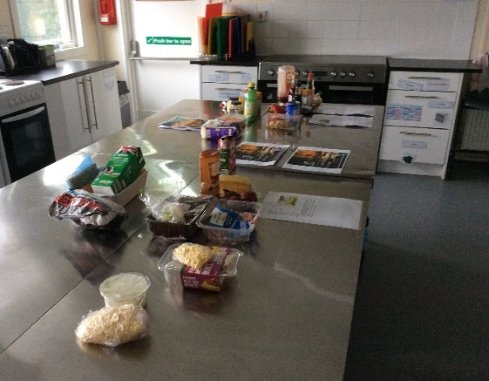
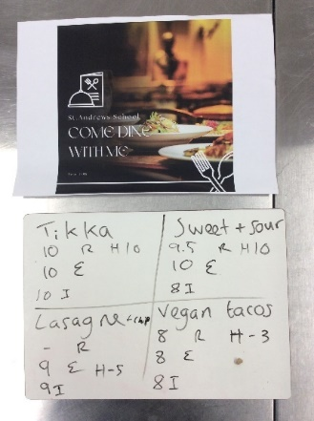

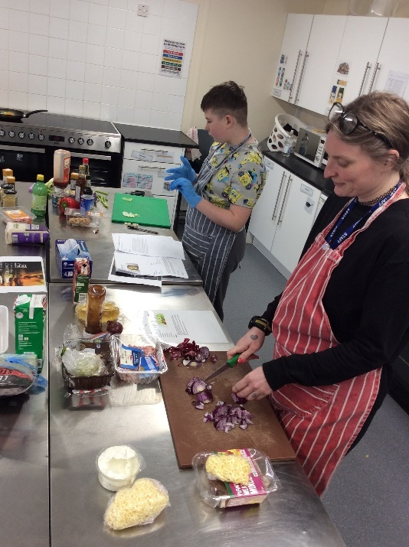
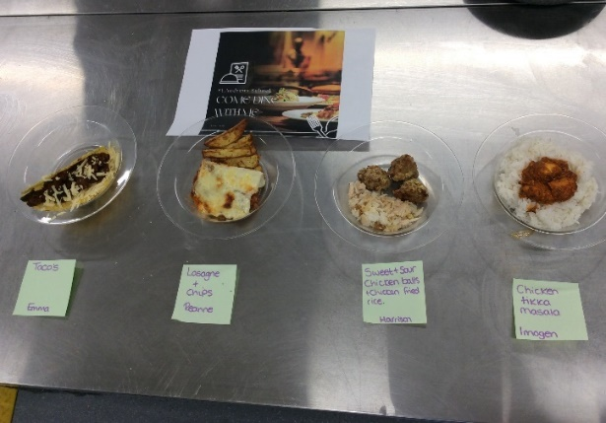

Emma Lawer – Food Technology Teacher
SMSC Wellbeing Day – Thriving Together
On Friday 16th January, students took part in our SMSC Wellbeing Day, themed “Thriving Together: Understanding and Improving Wellbeing.”
The day was designed to help pupils develop practical strategies for looking after their mental, emotional, and physical wellbeing, while strengthening social connections across the school.
Throughout the day, students engaged in a range of subject-based activities.
English: Pupils explored short wellbeing texts and expressed their thoughts and feelings through reflective poetry, encouraging emotional awareness and empathy.
PE: Team-building games: students learned how physical activity can support positive mental health and cooperation.
PSHE: Guided breathing, mindfulness, and grounding exercises helped pupils discover calm, balance, and the importance of self-care.
Art: Creative mindfulness activities and affirmation art allowed students to relax, focus, and express themselves positively.
Food: Pupils explored how nutrition affects energy and mood by preparing a simple healthy snack and learning about hydration and balanced eating.
IT: Students considered digital wellbeing, focusing on safe screen use, time management, and using technology responsibly to support wellbeing.

The day strongly supported our SMSC values, promoting spiritual reflection, social cooperation, moral responsibility, and cultural understanding. It was wonderful to see students engaging thoughtfully, supporting one another, and developing skills they can use both in school and beyond.
We are proud of the positive atmosphere created and look forward to continuing to prioritise wellbeing across the curriculum.
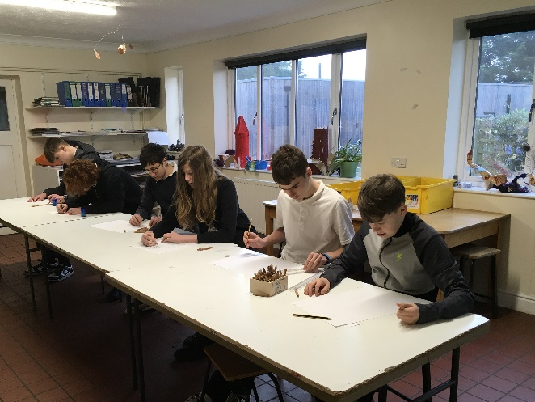
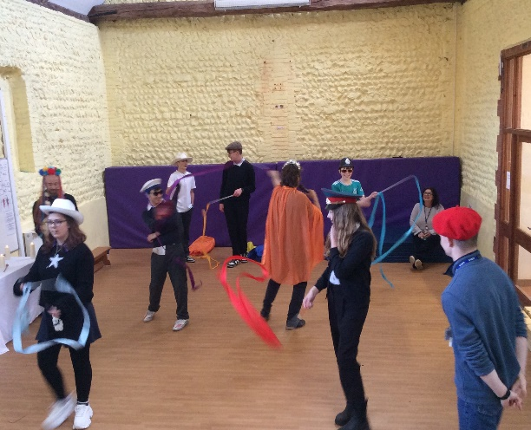

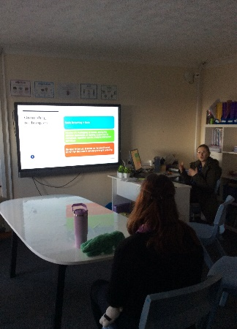
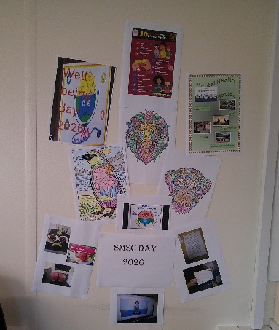

Paula Mayes – RSHE Teacher

