Head’s Note

It is hard to believe we are heading toward the final term of the school year! I am so proud of our wonderful students and all that they have achieved this term. A special 'well done' to our Year 11 students who are working really hard in their examinations. I look forward to all the opportunities that next term will bring, including all of the fantastic 'Gotcha' trips across the school. It is going to be another very busy half-term ahead and I hope that you all have a relaxing break next week.

Key Dates
Last day of half term: Friday 23rd May
Students return to school: Monday 2nd June

Wednesday 4th June: Pets as Therapy Dog
Tuesday 10th June: Work Experience commences for Year 10 students
Wednesday 11th June: Immunisation Catch Up Clinic
Thursday 12th June: Pyjamarama Day
Monday 16th June: Career Advisory Sessions for Year 10 students
Wednesday 18th June: Pets as Therapy Dog
Friday 20th June: Latitude Designer, Hattie Spice
Thursday 26th June: Sports Day
Friday 27th June: Year 11 - students last day
Monday 30th June: Year 10 - Paston College visit
Tuesday 1st July: SMSC Day
Wednesday 2nd July: Pets as Therapy Dog
Wednesday 9th July: Year 10 - City College & Easton, Norwich College visit
Thursday 10th July: Summer Fete
Monday 21st July: Last day of Summer Term

Students return: Thursday 4th September

Careers Coffee Morning
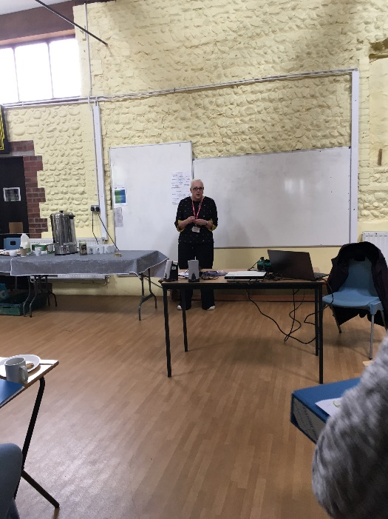
We are really pleased that so many parents and carers joined us for the Key Stage 3 and 4 Careers Coffee Morning at the beginning on term. This was an opportunity to show the students’ careers folders, which are a record of their careers journey throughout the curriculum, during their time at St Andrew’s. After an overview of some of the aspects of our careers programme, Pamela Birt from Norfolk County Council hosted a presentation about Supported Internships, specifically the Norfolk offers and Sophie Allan from Norfolk County Council sent in a video recording explaining Apprenticeships. Pam happily answered questions, and parent and carer feedback has been warmly welcomed. Thank you to everyone who could make the event.

Year 7 Geography Field Trip
Year 7A and 7B visited the Beeston Bump to conduct a Geography fieldwork project. The students worked incredibly hard gathering evidence to help them answer the main project question, ‘ Is the Beeston Bump a popular tourist attraction?’ The students used the geographical skills learnt in lessons to create a sketch map of the view from the top of the bump and to work out which features make the bump attractive to tourists. They also practised their social skills when asking members of the public whether they were local people or tourists. The students analysed the results and applied their knowledge of map skills to write their own conclusions in a follow up lesson.
Well done Year 7s, great Geography fieldwork!
Juanita Burrows – Head of Geography and Careers
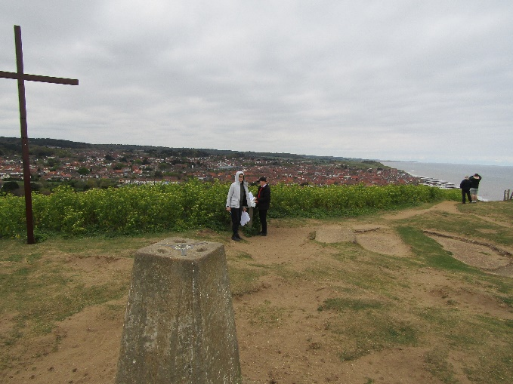
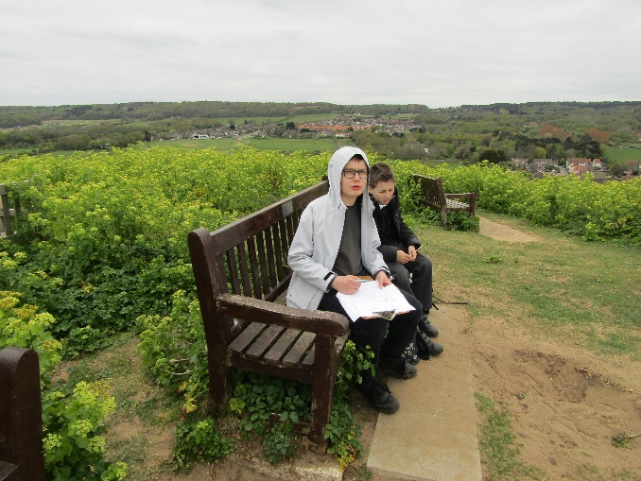

Music
In Music we have been enjoying using all our donated musical equipment and working on our band skills. We have been learning how to play chords on the keyboard as well as single notes and melodies, how to find and play notes on the new electric six string and bass guitars and we have been experimenting with adding in the drum kit and playing along as a band to “Just Shapes and Beats”. Next half term we are hoping to use these new skills to compose some music of our own to tie in with the “Little Gem” project – and then to learn to play along as a band to “Lava Chicken” for some end of term musical fun.
Judith Crass – Music Lead

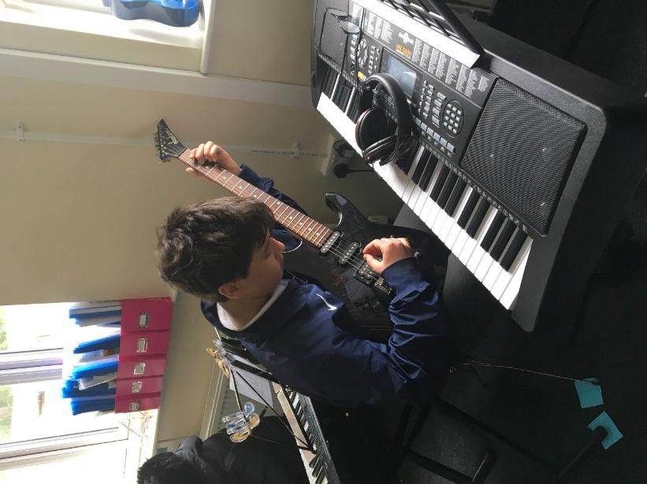
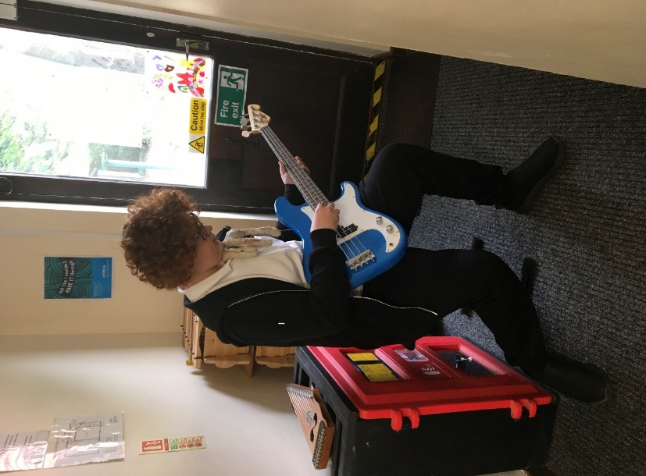

Violin Exam
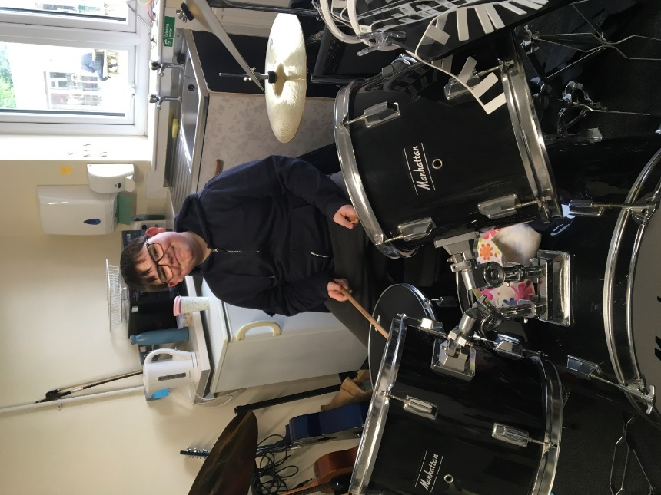
Congratulations to our Year 11 violin
Violin Exam student who passed his initial violin exam
with the Associated Board of the Royal
School of Music with a Merit. What a
wonderful achievement. A big thank
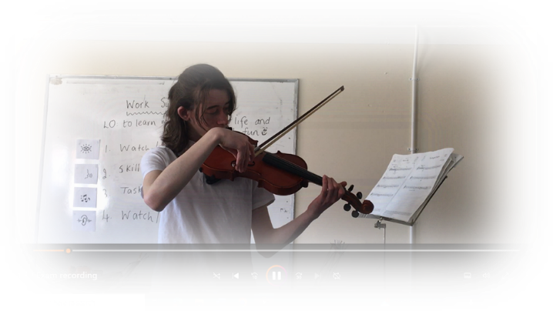
you to Eric, our peripatetic violin teacher.

Food Tech
Over the past few weeks in Food Technology, students have been working through an exciting assessment project focused on making chocolate cupcakes - we have called ourselves the 'Cupcake Crew'. Throughout this process, we’ve introduced clear assessment criteria, encouraged independent learning, and used a variety of metrics to track progress. The results have been outstanding — we’ve seen significant development in student confidence, collaboration, and practical skills.
Students are now actively supporting and guiding one another through each stage of the process, effectively using the tick method, and fully embracing independent learning. It's been fantastic to watch them take ownership of their work.
As part of the assessment, students have also gained valuable knowledge about different dietary requirements, including dairy-free, vegan, and vegetarian options, and how to adapt cupcake recipes to make them accessible for all. In addition, we've explored the ‘traffic light’ system and Treatwise guidelines to help them make more informed, healthier food choices.
Each week brought a new and engaging challenge: in the first lesson, students baked their cupcakes; the following week, they focused on creating icing and experimenting with a range of toppings; and finally, they refined their piping techniques, working on precision and presentation.
The progress made so far has been truly impressive — both in skills and teamwork!
Emma Lawer – Food Tech Instructor
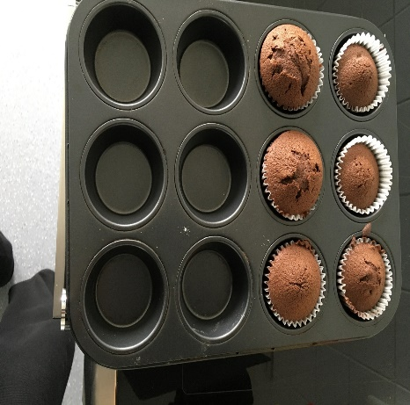
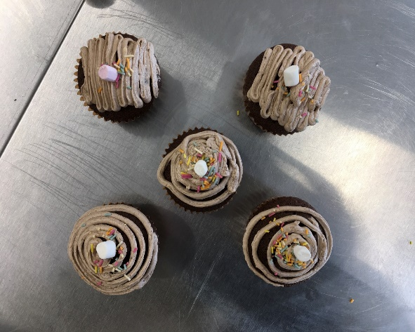
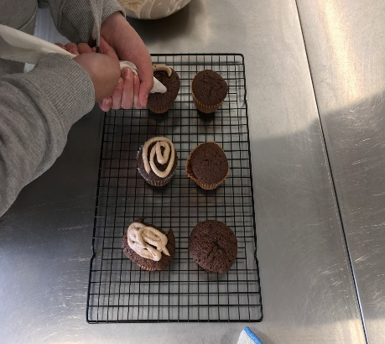

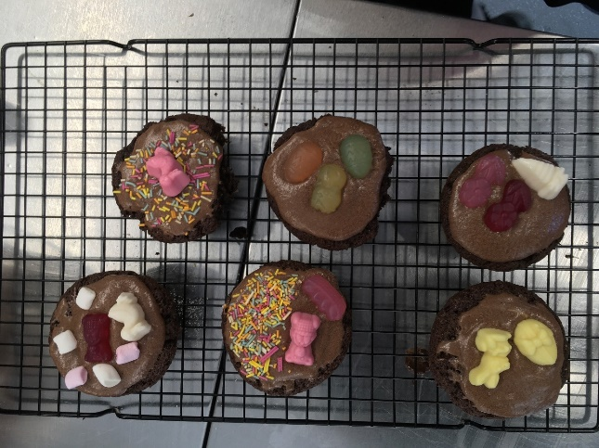
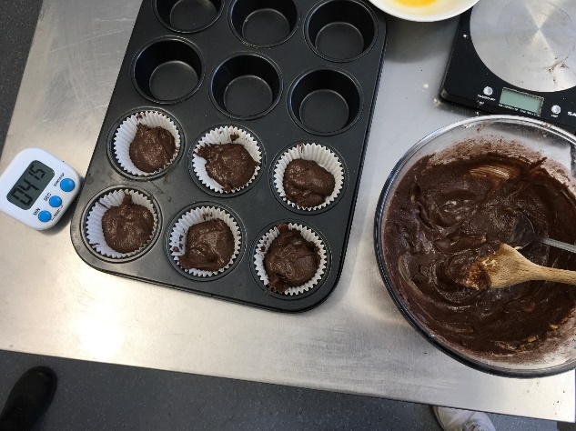
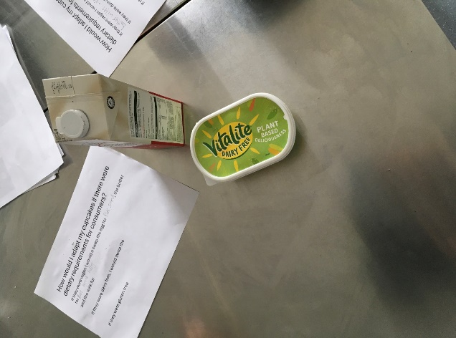

PE

PE
In PE this half term we have been joined by Abi from Norfolk Cricket on Thursdays so our students can experience some cricket coaching. Abi attends various schools around Norfolk, delivering cricket sessions to SEN students to promote cricket engagement through games.
We have managed to merge some classes so students can experience a session in a larger group, linking into our team games. Students have enjoyed the various activities Abi has delivered.
Vassy Stamatov – PE Teacher
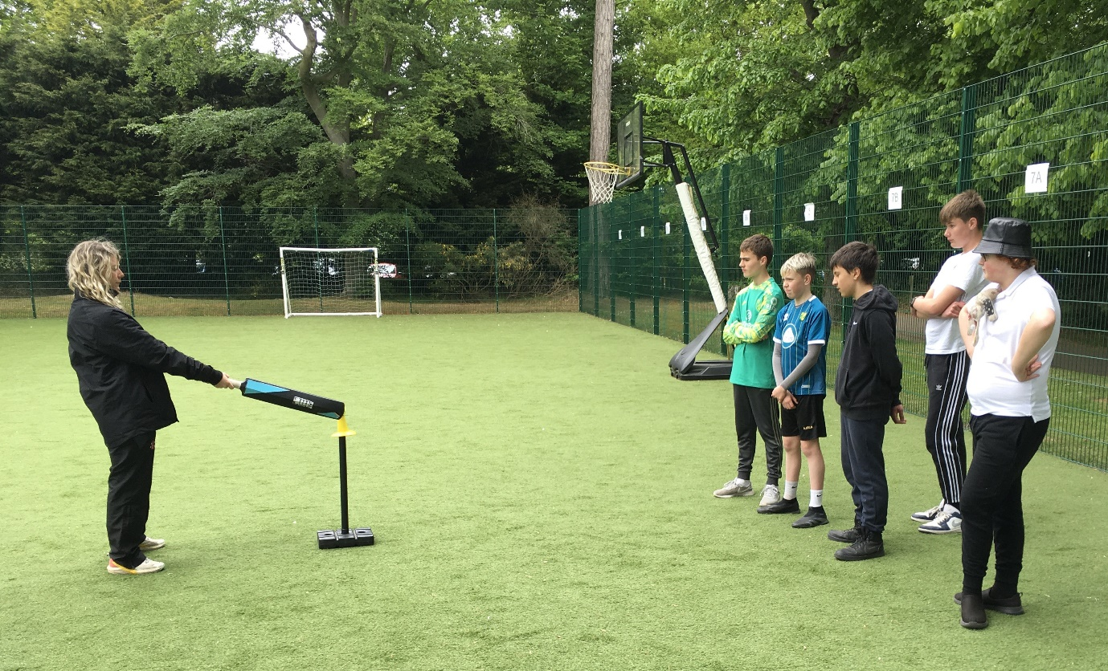

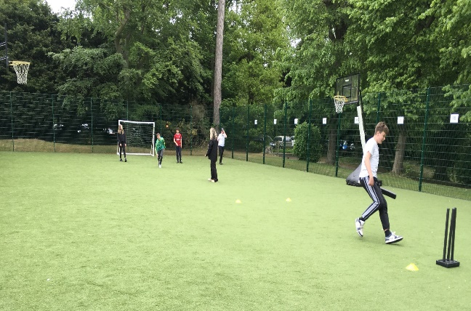
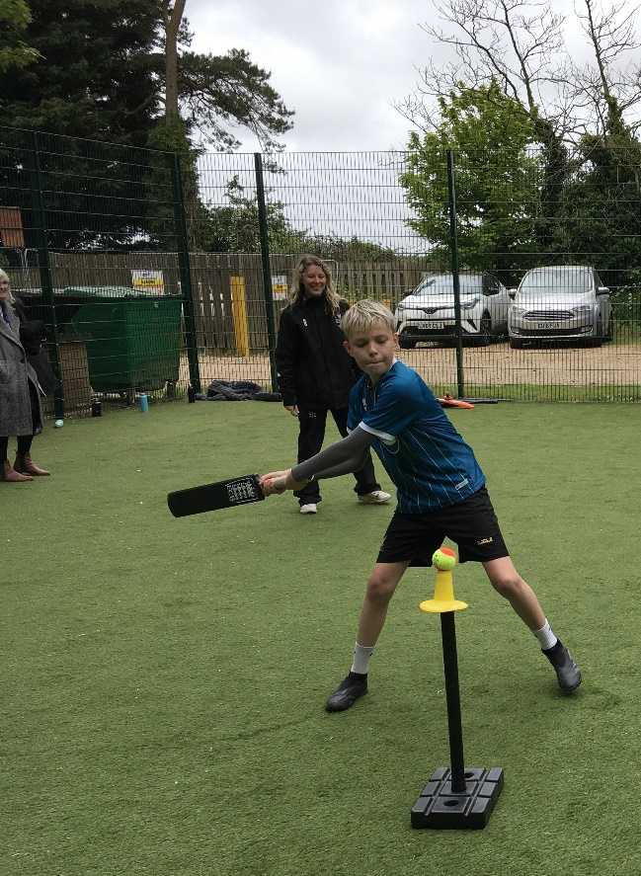

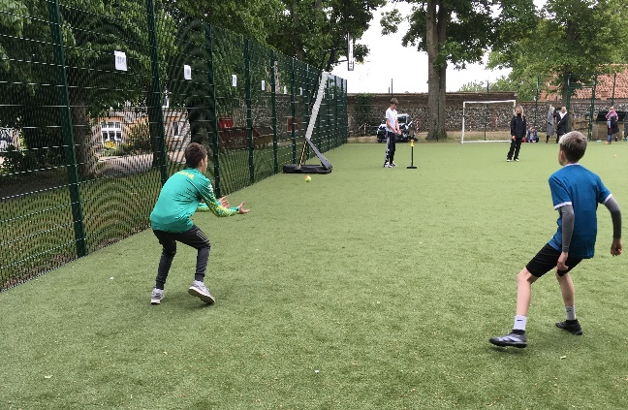

KS2 Social Trip
On Friday 16th May, KS2 used their social trip to go exploring in Felbrigg Hall National Trust Park to do some den building. Everyone took part in creating a den and worked really effectively as a team. Well done KS2!
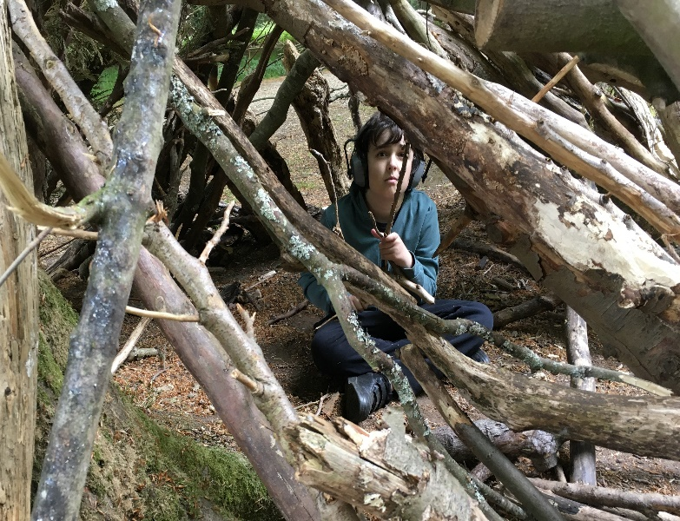
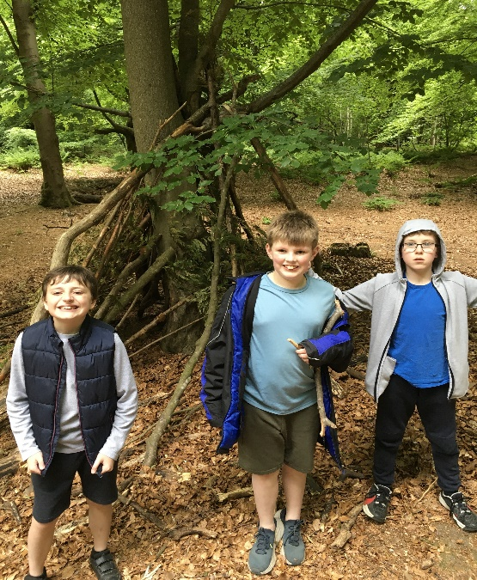

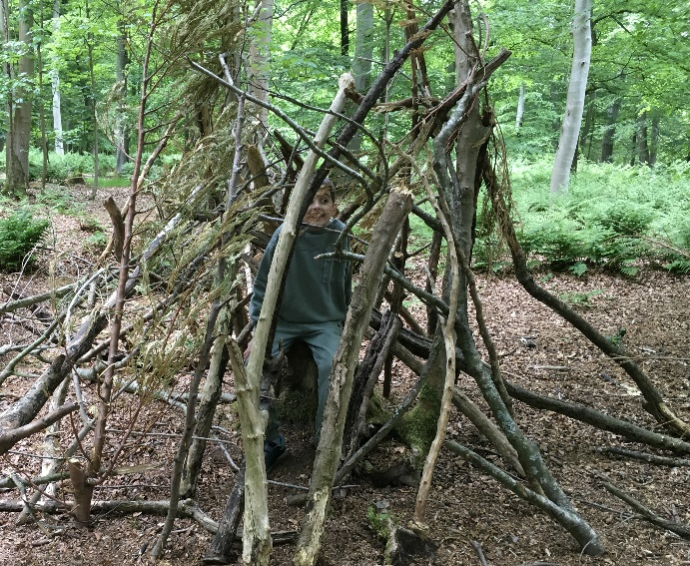
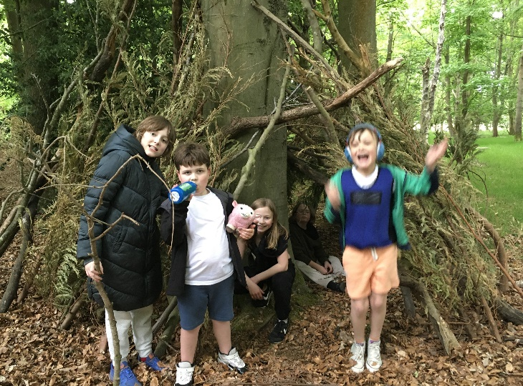

KS2 Swimming
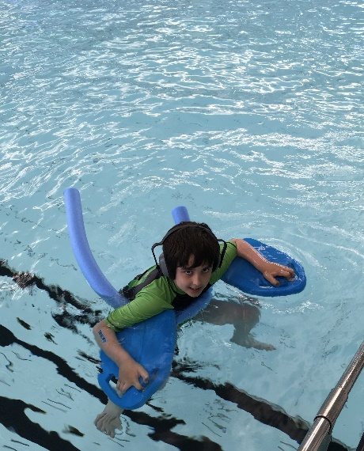
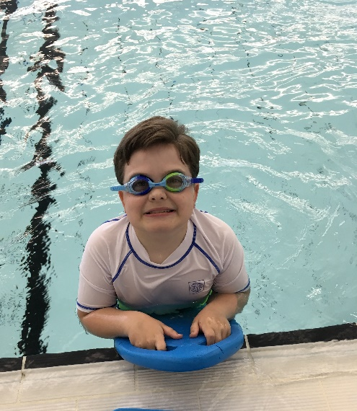
This year our KS2 students will have twice as many swimming lessons and the lessons are progressing well, with every student enjoying their time in the water. Keep up the good work KS2!

PSHE
On Thursday 8th May, our school marked VE Day (Victory in Europe Day) with a special History lesson. VE Day commemorates the end of World War II in Europe in 1945, and it gave us a chance to reflect on this important moment in history.
During the lesson, we explored what life was like during the war, especially for families living in Britain. One of the key topics was food rationing. Pupils learned how food was limited during the war and how people had to make the most of what they had. We also discussed how communities came together and shared what little they had to support one another.
It was a fascinating and thoughtful session that helped us appreciate the challenges faced during wartime and the significance of VE Day in shaping the peace we enjoy today.
Paula Mayes – PSHE Lead
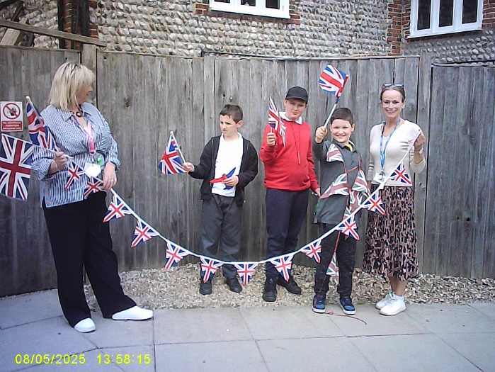
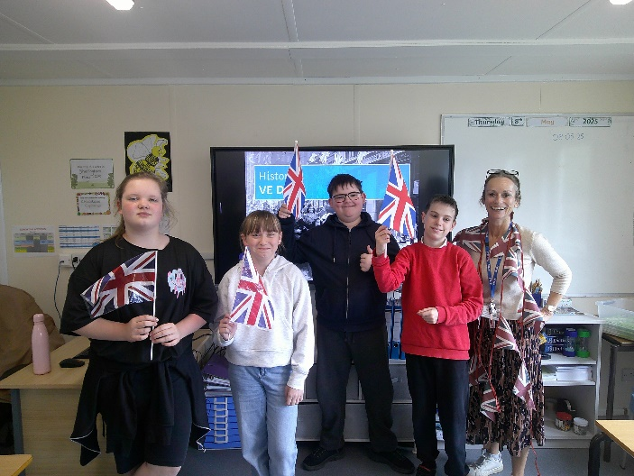

Gentle Reminders

Sickness
As the weather changes the multitude of viruses and bugs seem to become prominent in the school environment. It is fine for your child to attend school if they have a cold or sore throat but please do keep them at home if they have a temperature, sickness, or diarrhoea. We have a 48 hour clear policy for both sickness and diarrhoea so please do not send your child to school during this period.

All absences should be reported to the school on 01263 837927 before 8:30am please.

