Football Festival 22nd November:
As part of the PE curriculum with teamwork, sportsmanship, self-confidence and self-esteem being at the forefront, we travelled to The Nest, Norwich, to take part in a Football Festival organised by the Community Sports Foundation with other participating schools. The day consisted of several 7 a-side games where the students could experience working as part of a team and representing the school. In between matches, the students were able to enjoy watching some of the World Cup with Argentina v Saudi Arabia and Tunisia v Denmark to inspire and motivate.
It was a real success, with the students experiencing the highs and lows of sport with a victory to finish the afternoon.
Well done!

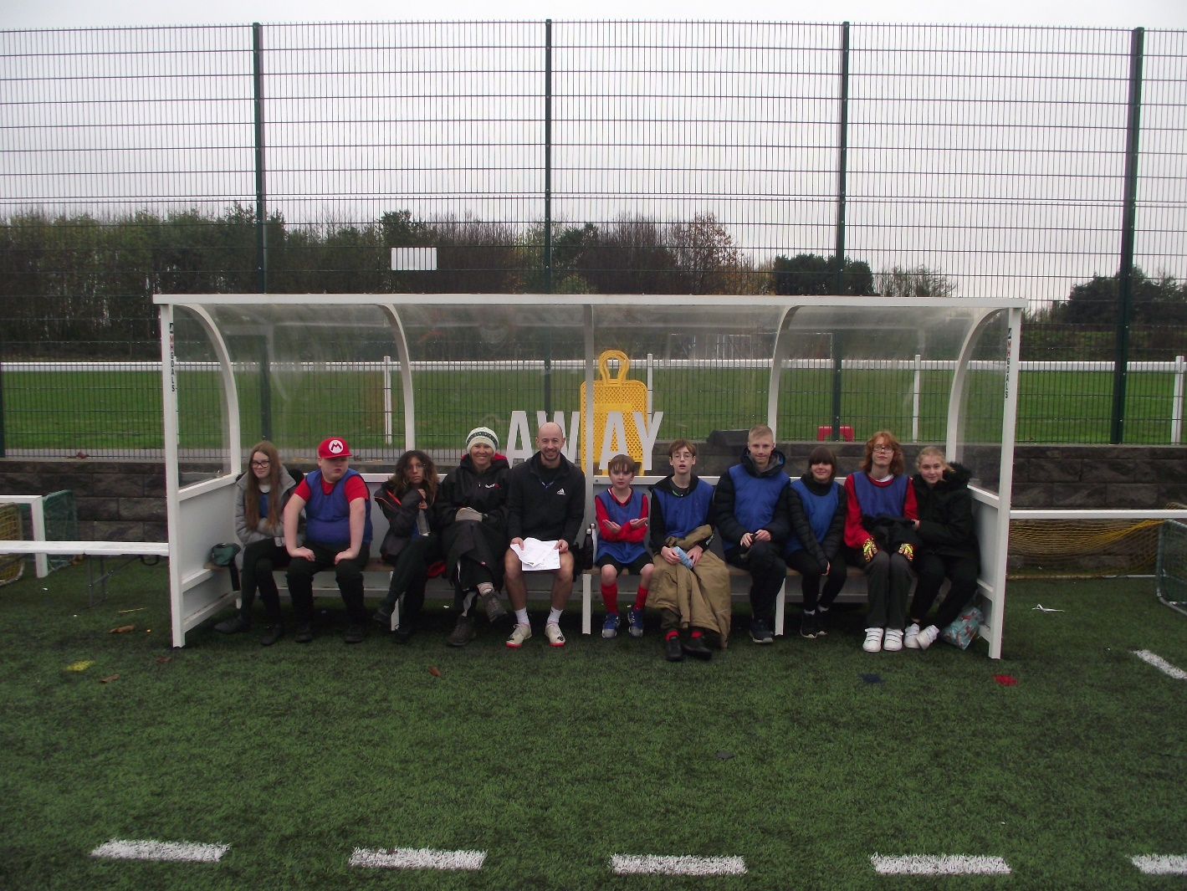
Hello All,
We have all enjoyed another busy term. The Grand Opening of our new build by the Lord Mayor of Sheringham was very well attended. Parents/carers, staff and students enjoyed refreshments and handmade gifts to buy. There was also a clothes swap arranged by the Eco Warriors of KS2 which proudly raised the sum of £126.36.
On Friday 18th November the students enjoyed our ‘spotty themed mufti day’ fund raising £49 for ‘Children in Need’.
Year 11 students enjoyed their visit to East Norfolk Sixth Form College and East Coast College.
Our SMSC day this term was all about Australia with activities including Aborigine art, Deadly 60, Cricket and Waltzing Matilda.
Students also participated in designing tea towels with their self-portraits as another fund-raising activity this term. There is still opportunity to make a purchase should you wish at a cost of £5.00.
Finally, Christmas is nearly upon us and the end of term approaches. As a Christmas treat each year, St Andrew’s School takes the students to either a pantomime or a cinema film as a special trip and social event which is always look forward too and enjoyed.
On behalf of all the staff, may I wish you all a Merry Christmas and a Happy, Healthy New Year.
Carol

Key Dates

School finishes for Christmas on: Students return to school on:
Friday 16th December @ 1:30pm Tuesday January 3rd

New Build Opening Ceremony & Christmas Fayre
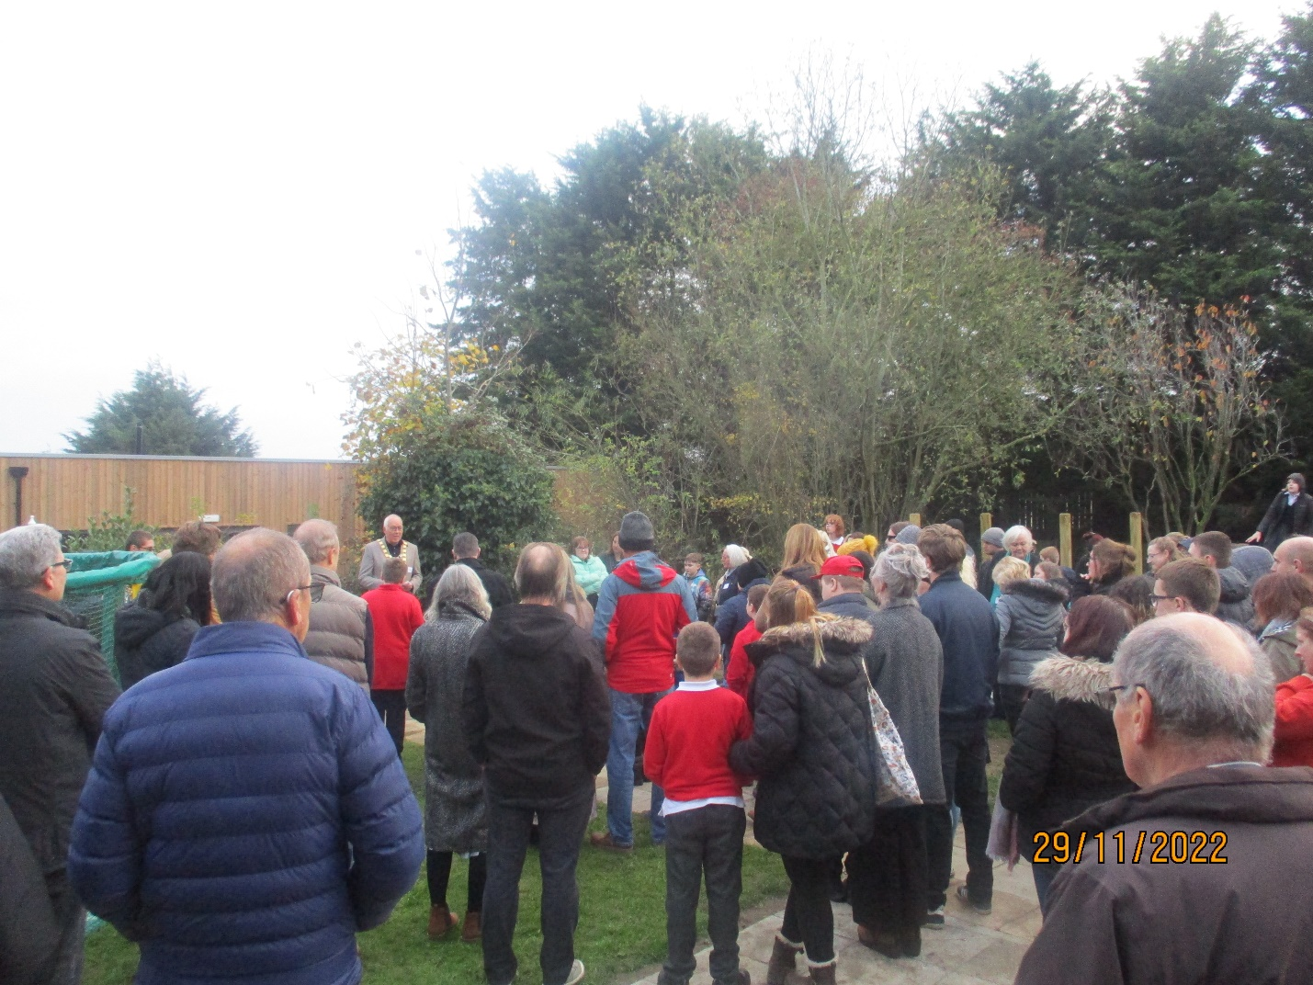
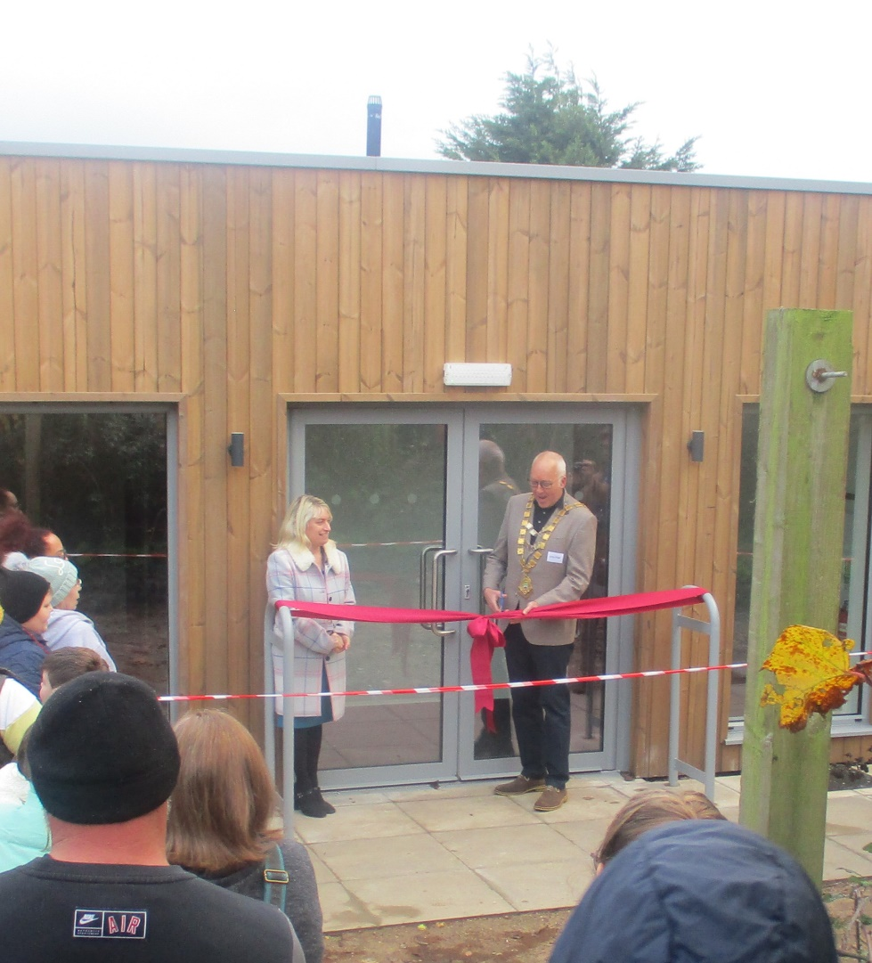
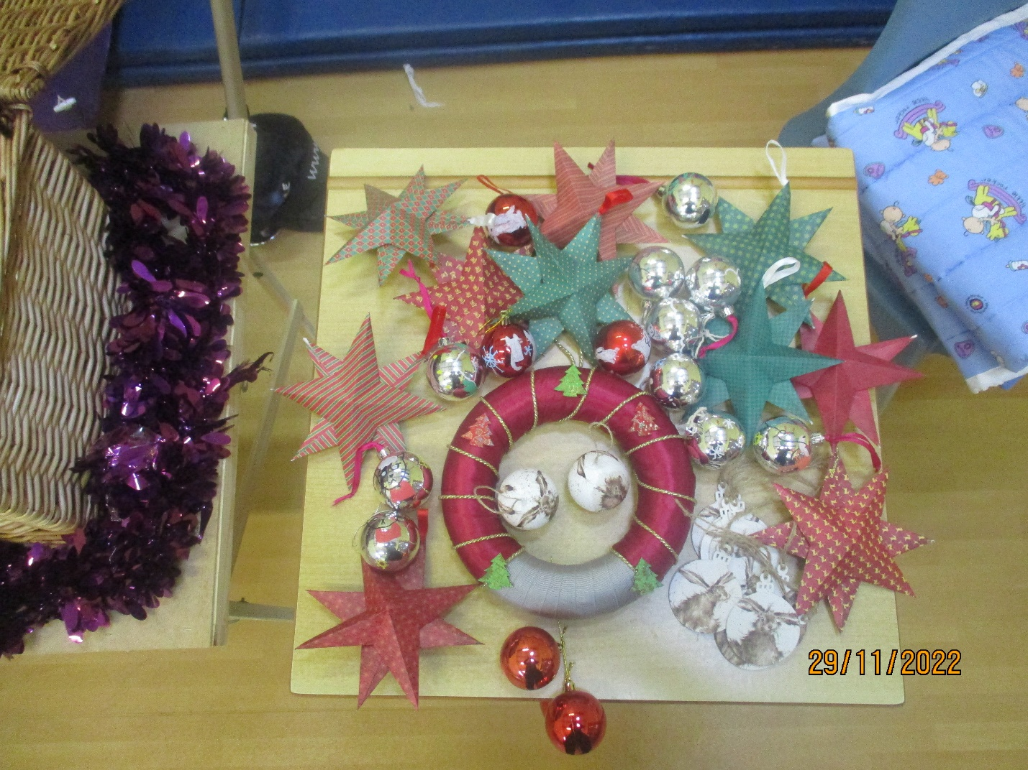
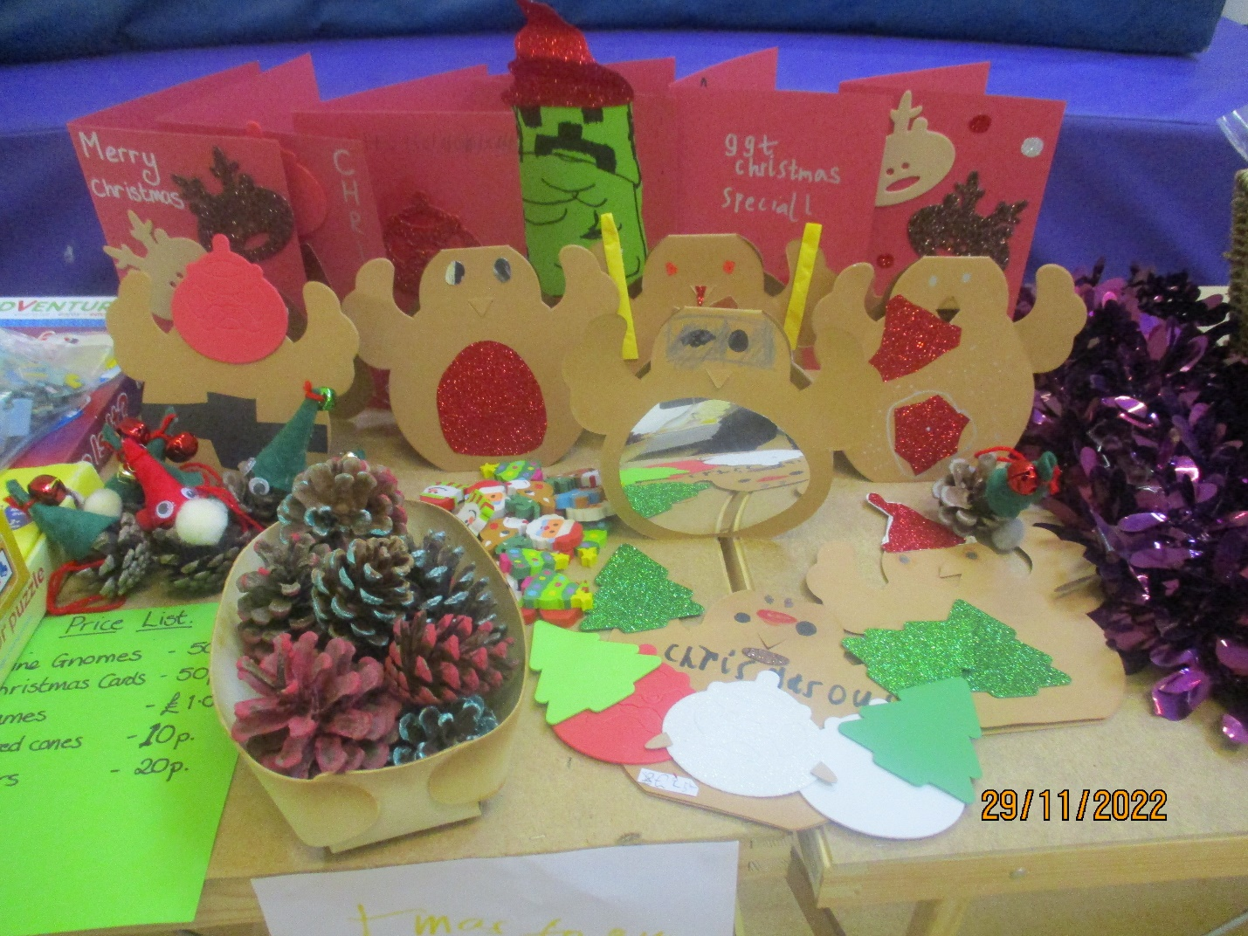
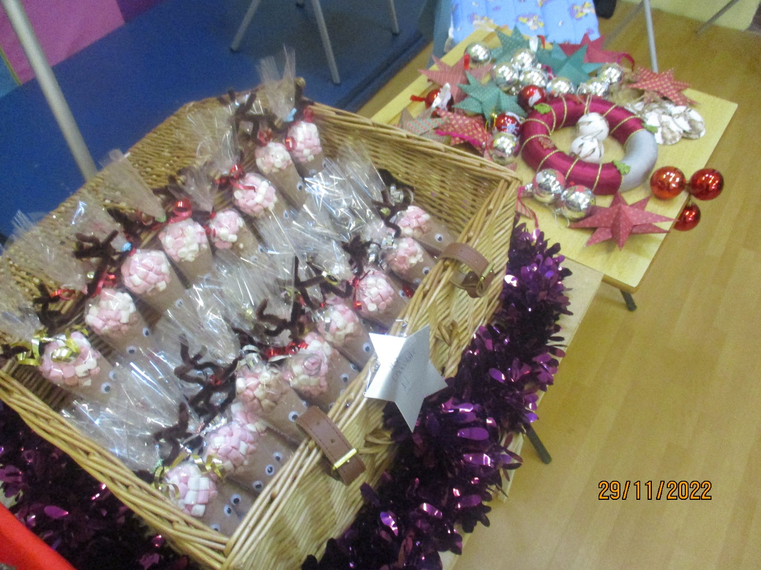
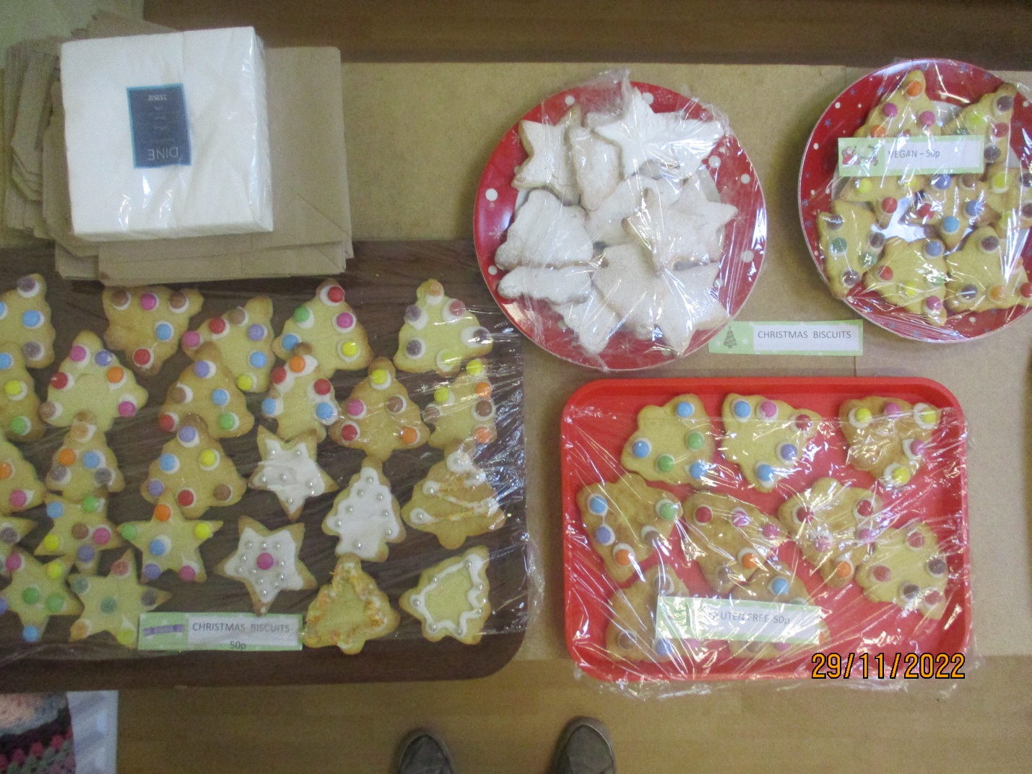

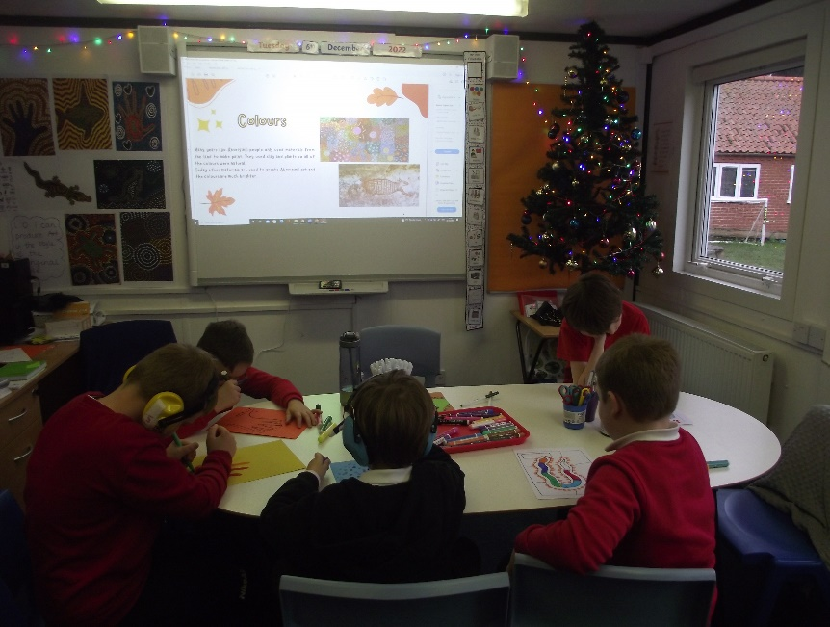
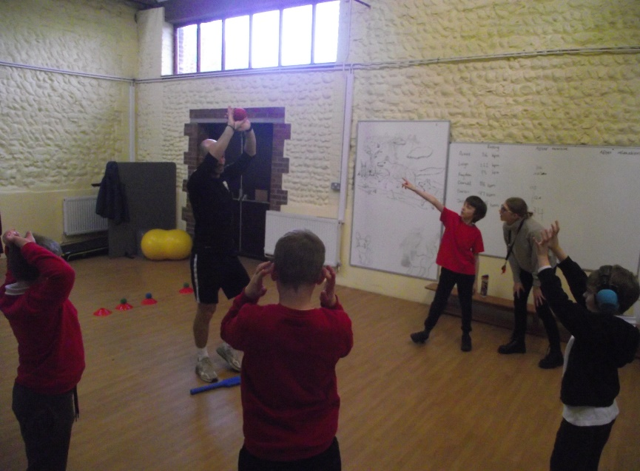
SMSC day this term was all about Australia.
Students had an explorative day looking at Aborigine art,
Deadly 60 creatures,
Cricket in Physical Education and Waltzing Matilda in Music

Music
The children are thoroughly enjoying our first proper Music Room. We had a friendly Open Day with jammy dodgers to welcome it in! We have already had the electric guitars out, and having a working whiteboard and plenty of space for the drumkit, percussion trolley, microphone stands and keyboards makes such a difference. It also feels a treat to have running water and toilets!
Eric’s peripatetic lessons are carrying on apace, karaoke is up and running in spare moments and the children are able to do more singing and moving to music now that we have the extra floor space. We all had fun singing and learning notes and chords to play along to Waltzing Matilda on Australia Day and learning about the Australian folk tale behind the song, and were even able to add in drums and steel drums and bells now that they are accessible.
New displays and a notice board are in the process of going up now that we have display boards (thank you Michelle and Sara), so the building should soon look really welcoming.
All in all a really positive move for the school. Thank you to Craig for all his hard work and kindness painting and cleaning, adding in sockets, installing new toilets and moving everything in so efficiently.

Music Careers talk
Three classes in KS3 had a lovely afternoon with Chris, our musical trustee, and his friend, John, from the band Charlie. John told the children all about his life as a professional bass player touring the world and supporting the likes of Fleetwood Mac, The Who and Iron Maiden.
The children had prepared questions and asked both Chris and John about music they liked, the road to becoming professional musicians and questions about a career as a musician. (And about Chris taking Kylie Minogue to lunch!).
Chris then showed the children some clips of their current band playing in and around the North Norfolk area. Adults and children all had such a good time.

Thank you very much both Chris and John for giving up your time for us. It is much appreciated.

