**Spring Term Horse Riding Lessons**

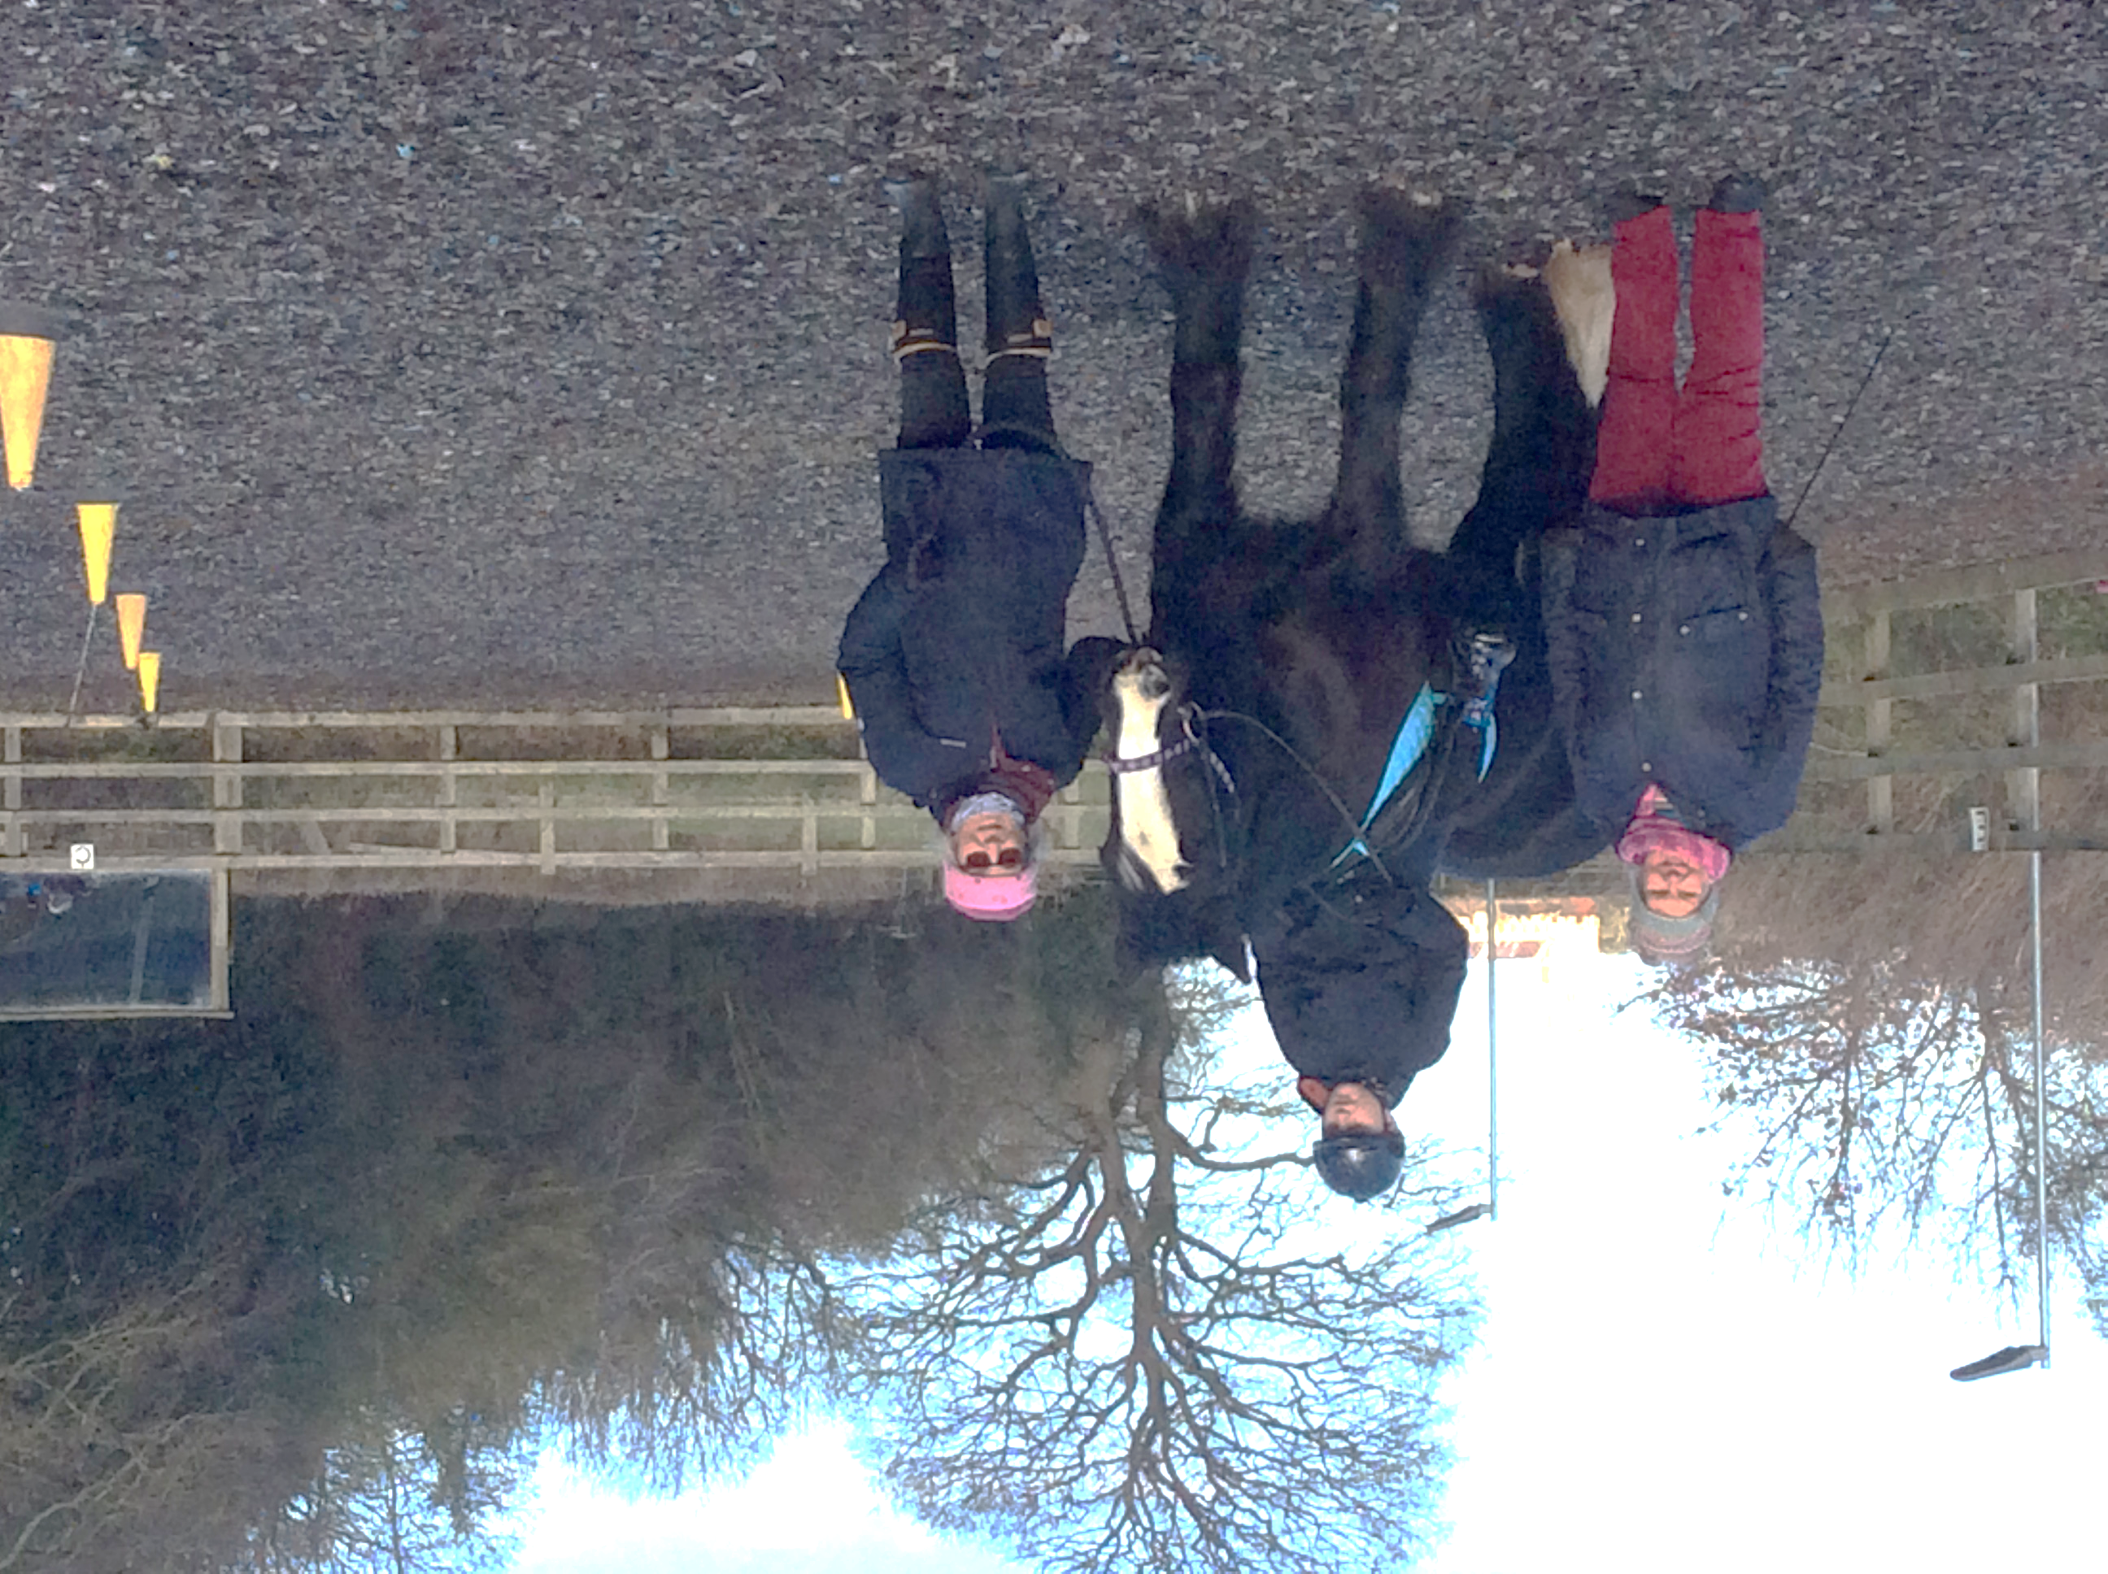

**KEY DATES**

**School Returns: Monday 27th February**

**World Book Day: Friday 3rd March Norfolk Showground Careers Event:**

**Coffee Morning: Thursday 30th March 10:00 – 12:00 Wednesday 8th March**

**Easter Holidays: Monday 3rd April – Friday 14th April**

**HEADS NOTE**

Welcome back.

I hope you all have had a restful Christmas.

Students from years 10 and 11 enjoyed the ‘Moving On’ Event, held at Sheringham Woodfield’s School this term. There will be an opportunity for these year groups to attend a careers event at the Norfolk Showground on Wednesday 8th March. Letters will be sent to parents/carers on our return to school.

Next term we will be inviting all parents/carers to our coffee morning, which will include an optional careers presentation. Letters will be sent in the new term.

May I wish you all a happy half term break.

On the 1st February, students from years 10 and 11 visited Sheringham Woodfields School for the ‘ Moving On’ event. This was a career event which provided the students with the opportunity to meet people from a variety of organisations from across Norfolk. This included local colleges, Norfolk County Council SEND and respite organisations such as About with Friends.

 The students challenged themselves by speaking to the stall providers and asking questions. Some students asked for booklets and/ or leaflets to take home and our school library now holds information packs from this careers fair.

Overall, the students gained a lot from the experience, and we are hoping to be visited again next year.