**Head’s Note**

As we come to the end of another very busy half term, it is important to reflect on all the students’ hard work and all of the opportunities the students have enjoyed. Everyone should be extremely proud of their achievements, and I was delighted to be handing out so many certificates and awards during our Achievement Assembly earlier this week. I would like to wish you all a lovely half-term holiday. It is a very short half-term ahead, but we already have lots of exciting activities planned.

**Key Dates**

**Friday 14th February: Last day of term**

**Monday 3rd March: Students return**

**Wednesday 5th March: ‘Festival of Knowledge’, Norfolk Showground Careers Event**

**Thursday 6th March: Mini Medics, First Aid Training (KS2, Years 7 & 8)**

**Friday 7th March: World Book Day**

**Friday 7th & 21st March: Bikeability**

**Friday 7th March: Mini Medics, First Aid Training (Years 9,10 & 11)**

**Friday 7th March: KS2 Swimming Lessons, The Reef, Sheringham**

**Monday 10th March – Friday 14th March: Readathon Week**

**Tuesday 11th March: MenACWY/DTP Vaccinations (Year 9 students only)**

**Wednesday 12th March: Year 10 ‘Moving On Event’**

**Wednesday 12th March: Football Festival, Norwich**

**Thursday 20th March: Comic Relief Day**

**Friday 4th April: Last day of term**

**Wednesday 23rd April: Students return**

**Careers**

During the spring term, every class will visit a local employer within their weekly trip lessons. The students will have the opportunity to participate in a tour and talk about job roles, daily tasks, employability skills and qualifications and training.

Additionally, Tesco and Bakers and Larners are tailoring their talks to apprenticeships, to help embed our students’ knowledge of academic and vocational training routes through real life training opportunities.

The students get to see behind the scenes of these companies and the chance to practice their social skills when asking questions and engaging with the speaker and staff on the tours.

Bakers & Larners of Holt

The Reef, Sheringham Action Community Enterprise (ACE), Norwich

Our Year 9 students visited ‘ACE’ in Norwich, which offers vocational training courses. Some of our current students attend ‘ACE’ for courses in construction, mechanics and hair and beauty. The students had the opportunity to ask questions whilst visiting the different learning areas, including the commercial kitchen used for catering courses.

**Norfolk County Council Visit**

Sophie, from Norfolk County Council, taught our Year 10 students about different types and aspects of work. The students engaged well and enjoyed the mystery box activity, where they had to link objects to different types of jobs and careers.

The Year 11 students participated in a lesson on employability skills and worked out examples of where they already demonstrate these skills, such as learning new skills at horse riding.

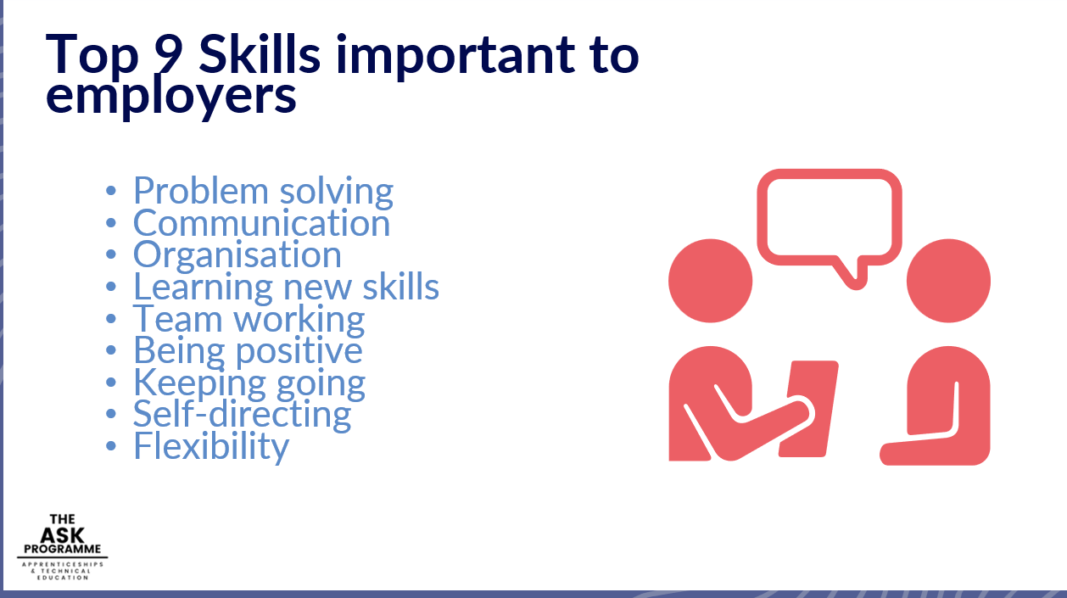

Juanita Burrows - Head of Careers

**PE - Gymnastics and Dance**

This half term we have covered Gymnastics and Dance in the PE curriculum, with students creating shapes and movements with their bodies and learning about poise, etiquette, routines, rhythm and moving to a beat. As gymnastics and dance share similarities in skills, this has demonstrated a good example of how transferable skills work with different activities, while incorporating creativity and expression. Our dance has been supported by a Nintendo Switch with 'Just Dance' to create a fun but useful follow-along tool, supporting us to move our bodies in a non-pressured environment.

Vassy Stamatov – PE teacher

**KS2B**

In KS2B we have been studying WW2 based on our book ’Friend or Foe’ by Michael Morpurgo, which is about two boys who are evacuated from London to Devon.

In our topic work we have learned about the history of WW2 and who was involved, created a Blitz display and portraits of soldiers, sewed marble pouches, played games from that time and cooked food from WW2 recipes.

We have all enjoyed this topic and the students have produced some great work!

Karen Massicks – KS2B teacher

**Music**

This term has seen the appointment of our first ever Music Captain. The Music Captain has designed his own job role and is now responsible for looking after musical equipment in the music room, setting up and putting back any musical equipment such as an amp, leads and microphones for the school talent show, and helping to provide any music for fetes/plays or special events. The Music Captain also teaches younger students with informal drum lessons when the opportunities arise and encourages others in all things musical.

Lessons have been fun with the further development of A.I music writing software, controversial though it is, showing students what can be achieved in a very short space of time, which has also led to some interesting discussions related to careers.

The music room now has some guitar racks to store the extremely generous donation of guitars we received. These will be well used in our Band Skills Unit and with the students. We are now planning to use the wonderful hand drums and wooden xylophones that were also donated as being part of our outdoor music-making in the summer with their lovely gentle mellow sounds.

Judith Crass – Music teacher

**Celebrating Children's Mental Health Week: Supporting Well-being with SCARF**

On Friday, February 7th, we proudly celebrated Children’s Mental Health Week by encouraging everyone in our school community to wear a SCARF. This special week highlights the importance of mental health for children and young people, and at our school, we take this occasion to emphasize key values that support emotional and social well-being.

The SCARF acronym stands for **Safety, Caring, Achievement, Resilience, and Friendship**. These values are at the heart of what we nurture every day here at our school, creating an environment where students feel supported, valued, and empowered to thrive.

* **Safety**: We prioritise creating a safe space where students can express themselves and grow without fear.
* **Caring**: Each member of our community is encouraged to be kind, empathetic, and considerate to others.
* **Achievement**: We celebrate the success and progress of all our students, no matter how big or small.
* **Resilience**: We empower our students to bounce back from challenges and approach difficulties with confidence.
* **Friendship**: Building strong, positive relationships is key to emotional well-being, and we encourage students to form connections based on respect and trust.

The day was a wonderful show of support, with many students and staff proudly wearing their scarves to symbolise these essential values. We were thrilled to see our community come together to raise awareness for mental health and demonstrate the importance of well-being in all aspects of life.

Paula - PSHE Lead

**Year 7 Explore the World of Microscopes: A Fascinating Science Lesson**

In an exciting hands-on Science lesson, our Year 7 students recently learned how to use their very own microscopes! The class was buzzing with enthusiasm as they explored the fascinating world that is often invisible to the naked eye.

To kick off the lesson, students had the opportunity to observe a variety of objects under magnification. They used a more powerful microscope, displayed on the interactive board, to take a close-up look at the skin of a bearded dragon (see photo). The intricate textures and patterns were revealed in stunning detail, captivating the students' attention.

But that wasn't all! The lesson also included a diverse range of specimens. Students examined their own **fingerprints**, marvelled at strands of **hair**, studied blades of **grass**, and got a closer look at insects such as a **wasp** and a **butterfly**. Each object offered a new perspective, encouraging curiosity and sparking questions about the natural world.

The energy in the classroom was palpable as the children eagerly explored, asking questions, making discoveries, and sharing their findings with one another. It was a fantastic opportunity for them to learn how microscopes work and appreciate the small wonders around us.

Overall, the lesson was a huge success, and it’s clear that the students are developing a deep interest in science and the power of observation. We look forward to seeing what other exciting experiments and discoveries Year 7 will continue to make throughout the year!

**Year 8 PSHE Lesson: Exploring Employability and Workplace Skills**

In a recent PSHE lesson, Year 8 students explored the exciting world of employability and workplace skills. This session gave them a valuable insight into what employers are looking for when hiring staff and the essential skills needed for success in different careers.

The class started by discussing the qualities and skills that employers value most in potential employees. From communication and teamwork to problem-solving and time management, students learned how these attributes play a key role in the workplace.

Next, the students explored various career paths, and the specific skills required for each one. To bring the lesson to life, they engaged in a series of role-playing activities that allowed them to put these skills into action. Whether it was demonstrating leadership in a management scenario or practicing customer service in a retail role, the students embraced the challenge and had a lot of fun along the way.

It was clear that the students really enjoyed the practical nature of the lesson, and they worked effectively to demonstrate their employability skills. By the end of the session, Year 8 had a much deeper understanding of the skills that will help them succeed in the world of work.

This lesson was an excellent opportunity for our students to develop a sense of the wider world of work and the skills they can start building today for future success. We look forward to continuing these discussions and helping our students prepare for their exciting career journeys ahead!

**Chinese New Year - SMSC Day**

**Chinese New Year- SMSC Day**

Students enjoyed a fantastic day, with activities based around the Chinese New Year. Here is a taste of the activities that took place:

**Dragon Dance Workshop**

Students worked together to create a mini dragon head using a cardboard box, fabric, and paint. They then rehearsed movements to simulate a traditional dragon dance.

**Tasting Chinese Cuisine**

Students enjoyeda sensory tasting session, sampling some Chinese foods such as rice crackers, prawn crackers, dumplings, and spring rolls.

**Lucky Red Envelope Workshop**

Students designed and decorated red envelopes ("hongbao") and placed positive affirmations or drawings inside for a friend or teacher.

**Sensory Storytelling: The Legend of Nian**

A storyteller narrated the legend of Nian, using sensory props such as drums for loud noises and different fabrics for textures.

**Calligraphy Fun / Creating Music**

Students tried writingChinese calligraphy and writing simple characters or created a piece of music.

**Exploring the Chinese Lunar Calendar**

Students learned about the Chinese lunar calendar and how the date of Chinese New Year is determined by the moon's cycle.

**SMSC Day Activities**

