St Andrew’s School Newsletter
July 2026

Dear Parents and Carers,
As we finish another academic year, it is lovely to remember everything that has been achieved. I would like to say a very big thank you to the St Andrew’s School staff for providing so many fantastic opportunities for our students to enjoy and for your support with everything we do as a school. This latest newsletter is 19 pages long and only captures part of the fantastic things that have taken place.
It was great to see so many parents, grandparents and siblings at the Summer Fayre. This makes such events even more special, and we were very proud of our students – it was lovely to see them enjoying themselves so much too.
In September, the school will be welcoming 17 new students, as well as some new members of staff. I hope you enjoyed reading the ‘All About Me’ information sheets about your child’s key members of staff and that your child enjoyed their Transition Week.
I hope you all have a wonderful summer break, and I look forward to welcoming you back in September.

Key Dates
Friday 17th July: Last day of term
Friday 4th September: Students return
Tuesday 22nd September: Year 10’s – Moving-On event
Wednesday 23rd September: Whole school flu vaccinations
Wednesday 19th October: Catch-up flu clinic, Year 8 HPV Immunisations & Year 9 DTP/MenACWY
Thursday 23rd October: Last day of term
School returns: Monday 9th November

Sports Day
On Thursday 18th June, we celebrated Sports Day with a full day of fun and inclusive sporting activities for all students to enjoy. The event featured a variety of challenges, from traditional athletics events such as the long jump and high jump, to fun activities, including the three-legged race, a smoothie bike, and football-themed games inspired by the World Cup.
To encourage teamwork and social interaction, classes were paired together to form larger groups. Students rotated around different activity stations across the school, giving everyone the opportunity to experience a wide range of events throughout the day.
The day concluded on the ASTRO with an exciting penalty shootout, followed by a presentation ceremony where all participants received medals. Special awards for 'Best Performer' and 'Best Sportsperson' were also presented to students who had particularly impressed with their effort, attitude, and sportsmanship throughout the day.
It was a fantastic day, filled with sport, teamwork, laughter, and friendship, and a wonderful opportunity to celebrate being active together.
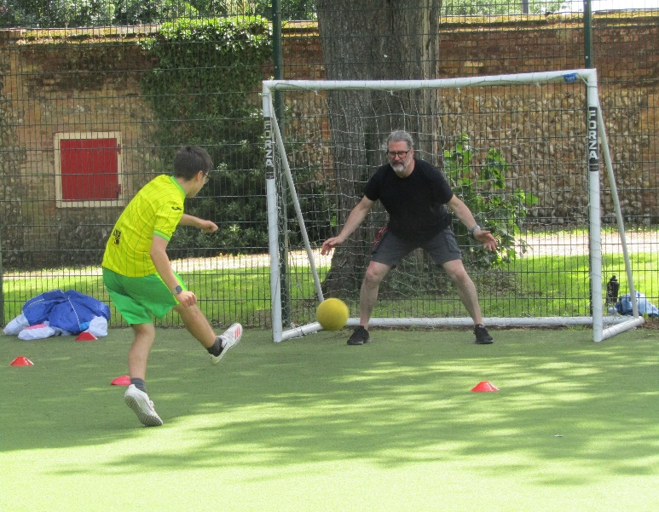
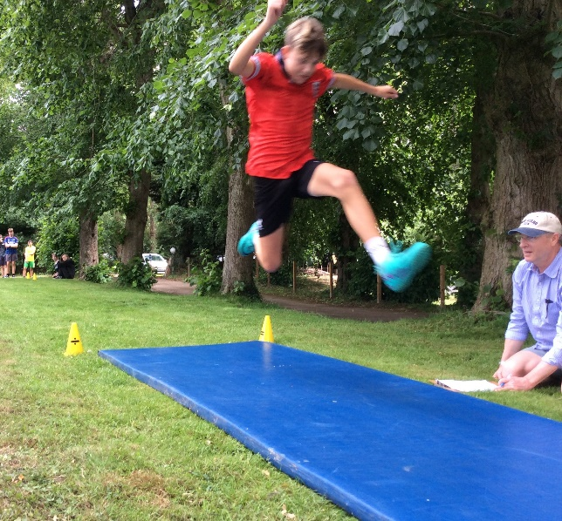

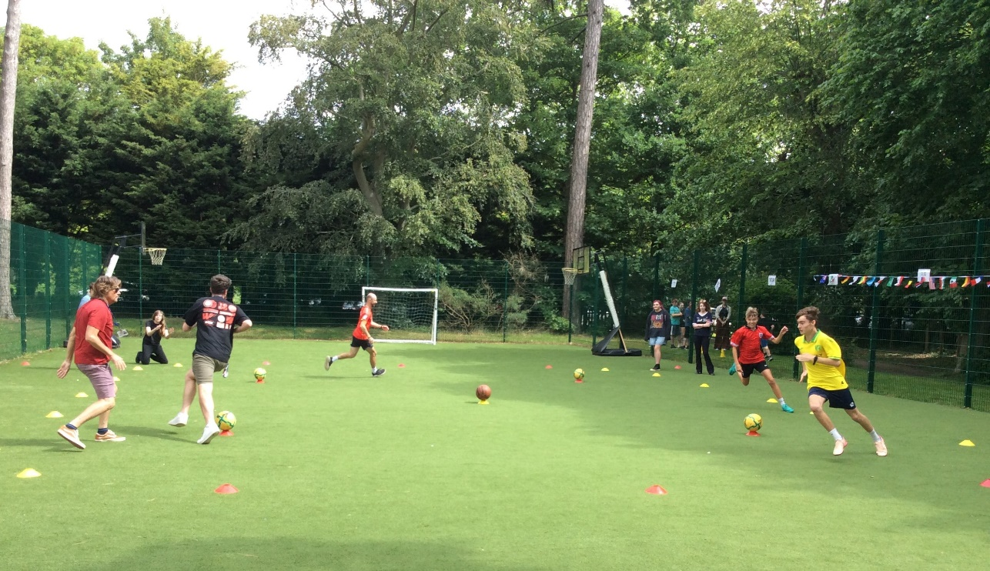

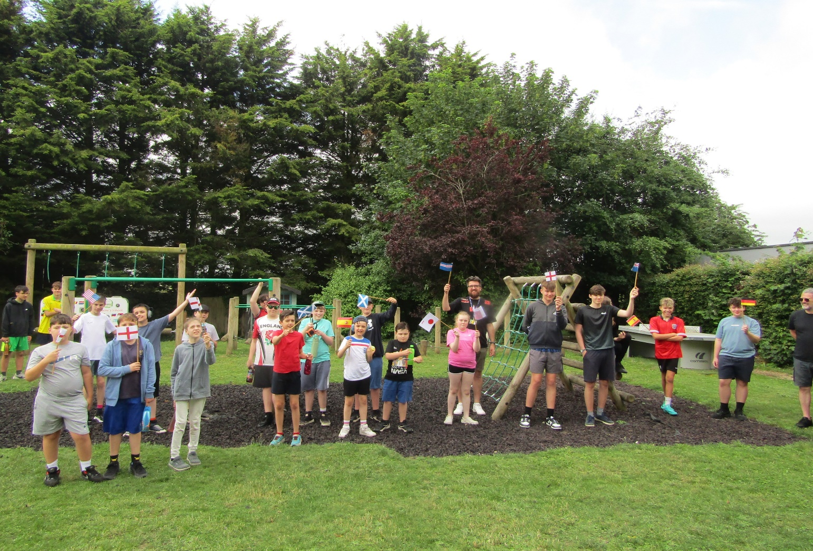

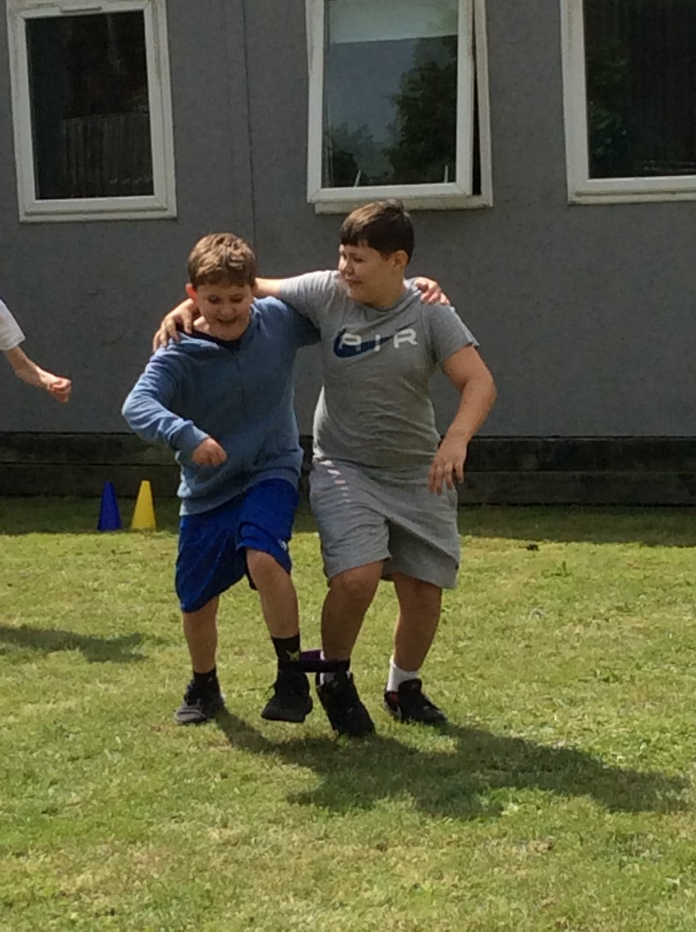

Sports Day 2026
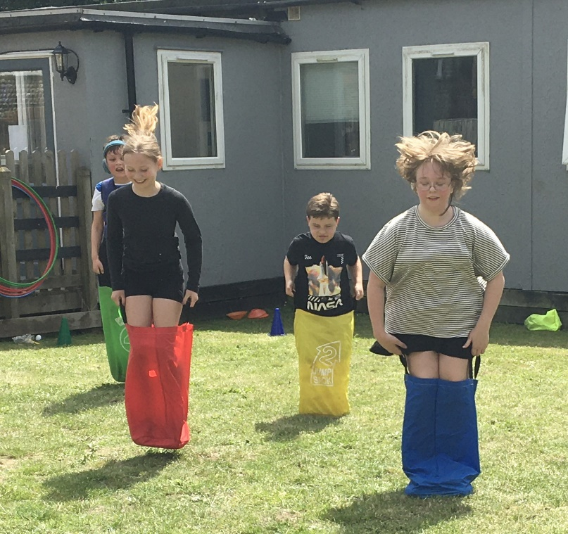

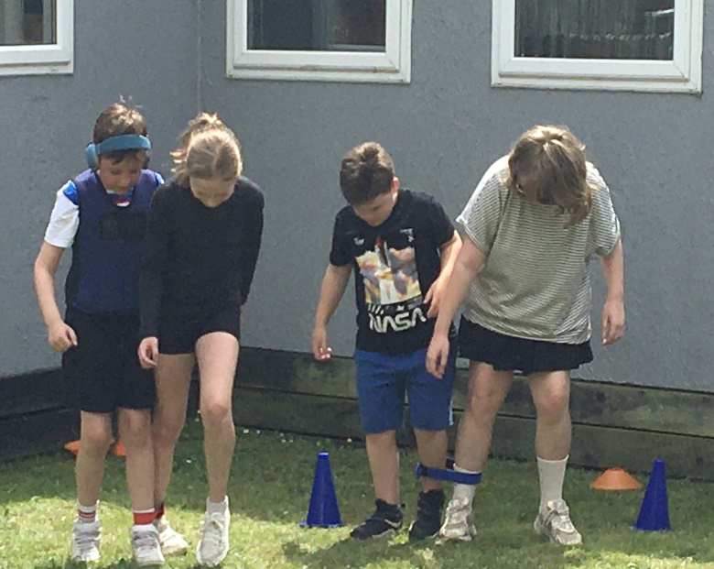
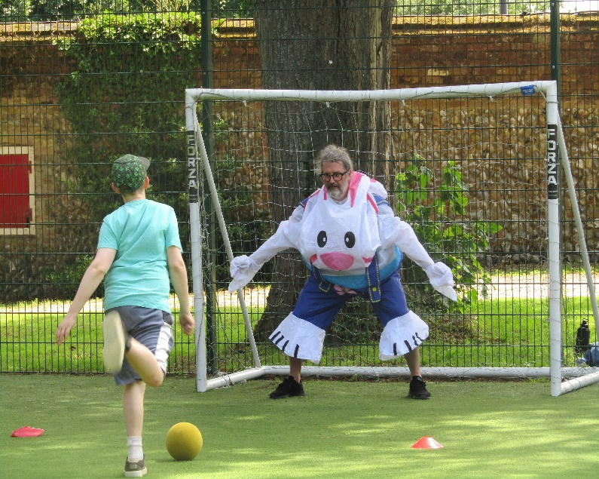

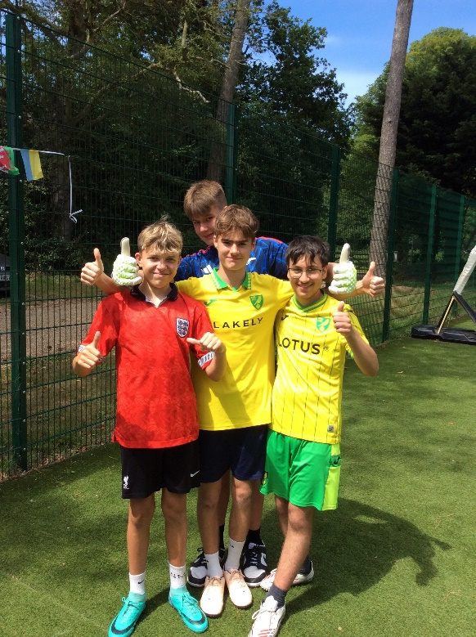
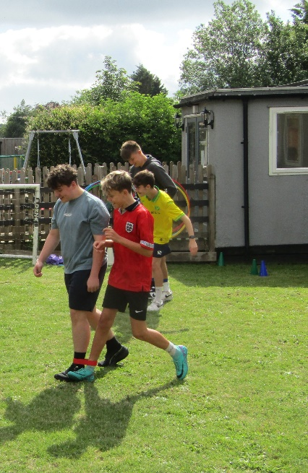
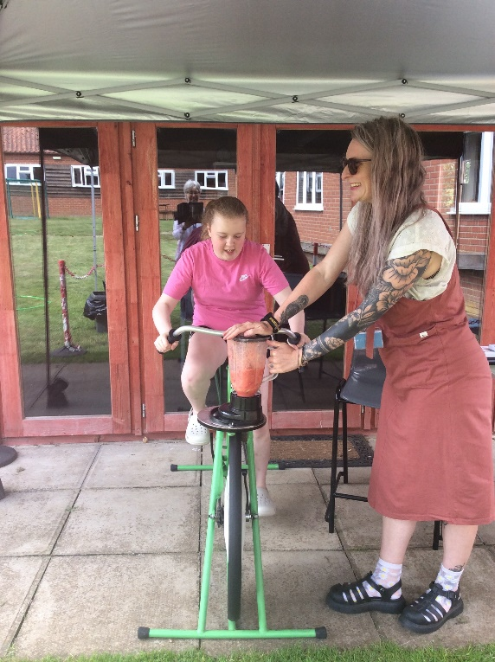

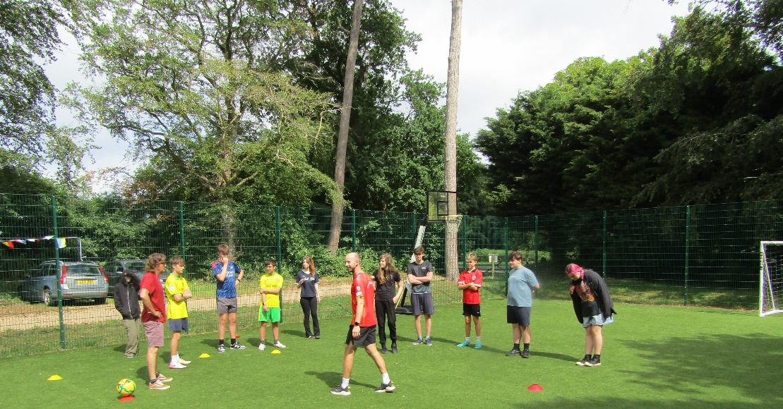
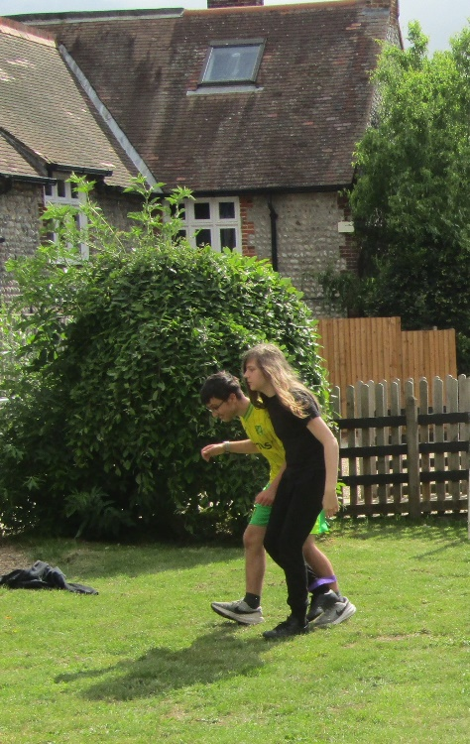

Vassy Stamatov – PE Teacher

KS2 Swimming:
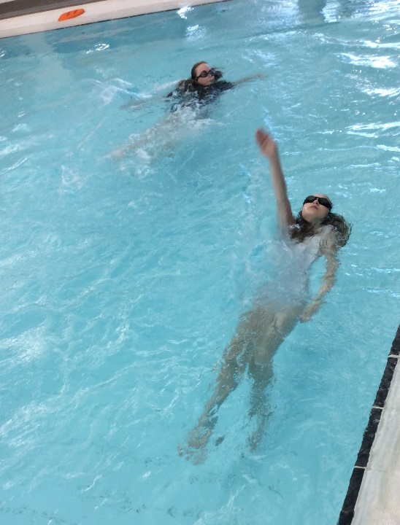
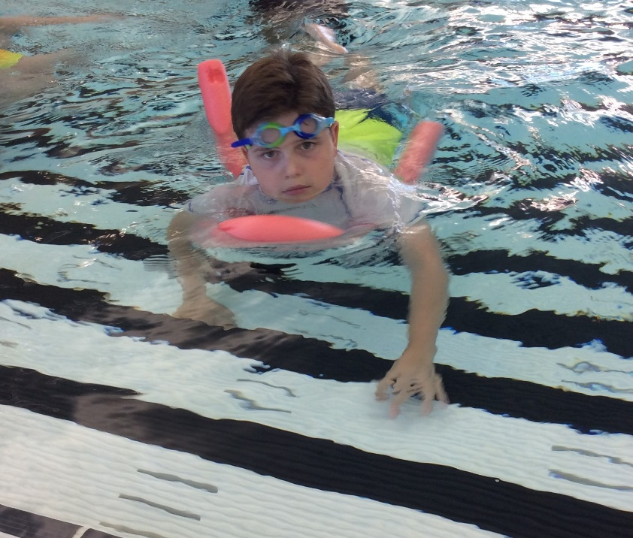
KS2 have just finished this year's swimming lessons, which started back in February, for 15 lessons at the local leisure centre. Students have been working on being independent by preparing for swimming with getting changed and dry, developing their water confidence and awareness and building general swimming skills to support them when in the water. It has been a pleasure to see how each student has developed in different ways over the past few months. Well done, KS2!

Football Tournament: The FDC
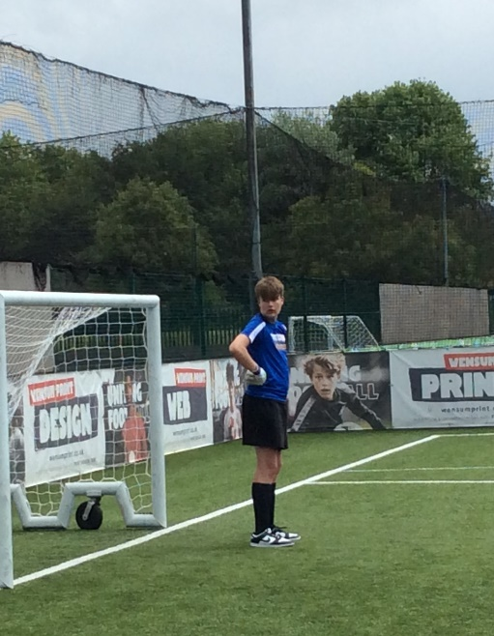
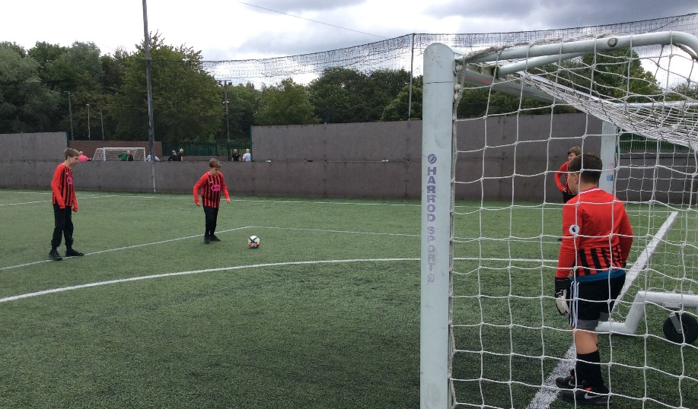
On Wednesday 10th June, St Andrew’s took part in a football tournament at the FDC, Bowthorpe, competing against other schools from across the area. We entered two teams, one in the Under-14s competition and one in the Under-16s. Throughout the day, our players experienced all the excitement that football has to offer, celebrating victories, learning from defeats, and enjoying some closely contested matches. Most importantly, every student demonstrated excellent teamwork, determination, and sportsmanship, supporting one another and representing the school with pride. Well done to everyone who took part and helped make the day such a positive and enjoyable experience.

8A Class visit to Angel Aquatics North Walsham
The students recently enjoyed an exciting and educational visit to Angel Aquatics. During the visit, students had the opportunity to see a wide variety of animals, including tropical and cold-water fish, snakes, bearded dragons, chameleons, geckos, spiders, and other reptiles.
One of the highlights was the chance for the children to safely handle some of the animals. This hands-on experience helped them learn more about the different species and develop their confidence when interacting with them.
The students asked many interesting questions and learned a great deal about animal habitats, feeding requirements, and the care needed to keep these creatures healthy and happy. The visit provided valuable insight into the responsibilities involved in caring for exotic animals.
We also learned about apprenticeship pathways and possible work experience opportunities within the animal care industry, helping students to explore potential future careers.
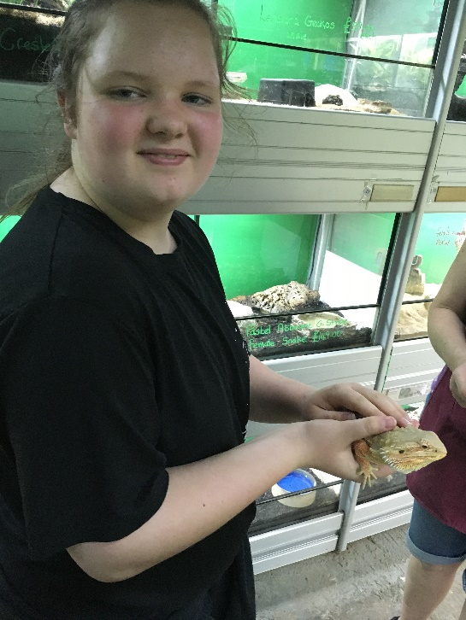
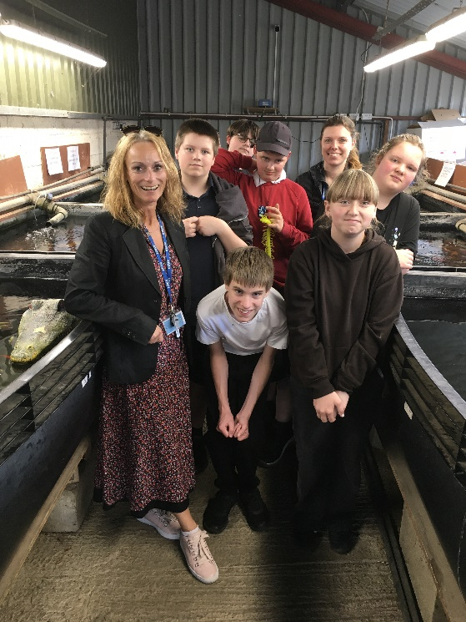
The visit was both enjoyable and informative, and the children represented the school exceptionally well throughout the afternoon.

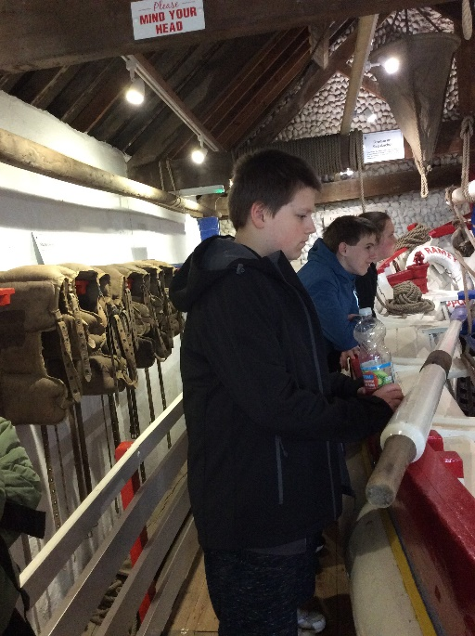
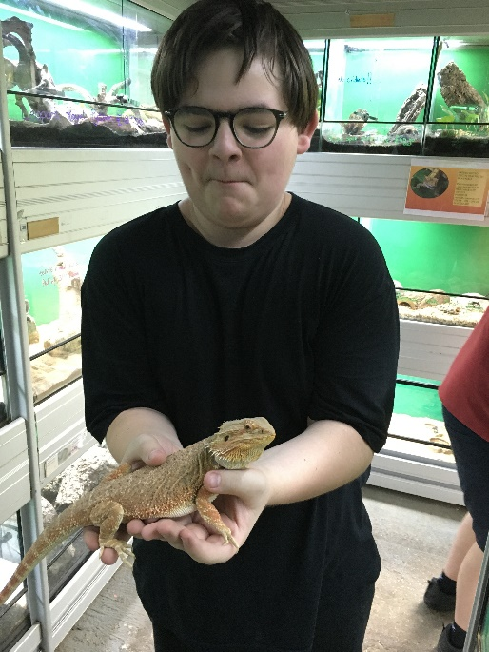

8A Visit to the Sheringham Society - Peter Coke Shell Gallery Museum and Henry Ramey Upcher Lifeboat
During the visit, students explored Peter Coke's impressive collection of shells from around the world. They were amazed by the beautiful and intricate creations he made using shells. The class enjoyed an informative talk about how Peter created his artwork, how long the pieces took to complete, and the many different countries from which the shells originated.
As part of the visit, students also explored the Henry Ramey Upcher Lifeboat Shed, which houses a historic lifeboat built in 1894. The lifeboat remained in service until 1935 and was launched 61 times, helping to rescue an incredible 202 lives during its years of operation.
One of the highlights of the day was a fascinating talk from a proud local lady whose great-grandfather had served on the lifeboat crew. She shared stories about the lifeboat's history and the brave men who risked their lives to rescue others at sea, bringing the exhibits to life for the students.
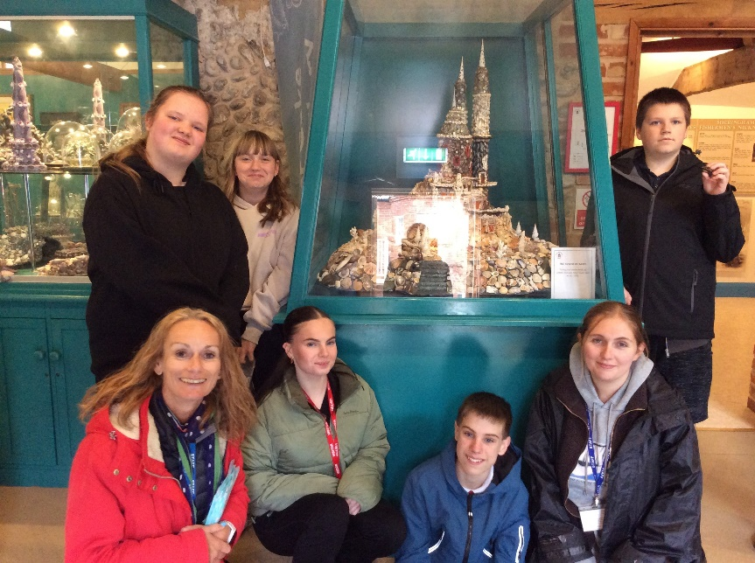
It was an engaging and educational experience that gave students the opportunity to learn about both natural history and Sheringham's rich maritime heritage. The students were a credit to the school and thoroughly enjoyed their visit.

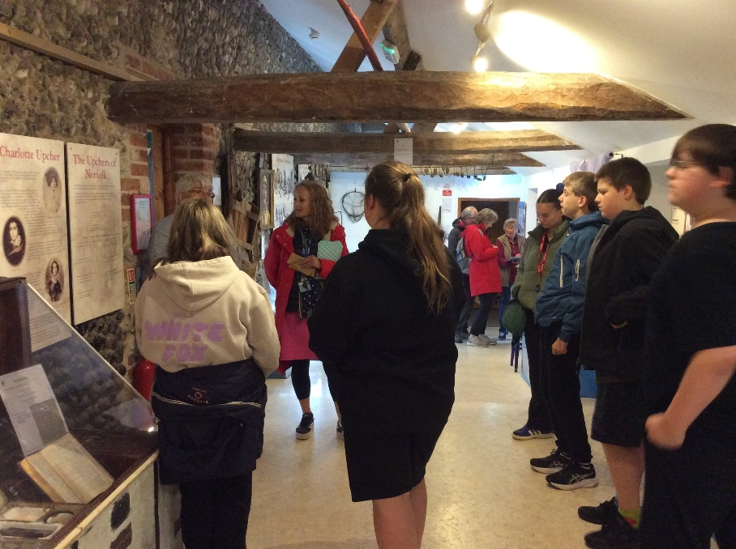

Paula Mayes – PSHE Teacher

Summer Fayre - Music
Music played a bigger part this year in our summer School Fayre, expertly compered by Eddie, featuring our first school DJ set, expertly DJ-ed by our year 7 DJ Monitor (on the equipment very kindly donated by Paul and Kerry), some heartfelt singing by two of our year 11 students and our TAs, Megan and Barney, entertaining us as a singing and guitar duo. Paul also generously gave us his time to help with all the equipment and kept all the music going. A sincere thank you to everyone.
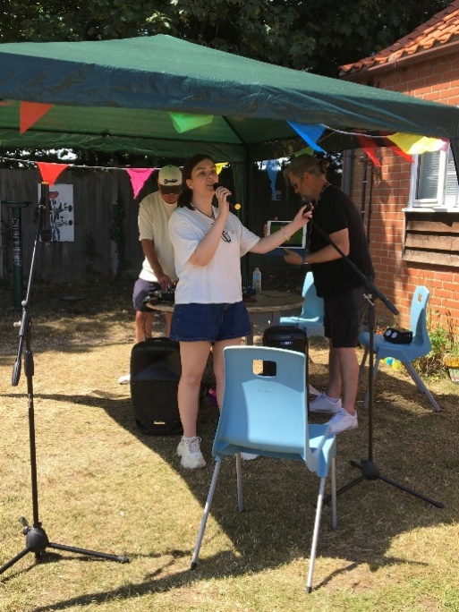
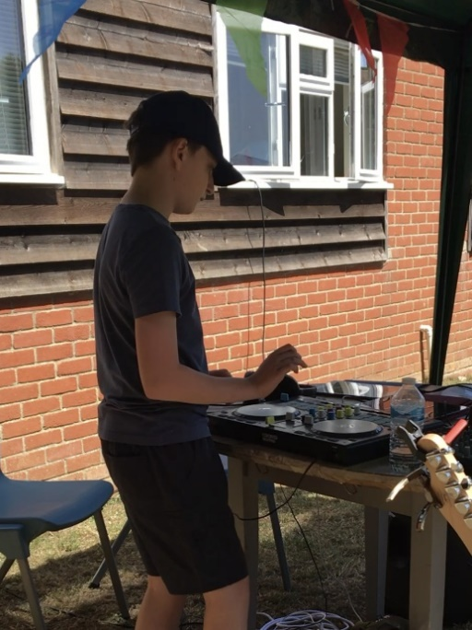

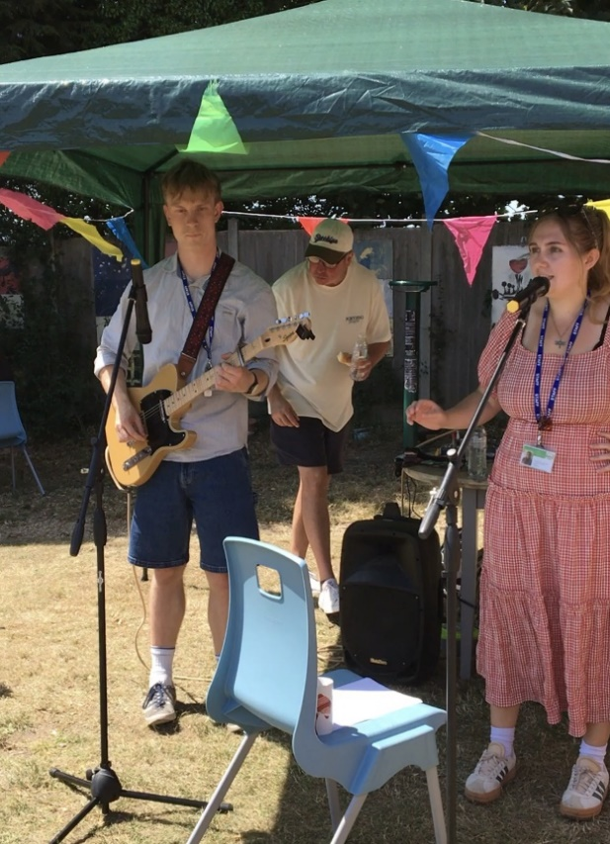
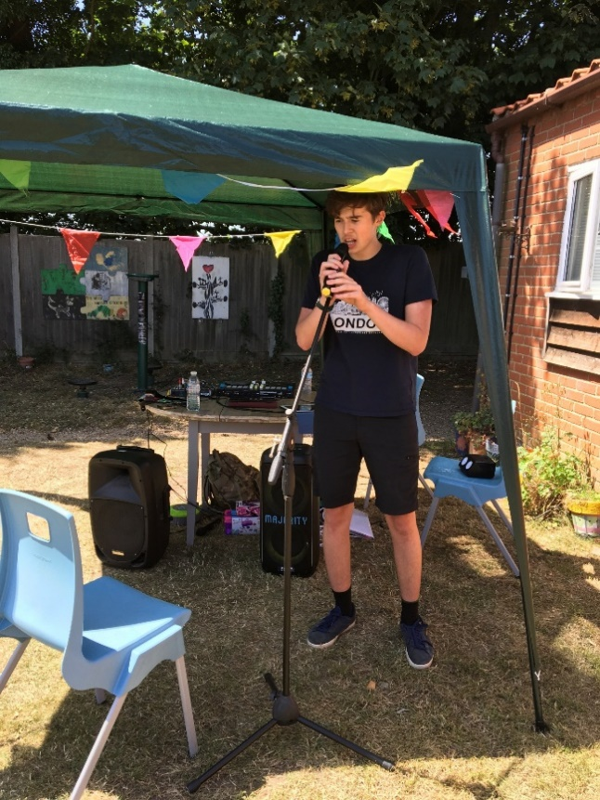

Judith Crass – Music Teacher
Summer Fayre Success
A huge thank you to everyone who helped make our Summer Fayre such a success. Students and staff worked hard to create and run fantastic stalls, including lemonade stands, a teddy bear tombola and various fun games.
We had very damp but refreshed teachers following on from the ‘Sponge the Teacher’ who are still trying to get jelly out their hair from the mystery gunge bucket! We were also impressed by the talents and courage of our performers who showcased their musical talents in front of friends and family.
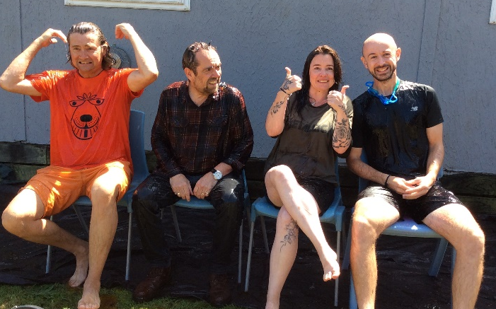
Thank you to everyone who donated prizes and supported the event. Together, we raised an amazing £674.04, which will help provide future opportunities for our students.
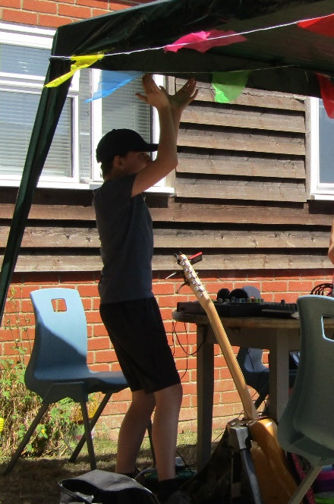

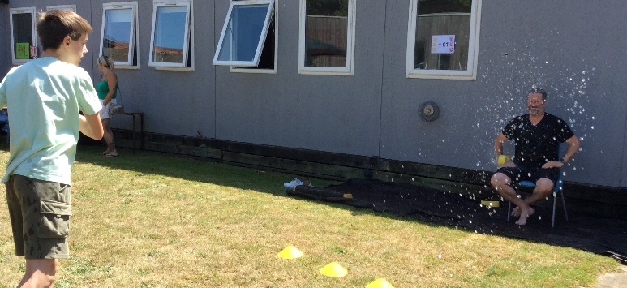

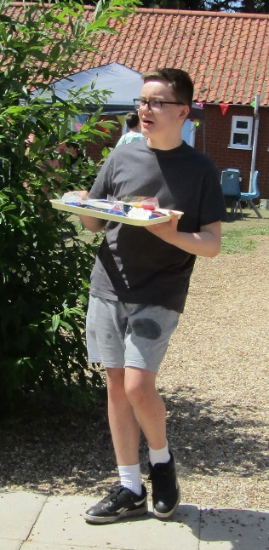

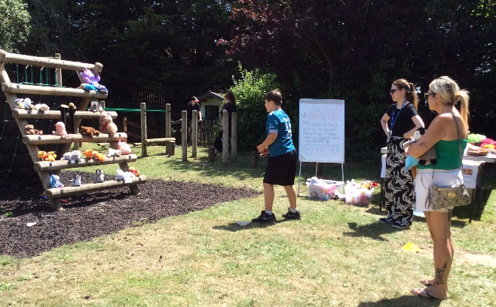
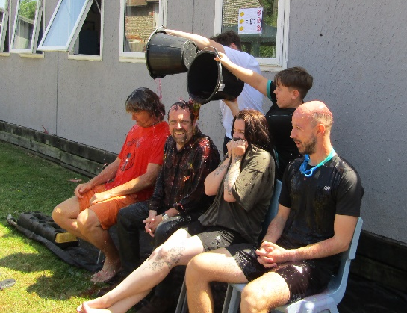

Lauren Burdett – Class Lead
Music clubs

Megan, our Year 8 TA, has started a singing club at lunchtimes and Barney, our Year 9 TA, is going to add in a guitar club in September, to add to his guitar tutoring when time allows. Eddie is now running the new DJ club and DJ Smallie came to our rescue with a gift of a new DJ mixing desk when our own decks started to wear out, for which we are really grateful. Thank you, Paul.

Music Curriculum
Music lessons are now building on the students’ year’s work, with free choice in the tasks as students explore their own musical interests.
Music GCSE
Helen from the Norfolk Music Hub has met the two year 9 students who are to be our first GCSE Music students in September and we welcome Helen to the team for the next two years (and hopefully beyond!) It is lovely to see GCSE Music finally beginning in the school, so thank you to Helen and the Music Hub for helping us to provide this opportunity.
The Big Legal Lesson
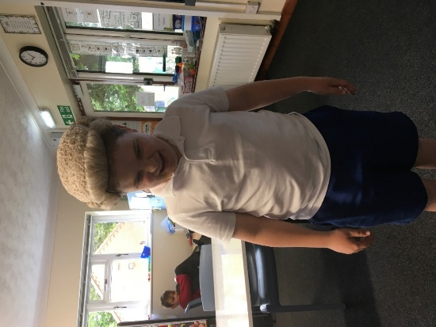
We were very fortunate to have a visit from a Judge to deliver ‘The Big Legal Lesson’ as a part of our Young Citizens affiliation in Citizenship. The judge spoke to three classes about her role in the Law Courts and how the law affects our everyday life – far more than any of us realised! It was a really good morning; we all learned lots, and it was a wonderful link between the law in theory and the law in real life. We very much hope that they will come back and do some more work with us in the future.

Judith Crass – Citizenship, RE & Music Teacher

7A’s Trip to Bewilderwood
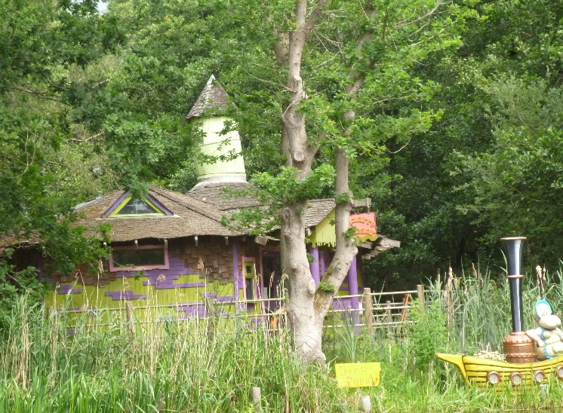
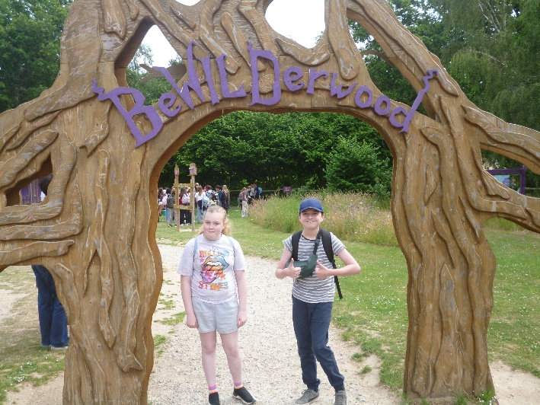
The class were very excited as they set off on their trip to Bewilderwood, near Wroxham. From the moment they arrived, the adventurous 7A soared down giant zip wires, explored magical treehouses, and navigated winding woodland trails. There was lots of laughter as they challenged themselves with daring rope bridges and slides. The enchanted forest was full of surprises, with secret hideaways and whimsical characters waiting to be discovered. It was a day packed with fun, adventure, and teamwork, creating unforgettable memories for everyone. The Bewilderwood adventure was truly a highlight of the year, leaving everyone eager for their next great adventure!

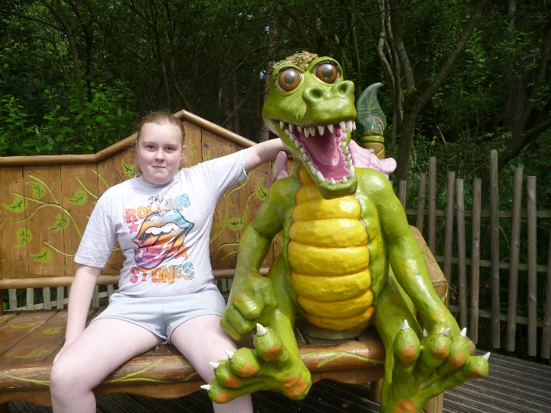
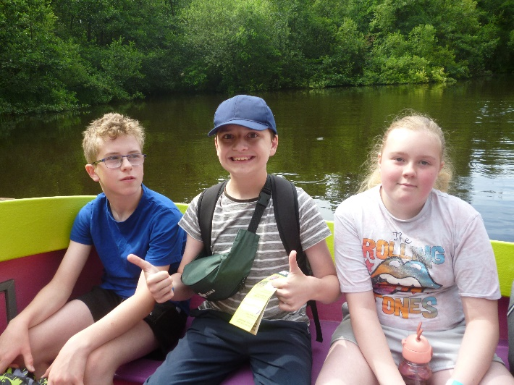

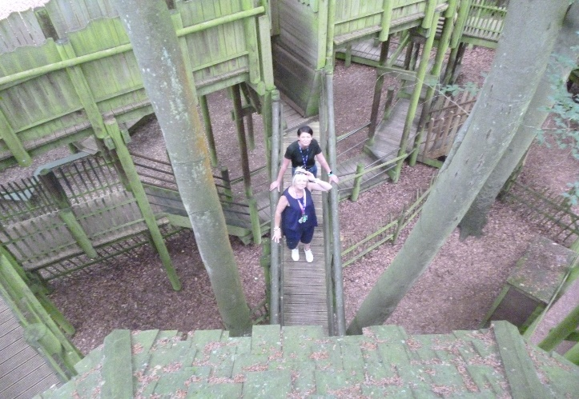
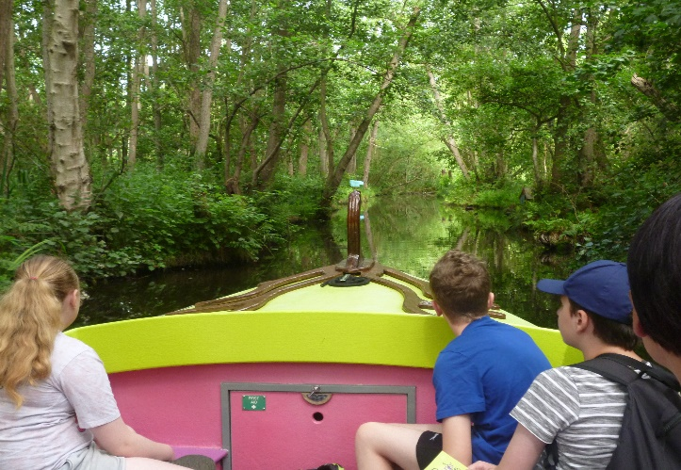

Tim Laurie – 7A Form Tutor
KS2 Lego Robotics Challenge
This term, KS2 students crafted their very own Lego robots using Spike software. With great creativity, they programmed their robots to perform amazing tasks, from navigating obstacle courses to solving puzzles. The exciting projects sparked curiosity, problem-solving skills, and a love for STEM. Watching their robots come to life through code was truly inspiring, showcasing KS2’s talent and imagination. The students had an unforgettable experience, blending technology and play to unlock endless possibilities. Get ready to be amazed by the future engineers of tomorrow!
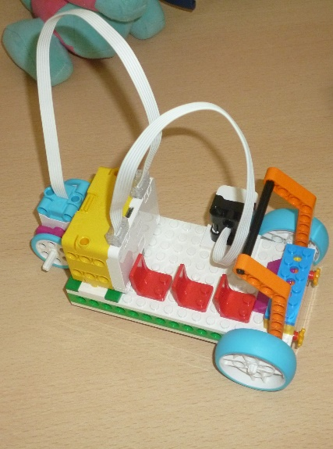
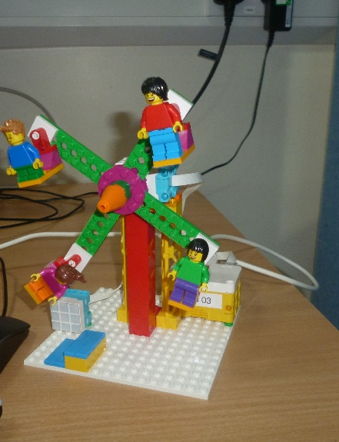
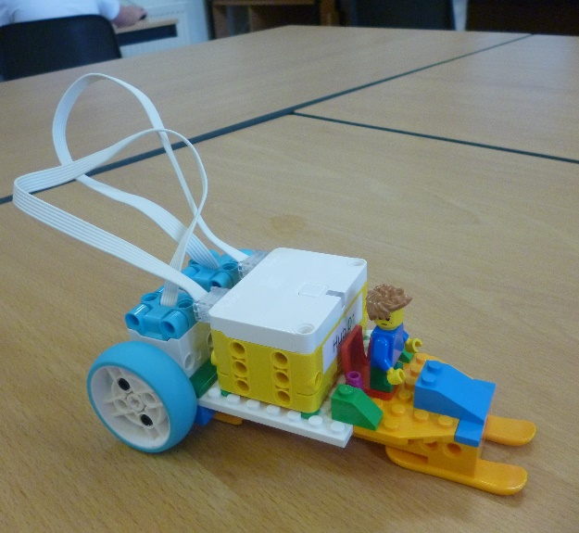

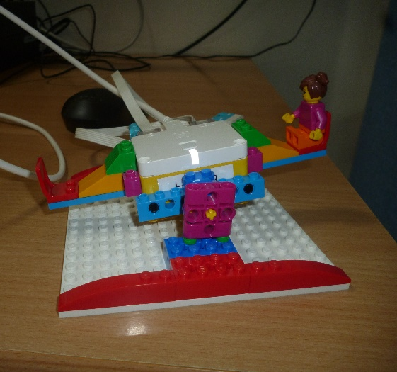
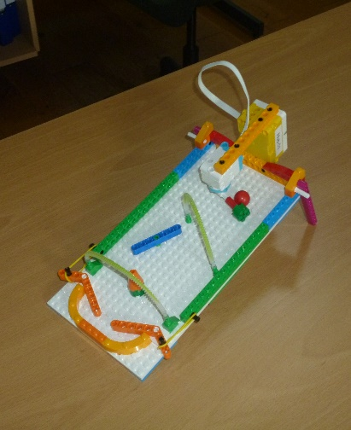
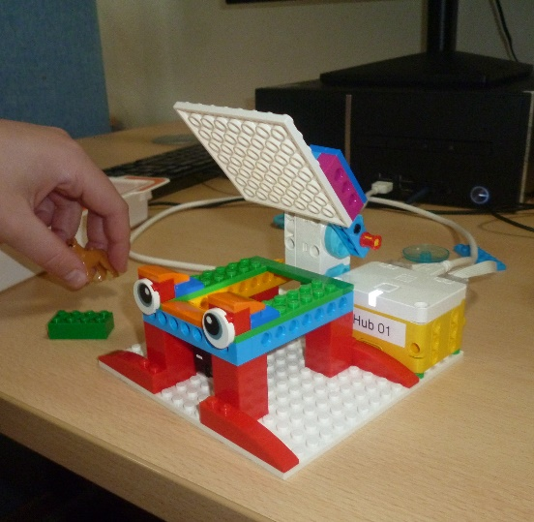

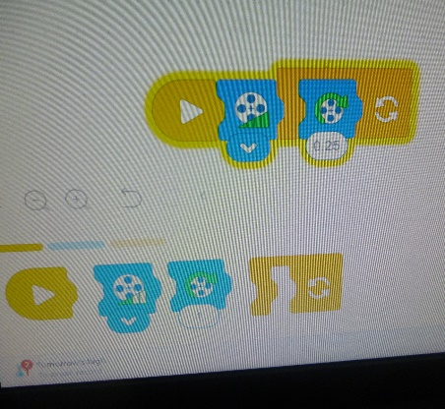
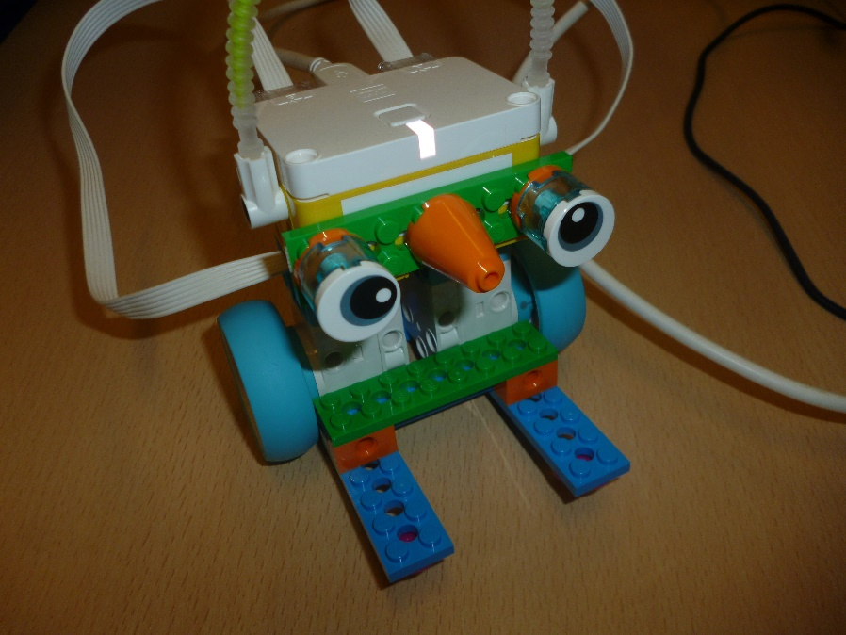

Tim Laurie – IT Teacher
Food Technology
Our Year 9 Food Technology students have been developing their independence in the kitchen by voting on recipes from the BBC Good Food website that they would like to make. As well as following recipes, pupils have been challenged to think carefully about the order of tasks, sequencing each stage of the cooking process independently and adapting recipes by halving the ingredients so they serve two people.
To finish one of their practical lessons, pupils took part in a group taste-testing session, where they sampled one another's dishes and gave positive feedback on appearance, flavour and texture. This has helped students develop their evaluation skills, build confidence in trying new foods and celebrate each other's achievements.
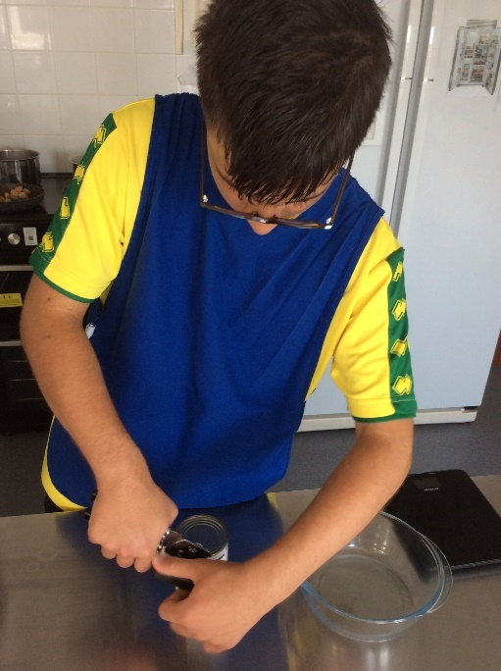
It has been wonderful to see the progress Year 9 have made in their practical skills, teamwork and independence. Well done, Year 9!

Read for Good Readathon Results!

Thanks to all those students and sponsors who donated time or money to the gentle art of broadening the mind. Here at St Andrew’s, we take pride in raising money for worthy causes, and children in hospital in the UK greatly appreciate the gift of a good book.
This year, we have raised £203 for the Book Trust and £12 from Key Stage 2 Pyjamarama, adding to a grand total of £1,205.00 in four years of student participation. Our top reader read for 20 hours 23 minutes in one-week - what commitment to the written word! Thanks again to all those who took part.

Emma Clark - Head of English



Science
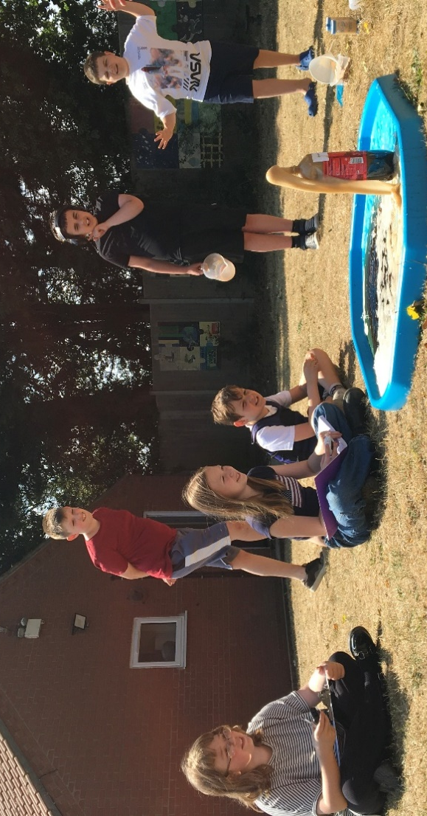
In Science, KS2 designed and carried out their own investigation. They decided what and how they would measure. We used bottles of Cola, bicarbonate of soda, washing up liquid, sand and Mentos. We were all looking forward to see whether there would be a reaction with the Cola. Some children decided to measure the time it took to fizzle out, whilst others measured the amount of Cola which ‘exploded’ out of the bottles, or the Cola which was left in the bottle. We all made predictions and were quite surprised that that they all created a reaction. We were a little disappointed when we tried to carry out the investigation again and only saw a little reaction. I wonder why?

Amanda Ward – KS2 Teacher

Year 11 GOTCHA:
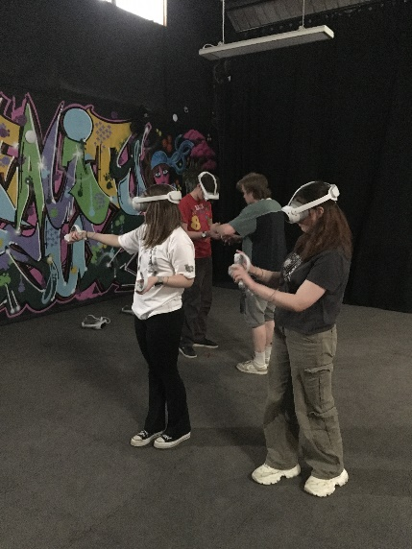
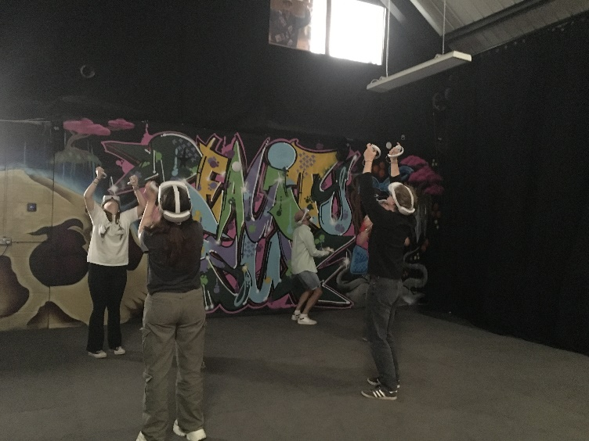
The year 11's GOTCHA trip took place on Monday 15th June, where we attended the VR room in Norwich for some fun, interactive games. This was a trip that all students were really keen to participate in, and a big thank you needs to go out to VR Norwich, who kindly hosted us for a private session to enable this trip to take place. For many, this was their first experience of VR, and it certainly did not disappoint! As a group, we participated in a variety of fun, team building interactive games incorporating communication in these imaginary worlds which was thoroughly enjoyable. It has been a pleasure to spend time with Year 11 and it concluded perfectly with this trip.

History Comes to Life at Weybourne Steam Station -Year 9 and 8A
Following our recent History lesson on the development of steam engines and how they work, our class enjoyed a fascinating afternoon visit to Weybourne Steam Station on the North Norfolk Railway.
We were warmly welcomed by Alan, who is the station manager, who gave us a behind-the-scenes tour of the engine shed and workshop. The children had the exciting opportunity to climb aboard a steam locomotive and even stand underneath it by using the inspection pit, giving them a unique view of the engine's impressive mechanics.
Alan explained how a steam engine works, showing the children how coal is burned to heat water, producing steam that powers the pistons and drives the wheels. The pupils were fascinated to see the enormous tools used to repair and maintain these historic engines and gained a real appreciation for the skill and engineering involved.
One of the highlights of the visit was watching a working steam train arrive at the station with passengers on board. Seeing the locomotive in action helped bring their classroom learning to life and gave everyone a greater understanding of the importance of steam railways in Britain's history.
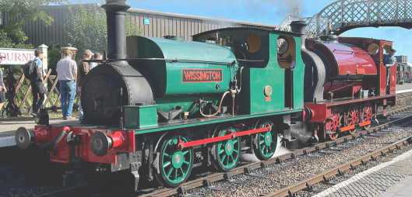
Throughout the visit, the children asked lots of thoughtful and insightful questions, demonstrating their curiosity and enthusiasm for learning. Their excellent behaviour and engagement were commented on by the staff, who were impressed with their interest and knowledge. It was a memorable educational experience that perfectly complemented our history topic.

Maths in 8B – Timing, Charts and Scalextric Fun!
This week, 8B have been developing their maths skills by learning all about time and reading charts. To bring our learning to life, we took part in an exciting Scalextric racing challenge!
Using stopwatches, everyone timed each lap and carefully recorded the results. We then used our data to create and interpret charts, comparing lap times and identifying patterns. It was a fantastic way to see how maths is used in real-life situations while having lots of fun.
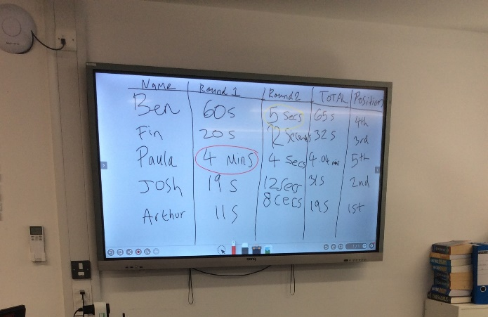
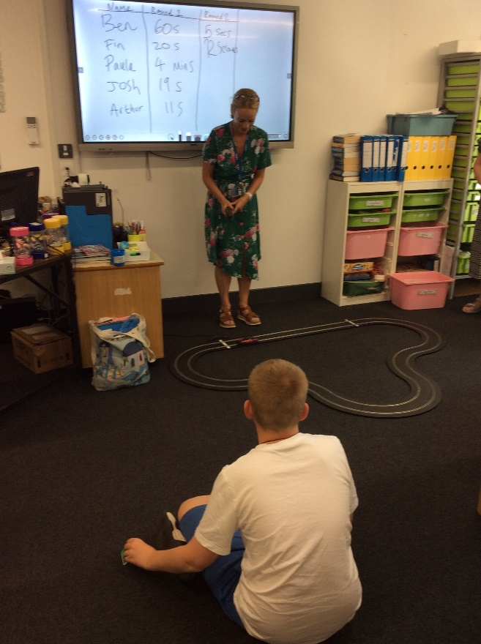
The class showed great teamwork, enthusiasm and excellent measuring skills throughout the activity. A huge congratulations goes to Ben, who raced to victory and finished as our overall Scalextric champion!

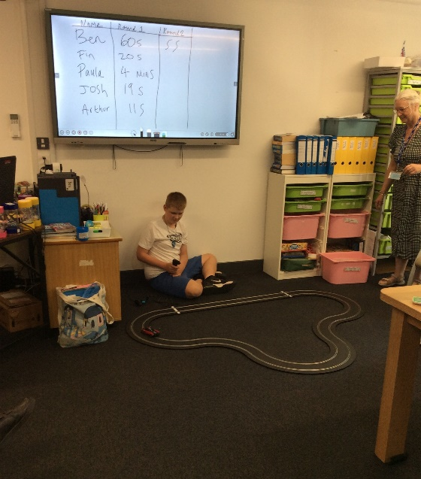

Paula Mayes

8A's Gotcha Trip to Pleasure Beach, Great Yarmouth
As a reward for earning their Gotchas, Class 8A enjoyed an exciting end-of-year trip to Pleasure Beach, Great Yarmouth. The children had a fantastic day experiencing a variety of thrilling rides and attractions.
One of the highlights was riding the Scenic Rollercoaster, the only remaining scenic railway of its kind in the UK. This historic roller coaster is Grade II listed for its heritage significance and is still operated by a traditional brake person, making it a unique and memorable experience for everyone.
The pupils also demonstrated their independence by ordering and paying for their own lunch, showing excellent manners and responsibility throughout the day. To round off the trip, everyone enjoyed a well-deserved ice cream before heading home.
The children were a credit to the school, displaying outstanding behaviour, enthusiasm, and respect throughout the visit. Well done, 8A, on earning such a fantastic reward!

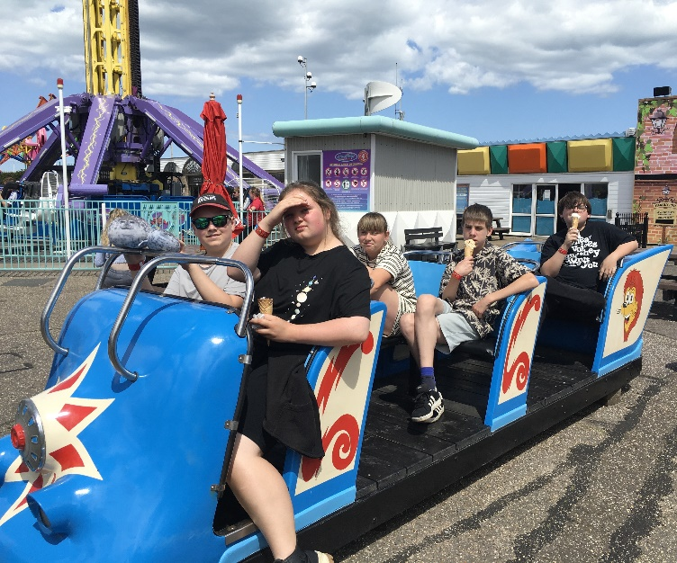
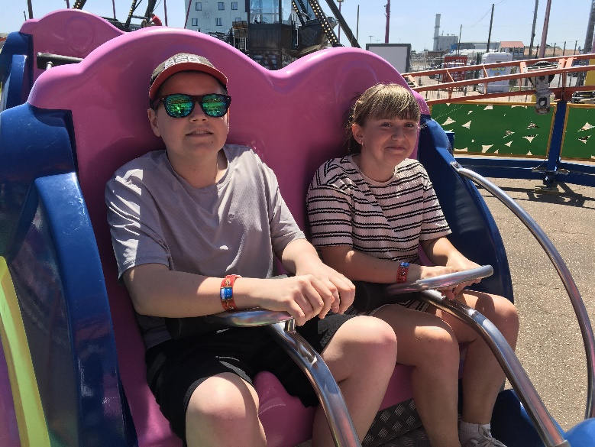

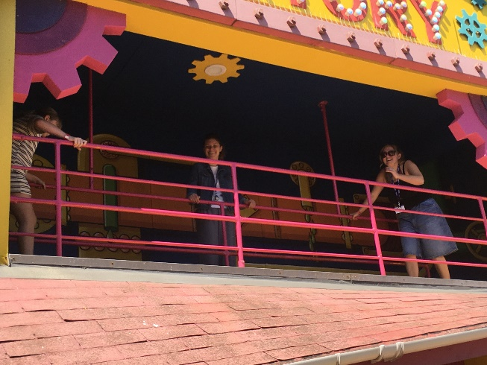

Paula, Kelly & Megan

Paula, Kelly & Megan.

Year 11 Leavers Trip:
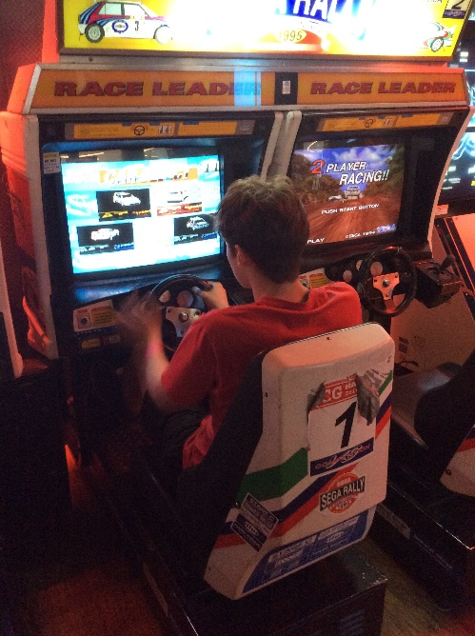
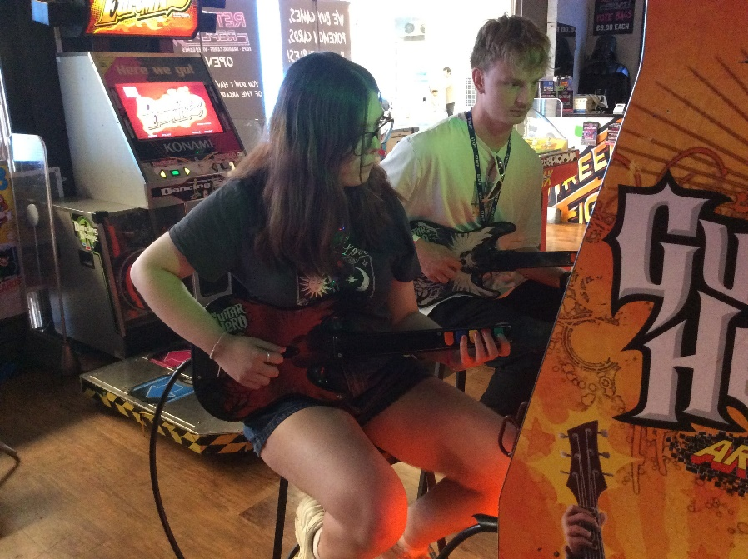
The Year 11's final trip, a celebration for all their hard work and success over their St. Andrew's journey, took place at Retro Arcade in Castle Quarter, Norwich. A private hire session with access to a large variety of old-school games allowing everyone the chance to play solo or in partnership. From the popular 'Pac-Man' to playing 'Guitar Hero', there really was something for everyone to play at their own leisure. The day was concluded with a picnic at Mousehold Heath, enjoying the sunshine before returning back to school.

Year 11 Class Leavers Party: Friday 26th June
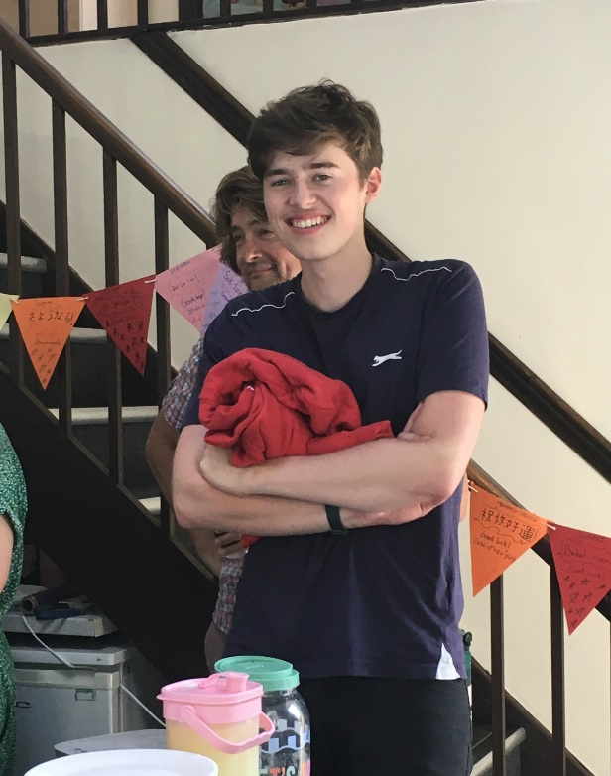
Their final day at St. Andrew's, celebrated by inviting each class, staff members and their own families to join us for final goodbyes and with some nostalgic photos collected over their time at the school. It really has been an incredible journey for all of them in their own individual ways and we all wish them the very best for their next chapters.

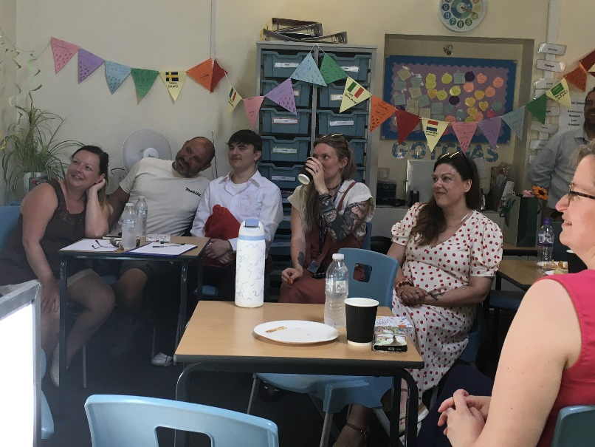

Vassy, Sam, Wendy & Barney
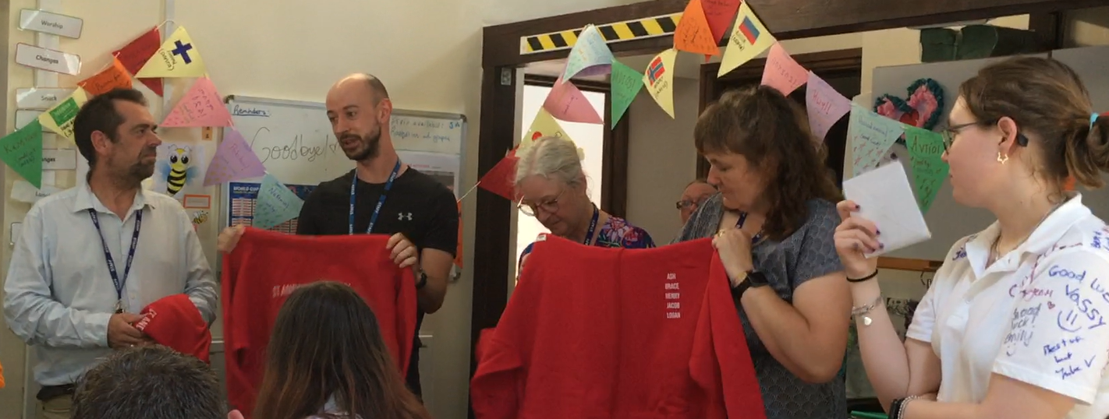

Vassy, Sam, Wendy and Barney
Year 11 Team

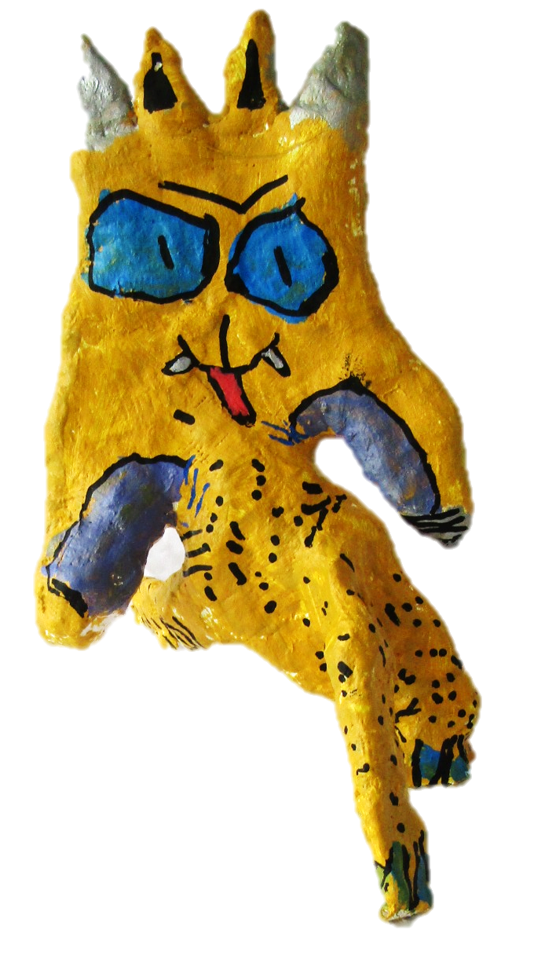
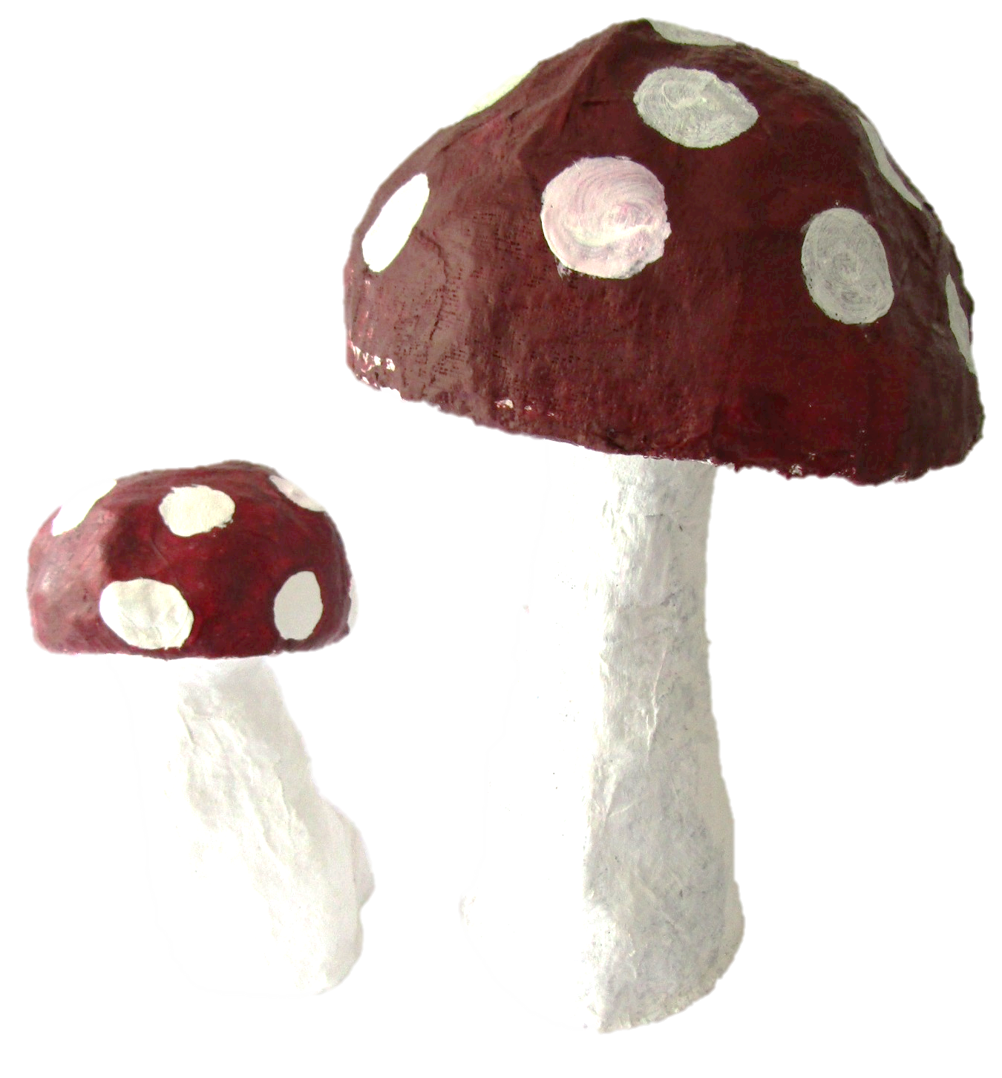
LATITUDE FESTIVAL 2026
Mini-Break Zen

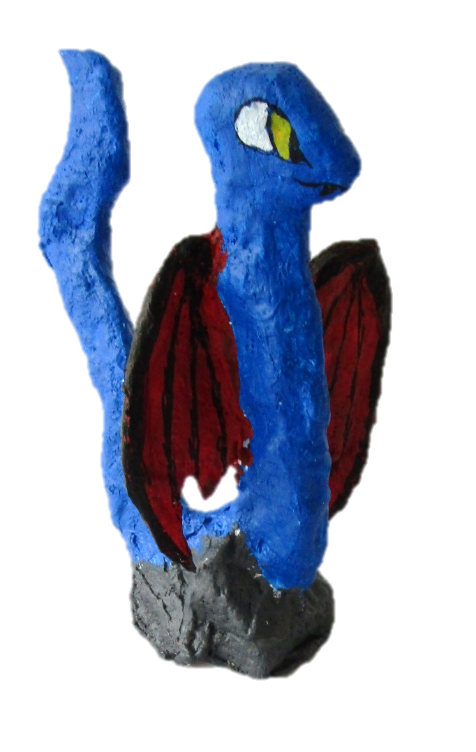
The countdown to Latitude Festival 2026 has begun, and once again the amazing artwork created by our students will be on display for thousands of festival visitors in the Mind, Body & Zen area.
Students from Key Stages 2–4 have created an extraordinary collection of artwork, exploring imagination, wellbeing and their unique ways of seeing the world. A huge thank you to every student and member of staff who has helped bring Mini-Break Zen to life, from supporting the creation of the artwork to writing the wonderful stories that accompany many of the pieces, inviting visitors to step into the students' worlds.
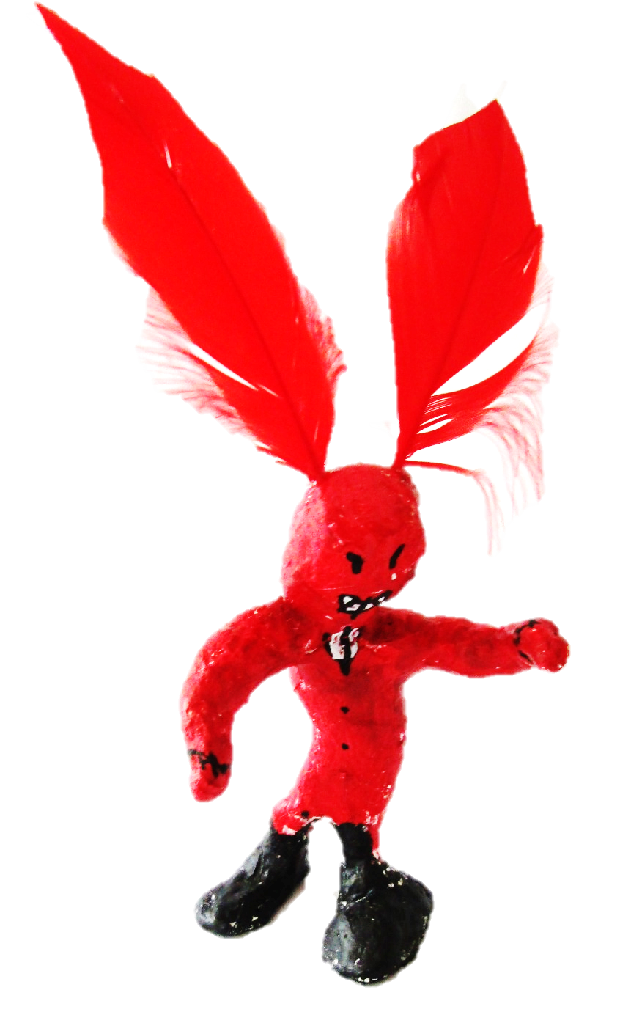
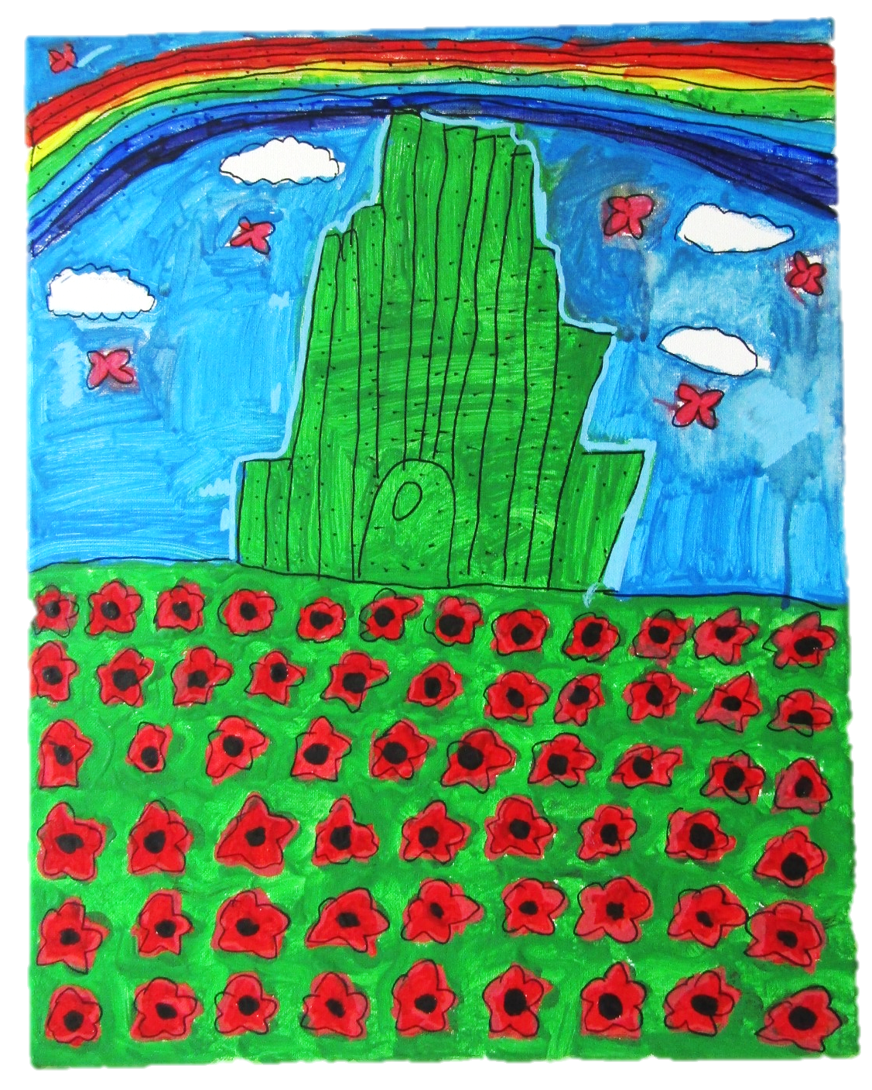
We're also delighted that two St Andrew's families will be joining us at the festival to celebrate the students' achievements. This week we'll be transforming our woodland shed into Mini-Break Zen, ready to welcome thousands of visitors into a magical space filled with art, stories and moments of calm.

We can't wait to share the finished installation and the response from festival-goers. Thank you to everyone who has helped make this project possible.

