St Andrew’s School Newsletter
May 2026
Headteacher: Adrian Crossland
Dear Parents and Carers,

I hope you enjoy the latest St. Andrew's newsletter, reading about some of the exciting learning that has been going on this term. A special mention must go to our Year 11 students, who are working so hard for their exams. We are very proud of you and hope you feel proud of yourselves too.
Year 10 students have been undertaking pre-visits for work experience and the feedback we have received from the community has been wonderful. We really enjoy the connection we have with the local community. Some of our students have recently had the opportunity to work with a local police officer and others took part in the ‘Big Legal Lesson’ this term, which they thoroughly enjoyed.
I hope you have a relaxing - and hopefully sunny! - half-term break and I look forward to welcoming our students back on 1st June.

Key Dates
Friday 22nd May: Last day of term
Week commencing Monday 18th May: Year 10 work experience pre-visits
Week commencing Monday 1st June: Work experience placements
Wednesday 10th June: Football tournament, FDC Norwich
Thursday 18th June: Sports day
Monday 22nd June: Year 11’s end of school trip
Thursday 25th June: Summer Fayre
Friday 26th June: Year 11’s last day and leavers party
Week commencing Monday 29th June: Gotcha reward trips week
Thursday 16th & Friday 17th July: Students transition to new classes
Friday 17th July: Last day of term
Friday 4th September: Students return
Just Out Of My Reach

I have a dream,
It’s somewhere in me,
And it keeps me awake at night,
It follows me around and hides in my shadow,
It clouds up my mind and is entirely hollow,
I don’t know what it means, but I have a dream,
And I know that it’s trying to call for me,
It bellows and shouts and bounds all about,
Desperate for my head to turn,
I look down and around, and it’s no longer there,
But maybe it’ll come back again tomorrow,
I have a dream,
I can’t find it yet,
But I sure do know that it’s there,
I have a dream,
It’s waiting for me,
And I can’t wait for the day that I finally find out where,
I have a dream,
It’s only just out of my reach.

Ash
Prize winner in the ‘Young Writers’ Competition
Berni Alexandrou: English Teacher

KS2: 5 Ways to Promote Positive Wellbeing
This week in PSHE, KS2 took part in an enjoyable and engaging lesson all about the 5 ways to promote positive wellbeing: Be Active, Give, Connect, Take Notice, and Keep Learning.
The class had a thoughtful discussion about what each of these wellbeing habits means and why they are important in everyday life. Students shared lots of excellent examples, such as being active through sports and play, giving by helping others, connecting with friends and family, taking notice of the world around them, and keeping learning by trying new things.
To make the lesson even more exciting, students used iPads to record interviews about why these five ways are so important. Everyone had the opportunity to take on different roles, including interviewer, interviewee, and camera operator. This helped students develop teamwork, communication, and digital media skills while exploring positive wellbeing.
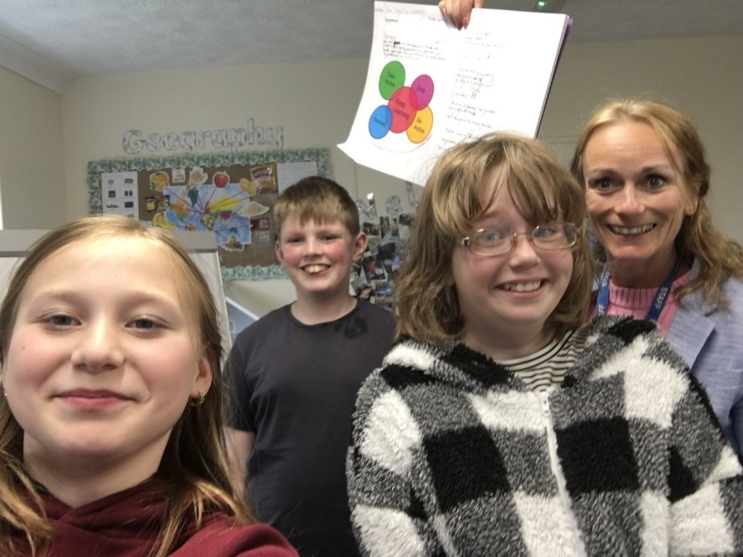
It was wonderful to see such enthusiasm, creativity, and confidence throughout the lesson. KS2 worked brilliantly together and showed a great understanding of how small daily actions can support positive mental health and wellbeing. Well done, KS2!

Year 7 History
This term in Year 7 History, students explored the events of 1095 and learned why Pope Urban II called on Christians to undertake the long journey to Jerusalem. They studied the reasons behind the campaign against the Seljuk Turks, who were Muslim, during what became known as the Crusades.
As part of their learning, students examined the motivations, challenges, and significance of this major historical event, gaining insight into the religious and political factors of the time.
To bring history to life, we also took part in a creative hands-on activity where students designed and made their own shields and swords, inspired by the equipment used during the period. This practical project helped deepen their understanding of medieval warfare and was thoroughly enjoyed by all.
It has been a highly engaging and enjoyable topic, and students showed great enthusiasm throughout their work.

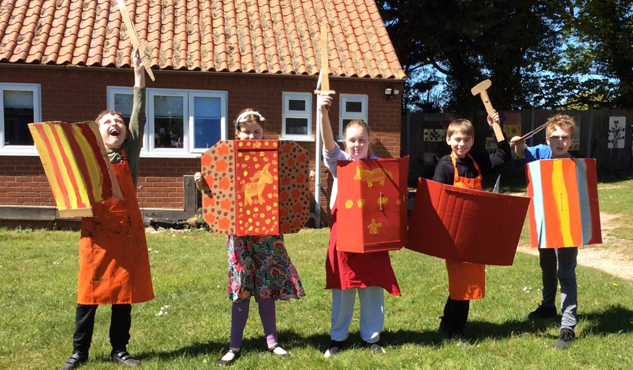

Paula Mayes – PSHE & History Teacher
Music
DJ Club is now underway with Eddie and our new DJ Monitor from 7A. We are considering moving it into the gym on Thursday lunchtimes to allow for extra numbers and space to move. Watch out for some good sets from our new talent at our next School Fayre.

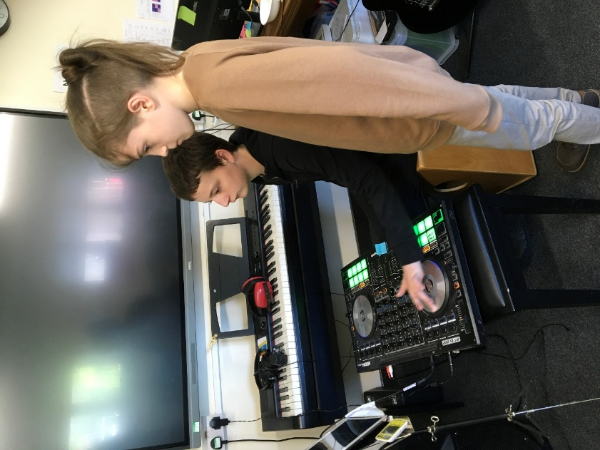

Judith Crass – Music Teacher
Year 8 Explore The BFG
Year 8 students have been studying The BFG through a range of creative classroom activities.
As part of their work on the novel, students took part in a hot seating activity where they answered questions in character as Sophie, the BFG, Bloodbottler, the Fleshlumpeater, the Queen, and Mr Tibbs. This helped students develop their understanding of the characters and themes within the text - it was very enjoyable and the students enjoyed the character faces!
Students also recreated the BFG’s famous snozzcumbers in different forms. They made shortbread versions inspired by the story before trying, or should I say looking at, a “snozzcumber” made from gherkins, icing, and sprinkles. The activity encouraged students to engage with the text in a practical and memorable way.
The lesson provided an enjoyable opportunity for students to combine literature, drama, and food technology while exploring Roald Dahl’s imaginative world.
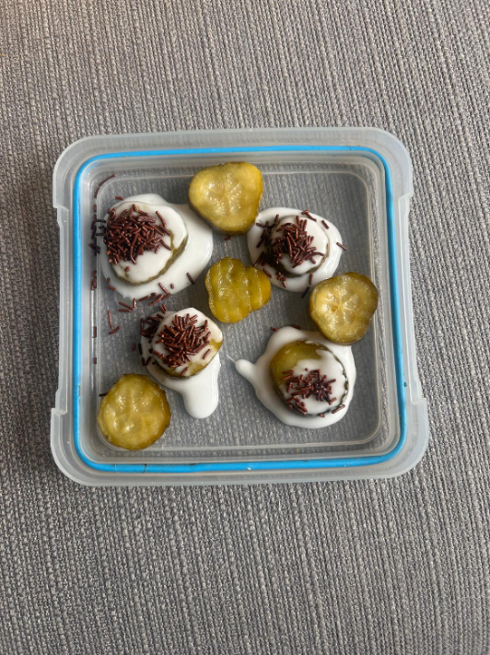
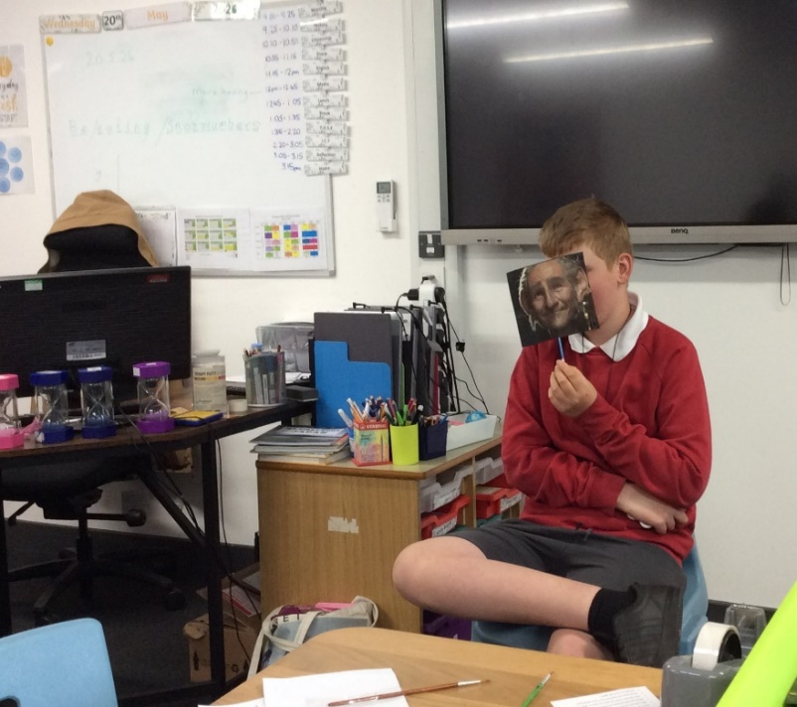

Emma Lawer – Food Technology Teacher

Mathematics
Celebrating National Numeracy Day – 20th May
National Numeracy Day is the UK’s only campaign dedicated to improving everyday maths. Each May, individuals, schools and organisations across the country come together to help children and adults feel more confident with numbers at work, at home and at school.
The theme for National Numeracy Day this year was 'Count on Your Community'. Millions of people across the UK lack confidence when it comes to numbers. But that can change and a bit of mutual encouragement and support from your community can make a world of difference.

St Andrew’s School students took part in the activities to celebrate national numeracy.

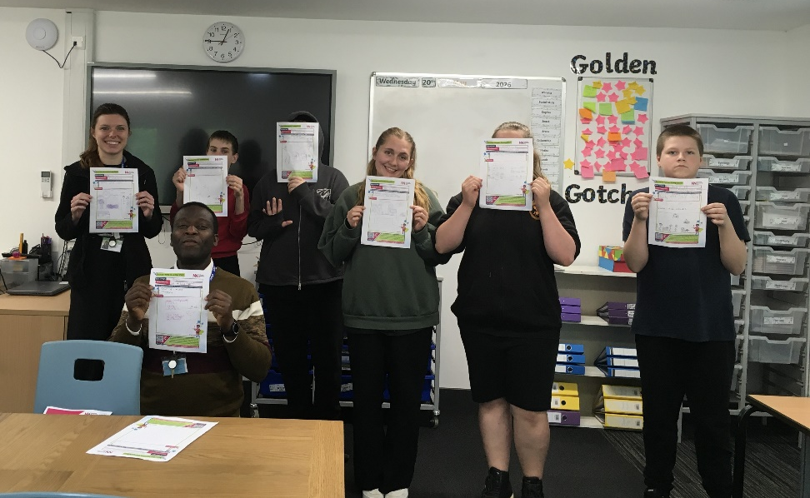

Class 8A tried to solve the ‘Collatz Conjecture’ during a Therapy session. The Prize of 120 million Japanese Yen is still uncollected, alas.
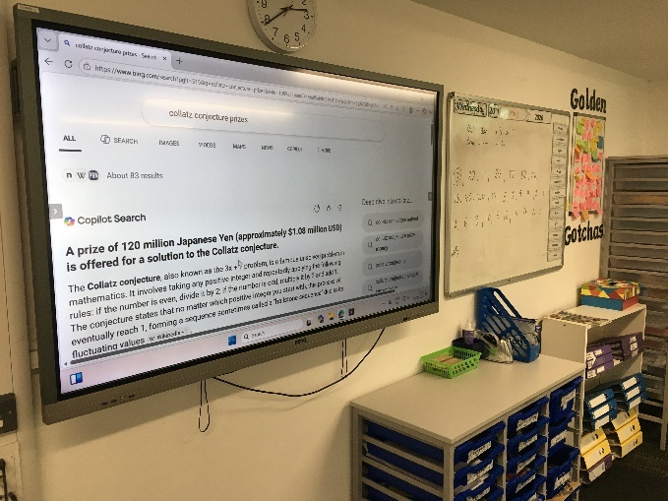
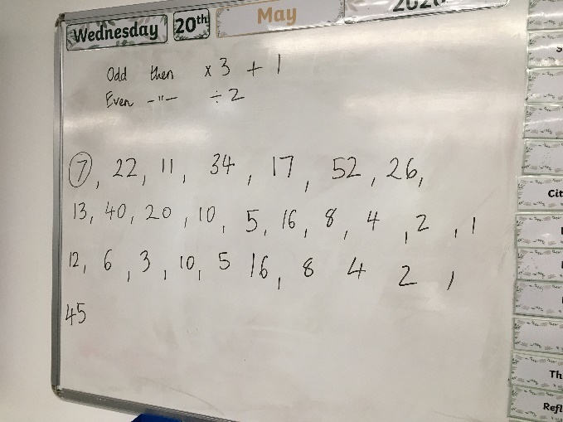

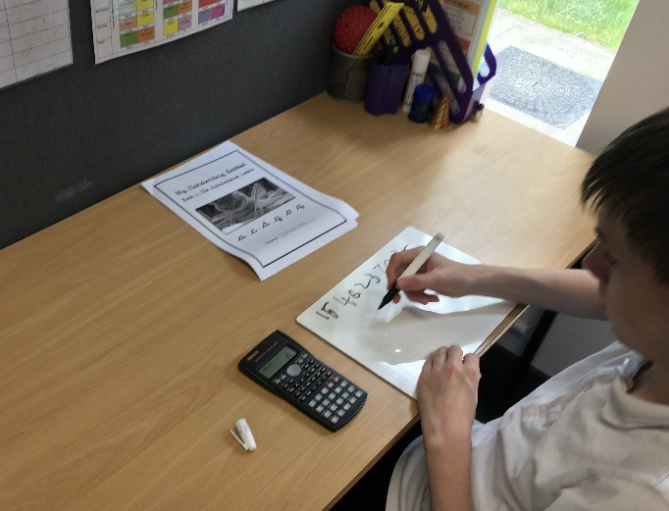

Hope Deih – Head of Maths

Abi - Norfolk Cricket Lessons + Cricket Trip to Horsford Cricket Club
We welcomed back Abi from Norfolk Cricket who has attended some PE lessons on a Monday and Wednesday this half term to deliver some cricket coaching. Abi has been able to share some fun, inclusive cricket sessions for everyone to try and give us a flavour of what a coaching session can look like outside of the school setting.
This tied in nicely to the cricket trip organised and run by Abi on Tuesday 12th May for an event at Horsford Cricket Club. This opportunity allowed us to participate in a series of cricket games with other SEN schools in some friendly paired cricket games, putting to practise some of the skills developed during Abi's visits at school. Each school played each other once, taking it in turn to bat, field and bowl, representing the school and trying cricket in larger groups. It was a lovely day for all involved and a big thank you to Abi and Norfolk Cricket for arranging this lovely opportunity.

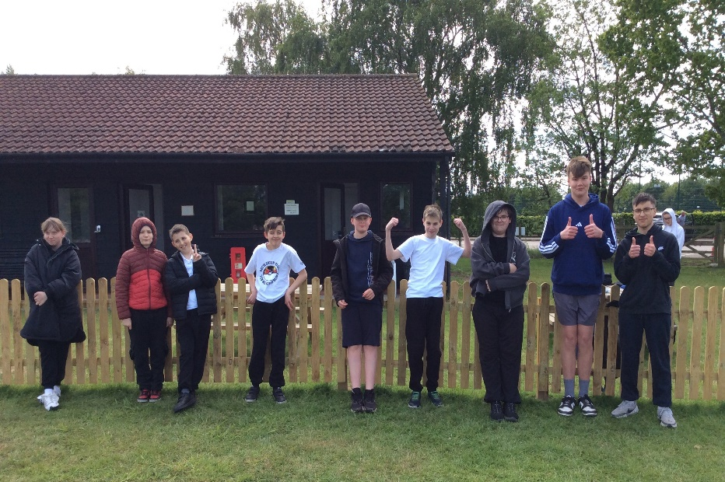
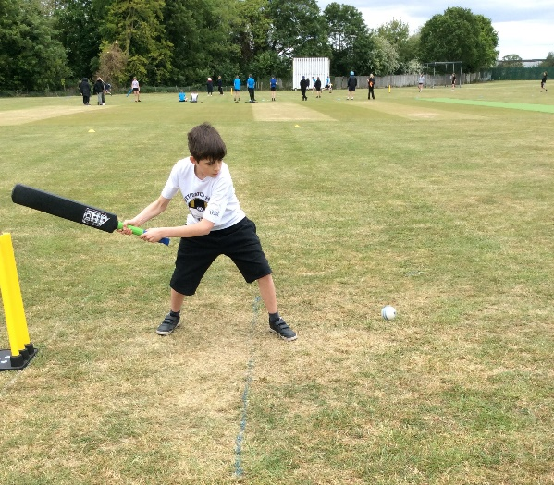

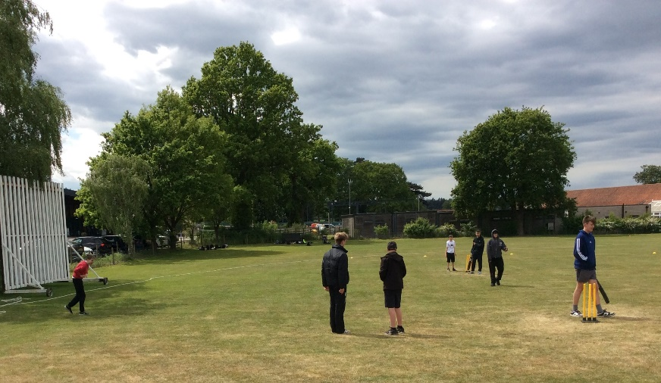
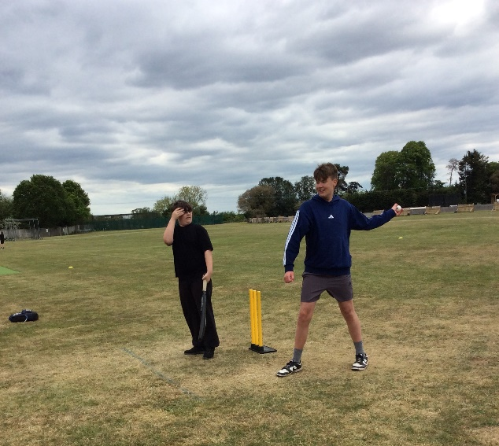

Dunston Hall, Year 11 Careers Visit & CV Writing Workshop
On Wednesday 20th May our year 11s had the wonderful opportunity to attend Dunston Hall for a careers tour and talk and a CV writing workshop to support their transition from St. Andrew's School. On the tour it was fascinating to see and learn about all the various rooms and their functions, while learning about the varied jobs and responsibilities. The visit concluded with a CV writing workshop, where students began developing their own CVs, with top tips that an employer would look for, to make it stand out from the crowd. It was really informative and interesting, and I hope it brought confidence in how employers seek key skills such as dedication, eye for detail and the right attitude - It is not just qualifications! Well done Year 11 and a big thank you to Dunston Hall.


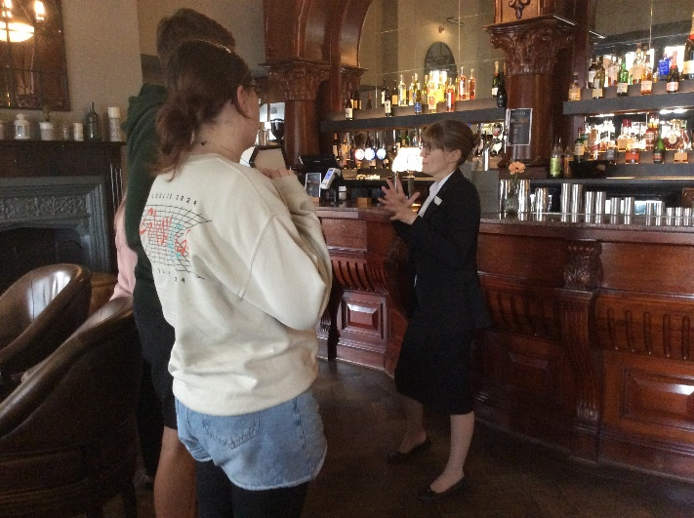
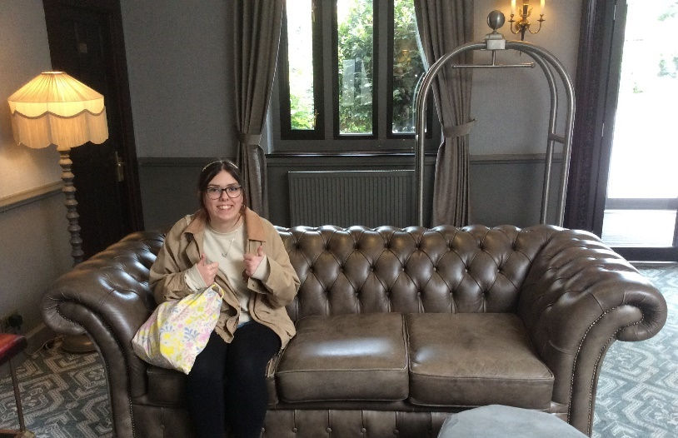

Vassy Stamatov – PE Teacher

Creativity on the Coast!
The Cromer Pier 125th Anniversary Art Competition has been a fantastic creative opportunity for our KS2 and KS3 students. Inspired by the pier, seaside memories and local wildlife, students have produced colourful and imaginative artwork full of personality and pride.

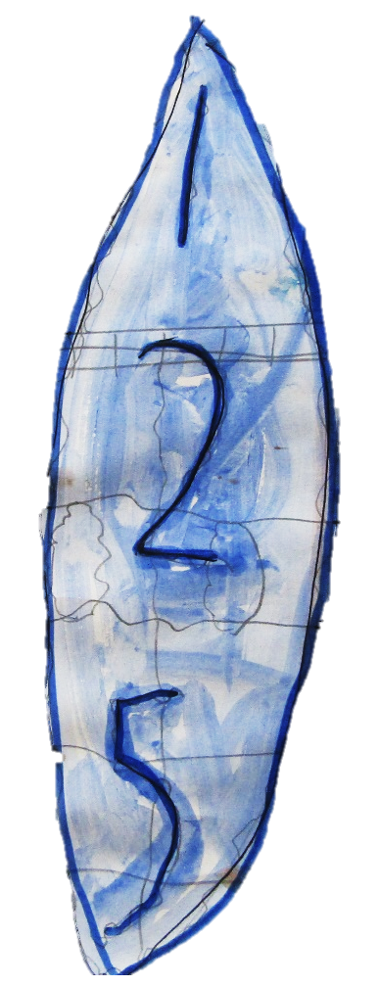


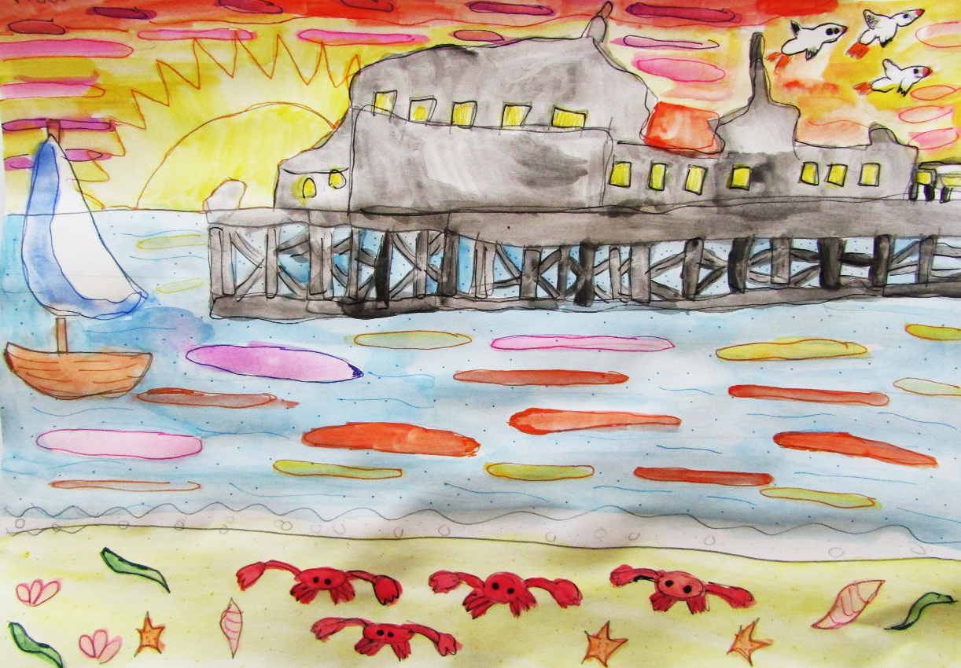

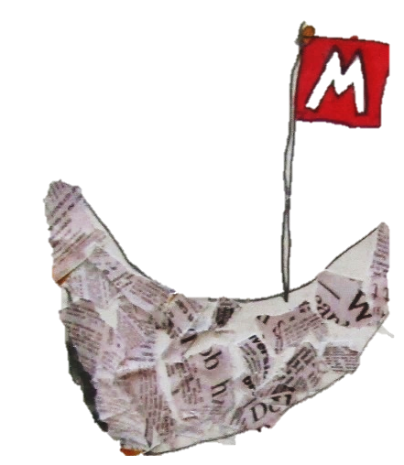

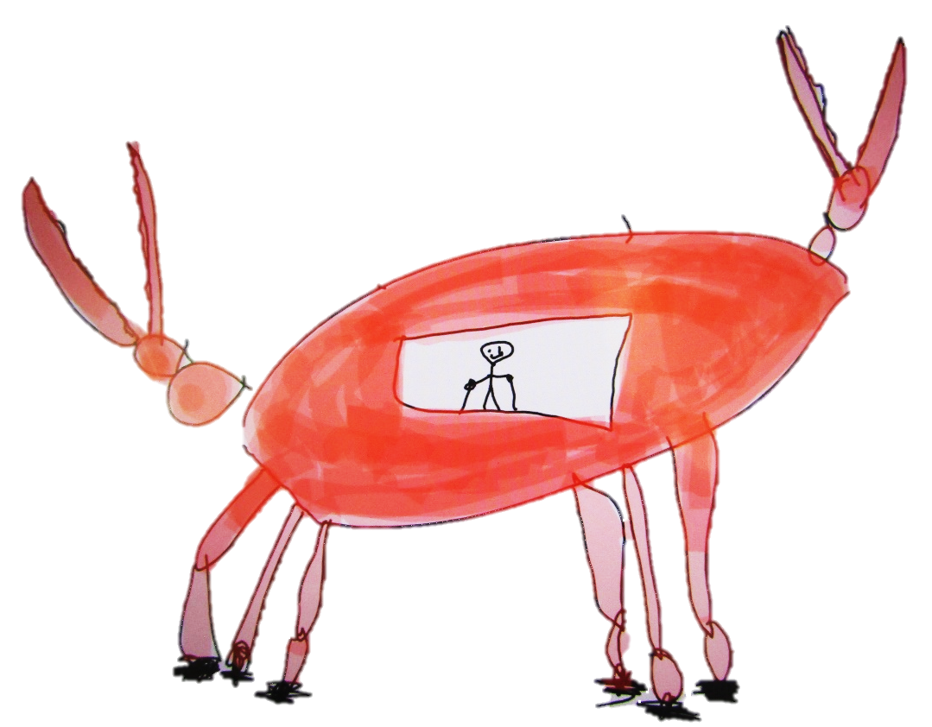

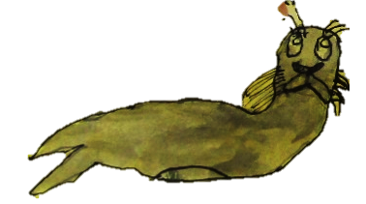



The standard of work has been excellent, with students exploring drawing, painting and mixed media to create bold designs for a possible public mural and exhibition.
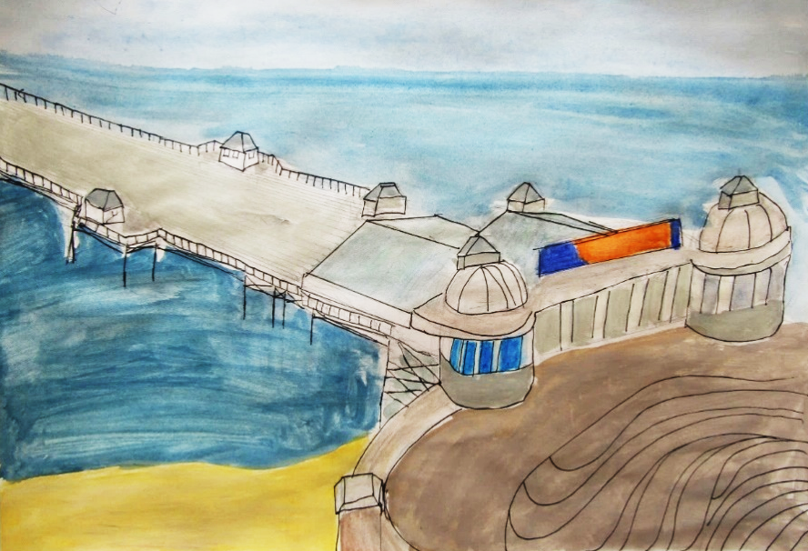



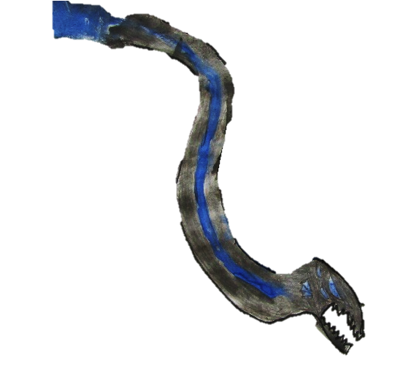
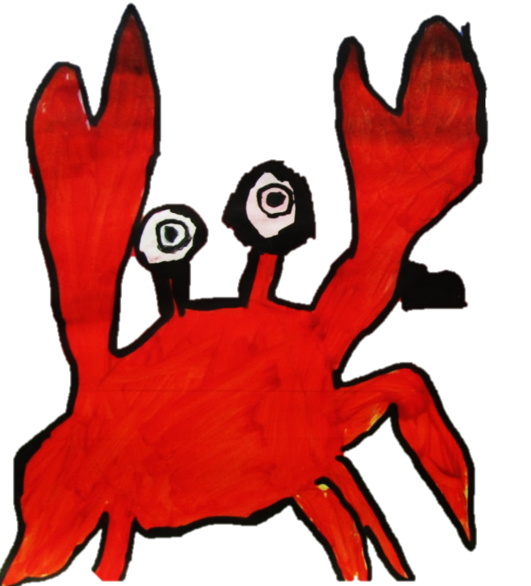
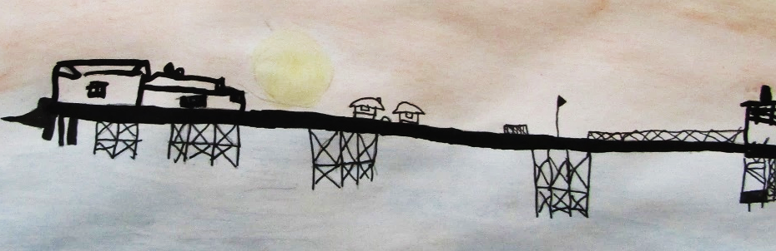

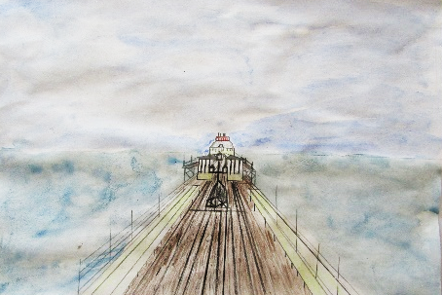
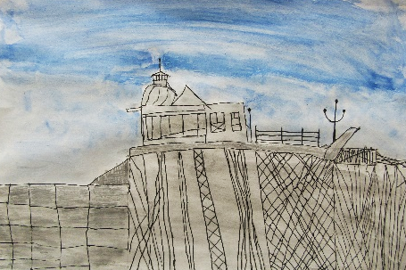
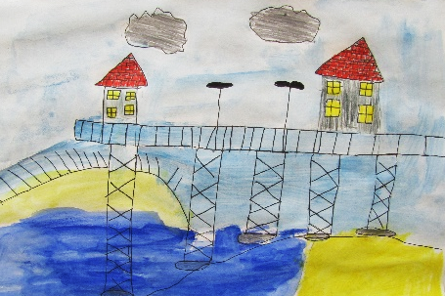
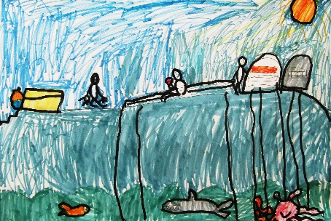
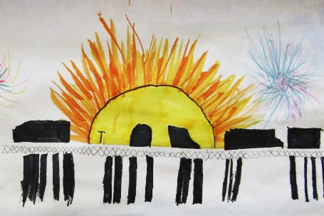
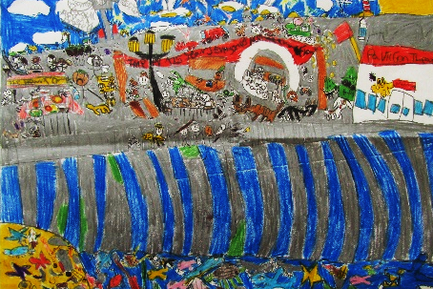
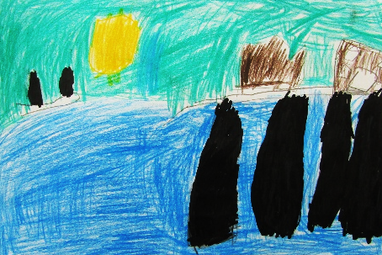

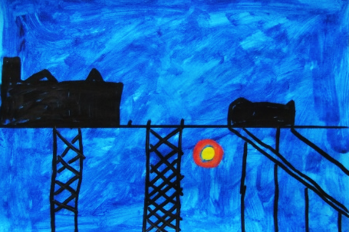
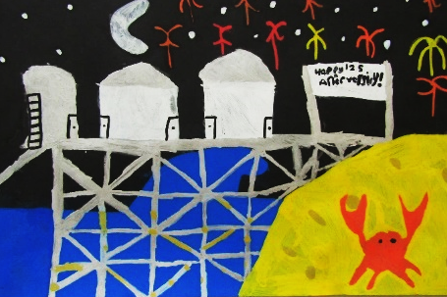
Projects like this are a wonderful way for students to connect with the local community, celebrate creativity beyond the classroom and take part in exciting real-world opportunities. We are incredibly proud of the artwork produced and excited to be involved in another creative partnership outside of school.

